REQUEST FOR BID (RFB)

DEPARTMENT OF ADMINISTRATION
PURCHASING DIVISION
BID NUMBER | 119016
BID TITLE | Snow Removal Services – Various Locations
BID DEADLINE | September 4, 2019  2:00 p.m. (CST)  Unsigned, late, faxed, or electronically mailed bids will be rejected.
MANDATORY SITE VISITS | There will be a mandatory site visit for each of the 10 locations listed within this bid. The site visits will occur over the course of 2 days.
SUBMIT BID TO THIS ADDRESS | CITY COUNTY BUILDING  DANE COUNTY PURCHASING DIVISION  210 MARTIN LUTHER KING JR BLVD ROOM 425  MADISON, WI 53703-3345
# OF REQUIRED  BID COPIES | Bidders must submit (1) original and (1) copy
DIRECT  ALL INQUIRES TO | NAME | Pete Patten
 | TITLE | Purchasing Agent
 | PHONE # | 608-267-3523
 | EMAIL | patten.peter@countyofdane.com
 | WEB SITE | www.danepurchasing.com
DATE BID ISSUED: August 9, 2019

BID SUBMISSION CHECKLIST
Read Entire Bid Document  Completed Bid Packet (stapled)  Section 2 – Vendor Information  Section 3 – Bid Specifications  Section 4 – Price Proposal  Section 5 – Standard Terms and Conditions | Bid Packets: (1) original and (1) copy  Sealed envelope/package containing bid packets and labeled with:  Vendor Name  Bid Number  Bid Deadline Date/Time  Up-to-date Vendor Registration
PROPOSALS MUST BE DATE/TIME STAMPED BY A DANE COUNTY ADMINISTRATION STAFF MEMBER
Revised 06/2018 (S)(LVP)

- Introduction
Dane County invites and will accept bids for services outlined within this bid. The County as represented by Purchasing Division, intends to use the results of this process to purchase goods or services here within.

- Clarification/Questions:
Any questions concerning this bid must be submitted in writing by mail, fax or email at least five working days prior to the bid deadline. Requests submitted after that time will not be considered. All inquiries must be directed to the Purchasing Agent indicated on the cover page.

- Addendums:
In the event that it becomes necessary to provide additional clarifying data or information, or to revise any part of this bid, addenda and/or supplements will be posted on the Purchasing Division web site at www.danepurchasing.com. Bidders are responsible to regularly monitor the web site for any such postings. It is recommended to check the website for addenda prior to submitting a proposal. Bidders must acknowledge the receipt/review of any addenda on the Vendor Information page.

The Purchasing Division has the sole authority for modifications to specifications and/or this bid document.

- Vendor Registration Program:
All bidders are strongly encouraged to be a registered vendor with Dane County. Registering allows vendors an opportunity to receive notifications for bids issued by the County and provides the County with up-to-date company contact information.

Provide your Dane County Vendor # in the Vendor Information section of the bid submission packet.

For Non-Registered Vendors:
Complete vendor registration by visiting www.danepurchasing.com. On the top menu bar, click Vendor Registration and then click Create Vendor Account. You will receive an email confirmation once your account is created and again when your vendor registration is complete. Retain your user name/email address and password for ease of re-registration in future years. Within 2-4 days of completing the registration, a vendor number will be assigned and emailed to you.

For Registered Vendors:
Check to make sure your vendor information including commodity codes is up-to-date by signing into your account at www.danepurchasing.com. On the top menu bar, click Vendor Registration and then click Vendor Log In.

- Local Purchasing Preference:
Under Dane County Ordinance 25.08(11)(c-e), a Locally Based and Owned Vendor, Locally Operated Vendor, or Non-Locally Operated Vendor may be invited to match the low bid if the low bid is offered by a vendor that is not identified as a Locally Based and Owned Vendor, Locally Operated Vendor, or Non-Locally Operated Vendor according to Dane County Ordinance requirements.

Locally Based and Owned Vendor Criteria
- Your business or corporate headquarters is physically located in Dane County and;
- Your business owners or shareholders totaling more than 50% of ownership live in Dane County and;
- Your business is registered and authorized to do business in the State of Wisconsin.

Locally Operated Vendor Criteria
- Your business is registered and authorized to do business in the State of Wisconsin and;
- Your business has an established place of business within Dane County.
    - A post office box address does not qualify a vendor as a Locally Operated Vendor.

Non-Locally Operated Vendor Criteria
- Your business is registered and authorized to do business in the State of Wisconsin and;
- Your business has an established place of business in one of the following Wisconsin Counties: Columbia, Dodge, Green, Iowa, Jefferson, Rock, or Sauk.
  - A post office box address does not qualify a vendor as a Non-Locally Operated Vendor.

Local Purchasing Preference Order of Events:
Locally Based and Owned Vendors:
- When bids are reviewed, the County will determine if a Locally Based and Owned Vendor responding to the bid is the low bidder. If a Locally Based and Owned Vendor is the low bidder, they will be awarded the bid.
- If a Locally Based and Owned Vendor is not the low bidder but is within 15% of the low bid, the County will contact the Locally Based and Owned Vendor and provide that vendor the option of matching the low bid price.
- If no Locally Based and Owned Vendors are among the responding bidders, or the Locally Based and Owned Vendor declines to match the low bid, then the County will determine if a Locally Operated Vendor has responded to the bid.

Locally Operated Vendors:
- If a Locally Operated Vendor is within 10% of the low bid, the County will contact the Locally Operated Vendor and provide that vendor the option of matching the low bid price.
- If no Locally Operated Vendors are among the responding bidders, or the Locally Operated Vendor declines to match the low bid, then the County will determine if a Non-Locally Operated Vendor has responded to the bid.

Non-Locally Operated Vendors:
- If a Non-Locally Operated Vendor is within 5% of the low bid, the County will contact the Non-Locally Operated Vendor and provide that vendor the option of matching the low bid price.
- If no Non-Locally Operated Vendors are among the responding bidders, or the Non-Locally Operated Vendor declines to match the low bid, then the County will award the bid to the low bidder without regard to the location of the vendor.

- Pricing:
The price quoted shall include all labor, materials, equipment, shipping, and other costs. All prices and conditions outlined in the bid shall remain fixed.

- Bid Submission and Acceptance:
Bids must be received by the Dane County Purchasing Division by the specified date and time stated on the cover page. All proposals must be time-stamped in by a Dane County Purchasing or Administration staff member. Bids not so stamped will not be accepted.

Unsigned, late, faxed, or electronically mailed bids will be rejected.

Vendors must submit an original and the required number of copies of all bid materials required for acceptance as instructed on the cover page of the bid.

Multiple bids from a vendor will be permissible, however, each proposal must conform fully to the requirements for bid submission. Each such bid must be separately submitted and labeled as Bid# 1, Bid# 2, etc.

Dane County reserves the right to accept any part of this bid deemed to be in the best interest
of the County. The County also retains the right to accept or reject any or all bids.

- Cooperative Purchasing
Participating in cooperative purchasing gives vendors opportunities for additional sales without additional bidding. Municipalities and state agencies use cooperative purchasing to expedite purchases. A “municipality” is defined as any county, city, village, town , school district, board of school directors, sewer district, drainage district, vocational, technical and adult education district, or any other public body having authority to award public contracts (s. 16.70(8), Wis. Stats.). Federally recognized Indian tribes and bands in this state may participate in cooperative purchasing with the state or any municipality under ss. 66.0301(1) and (20, Wis. Stats.

On the Vendor Information page, you will have the opportunity to participate in allowing municipalities and state agencies to piggyback this bid. Participation is not mandatory. A vendor’s decision on participating in this service has no effect on awarding the bid.

Dane County is not a party to these purchases or any dispute arising from these purchases and is not liable for delivery or payment of any of these purchases.

- Award:
The County will award the bid to the responsive and responsible bidder whose bid is most advantageous to the County. In determining the most advantageous bid, the County will consider criteria such as, but not limited to, cost, bidder’s past performance and/or service reputation, and service capability, quality of the bidder’s staff or services, customer satisfaction, references, the extent to which the bidder’s staff or services meet the County’s needs, bidder’s past relationship with the County, total long term cost to the County, fleet continuity and any other relevant criteria listed in this solicitation.

Written notice of award to a vendor in the form of a purchase order or other document, mailed or delivered to the address shown on the bid will be considered sufficient notice of acceptance of bid.

This contract and any part thereof shall not be subcontracted or assigned to another Contractor
without prior written permission of the County. The Contractor shall be directly responsible for any
subcontractor's performance and work quality when used by the Contractor to carry out the scope
of the job. Subcontractors must abide by all terms and conditions under this Contract.

- Payment Terms and Invoicing:
Unless otherwise agreed, Dane County will pay properly submitted vendor invoices within thirty (30) days of receipt of goods or services. Payment will not be made until goods or services are delivered, installed (if required), and accepted as specified. Invoices presented for payment shall be submitted to the bill to address and/or County Representative listed on the Dane County purchase order. The Dane County purchase order number must be noted on the submitted invoice.

Other incidental or standard industry charges not identified herein, are not allowed under this contract. Miscellaneous service charges used to help the Contractor pay various fluctuating current and future costs are not allowed. These charges include, but are not limited to, costs directly or indirectly related to the environment, energy issues, fuel charges, service and delivery of goods and services.

- Permits and Licenses:
The Contractor selected under this bid shall be required to obtain the necessary permits and licenses prior to performing any work under this contract. The Contractor will be required to demonstrate valid possession of appropriate required licenses and will keep them in effect for the term of this contract.

Contractor must be financially responsible for obtaining all required permits and licenses to comply with pertinent regulations, municipal, county, State of Wisconsin and Federal laws, and shall assume liability for all applicable taxes.

- Satisfactory Work:
Any work found to be in any way defective or unsatisfactory shall be corrected by the Contractor at its own expense at the order of the County. The County also reserves the right to contract out services not satisfactorily completed and to purchase substitute services elsewhere. The County reserves the right to charge the vendor with any or all costs incurred or retain/deduct the amount of such costs incurred from any monies due or which may become due under this contract.

- Government Standards:
All materials, equipment, and supplies provided to the County must fully comply with all safety requirements as set forth by the Wisconsin Department of Commerce and all applicable OSHA Standards. Bidders shall comply with all local, state and federal regulations, directives and laws.

- Warranty:
The length, time, and conditions of warranty must be attached to or stated in the bid document. The seller and/or manufacturer warrants that the goods sold hereunder will be merchantable quality, will conform to applicable specifications, and will be free from defects in material and workmanship and will be fit for the particular purpose intended.

Warranty does not commence until after the complete unit has been accepted and placed into service by the user agency. Bidder shall indicate the name and the geographical location of the nearest authorized dealer to perform subsequent warranty service. This information shall be stated in the pricing section of bid or otherwise specified.

- Inspection of Premises/Vendor Site Visit:
Bidder’s may inspect site(s) prior to submitting bids to determine all requirements associated with the project by contacting the Purchasing Agent listed on the cover page. Failure to do so will in no way relieve the successful bidder from the necessity of providing, without additional cost to the County, all necessary services that may be required to carry out the intent of the resulting contract.

- Contracting Assignment – Subcontractors
This contract and any part thereof shall not be subcontracted or assigned to another Contractor
without prior written permission of the County. The Contractor shall be directly responsible for any
subcontractor's performance and work quality when used by the Contractor to carry out the scope
of the job. Subcontractors must abide by all terms and conditions under this Contract.

- Contract Additions
The County reserves the right to add new items and locations at a price conforming to other like items on the contract. The procedure for such additions shall be as follows:

The County Purchasing Agent will contact the vendor requesting pricing for the item(s) to be added. The vendor, within three working days, should respond in writing and include the bid number, contract period and the price for each item or service to be provided. Upon receipt, the County shall issue a Change Order adding the service or product(s) to the Contract or Purchase Order. The County reserves the right to accept or reject prices and obtain bids on the open market for these add-ons.

When applicable, Contractor may be required to sign a Dane County Contract.

- Contract/Project Administration
The County department(s) utilizing the service will be responsible for coordinating, monitoring and administering the resulting service contract/purchase order. The department shall be responsible for notifying the awarded vendor about contract renewals or extensions. Any modifications or additions to the contract(s)/purchase order(s) shall be communicated by the department to the Purchasing Division.

- Contract Termination
If for any reason the successful contractor fails to fulfill the requirements of the contract for providing the specified services, the County shall have the right to cancel the contract at any time and negotiate for the services with another contractor.

- Insurance:
The successful vendor is required to submit to Dane County a Certificate of Insurance prior to performing any work under this contract. The certificate is required prior to issuance of purchase order. See Section 20.0 Insurance Responsibility in the Standard Terms & Conditions.

Please contact your insurance representative to issue an Additional Insured Endorsement naming COUNTY OF DANE, a municipal corporation, its boards, commissions, agencies, officers, employees and representatives listed as an ADDITIONAL INSURED on the General Liability policy..

Indicate mailing address as:

COUNTY OF DANE
Risk Management
City County Building Room 425
210 Martin Luther King Jr., Blvd.
Madison, WI 53703

You may fax it (608-266-4425) or mail it to Risk Management.

Please inform your insurance representative that you have agreed to provide us with 30 Days written notice in the event of cancellation for any reason before the expiration date of your policy or policies.

Call 608-266-4965 with any questions.

- Dane County Sustainability Principles:
On October 18, 2012, the Dane County Board of Supervisors adopted Resolution 103, 2012-2013 establishing the following sustainability principles for the county:

- Reduce and eventually eliminate Dane County government’s contribution to fossil fuel dependence and to wasteful use of scarce metals and minerals;
- Reduce and eventually eliminate Dane County government’s contribution to dependence upon persistent chemicals and wasteful use of synthetic substances;
- Reduce and eventually eliminate Dane County government’s contribution to encroachment upon nature and harm to life-sustaining ecosystems (e.g., land, water, wildlife, forest, soil, ecosystems); and
- Reduce and eventually eliminate Dane County government’s contribution to conditions that undermine people’s ability to meet their basic human needs.

- Fair Labor Practices:
Dane County Ord. 25.09 (1) is as follows:
(28) BIDDER RESPONSIBILITY. (a) Any bid, application or proposal for any contract with the county, including public works contracts regulated under chapter 40, shall include a certification indicating whether the bidder has been found by the National Labor Relations Board (NLRB) or the Wisconsin Employment Relations Committee (WERC) to have violated any statute or regulation regarding labor standards or relations within the last seven years. The purchasing manager shall investigate any such finding and make a recommendation to the committee, which shall determine whether the conduct resulting in the finding affects the bidder’s responsibility to perform the contract.

If you indicate that you have been found by the NLRB or WERC to have such a violation on the Vendor Information page, you must include a copy of any relevant information regarding such violation with your proposal, bid or application.

Additional information about the NLRB and WERC can be found using the following links:
www.nlrb.gov and http://werc.wi.gov.

VENDOR INFORMATION

VENDOR NAME:

Vendor Information (address below will be used to confirm Local Vendor Preference)
Address
City |  | County
State |  | Zip+4
Vendor Rep. Name |  | Telephone
Title
Email
Dane County Vendor #

Local Vendor Preference
(Reference General Guidelines #5)
Locally Based & Owned Vendor
Locally Operated Vendor
Non-Locally Operated Vendor
No Preference

Cooperative Purchasing (Reference General Guidelines #8)
Does not apply to this bid.

Fair Labor Practice Certification (Reference General Guidelines #22)
Vendor has not been found by the National Labor Relations Board (“NLRB”) or the Wisconsin Employment Relations Commission (“WERC”) to have violated any statute or regulation regarding labor standards or relations in the seven years prior to the date this bid submission is signed.
Vendor has been found by the National Labor Relations Board (“NLRB”) or the Wisconsin Employment Relations Commission (“WERC”) to have violated any statute or regulation regarding labor standards or relations in the seven years prior to the date this bid submission is signed.

Addenda – we hereby acknowledge receipt, review and use of the following addenda, if applicable.
Addendum #1 | Addendum #2 | Addendum #3 | Addendum #4 | None

Signature Affidavit
In signing this bid, we certify that we have not, either directly or indirectly, entered into any agreement or participated in any collusion or otherwise taken any action in restraint of free competition; that no attempt has been made to induce any other person or firm to submit or not to submit a bid; that this bid has been independently arrived at without collusion with any other bidder, competitor or potential competitor; that this bid has not been knowingly disclosed prior to the opening of bids to any other bidder or competitor; that the above statement is accurate under penalty of perjury.

The undersigned, submitting this bid, hereby agrees with all the terms, conditions, and specifications required by the County in this Request for Bid, and declares that the attached bid and pricing are in conformity therewith.
Signature |  | Title
Name (Printed) |  | Date

BID AND SPECIFICATION OVERVIEW

Dane County as represented by the Purchasing Division will accept bids for the purchase of specified item(s) as described within this document.

Mandatory Site Visits: Any vendor submitting a proposal for a specific location must attend the mandatory site visit for that specific location. Dates, times and locations are listed in the table below. A color copy of each location map will be provided at each site visit.

Day 1 – Tuesday, August 20, 2019
Site | Site Address | Date | Time
Medical Examiner's Office | 3111 Luds Lane, McFarland, WI 53558 | 8/20 | 8:00 AM - 8:45 AM
Human Services Stoughton | 125 Veterans Road, Stoughton, WI 53589 | 8/20 | 9:00 AM - 9:30 AM
Fen Oak | 5201 Fen Oak Drive, Madison, WI 53718 | 8/20 | 10:00 AM - 10:45 AM
Detox | 2914 Industrial Drive, Madison, WI 53713 | 8/20 | 11:00 AM - 11:45 AM
Ferris Center | 2120 Rimrock Road, Madison, WI 53713 | 8/20 | 12:00 PM - 12:30 PM

Day 2 – Wednesday, August 21, 2019
Site | Site Address | Date | Time
Badger Prairie Campus | 1100 E Verona Road, Verona, WI 53593 | 8/21 | 8:00 AM – 8:45 AM
Saddlebrook | 5668 Woodland Drive, Waunakee, WI 53597 | 8/21 | 9:15 AM - 9:45 AM
Job Center | 1819 Aberg Avenue, Madison, WI 53704 | 8/21 | 10:00 AM - 10:45 AM
Juvenile Shelter | 2402 Atwood Avenue, Madison, WI 53704 | 8/21 | 11:00 AM - 11:45 AM
Airport | 2601 Darwin Road, Madison, WI 53704 | 8/21 | 1:00 PM - 3:00PM

Specification Compliance: Bidder shall complete every space in the area provided with either a check mark to indicate the item being bid is exactly as specified (Yes), or deviates from bid specification (No). Any deviation from the minimum specifications stated herein must be identified in detail in the Specifications Deviations section of the bid and must include a description of how the proposed item(s) differ from the bid requirements, along with detailed justification for such deviation. Bidder shall include photos and schematics as necessary, for complete clarification.

The specifications below describe an acceptable product. Minor variations in specification may be accepted if, in the opinion of County staff, they do not adversely affect the quality, maintenance or performance of the item(s). Dane County reserves the right to accept or reject any and all bids, to waive informalities and to choose the bid that best meets the specifications and needs of the County.

NOTE:
- General Specifications 1-22 apply to all locations.
- Specifications 23-39 apply only to the Fen Oak location.
- Specifications 40-53 apply only to the Airport location.

Term: The contract shall be effective on the date indicated on the Dane County purchase order or the Dane County contract execution date and shall run for one year from that date, with options by mutual agreement of the County and Contractor, to renew for four (4) additional one-year terms.

If applicable, any renewal terms are not automatic extensions. Vendor performance may be taken into consideration in the decision by the contracting agencies and the Purchasing Division to either continue this contract into each possible renewal term or to terminate and re-bid this contract.

Anticipated Start Date: September 2019

Service Schedule Requirements: Each location may have a different scope of work or services needed. The site maps for each location provide a general idea of which areas need to be plowed and salted along with where snow can be piled up. The mandatory site visits will provide vendors an opportunity to see each location in person and follow up with any questions or clarifications.

Location Maps: A map for each location is provided within this bid and is color coded with Parking/Driveway areas shown in green and sidewalks shown in orange. Some maps may be outlined in green/orange while others are filled in green/orange. The provided maps are only estimations of the areas requiring snow removal and de-icing services. Exact areas can and should be confirmed during each site visit.
WISCONSIN SALT WISE & CHLORIDE SUMMARY

Dane County Land and Water Resources Department is a member of Wisconsin Salt Wise, an organization working to educate residents, businesses and winter maintenance professionals about the effects of excessive winter salt use and best practices to reduce the impact to our waters without compromising safety.
Overview
Once winter salt is applied on our roads, parking lots and driveways it doesn’t go away. It ends up in our lakes, rivers, streams and wetlands, putting our aquatic life at risk and endangering our freshwater resources. Our local lakes, waterways, groundwater and soil have been absorbing virtually all of the salt spread in Dane County for more than six decades. Chloride from salt is toxic to small aquatic life and degrades the natural eco-system of our lakes. Once salt is in our waterways, it does not break down – it’s here to stay. It only takes 1 teaspoon of salt to permanently pollute 5 gallons of water to a level that is toxic to freshwater ecosystems.

Impacts
Surface waters
In Dane County, winter salt causes large seasonal spikes in chloride levels of area lakes, rivers, streams and wetlands. Salt is already showing up at alarming levels in local water resources. Madison’s Lake Wingra’s chloride concentration has increased from 5 mg/L before the use of road salt to 115 mg/L today. In Lake Mendota, salt concentrations increase about 1 mg/L each year. If that rate continues, the waters will eventually taste salty and exceed toxic concentrations for aquatic life.

Drinking water
Road salt degrades our drinking water. In Madison, salt infiltration is increasing at five of the 23 drinking water wells. Shallow private wells near major roadways that are heavily salted are also particularly susceptible to chloride contamination.
Economic
- Once salt gets into water it is very difficult to remove. Treatment, like reverse osmosis or ion exchange, is costly to install and even more expensive to operate. Preventing salt from entering our drinking water resources in the first place is the most cost-effective solution.
- In 2016-2017, Wisconsin spent $36,170,919 on salt for its highways. That is about 526,199 tons of salt and that doesn't include what communities, businesses and homeowners applied (source).
- Salt weakens the concrete, brick and stone that make up our homes, garages, bridges, and roads. One ton of rock salt causes between $800 and $3,300 of damage to buildings, bridges and other infrastructure (source).
You Can Help!
Dane County Land and Water Resources Department is encouraging winter maintenance professionals that provide snow removal services in Dane County and all surrounding communities to:
- Shovel- Use mechanical means (shovels, brooms, scrapers) to clear as much snow as possible before the snow packs down and turns to ice.
- Scatter- If salt is needed; scatter so that there is space between the grains. Follow suggested Dane County Application Rates. Sweep up any remaining piles.
- Switch- When pavement temperatures drop below 15 degrees, salt won’t work. Switch to a different ice melter that works at lower temperatures.
- Attend a Winter Salt Certification Training this fall. The training is open to all contractors who apply winter salt in Dane County. Dane County will cover training costs (registration and time) for contractors hired to maintain a Dane County facility.
Visit www.wisaltwise for more information.

BID SPECIFICATIONS
GENERAL SPECS – ALL LOCATIONS

Item # | Description | Spec Compliance
 |  | Yes | No
1 | All work listed shall be performed in a thorough and professional manner and in accordance with accepted industry methods and practices. All work shall be in strict compliance with all local and state codes, ordinances, laws, and policies.
2 | Provider shall furnish all necessary labor, equipment, tools, and permits as herein noted, transportation, insurance and all necessary supervision.
3 | Provider shall provide an adequate number of competent, properly trained personnel with sufficient supervision to provide the required services at all times. The Provider shall provide all personnel with a complete set of specifications and schedules to ensure all required services are completed accurately.
4 | Any work found to be in any way defective or unsatisfactory shall be corrected by the Provider at its own expense at the order of the County.
5 | The County also reserves the right to contract out services not satisfactorily completed and to purchase substitute services elsewhere. The County reserves the right to charge the vendor with any or all costs incurred or retain/deduct the amount of such costs incurred from any monies due or which may become due under this contract.
6 | The contractor shall be responsible for damage to curbs, curb stops, sidewalks, vehicles, etc. caused by the plowing operation; the contractor shall notify County of damage within one day of occurrence. A certificate of insurance will be required from the successful bidder(s) prior to bid award.
7 | Provider shall immediately report any damage to the County’s equipment or to property and shall be held responsible for the restitution of any said damage if caused by its neglect or incompetence.
8 | If damage should occur to the County’s property for which the Provider is deemed responsible, the Provider shall be notified and given the opportunity to repair said damage before County makes other arrangements.
9 | Provider shall be responsible for maintaining a high level of safety in equipment and work conditions.
10 | Provider shall deliver the frequency and quantity of services as outlined for each location awarded. Additional or less snow removal services may be required depending upon conditions.
11 | Provider shall reseed damaged lawn areas.

Item # | Description | Spec Compliance
 |  | Yes | No
12 | Must have a minimum of 2 years of snow plowing experience with comparably sized facilities.
13 | Plowing shall be completed between 6:00 p.m. and 6:00 a.m. on weekdays, although daytime plowing may be requested if a heavy snowfall occurs during a workday. See Special Circumstances/Areas of Concern section for each location.
14 | In the event of scheduling conflicts caused by heavy workload, the County shall receive priority service from the contractor.
15 | Salt, sand or a combination of both, when requested, shall be applied in a manner to prevent excess tracking into the building or salt damage to adjacent vegetation.
16 | Any and all small piles or mounds of salt and/or sand must be removed before leaving the location.
17 | Salting services shall be verified with the site or location contact. Each location may request or require different levels of salting services.
18 | Snow between parked cars shall be removed as much as is feasibly possible with equipment.
19 | Snow will be plowed into a pile at the site, minimizing blockage of parking stalls.
20 | Snow removal from the site will require prior authorization from the County and/or site contact.
21 | The contractor will be responsible for finding an off-site location to dump the snow that is hauled away, except at the Airport, which has an on-site location for dumping snow.
22 | Determination of snow depth for payment will be as recorded by the National Weather Service Office in Sullivan, WI.  https://www.weather.gov/mkx/

BID SPECIFICATIONS
FEN OAK LOCATION ONLY

Item # | Description – Fen Oak Location Only | Spec Compliance
23 | GENERAL | Yes | No
24 | Awarded Contractor will be required to attend the City of Madison Winter Salt Certification Training in fall 2019.
25 | NOTE: Trainings are 5 hours in length, include lunch and will be offered in Madison on:  -October 8 and 9, 2019  -November 5 and 6, 2019
26 | NOTE: Dane County will pay for both registration and staff time (up to $25/hour for each staff member) to attend this training for 1 to 6 staff.
27 | Awarded Contractor will be required to attend a pre-season meeting with County staff at this location.
28 | SALTING | Yes | No
29 | Only the section of sidewalk that runs along the parking lot to the main entrance should be salted.
30 | Mechanical snow removal (shovel, blower, broom, etc.) should always be done first.
31 | Salt should only be used when conditions warrant salting using the drop spreader/hand spreader provided or other equipment supplied by contractor that can meet Dane County Application Rates.
32 | The sidewalks around the building and the circle should not be salted, only cleared. See site plan.
33 | Contractor shall follow Dane County Application Rates on walkways and entryways and try their best to follow suggested application rates when applying salt on parking lot, as equipment allows.
34 | County will provide a drop spreader for applying salt on walkway and entryways at this location if contractor does not have equipment that can meet Dane County Application Rates.
35 | Do not salt last lane of parking lot, only use mechanical removal in this area. See site plan.
36 | SPECIAL CIRCUMSTANCES / AREAS OF CONCERN | Yes | No
37 | Only pile snow in areas marked on site plan.
38 | Avoid placing snow piles in garden circle and gardens around building (red areas on plan).
39 | LWRD is concerned about increasing chloride levels in our surface and groundwater and is asking winter maintenance professionals that maintain our facility to use practices that reduce winter salt use.

BID SPECIFICATIONS
DANE COUNTY REGIONAL AIRPORT LOCATION ONLY

Item # | Description – Airport Location Only | Spec Compliance
40 | STAFFING AND EQUIPMENT | Yes | No
41 | Contractor shall provide adequate staffing and equipment to maintain access to all areas during snow events.
42 | Contractor shall provide adequate staffing to simultaneously work on International Lane, ramp rooftops, and surface parking lots.
43 | All Contractor employees shall act in a professional and courteous manner when in contact with Airport customers, tenants and employees.
44 | PARKING RAMPS | Yes | No
45 | The Airport requires snow to be hauled from the parking ramps during snow events. Contractor will remove snow from top floors of the ramps via six snow chutes along the west, north and south sides of the garages.
46 | Access to the chutes is via ground level drive lanes that run parallel to the ramps, and which allow trucks to drive under and through.
47 | Contractor will provide trucks into which Contractor will load snow via the snow chutes.
48 | Snow is only pushed down chutes when a dump truck is positioned under the chute for loading.
49 | Contractor will then haul snow to dumping locations on Airport property, usually within one mile of garage.
50 | Contractor is responsible for clearing snow from base of snow chutes after completing loading operations.
51 | Under no circumstances shall Contractor utilize steel cutting edges on plows or buckets used on parking ramp decks. Only rubber or polyurethane cutting edges may be used on the precast concrete parking decks.
52 | No salt or corrosive deicing agents may be applied on parking ramp decks by Contractor. Deicing will be performed by Airport staff, as required.
53 | Airport may request additional snow removal work as needed, at hourly rates specified in “Snow Removal and Hauling" section.

SPECIFICATION DEVIATIONS

Check One:
No deviations from bid specifications
Deviations from the bid specifications are present – see list below

Item # Deviation Explanation

_________ ________________________________________________________________________

_________ ________________________________________________________________________

_________ ________________________________________________________________________

_________ ________________________________________________________________________

_________ ________________________________________________________________________

_________ ________________________________________________________________________

_________ ________________________________________________________________________

_________ ________________________________________________________________________

_________ ________________________________________________________________________

_________ ________________________________________________________________________

_________ ________________________________________________________________________

_________ ________________________________________________________________________

_________ ________________________________________________________________________

_________ ________________________________________________________________________

_________ ________________________________________________________________________

_________ ________________________________________________________________________

_________ ________________________________________________________________________

_________ ________________________________________________________________________

_________ ________________________________________________________________________

_________ ________________________________________________________________________

STATEMENT OF QUALIFICATIONS / QUESTIONNAIRE
Provide detailed and descriptive information about your company’s qualifications and experience. Use the space provided to answer all questions and attach additional sheets as necessary.

1 | Number of years in business under the present name:
2 | Number of years of experience in providing similar services as specified in this solicitation:
3 | Number of employees:
4 | Number of employees providing snow removal services:
5 | List any and all Professional Certifications currently held:
6 | Experience: List and describe previous accounts that are similar in size and nature:
7 | Describe the type of training program that staff receive to provide snow removal services:
8 | Describe the procedures to problem solve customer issues:
9 | Would you attend a Winter Salt Certification Training class (5 hours) this fall, if the registration and staff time to attend were reimbursed by Dane County?
10 | Prior to reading this bid solicitation, were you aware of Dane County Winter Maintenance Application Rates and Guidance for Parking Lots, Sidewalks, and Trails?

PRICE PROPOSAL

VENDOR NAME:
Pricing shall be inclusive of all labor, delivery costs and other expenses necessary to provide product in accordance with the specifications and terms and conditions of this bid document and your proposal.

Medical Examiner’s Office
3111 Luds Lane, McFarland, WI 53558
Barry Irmen – 608-284-6000
Suzanne Eskola – 608-284-6000

Snow Plowing Per Event | Parking/Driveway | Sidewalks |  | Combined Total
Per snow removal 0" - 1" | $ | $ |  | $
Per snow removal 1.1" - 2" | $ | $ |  | $
Per snow removal 2.1" - 3" | $ | $ |  | $
Per snow removal 3.1" - 4" | $ | $ |  | $
Per snow removal 4.1"-6" | $ | $ |  | $
Per snow removal 6.1"-8" | $ | $ |  | $
Per snow removal 8.1"-10" | $ | $ |  | $
Per snow removal 10.1"-12" | $ | $ |  | $
Per snow removal 12.1"-14" | $ | $ |  | $
Per snow removal 14.1"-16" | $ | $ |  | $
Per snow removal 16.1"-18" | $ | $ |  | $
Per snow removal 18.1"-20" | $ | $ |  | $
Salt Application | Parking/Driveway | Sidewalks |  | Combined Total
Per salt application | $ | $ |  | $
Sand Application | Parking/Driveway | Sidewalks |  | Combined Total
Per sand application | $ | $ |  | $
Salt/Sand Mix Application | Parking/Driveway | Sidewalks |  | Combined Total
Per salt/sand mix application | $ | $ |  | $

 | Plowing | Salting
Parking/Driveway | Yes | Yes
Sidewalks | Yes | *Yes/No

Special Circumstances / Areas of Concern
24/7 Operation, therefore the driveways and garage entrances must be clear regardless of the time of day. Do not pile snow in Gate Travel Areas in front and back. Parking blocks on curb sides of building must be cleaned out.

MEDICAL EXAMINER BUILDING MAP
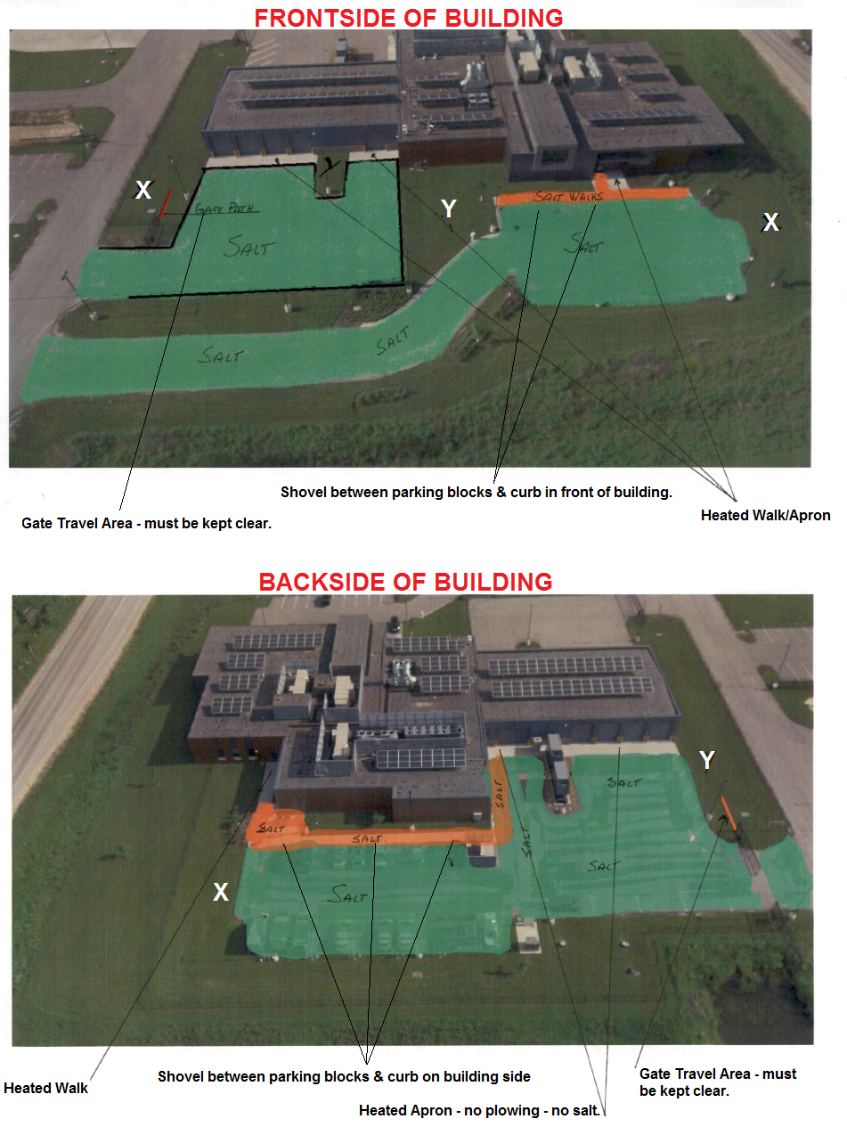
PRICE PROPOSAL

VENDOR NAME:
Pricing shall be inclusive of all labor, delivery costs and other expenses necessary to provide product in accordance with the specifications and terms and conditions of this bid document and your proposal.

Human Services Stoughton
125 Veterans Road, Stoughton, WI 53589
Amanda DePagter – 608-215-6273
Steve Hutchinson – 608-576-1273

Snow Plowing Per Event | Parking/Driveway | Sidewalks |  | Combined Total
Per snow removal 0" - 1" | $ | $ |  | $
Per snow removal 1.1" - 2" | $ | $ |  | $
Per snow removal 2.1" - 3" | $ | $ |  | $
Per snow removal 3.1" - 4" | $ | $ |  | $
Per snow removal 4.1"-6" | $ | $ |  | $
Per snow removal 6.1"-8" | $ | $ |  | $
Per snow removal 8.1"-10" | $ | $ |  | $
Per snow removal 10.1"-12" | $ | $ |  | $
Per snow removal 12.1"-14" | $ | $ |  | $
Per snow removal 14.1"-16" | $ | $ |  | $
Per snow removal 16.1"-18" | $ | $ |  | $
Per snow removal 18.1"-20" | $ | $ |  | $
Salt Application | Parking/Driveway | Sidewalks |  | Combined Total
Per salt application | $ | $ |  | $
Sand Application | Parking/Driveway | Sidewalks |  | Combined Total
Per sand application | $ | $ |  | $
Salt/Sand Mix Application | Parking/Driveway | Sidewalks |  | Combined Total
Per salt/sand mix application | $ | $ |  | $

Human Services – Stoughton Map
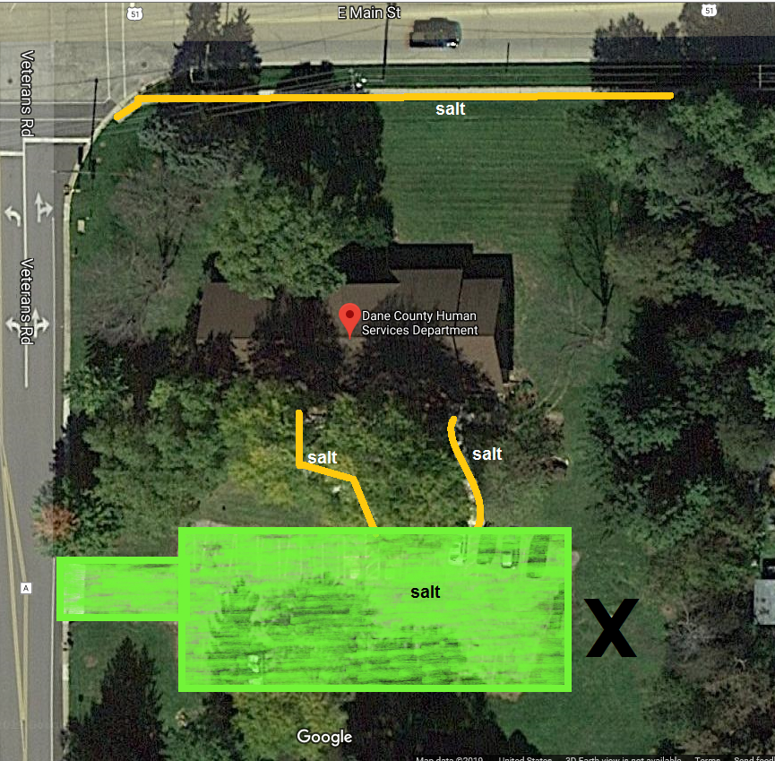

 | Plowing | Salting
Parking/Driveway | Yes | Yes
Sidewalks | Yes | Yes

Special Circumstances / Areas of Concern
Parking lot should be cleared/de-iced prior to 7:45am M-F and again as needed during business hours (7:45am-4:30pm M-F) during large winter storm events.

PRICE PROPOSAL

VENDOR NAME:
Pricing shall be inclusive of all labor, delivery costs and other expenses necessary to provide product in accordance with the specifications and terms and conditions of this bid document and your proposal.

Land & Water/Fen Oak
5201 Fen Oak Drive, Madison, WI 53718
Jeremy Balousek – 608-225-6535

Snow Plowing Per Event | Parking/Driveway | Sidewalks |  | Combined Total
Per snow removal 0" - 1" | $ | $ |  | $
Per snow removal 1.1" - 2" | $ | $ |  | $
Per snow removal 2.1" - 3" | $ | $ |  | $
Per snow removal 3.1" - 4" | $ | $ |  | $
Per snow removal 4.1"-6" | $ | $ |  | $
Per snow removal 6.1"-8" | $ | $ |  | $
Per snow removal 8.1"-10" | $ | $ |  | $
Per snow removal 10.1"-12" | $ | $ |  | $
Per snow removal 12.1"-14" | $ | $ |  | $
Per snow removal 14.1"-16" | $ | $ |  | $
Per snow removal 16.1"-18" | $ | $ |  | $
Per snow removal 18.1"-20" | $ | $ |  | $
Salt Application | Parking/Driveway | Sidewalks |  | Combined Total
Per salt application | $ | $ |  | $
Sand Application | Parking/Driveway | Sidewalks |  | Combined Total
Per sand application | $ | $ |  | $
Salt/Sand Mix Application | Parking/Driveway | Sidewalks |  | Combined Total
Per salt/sand mix application | $ | $ |  | $

Land & Water – Fen Oak Map
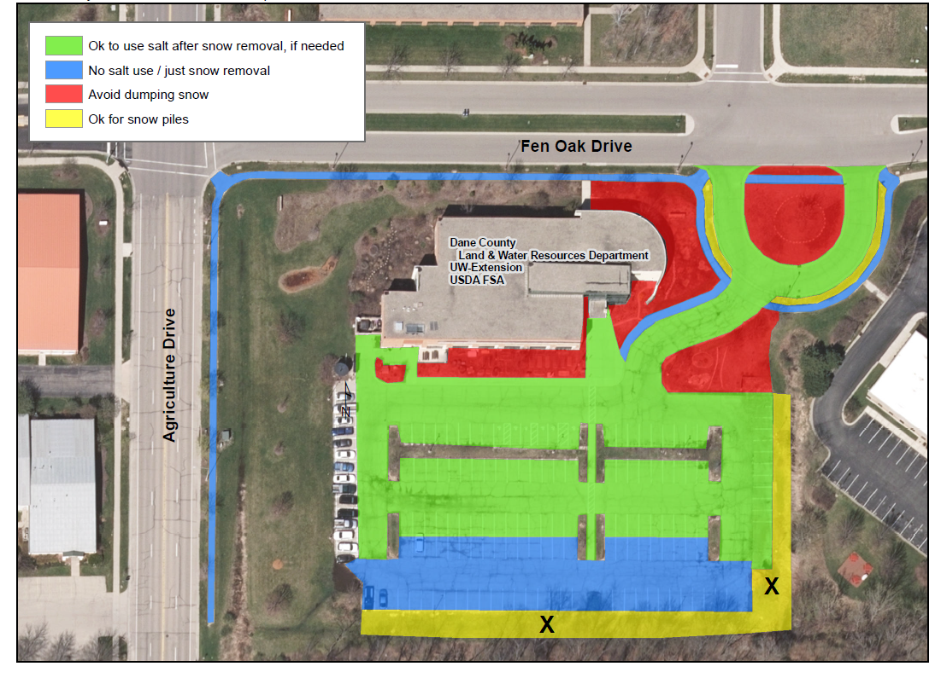

 | Plowing | Salting
Parking/Driveway | Yes | *Yes/No
Sidewalks | Yes | *Yes/No

Special Circumstances / Areas of Concern
1. Only the section of sidewalk that runs along the parking lot to the main entrance should be salted.
2. Mechanical snow removal (shovel, blower, broom, etc.) should always be done first.
3. Salt should only be used when conditions warrant salting using the drop spreader/hand spreader provided or other equipment supplied by contractor that can meet Dane County Application Rates.
4. The sidewalks around the building and the circle should not be salted, only cleared. See site plan.
5. Snow should not be piled up in the garden circle entrance area and gardens around the building.
6. Contractor follow Dane County Application Rates on walkways and entryways and tries their best to follow suggested application rates when applying salt on parking lot, as equipment allows.
7. County will provide a drop spreader for applying salt on walkway and entryways at this location if contractor does not have equipment that can meet Dane County Application Rates.
8. Do not salt last lane of parking lot, only use mechanical removal in this area. See site plan.
9. Awarded Contractor will be required to attend the City of Madison Winter Salt Certification Training in fall 2019 – see specifications #23 - 39.
10. Awarded Contractor will be required to attend a pre-season meeting with County staff at this location.

PRICE PROPOSAL

VENDOR NAME:
Pricing shall be inclusive of all labor, delivery costs and other expenses necessary to provide product in accordance with the specifications and terms and conditions of this bid document and your proposal.

Detox Center
2914 Industrial Drive, Madison, WI 53713
Amanda DePagter – 608-215-6273

Snow Plowing Per Event | Parking/Driveway | Sidewalks |  | Combined Total
Per snow removal 0" - 1" | $ | $ |  | $
Per snow removal 1.1" - 2" | $ | $ |  | $
Per snow removal 2.1" - 3" | $ | $ |  | $
Per snow removal 3.1" - 4" | $ | $ |  | $
Per snow removal 4.1"-6" | $ | $ |  | $
Per snow removal 6.1"-8" | $ | $ |  | $
Per snow removal 8.1"-10" | $ | $ |  | $
Per snow removal 10.1"-12" | $ | $ |  | $
Per snow removal 12.1"-14" | $ | $ |  | $
Per snow removal 14.1"-16" | $ | $ |  | $
Per snow removal 16.1"-18" | $ | $ |  | $
Per snow removal 18.1"-20" | $ | $ |  | $
Salt Application | Parking/Driveway | Sidewalks |  | Combined Total
Per salt application | $ | $ |  | $
Sand Application | Parking/Driveway | Sidewalks |  | Combined Total
Per sand application | $ | $ |  | $
Salt/Sand Mix Application | Parking/Driveway | Sidewalks |  | Combined Total
Per salt/sand mix application | $ | $ |  | $

DETOX CENTER MAP
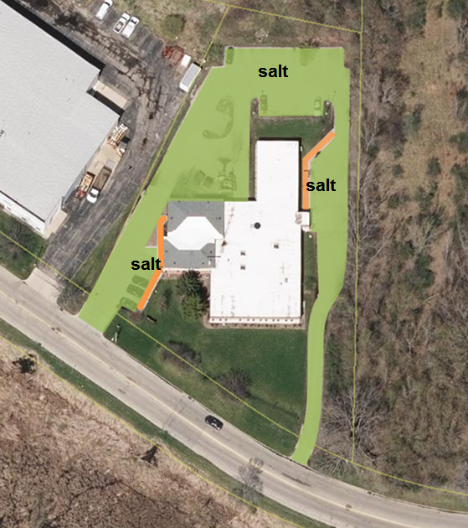

 | Plowing | Salting
Parking/Driveway | Yes | Yes
Sidewalks | Yes | Yes

Special Circumstances / Areas of Concern
Facility operates 24/7. Parking lot should be cleared/de-iced at end of storm and also as needed during large storm events for accessibility.

PRICE PROPOSAL

VENDOR NAME:
Pricing shall be inclusive of all labor, delivery costs and other expenses necessary to provide product in accordance with the specifications and terms and conditions of this bid document and your proposal.

Ferris Center
2120 Rimrock Road, Madison, WI 53713
Sgt. Brad Lindsley

Snow Plowing Per Event | Parking/Driveway
Per snow removal 0" - 1" | $
Per snow removal 1.1" - 2" | $
Per snow removal 2.1" - 3" | $
Per snow removal 3.1" - 4" | $
Per snow removal 4.1"-6" | $
Per snow removal 6.1"-8" | $
Per snow removal 8.1"-10" | $
Per snow removal 10.1"-12" | $
Per snow removal 12.1"-14" | $
Per snow removal 14.1"-16" | $
Per snow removal 16.1"-18" | $
Per snow removal 18.1"-20" | $
Salt Application | Parking/Driveway
Per salt application | $
Sand Application | Parking/Driveway
Per sand application | $
Salt/Sand Mix Application | Parking/Driveway
Per salt/sand mix application | $

FERRIS CENTER MAP
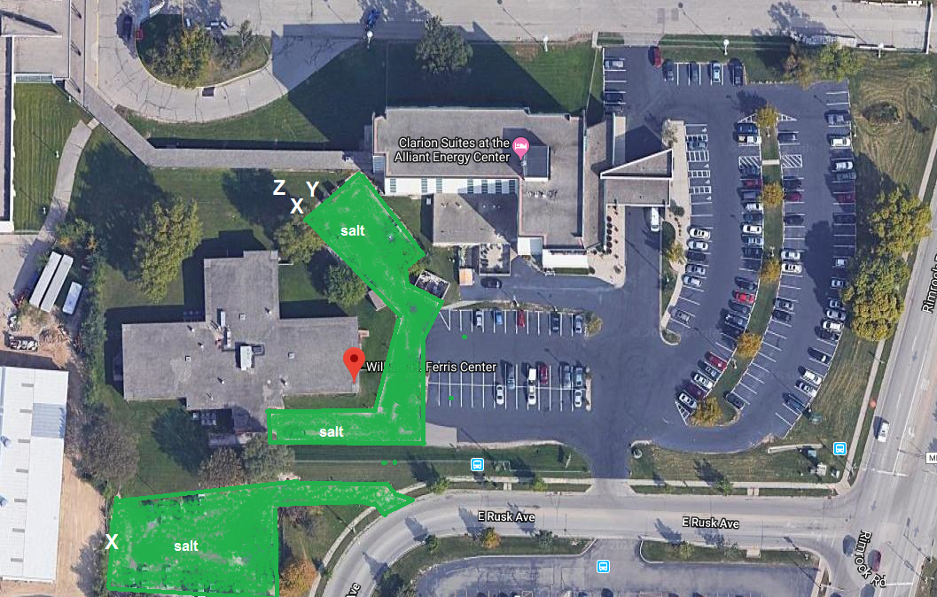

 | Plowing | Salting
Parking/Driveway | Yes | Yes
Sidewalks | N/A | N/A

Special Circumstances / Areas of Concern
Parking Lots - lower, upper and drive in.

PRICE PROPOSAL

VENDOR NAME:
Pricing shall be inclusive of all labor, delivery costs and other expenses necessary to provide product in accordance with the specifications and terms and conditions of this bid document and your proposal.

Badger Prairie Campus
1100 E Verona Road, Verona, WI 53593
Kelly Otto – 608-845-1269
Amanda DePagter – 608-215-6273
Steve Hutchinson – 608-576-1273

 |  | Service Level 1 - Option 1 |  |  |  | Service Level 2 - Option 2
Snow Plowing Per Event |  | Parking / Driveway | Sidewalks | Combined Total |  | Parking / Driveway | Sidewalks | Combined Total
Per snow removal 0" - 1" |  | $ | $ | $ |  | $ | $ | $
Per snow removal 1.1" - 2" |  | $ | $ | $ |  | $ | $ | $
Per snow removal 2.1" - 3" |  | $ | $ | $ |  | $ | $ | $
Per snow removal 3.1" - 4" |  | $ | $ | $ |  | $ | $ | $
Per snow removal 4.1"-6" |  | $ | $ | $ |  | $ | $ | $
Per snow removal 6.1"-8" |  | $ | $ | $ |  | $ | $ | $
Per snow removal 8.1"-10" |  | $ | $ | $ |  | $ | $ | $
Per snow removal 10.1"-12" |  | $ | $ | $ |  | $ | $ | $
Per snow removal 12.1"-14" |  | $ | $ | $ |  | $ | $ | $
Per snow removal 14.1"-16" |  | $ | $ | $ |  | $ | $ | $
Per snow removal 16.1"-18" |  | $ | $ | $ |  | $ | $ | $
Per snow removal 18.1"-20" |  | $ | $ | $ |  | $ | $ | $
Salt Application |  | Parking / Driveway | Sidewalks | Combined Total |  | Parking / Driveway | Sidewalks | Combined Total
Per salt application |  | $ | $ | $ |  | $ | $ | $
Sand Application |  | Parking / Driveway | Sidewalks | Combined Total |  | Parking / Driveway | Sidewalks | Combined Total
Per sand application |  | $ | $ | $ |  | $ | $ | $
Salt/Sand Mix Application |  | Parking / Driveway | Sidewalks | Combined Total |  | Parking / Driveway | Sidewalks | Combined Total
Per salt/sand mix application |  | $ | $ | $ |  | $ | $ | $

Badger Prairie Campus Map

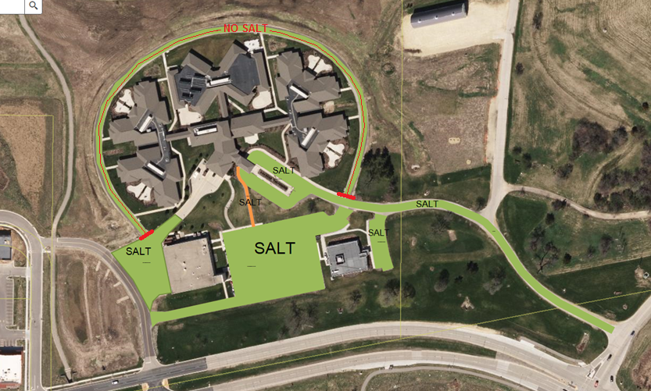

 | Plowing | Salting
Parking/Driveway | Yes | *Yes/No
Sidewalks | Yes | Yes

Special Circumstances / Areas of Concern
*Salt usage and turf disturbance must be minimal near any rain gardens and the restored prairie.

**Due to the proximity of the restored prairie and rain gardens, salting (bagged salt blend) should be applied sparingly, but as needed. THAW MASTER is the recommended product to use.

This facility is operational 24/7, therefore snow removal services are needed to make sure staff can get to and from the building during shift changes. Shift changes occur at 6AM, 2PM, and 10PM every day of the year including weekends and holidays.
Service Level 1 – 1 Shift Change Only (10 PM)  Identified areas to be cleared of snow prior to the 10PM shift change if: | Service Level 2 – 3 Shift Changes (6AM, 2PM, 10PM)  Identified areas to be cleared of snow prior to the upcoming shift change if:
2” of snow or more has accumulated by 9 pm  OR  2” of snow or more is estimated to be accumulated  by 10 pm. | 2” of snow or more has accumulated by 5 am, 1 pm, or 9 pm  OR  2” of snow or more is estimated to be accumulated  by 6am, 2pm, or 10pm
NOTE: Snow removal services only necessary to cover the 10pm shift change. | Snow removal to occur upon end of storm if a snow event produces less than 2” of snow accumulation.

PRICE PROPOSAL

VENDOR NAME:
Pricing shall be inclusive of all labor, delivery costs and other expenses necessary to provide product in accordance with the specifications and terms and conditions of this bid document and your proposal.

Saddlebrook
5668 Woodland Drive, Waunakee, WI 53597
Site Contact - TBD

Snow Plowing Per Event | Parking/Driveway
Per snow removal 0" - 1" | $
Per snow removal 1.1" - 2" | $
Per snow removal 2.1" - 3" | $
Per snow removal 3.1" - 4" | $
Per snow removal 4.1"-6" | $
Per snow removal 6.1"-8" | $
Per snow removal 8.1"-10" | $
Per snow removal 10.1"-12" | $
Per snow removal 12.1"-14" | $
Per snow removal 14.1"-16" | $
Per snow removal 16.1"-18" | $
Per snow removal 18.1"-20" | $
Salt Application | Parking/Driveway
Per salt application | $
Sand Application | Parking/Driveway
Per sand application | $
Salt/Sand Mix Application | Parking/Driveway
Per salt/sand mix application | $

SADDLEBROOK MAP
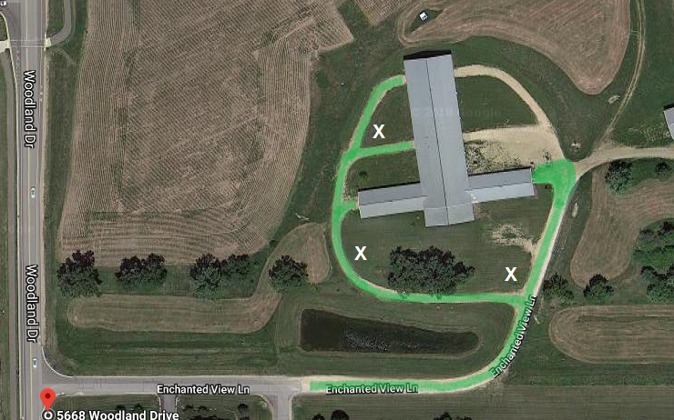

 | Plowing | Salting
Parking/Driveway | Yes | No
Sidewalks | N/A | N/A

Special Circumstances / Areas of Concern
None

PRICE PROPOSAL

VENDOR NAME:
Pricing shall be inclusive of all labor, delivery costs and other expenses necessary to provide product in accordance with the specifications and terms and conditions of this bid document and your proposal.

Dane County Job Center/NIP
1819 Aberg Avenue, Madison, WI 53704
Amanda DePagter – 608-215-6273
Steve Hutchinson – 608-576-1273

Snow Plowing Per Event | Parking/Driveway | Sidewalks |  | Combined Total
Per snow removal 0" - 1" | $ | $ |  | $
Per snow removal 1.1" - 2" | $ | $ |  | $
Per snow removal 2.1" - 3" | $ | $ |  | $
Per snow removal 3.1" - 4" | $ | $ |  | $
Per snow removal 4.1"-6" | $ | $ |  | $
Per snow removal 6.1"-8" | $ | $ |  | $
Per snow removal 8.1"-10" | $ | $ |  | $
Per snow removal 10.1"-12" | $ | $ |  | $
Per snow removal 12.1"-14" | $ | $ |  | $
Per snow removal 14.1"-16" | $ | $ |  | $
Per snow removal 16.1"-18" | $ | $ |  | $
Per snow removal 18.1"-20" | $ | $ |  | $
Salt Application | Parking/Driveway | Sidewalks |  | Combined Total
Per salt application | $ | $ |  | $
Sand Application | Parking/Driveway | Sidewalks |  | Combined Total
Per sand application | $ | $ |  | $
Salt/Sand Mix Application | Parking/Driveway | Sidewalks |  | Combined Total
Per salt/sand mix application | $ | $ |  | $

JOB CENTER/NIP MAP
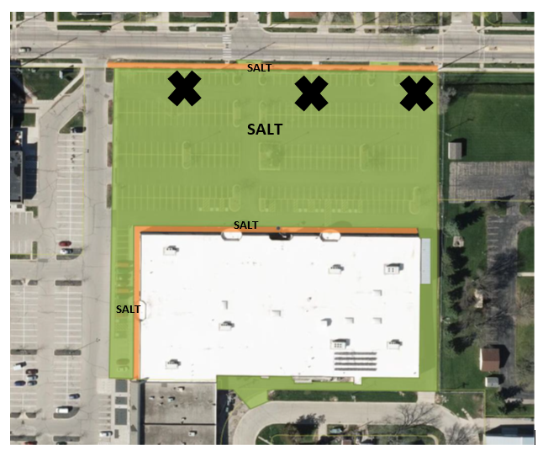

 | Plowing | Salting
Parking/Driveway | Yes | Yes
Sidewalks | Yes | Yes

Special Circumstances / Areas of Concern
Parking lot should be cleared/de-iced prior to 7:45am M-F and again as needed during business hours (7:45am-4:30pm M-F) during large winter storm events.

NIP Entrance/Walkway, Area around stairwell to Entrance #4, Snow Pile Storage - may require snow hauling.

PRICE PROPOSAL

VENDOR NAME:
Pricing shall be inclusive of all labor, delivery costs and other expenses necessary to provide product in accordance with the specifications and terms and conditions of this bid document and your proposal.

Juvenile Shelter
2402 Atwood Avenue, Madison, WI 53704
Suzanne Stute – 608-576-3049

Snow Plowing Per Event | Parking/Driveway | Sidewalks |  | Combined Total
Per snow removal 0" - 1" | $ | $ |  | $
Per snow removal 1.1" - 2" | $ | $ |  | $
Per snow removal 2.1" - 3" | $ | $ |  | $
Per snow removal 3.1" - 4" | $ | $ |  | $
Per snow removal 4.1"-6" | $ | $ |  | $
Per snow removal 6.1"-8" | $ | $ |  | $
Per snow removal 8.1"-10" | $ | $ |  | $
Per snow removal 10.1"-12" | $ | $ |  | $
Per snow removal 12.1"-14" | $ | $ |  | $
Per snow removal 14.1"-16" | $ | $ |  | $
Per snow removal 16.1"-18" | $ | $ |  | $
Per snow removal 18.1"-20" | $ | $ |  | $
Salt Application | Parking/Driveway | Sidewalks |  | Combined Total
Per salt application | $ | $ |  | $
Sand Application | Parking/Driveway | Sidewalks |  | Combined Total
Per sand application | $ | $ |  | $
Salt/Sand Mix Application | Parking/Driveway | Sidewalks |  | Combined Total
Per salt/sand mix application | $ | $ |  | $

JUVENILE SHELTER MAP
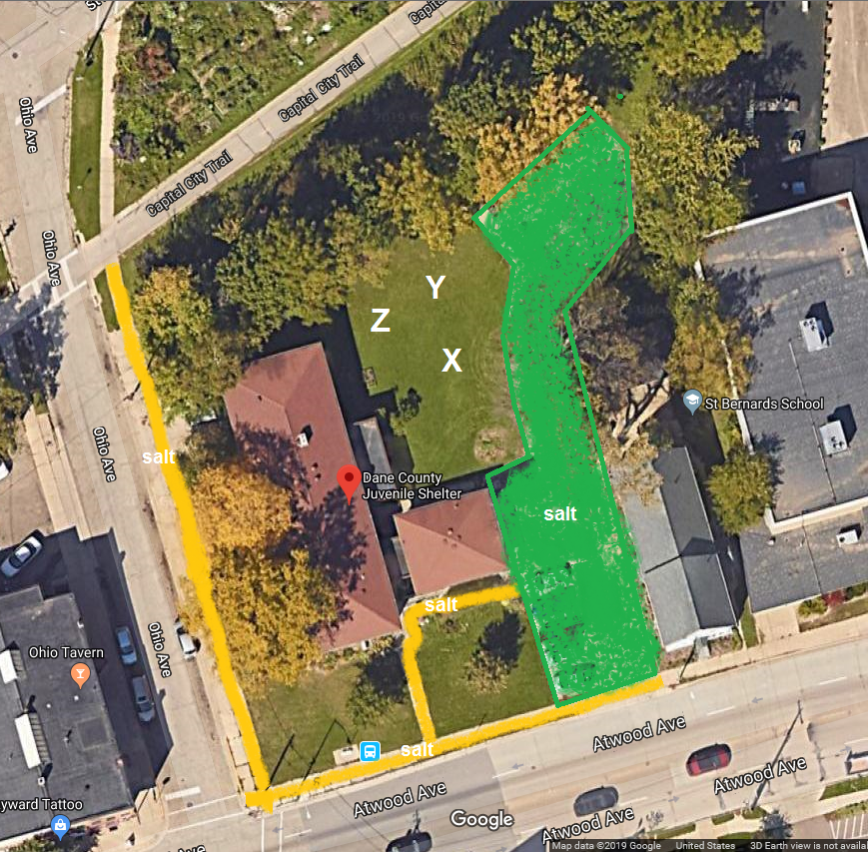

 | Plowing | Salting
Parking/Driveway | Yes | Yes
Sidewalks | Yes | Yes

Special Circumstances / Areas of Concern
Sidewalks need to be cleared past the driveway on Atwood and to the bike path on Ohio. Special attention needs to be paid to the walk way/curb on the corner of Atwood and Ohio.

PRICE PROPOSAL

VENDOR NAME:
Pricing shall be inclusive of all labor, delivery costs and other expenses necessary to provide product in accordance with the specifications and terms and conditions of this bid document and your proposal.

Dane County Regional Airport
1 – Taxi Ready Stand/Loading Dock & Rental Sidewalks
4000 International Lane, Madison, WI 53704

Snow Plowing Per Event | Parking/Driveway | Sidewalks |  | Combined Total
Per snow removal 0" - 1" | $ | $ |  | $
Per snow removal 1.1" - 2" | $ | $ |  | $
Per snow removal 2.1" - 3" | $ | $ |  | $
Per snow removal 3.1" - 4" | $ | $ |  | $
Per snow removal 4.1"-6" | $ | $ |  | $
Per snow removal 6.1"-8" | $ | $ |  | $
Per snow removal 8.1"-10" | $ | $ |  | $
Per snow removal 10.1"-12" | $ | $ |  | $
Per snow removal 12.1"-14" | $ | $ |  | $
Per snow removal 14.1"-16" | $ | $ |  | $
Per snow removal 16.1"-18" | $ | $ |  | $
Per snow removal 18.1"-20" | $ | $ |  | $
Salt Application | Parking/Driveway | Sidewalks |  | Combined Total
Per salt application | $ | $ |  | $
Sand Application | Parking/Driveway | Sidewalks |  | Combined Total
Per sand application | $ | $ |  | $
Salt/Sand Mix Application | Parking/Driveway | Sidewalks |  | Combined Total
Per salt/sand mix application | $ | $ |  | $

1 | Taxi Ready Stand/Loading Dock and Rental Sidewalks
 | Loading dock and taxi ready stand.
 | Sidewalks - under canopy in north Car Rental Lot (sidewalk only in this area - lot is plowed by others).
 | Salt Application - Airport will notify Contractor if salt should be applied.

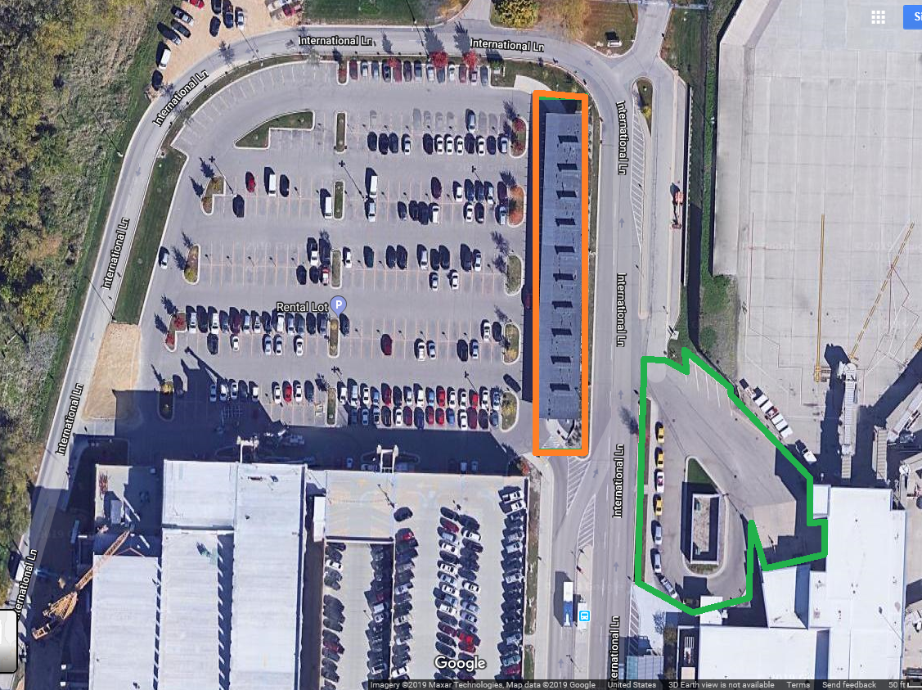

PRICE PROPOSAL

VENDOR NAME:
Pricing shall be inclusive of all labor, delivery costs and other expenses necessary to provide product in accordance with the specifications and terms and conditions of this bid document and your proposal.

Dane County Regional Airport
2 – Parking Ramps – East and West
4000 International Lane, Madison, WI 53704

Snow Plowing Per Event | Parking/Driveway | Snow Hauling  (Specs 40-53)
Per snow removal 0" - 1" | $ | $
Per snow removal 1.1" - 2" | $ | $
Per snow removal 2.1" - 3" | $ | $
Per snow removal 3.1" - 4" | $ | $
Per snow removal 4.1"-6" | $ | $
Per snow removal 6.1"-8" | $ | $
Per snow removal 8.1"-10" | $ | $
Per snow removal 10.1"-12" | $ | $
Per snow removal 12.1"-14" | $ | $
Per snow removal 14.1"-16" | $ | $
Per snow removal 16.1"-18" | $ | $
Per snow removal 18.1"-20" | $ | $
Salt Application | Parking/Driveway
Per salt application | $
Sand Application | Parking/Driveway
Per sand application | $
Salt/Sand Mix Application | Parking/Driveway
Per salt/sand mix application | $

2 | Parking Ramps - East and West | East Ramp | West Ramp
 | Sidewalks - none | Approx. 470 rooftop stalls | Approx. 470 rooftop stalls
 | Salt Application - Airport will notify Contractor if salt should be applied. | Interior turnarounds at both ends of 3 levels | Turnarounds at both ends of 5 levels.
 | All entry doors on rooftop and ground levels. | 2 snow chutes | 4 snow chutes
 | **Includes Snow Hauling – see Specs 40-53**

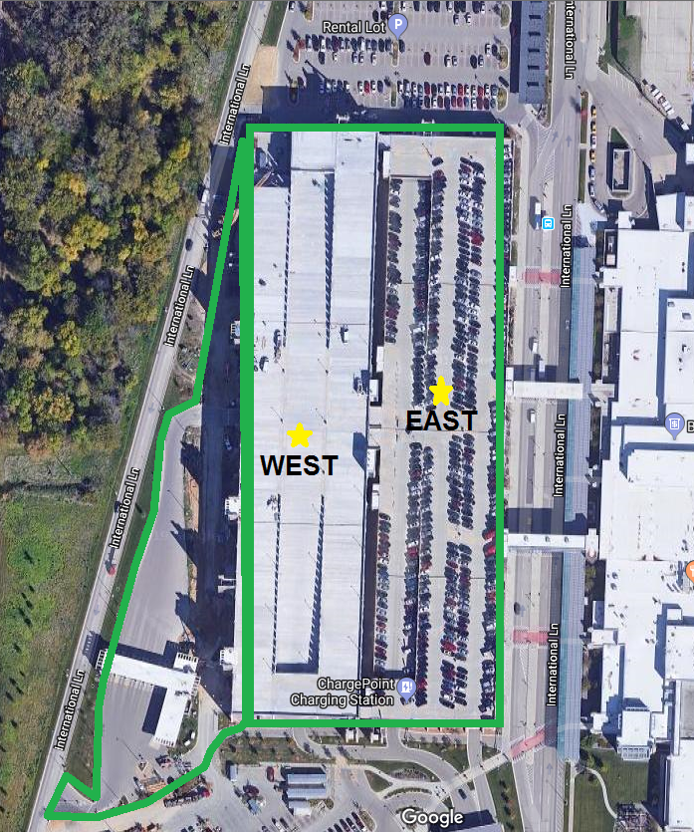

PRICE PROPOSAL

VENDOR NAME:
Pricing shall be inclusive of all labor, delivery costs and other expenses necessary to provide product in accordance with the specifications and terms and conditions of this bid document and your proposal.

Dane County Regional Airport
3 – Daily Surface Lot
4000 International Lane, Madison, WI 53704

Snow Plowing Per Event | Parking/Driveway
Per snow removal 0" - 1" | $
Per snow removal 1.1" - 2" | $
Per snow removal 2.1" - 3" | $
Per snow removal 3.1" - 4" | $
Per snow removal 4.1"-6" | $
Per snow removal 6.1"-8" | $
Per snow removal 8.1"-10" | $
Per snow removal 10.1"-12" | $
Per snow removal 12.1"-14" | $
Per snow removal 14.1"-16" | $
Per snow removal 16.1"-18" | $
Per snow removal 18.1"-20" | $
Salt Application | Parking/Driveway
Per salt application | $
Sand Application | Parking/Driveway
Per sand application | $
Salt/Sand Mix Application | Parking/Driveway
Per salt/sand mix application | $

3 | Daily Surface Lot
 | Sidewalks - none
 | Salt Application - Airport will notify Contractor if salt should be applied.
 | Approx. 670 stalls
 | Surface parking lot located south of parking ramps.
 | Includes parking roadways and drive lanes at parking entry and exit plazas.

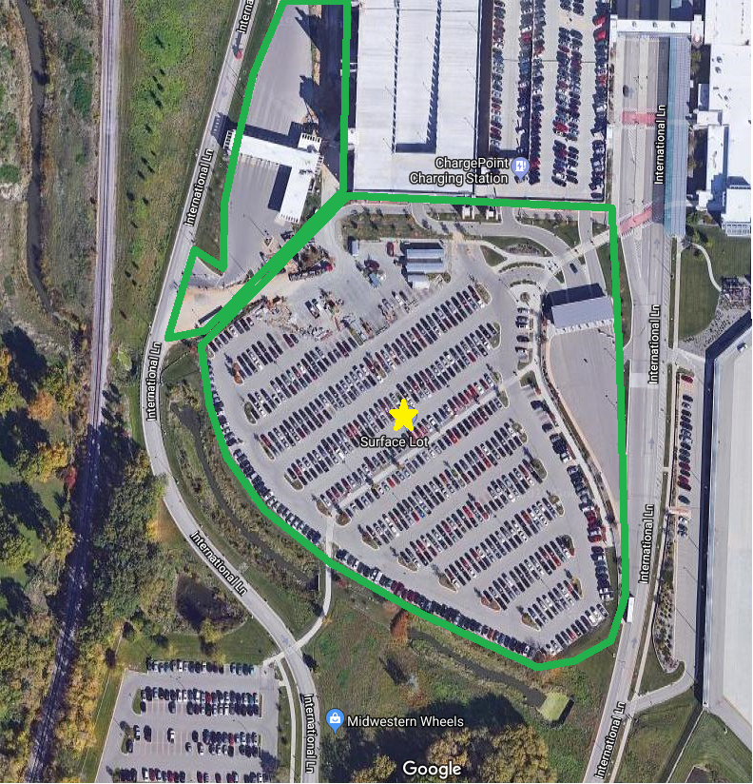

PRICE PROPOSAL

VENDOR NAME:
Pricing shall be inclusive of all labor, delivery costs and other expenses necessary to provide product in accordance with the specifications and terms and conditions of this bid document and your proposal.

Dane County Regional Airport
4 – Manager Lot
4000 International Lane, Madison, WI 53704

Snow Plowing Per Event | Parking/Driveway
Per snow removal 0" - 1" | $
Per snow removal 1.1" - 2" | $
Per snow removal 2.1" - 3" | $
Per snow removal 3.1" - 4" | $
Per snow removal 4.1"-6" | $
Per snow removal 6.1"-8" | $
Per snow removal 8.1"-10" | $
Per snow removal 10.1"-12" | $
Per snow removal 12.1"-14" | $
Per snow removal 14.1"-16" | $
Per snow removal 16.1"-18" | $
Per snow removal 18.1"-20" | $
Salt Application | Parking/Driveway
Per salt application | $
Sand Application | Parking/Driveway
Per sand application | $
Salt/Sand Mix Application | Parking/Driveway
Per salt/sand mix application | $

4 | Manager Lot
 | Sidewalks - none
 | Salt Application - Airport will notify Contractor if salt should be applied.
 | Approx. 39 stalls

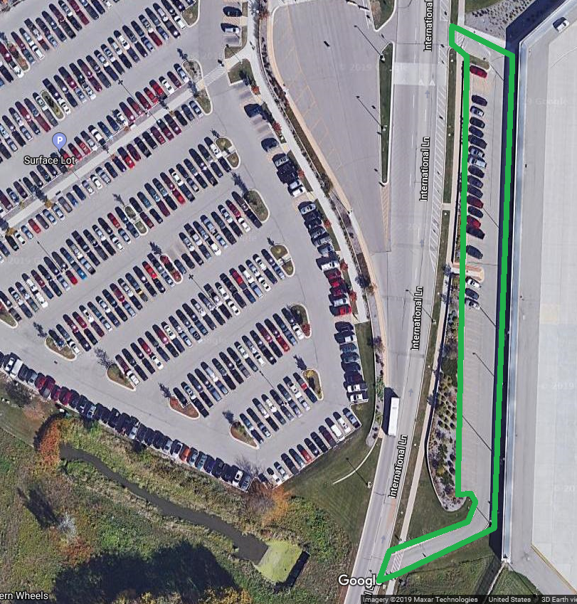

PRICE PROPOSAL

VENDOR NAME:
Pricing shall be inclusive of all labor, delivery costs and other expenses necessary to provide product in accordance with the specifications and terms and conditions of this bid document and your proposal.

Dane County Regional Airport
5 – Economy Lot
4000 International Lane, Madison, WI 53704

Snow Plowing Per Event | Parking/Driveway
Per snow removal 0" - 1" | $
Per snow removal 1.1" - 2" | $
Per snow removal 2.1" - 3" | $
Per snow removal 3.1" - 4" | $
Per snow removal 4.1"-6" | $
Per snow removal 6.1"-8" | $
Per snow removal 8.1"-10" | $
Per snow removal 10.1"-12" | $
Per snow removal 12.1"-14" | $
Per snow removal 14.1"-16" | $
Per snow removal 16.1"-18" | $
Per snow removal 18.1"-20" | $
Salt Application | Parking/Driveway
Per salt application | $
Sand Application | Parking/Driveway
Per sand application | $
Salt/Sand Mix Application | Parking/Driveway
Per salt/sand mix application | $

5 | Economy Lot
 | Sidewalks - none
 | Salt Application - Airport will notify Contractor if salt should be applied.
 | Approx. 1,000 stalls
 | Entrance and exit lanes

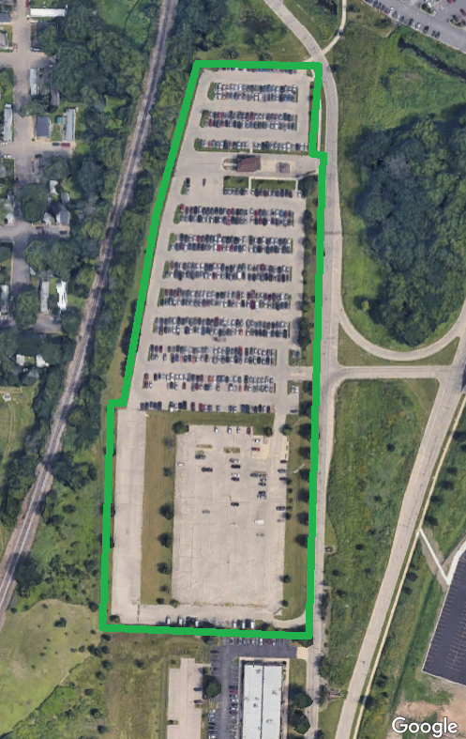

PRICE PROPOSAL

VENDOR NAME:
Pricing shall be inclusive of all labor, delivery costs and other expenses necessary to provide product in accordance with the specifications and terms and conditions of this bid document and your proposal.

Dane County Regional Airport
6 – Cell Phone & Employee Lots & Freight Building
3521-3527 International Lane, Madison, WI 53704

Snow Plowing Per Event | Parking/Driveway
Per snow removal 0" - 1" | $
Per snow removal 1.1" - 2" | $
Per snow removal 2.1" - 3" | $
Per snow removal 3.1" - 4" | $
Per snow removal 4.1"-6" | $
Per snow removal 6.1"-8" | $
Per snow removal 8.1"-10" | $
Per snow removal 10.1"-12" | $
Per snow removal 12.1"-14" | $
Per snow removal 14.1"-16" | $
Per snow removal 16.1"-18" | $
Per snow removal 18.1"-20" | $
Salt Application | Parking/Driveway
Per salt application | $
Sand Application | Parking/Driveway
Per sand application | $
Salt/Sand Mix Application | Parking/Driveway
Per salt/sand mix application | $

6 | Cell Phone & Employee Lots & Freight Building
 | Sidewalks - none
 | Salt Application - Airport will notify Contractor if salt should be applied.
 | 3521-3527 International Lane.
 | Approx. 375 stalls
 | Entrance and exit lanes

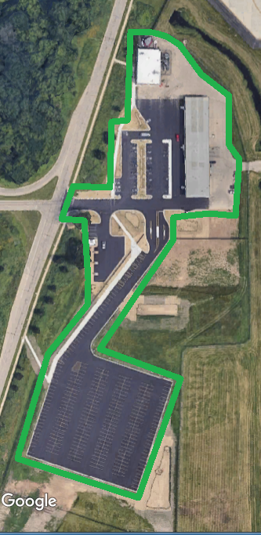

PRICE PROPOSAL

VENDOR NAME:
Pricing shall be inclusive of all labor, delivery costs and other expenses necessary to provide product in accordance with the specifications and terms and conditions of this bid document and your proposal.

Dane County Regional Airport
7 – International Lane
4000 International Lane, Madison, WI 53704

Snow Plowing Per Event | Parking/Driveway
Per snow removal 0" - 1" | $
Per snow removal 1.1" - 2" | $
Per snow removal 2.1" - 3" | $
Per snow removal 3.1" - 4" | $
Per snow removal 4.1"-6" | $
Per snow removal 6.1"-8" | $
Per snow removal 8.1"-10" | $
Per snow removal 10.1"-12" | $
Per snow removal 12.1"-14" | $
Per snow removal 14.1"-16" | $
Per snow removal 16.1"-18" | $
Per snow removal 18.1"-20" | $
Salt Application | Parking/Driveway
Per salt application | $
Sand Application | Parking/Driveway
Per sand application | $
Salt/Sand Mix Application | Parking/Driveway
Per salt/sand mix application | $

7 | International Lane
 | Sidewalks - none
 | Salt Application - Airport will notify Contractor if salt should be applied.
 | Full roadway loop north from Darwin Road intersection.
 | Taxi holding area and entrances to all parking areas, and continuing south to Darwin.
 | **This roadway must remain open at all times.

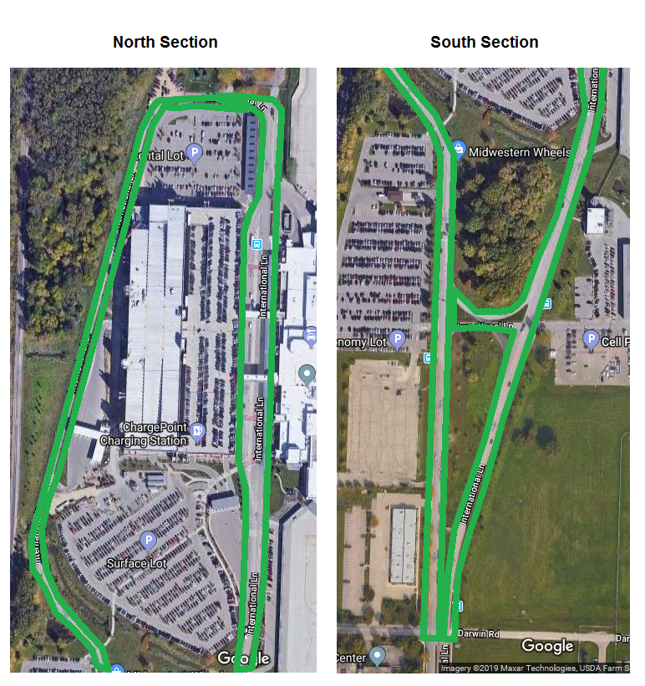

PRICE PROPOSAL

VENDOR NAME:
Pricing shall be inclusive of all labor, delivery costs and other expenses necessary to provide product in accordance with the specifications and terms and conditions of this bid document and your proposal.

Dane County Regional Airport
8 – Misc. Sidewalks
International Lane, Anderson Street, Pankratz Street, Skuldt Street (See Map)

Snow Plowing Per Event | Sidewalks
Per snow removal 0" - 1" | $
Per snow removal 1.1" - 2" | $
Per snow removal 2.1" - 3" | $
Per snow removal 3.1" - 4" | $
Per snow removal 4.1"-6" | $
Per snow removal 6.1"-8" | $
Per snow removal 8.1"-10" | $
Per snow removal 10.1"-12" | $
Per snow removal 12.1"-14" | $
Per snow removal 14.1"-16" | $
Per snow removal 16.1"-18" | $
Per snow removal 18.1"-20" | $
Salt Application | Sidewalks
Per salt application | $
Sand Application | Sidewalks
Per sand application | $
Salt/Sand Mix Application | Sidewalks
Per salt/sand mix application | $

8 | Misc. Sidewalks
 | Sidewalks - See below and Map. All sidewalks shall be salted.
 | Salt Application - Airport will notify Contractor if salt should be applied.
 | International Lane from Anderson Street south to Packers Avenue (both sides).
Anderson Street from International Lane east to end of sidewalk.
(south side of Anderson Street only).
Pankratz Street from Anderson Street to Ale Asylum parking lot entrance.
(single sidewalk only).
 | Skuldt Street between International Lane and Pankratz Street. (both sides).

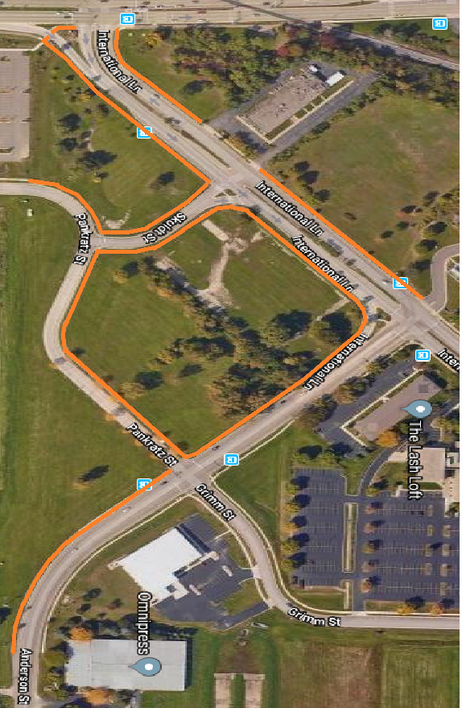

PRICE PROPOSAL

VENDOR NAME:
Pricing shall be inclusive of all labor, delivery costs and other expenses necessary to provide product in accordance with the specifications and terms and conditions of this bid document and your proposal.

Dane County Regional Airport
9 – Wright Street Sidewalk
1439 Wright Street, Madison, WI 53704

Snow Plowing Per Event | Sidewalks
Per snow removal 0" - 1" | $
Per snow removal 1.1" - 2" | $
Per snow removal 2.1" - 3" | $
Per snow removal 3.1" - 4" | $
Per snow removal 4.1"-6" | $
Per snow removal 6.1"-8" | $
Per snow removal 8.1"-10" | $
Per snow removal 10.1"-12" | $
Per snow removal 12.1"-14" | $
Per snow removal 14.1"-16" | $
Per snow removal 16.1"-18" | $
Per snow removal 18.1"-20" | $
Salt Application | Sidewalks
Per salt application | $
Sand Application | Sidewalks
Per sand application | $
Salt/Sand Mix Application | Sidewalks
Per salt/sand mix application | $

9 | Wright Street
 | Sidewalks - East side of Wright Street, between Straubel Street and Crescent Electric.
 | Salt Application - Airport will notify Contractor if salt should be applied.

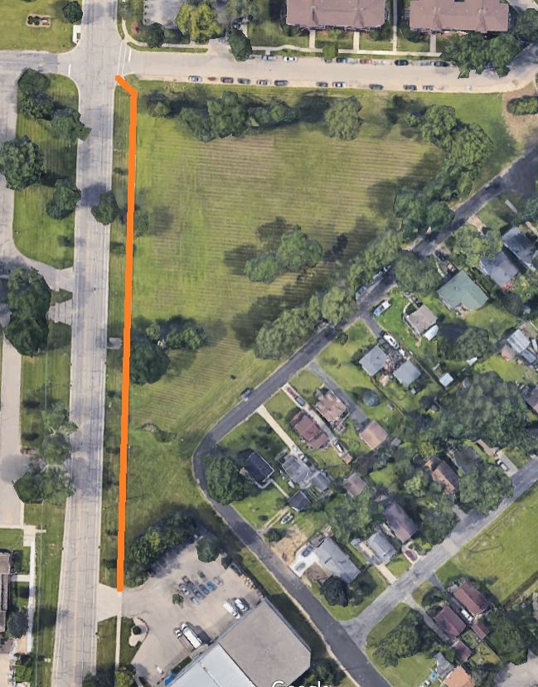

PRICE PROPOSAL

VENDOR NAME:
Pricing shall be inclusive of all labor, delivery costs and other expenses necessary to provide product in accordance with the specifications and terms and conditions of this bid document and your proposal.

SNOW REMOVAL AND HAULING
(ALL LOCATIONS)
(Equipment + Operator)

Equipment + Operator | Hourly Rate
Large Loader (3-5 yard bucket) | $ | /hour
Medium Loader (1-3 yard bucket) | $ | /hour
Skid Steer Loader | $ | /hour
Dump Truck | $ | /hour
Broom/Sweeper | $ | /hour
Blowing/Drifting Clean Up | $ | /hour
Other: | $ | /hour
Other: | $ | /hour
Other: | $ | /hour
Other: | $ | /hour
Other: | $ | /hour

Future Pricing % Increase – All Locations
Includes Plowing, Salting, Sanding & Equipment

Future Pricing
Term 2 % Increase |  | %
Term 3 % Increase |  | %
Term 4 % Increase |  | %
Term 5 % Increase |  | %

STANDARD TERMS AND CONDITIONS
Request for Bids/Proposals/Contracts
Rev. 4/2018

1.0 APPLICABILITY: The terms and conditions set forth in this document apply to Requests for Proposals (RFP), Bids and all other transactions whereby the County of Dane acquires goods or services, or both.

1.1 ENTIRE AGREEMENT: These Standard Terms and Conditions shall apply to any contract, including any purchase order, awarded as a result of this request. Special requirements of a resulting contract may also apply. Said written contract with referenced parts and attachments shall constitute the entire agreement, and no other terms and conditions in any document, acceptance, or acknowledgment shall be effective or binding unless expressly agreed to in writing by the County. Unless otherwise stated in the agreement, these standard terms conditions supersede any other terms and/or conditions applicable to this agreement.

1.2 DEFINITIONS: As used herein, “vendor” includes a provider of goods or services, or both, who is responding to an RFP or a bid, and “bid” includes a response to either an RFP or a bid.

2.0 SPECIFICATIONS: The specifications herein are the minimum acceptable. When specific manufacturer and model numbers are used, they are to establish a design, type of construction, quality, functional capability or performance level, or any combination thereof, desired. When alternates are proposed, they must be identified by manufacturer, stock number, and such other information necessary to establish equivalency. Dane County shall be the sole judge of equivalency. Vendors are cautioned to avoid proposing alternates to the specifications that may result in rejection of their bid.

3.0 DEVIATIONS AND EXCEPTIONS: Deviations and exceptions from terms, conditions, or specifications shall be described fully in writing, signed, and attached to the bid. In the absence of such statement, the bid shall be accepted as in strict compliance with all terms, conditions, and specifications and vendor shall be held liable for injury resulting from any deviation.

4.0 QUALITY: Unless otherwise indicated in the request, all material shall be first quality. No pre-owned, obsolete, discontinued or defective materials may be used.

5.0 QUANTITIES: The quantities shown herein are based on estimated needs. The County reserves the right to increase or decrease quantities to meet actual needs.

6.0 DELIVERY: Deliveries shall be FOB destination freight prepaid and included unless otherwise specified. County will reject shipments sent C.O.D. or freight collect.

7.0 PRICING: Unit prices shown on the bid shall be the price per unit of sale as stated on the request or contract. For any given item, the quantity multiplied by the unit price shall establish the extended price, the unit price shall govern in the bid evaluation and contract administration.
7.1 Prices established in continuing agreements and term contracts may be lowered due to market conditions, but prices shall not be subject to increase for the term specified in the award. Vendor shall submit proposed increases to the Purchasing Division thirty (30) calendar days before the proposed effective date of the price increase. Proposed increases shall be limited to fully documented cost increases to the vendor that are demonstrated to be industry wide. Price increases may not be granted unless they are expressed in bid documents and contracts or agreements.

7.2 Submission of a bid constitutes bidder’s certification that no financial or personal relationship exists between the bidder and any county official or employee except as specially set forth in writing attached to and made a part of the bid. The successful bidder shall disclose any such relationship which develops during the term of the contract.

8.0 ACCEPTANCE-REJECTION: Dane County reserves the right to accept or reject any or all bids, to waive any technicality in any bid submitted and to accept any part of a bid as deemed to be in the best interests of the County. Submission of a proposal or a bid constitutes the making of an offer to contract and gives the County an option valid for 60 days after the date of submission to the County.

8.1 Bids MUST be dated and time stamped by the Dane County Purchasing Division Office on or before the date and time that the bid is due. Bids deposited or time stamped in another office will be rejected. Actual receipt in the office of the purchasing division is necessary; timely deposit in the mail system is not sufficient. THERE WILL BE NO EXCEPTIONS TO THIS POLICY.

9.0 METHOD OF AWARD: Award shall be made to the lowest responsible responsive bidder conforming to specifications, terms, and conditions, or to the most advantageous bid submitted to the County on a quality versus price basis.

10.0 ORDERING/ACCEPTANCE: Written notice of award to a vendor in the form of a purchase order or other document, mailed or delivered to the address shown on the bid will be considered sufficient notice of acceptance of bid. A formal contract containing all provisions of the contract signed by both parties shall be used when required by the Dane County Purchasing Division.

11.0 PAYMENT TERMS AND INVOICING: Unless otherwise agreed, Dane County will pay properly submitted vendor invoices within thirty (30) days of receipt of goods and services. Payment will not be made until goods or services are delivered, installed (if required), and accepted as specified. Invoices presented for payment must be submitted in accordance with instructions contained on the purchase order.

11.1 NO WAIVER OF DEFAULT: In no event shall the making of any payment or acceptance of any service or product required by this Agreement constitute or be construed as a waiver by County of any breach of the covenants of the Agreement or a waiver of any default of the successful vendor, and the making of any such payment or acceptance of any such service or product by County while any such default or breach shall exist shall in no way impair or prejudice the right of County with respect to recovery of damages or other remedy as a result of such breach or default.

12.0 TAXES: The County and its departments are exempt from payment of all federal tax and Wisconsin state and local taxes on its purchases except Wisconsin excise taxes as described below. The State of Wisconsin Department of Revenue has issued tax exempt number ES41279 to Dane County.

12.1 The County is required to pay the Wisconsin excise or occupation tax on its purchase of beer, liquor, wine, cigarettes, tobacco products, motor vehicle fuel and general aviation fuel. The County is exempt from Wisconsin sales or use tax on these purchases. The County may be subject to other states’ taxes on its purchases in that state depending on the laws of that state. Vendors performing construction activities are required to pay state use tax on the cost of materials.

13.0 GUARANTEED DELIVERY: Failure of the vendor to adhere to delivery schedules as specified or to promptly replace rejected materials shall render the vendor liable for all costs in excess of the contract price when alternate procurement is necessary. Excess costs shall include administrative costs.

14.0 APPLICABLE LAW AND VENUE: This contract shall be governed under the laws of the State of Wisconsin, and venue for any legal action between the parties shall be in Dane County Circuit Court. The vendor shall at all times comply with and observe all federal and state laws, local laws, ordinances, and regulations which are in effect during the period of this contract and which in any manner affect the work or its conduct.

15.0 ASSIGNMENT: No right or duty in whole or in part of the vendor under this contract may be assigned or delegated without the prior written consent of Dane County.

16.0 NONDISCRIMINATION/AFFIRMATIVE ACTION: During the term of this Agreement the vendor agrees, in accordance with sec. 111.321, Wis. Stats., and Chapter 19 of the Dane County Code of Ordinances, not to discriminate against any person, whether an applicant or recipient of services, an employee or applicant for employment, on the basis of age, race, ethnicity, religion, color, gender, disability, marital status, sexual orientation, national origin, cultural differences, ancestry, physical appearance, arrest record or conviction record, military participation or membership in the national guard, state defense force or any other reserve component of the military forces of the United States, or political beliefs. The vendor shall provide a harassment-free work environment. These provisions shall include, but not be limited to, the following: employment, upgrading, demotion, transfer, recruitment, advertising, layoff, termination, training, including apprenticeships, rates of pay or other forms of compensation.

16.1 Vendors who have twenty (20) or more employees and a contract of twenty thousand dollars ($20,000) or more must submit a written affirmative action plan to the County’s Contract Compliance Officer within fifteen (15) working days of the effective date of the contract. The County may elect to accept a copy of the current affirmative action plan filed with and approved by a federal, state or local government unit.

16.2 The vendor agrees to post in conspicuous places, available for employees and applicants for employment, notices setting forth the provisions of this Agreement as they relate to affirmative action and nondiscrimination.

16.3 Failure to comply with these Terms and Conditions may result in the vendor being debarred, termination of the contract and/or withholding of payment.

16.4 The vendor agrees to furnish all information and reports required by Dane County’s Contract Compliance Officer as the same relate to affirmative action and nondiscrimination, which may include any books, records, or accounts deemed appropriate to determine compliance with Chapter 19, D.C. Ords. and the provisions of this Agreement.

16.5 AMERICANS WITH DISABILITIES ACT: The vendor agrees to the requirements of the ADA, providing for physical and programmatic access to service delivery and treatment in all programs and activities.

17.0 PATENT, COPYRIGHT AND TRADEMARK INFRINGEMENT: The vendor guarantees goods sold to the County were manufactured or produced in accordance with applicable federal labor laws, and that the sale or use of the articles described herein do not infringe any patent, copyright or trademark. The vendor covenants that it will, at its own expense, defend every suit which shall be brought against the County (provided that such vendor is promptly notified of such suit, and all papers therein are delivered to it) for any alleged infringement of any patent, copyright or trademark by reason of the sale or use of such articles, and agrees that it will pay all costs, damages, and profits recoverable in any such suit.

18.0 SAFETY REQUIREMENTS: All materials, equipment, and supplies provided to the County must fully comply with all safety requirements as set forth by the Wisconsin Department of Commerce and all applicable OSHA Standards.

18.1 MATERIAL SAFETY DATA SHEET: If any item(s) on an order(s) resulting from this award(s) is a hazardous chemical, as defined under 29 CFR 1910.1200, provide one (1) copy of the Material Safety Data Sheet for each item with the shipped container(s) and one (1) copy with the invoice(s).

19.0 WARRANTY: Unless specifically expressed otherwise in writing, goods and equipment purchased as a result of this request shall be warranted against defects by the vendor for one (1) year from date of receipt. An equipment manufacturer’s standard warranty shall apply as a minimum and must be honored by the vendor.

20.0 INDEMNIFICATION & INSURANCE.

20.1. Vendor shall indemnify, hold harmless and defend County, its boards, commissions, agencies, officers, employees and representatives against any and all liability, loss (including, but not limited to, property damage, bodily injury and loss of life), damages, costs or expenses which County, its officers, employees, agencies, boards, commissions and representatives may sustain, incur or be required to pay by reason of vendor furnishing the services or goods required to be provided under this Agreement, provided, however, that the provisions of this paragraph shall not apply to liabilities, losses, charges, costs, or expenses caused by or resulting from the acts or omissions of County, its agencies, boards, commissions, officers, employees or representatives. The obligations of vendor under this paragraph shall survive the expiration or termination of this Agreement.

20.2. In order to protect itself and County its officers, boards, commissions, agencies, agents, volunteers, employees and representatives under the indemnity provisions of the subparagraph above, vendor shall, at vendor’s own expense, obtain and at all times during the term of this Agreement keep in full force and effect the insurance coverages, limits, and endorsements listed below. When obtaining required insurance under this Agreement and otherwise, vendor agrees to preserve County’s subrogation rights in all such matters that may arise that are covered by vendor’s insurance. Neither these requirements nor the County’s review or acceptance of vendor’s certificates of insurance is intended to limit or qualify the liabilities or obligations assumed by the vendor under this Agreement. The County expressly reserves the right to require higher or lower insurance limits where County deems necessary.

20.2.1. Commercial General Liability.
Vendor agrees to maintain Commercial General Liability insurance at a limit of not less than $1,000,000 per occurrence. Coverage shall include, but not be limited to, Bodily Injury and Property Damage to Third Parties, Contractual Liability, Personal Injury and Advertising Injury Liability, Premises-Operations, Independent vendors and Subcontractors, and Fire Legal Liability. The policy shall not exclude Explosion, Collapse, and Underground Property Damage Liability Coverage. The policy shall list DANE COUNTY as an Additional Insured.

20.2.2. Commercial/Business Automobile Liability.
Vendor agrees to maintain Commercial/Business Automobile Liability insurance at a limit of not less than $1,000,000 Each Occurrence. Vendor further agrees coverage shall include liability for Owned, Non-Owned & Hired automobiles. In the event vendor does not own automobiles, vendor agrees to maintain coverage for Hired & Non-Owned Auto Liability, which may be satisfied by way of endorsement to the Commercial General Liability policy or separate Business Auto Liability policy.

20.2.3. Environmental Impairment (Pollution) Liability
Vendor agrees to maintain Environmental Impairment (Pollution) Liability insurance at a limit of not less than $1,000,000 per occurrence for bodily injury, property damage, and environmental cleanup costs caused by pollution conditions, both sudden and non-sudden. This requirement can be satisfied by either a separate environmental liability policy or through a modification to the Commercial General Liability policy. Evidence of either must be provided.

20.2.4. Workers’ Compensation.
Vendor agrees to maintain Workers Compensation insurance at Wisconsin statutory limits.

20.2.5. Umbrella or Excess Liability.
Vendor may satisfy the minimum liability limits required above for Commercial General Liability and Business Auto Liability under an Umbrella or Excess Liability policy. There is no minimum Per Occurrence limit of liability under the Umbrella or Excess Liability; however, the Annual Aggregate limit shall not be less than the highest “Each Occurrence” limit for the Commercial General Liability and Business Auto Liability. vendor agrees to list DANE COUNTY as an “Additional Insured” on its Umbrella or Excess Liability policy.

20.3. Upon execution of this Agreement, vendor shall furnish County with a Certificate of Insurance listing County as an additional insured and, upon request, certified copies of the required insurance policies. If vendor's insurance is underwritten on a claims-made basis, the retroactive date shall be prior to or coincide with the date of this Agreement, the Certificate of Insurance shall state that professional malpractice or errors and omissions coverage, if the services being provided are professional services coverage is claims-made and indicate the retroactive date, vendor shall maintain coverage for the duration of this Agreement and for six (6) years following the completion of this Agreement. Vendor shall furnish County, annually on the policy renewal date, a Certificate of Insurance as evidence of coverage. It is further agreed that vendor shall furnish the County with a 30-day notice of aggregate erosion, in advance of the Retroactive Date, cancellation, or renewal. It is also agreed that on claims-made policies, either vendor or County may invoke the tail option on behalf of the other party and that the extended reporting period premium shall be paid by vendor. In the event any action, suit or other proceeding is brought against County upon any matter herein indemnified against, County shall give reasonable notice thereof to vendor and shall cooperate with vendor's attorneys in the defense of the action, suit or other proceeding. Vendor shall furnish evidence of adequate Worker's Compensation Insurance. In case of any sublet of work under this Agreement, vendor shall furnish evidence that each and every subcontractor has in force and effect insurance policies providing coverage identical to that required of vendor. In case of any sublet of work under this Agreement, vendor shall furnish evidence that each and every subcontractor has in force and effect insurance policies providing coverage identical to that required of vendor.

20.4. The parties do hereby expressly agree that County, acting at its sole option and through its Risk Manager, may waive any and all requirements contained in this Agreement, such waiver to be in writing only. Such waiver may include or be limited to a reduction in the amount of coverage required above. The extent of waiver shall be determined solely by County's Risk Manager taking into account the nature of the work and other factors relevant to County's exposure, if any, under this Agreement.

21.0 CANCELLATION: County reserves the right to terminate any Agreement due to non-appropriation of funds or failure of performance by the vendor. This paragraph shall not relieve County of its responsibility to pay for services or goods provided or furnished to County prior to the effective date of termination.

22.0 PUBLIC RECORDS ACCESS: It is the intention of the County to maintain an open and public process in the solicitation, submission, review, and approval of procurement activities. Bid openings are public unless otherwise specified. Records are not available for public inspection prior to issuance of the notice of intent to award or the award of the contract. Bid results may be obtained by visiting the Dane County Purchasing Office Monday – Friday, between 8:00 a.m. and 4:00 p.m. Prior appointment is advisable.

22.1 PROPRIETARY INFORMATION: If the vendor asserts any of its books and records of its business practices and other matters collectively constitute a trade secret as that term is defined in s. 134.90(1)(c), Wis. Stats., County will not release such records to the public without first notifying the vendor of the request for the records and affording the vendor an opportunity to challenge in a court of competent jurisdiction the requester’s right to access such records. The entire burden of maintaining and defending the trade secret designation shall be upon the vendor. The vendor acknowledges and agrees that if the vendor shall fail, in a timely manner, to initiate legal action to defend the trade secret designation or be unsuccessful in its defense of that designation, County shall be obligated to and will release the records.

22.2 Any material submitted by the vendor in response to this request that the vendor considers confidential and proprietary information and which vendor believes qualifies as a trade secret, as provided in section 19.36(5), Wis. Stats., must be identified on a designation of Confidential and Proprietary Information form. Pricing will not be held confidential after award of contract.

22.3 Data contained in a bid, all documentation provided therein, and innovations developed as a result of the contracted commodities or services cannot be copyrighted or patented. All data, documentation, and innovations shall be the property of the County.

23.0 RECYCLED MATERIALS: Dane County is required to purchase products incorporating recycled materials whenever technically and economically feasible. Vendors are encouraged to bid products with recycled content which meet specifications.

24.0 PROMOTIONAL ADVERTISING: Reference to or use of Dane County, any of its departments or sub-units, or any county official or employee for commercial promotion is prohibited.

25.0 ANTITRUST ASSIGNMENT: The vendor and the County of Dane recognize that in actual economic practice, overcharges resulting from antitrust violation are in fact usually borne by the Purchaser. Therefore, the successful vendor hereby assigns to the County of Dane any and all claims for such overcharges as to goods, materials or services purchased in connection with this contract.

26.0 RECORDKEEPING AND RECORD RETENTION-COST REIMBURSEMENT CONTRACTS: Where payment to the vendor is based on the vendor’s costs, vendor shall establish and maintain adequate records of all expenditures incurred under the contract. All records must be kept in accordance with generally accepted accounting procedures. The County contracting agency shall have the right to audit, review, examine, copy, and transcribe any pertinent records or documents relating to any contract resulting from this bid/proposal held by the vendor. The vendor will retain all documents applicable to the contract for a period of not less than three (3) years after final payment is made.

27.03 COMPLIANCE WITH FAIR LABOR STANDARDS. During the term of this Agreement, vendor shall report to the Controller, within ten (10) days, any allegations to, or findings by the National Labor Relations Board (NLRB) or Wisconsin Employment Relations commission (WERC) that vendor has violated a statute or regulation regarding labor standards or relations within the seven years prior to entering this Agreement. If an investigation by the Controller results in a final determination that the matter adversely affects vendor’s responsibilities under this Agreement, and which recommends termination, suspension or cancellation of this agreement, the County may take such action.

27.04 VENDOR may appeal any adverse finding by the Controller as set forth in sec. 25.08(20)(c) through (e).

27.05 VENDOR shall post the following statement in a prominent place visible to employees: “As a condition of receiving and maintaining a contract with Dane County, this employer shall comply with federal, state and all other applicable laws prohibiting retaliation for union organizing.

