COUNTY OF DANE
DEPARTMENT OF ADMINISTRATION
PURCHASING DIVISION
Room 425 City-County Building
210 Martin Luther King Jr. Blvd.
Madison, WI 53703-3345
608-266-4131
FAX 608-266-4425 TDD 608-266-4941
CARLOS PABELLON  Director of Administration |  | CHARLES HICKLIN  Controller

DATE: March 17, 2017
TO: All Proposers RFP #117017 – Landfill Scale System Software

FROM: Pete Patten, Purchasing Agent
SUBJECT: ADDENDUM #3

The following responses are provided to questions received.
- How many users at the following locations:
  - County Office / Solid Waste Office
1 (Jan uses the accounting/billing at the PW office)
  - Accounting / Billing
1 (same person as County Office)
  - Scale Office
1 (scale attendant)
  - Clean Sweep Office
1 (CS attendant)
  - Material Recovery Facility (MRF)
0 (this is tracked by scale attendant, a waste category selected by the customer from the outside terminal)

- Are all of the users needing access at the same time? Concurrent?
Yes

- What is the maximum number of Concurrent users needed?
Minimum 3-4 depending on if more than one user can sign into the device at the same time

- What type of RFID tag solution is preferred?
  - (Long Range) Fixed Mounted (Tags attached to the body or as window stickers)
    - RFP States 50 tags – are there already tags installed?
No
  - (Short Range) Portable (proximity cards, key fobs)?
    - RFP States 400 tags – are these already deployed?
There are existing tags that may be able to be used depending on the programming but the 400 tags referenced in the RFP would still need to be included.
  - What are the make, model, and type of RFID tag readers for both vehicle mounted tags and proximity cards currently in use?
This information is not available at this time.
  - What type of vehicles with be assigned RFID tags for kiosks?
    - County Owned Trucks?
Yes
    - 3rd Party Trucks?
Yes

- Is the County providing all the Computers/Servers/Printers and other Hardware required for the scale management system? This includes the client PCs in the Scalehouse and back office servers.
Dane County will be providing computers, servers and printers for the computers. Any printer that may be associated with the terminal or providing printed tickets would be supplied by the vendor. Within the RFP, there are two tables showing hardware and software that is supported by Dane County Information Management. The software must be compatible with Dane County’s technology components.

- How many workstations are in use at each Scale house?
1 workstation at the Landfill Scale House and 1 workstation at the Clean Sweep Facility.

- What are the standard performance specifications of the client PCs in use?
See Table 1 and Table 2 of Attachment F.

- What are the current Software systems in use for the attended operations at the landfill?
See 1.2 Scope of Project – Fairbanks and Paradigm

- What is the County’s Financial / Accounting software?
MUNIS - the scale software does not necessarily need to tie into the MUNIS software.

- What is the County’s Enterprise Resource Planning Software?
N/A

- What is the current software in use by the County of Dane for its Scale Management Systems which the database would be converted from?
See 1.2 Scope of Project – Paradigm
- Please list all systems in use will require data conversion?
Paradigm and Fairbanks
- How many years of historical data will need to be converted to the new system?
Approximately 12 years. The current system, Paradigm, went live in 2006.

- What systems will need to be provided an export of scale information?
This would be dependent upon the incoming system.

- What systems are being integrated with?
The scale and terminal inputs along with the Clean Sweep Facility will be integrated to one system.

- Please describe any other incoming data the County would like to pair the inbound/outbound transaction information with.
Nothing at this time.

- Is there any other software/hardware modules the County would like the vendor to include to expedite and streamline the scale transaction process.
Any additional modules that are not covered within the specifications should be listed in the “Other Hardware, Accessories, or Optional Equipment” section of the Cost Proposal. Indicate unit price, quantity, and total price.

- Can the County provide a diagram and pictures of the Scale house(s)?
See attached diagram.

- What is the connectivity and connection speed (up/down) from the Scalehouse locations to the County’s Back Office? What is the County’s connection speed to the internet?
The landfill site is connected via 1 GB Fiber to the main County computer room located at 210 Martin Luther King Jr. Blvd., Madison, WI 53703. There is a 10 GB fiber connection to the internet.

- Does the County use special/contract pricing for any customers?
Yes.

- How does the County address and modify rate changes?
If a customer has a special pricing rate, each rate is saved within the software program as a separate category/rate. Price changes are generally done via Dane County Ordinance Amendment, once or twice per year at most.

- Can the County provide an example of current materials and material codes in use?
A full list of materials and materials is not available at this time. Materials would include but not limited to shingles, paint, appliances, tires, building materials, etc.

- Are you intending to replace the Fairbanks and paradigm terminals?
Yes – terminals would be replaced.

- What software is the County of Dane running for attended transactions by the scale operator? See 1.2 Scope of Project – Paradigm

- Please describe the relationship between Clean Sweep and the Landfill Operations.
Clean sweep is another service that solid waste offers to Dane County residents. Clean Sweep is a place to bring hazardous household materials such as oil-based paints, paint-related products, pesticides, poisons, product with organic solvents, ignitables, aerosols, and rechargeable batteries. County employees operate facility.

- While all scale tickets are unique, our system utilizes one set of rolling ticket numbers when assigning scale ticket transaction numbers. If Clean Sweep and Landfill Site 2 Operations must be kept separate, our system would require two instances of the software. Does the County accept this limitation of a single instance of the software or would this disqualify our system from submitting a successful RFP response?
Dane County encourages proposals to be submitted even if there may be a deviation from the specifications outlined within the RFP.

- Is the existing hardware for Scalehouse operator computers and servers going to be replaced? See the answer provided to Question 5.

- What scale software exists at Landfill Site 1?
None at this time, waste is not being placed at the Verona landfill.

- What is the intention of the Uninterrupted Power Supply (UPS)? What hardware component will it be protecting? i.e. DAT or Kiosk, Back-Office Server, Scale house Computer/PC?
The intention of the UPS, is to allow a continuous and uninterrupted service of the landfill and Clean Sweep. If power was to be lost, the system would not be able to function. The UPS would prevent any need to write hand tickets. The UPS would protect all components that operate from the incoming power supply.

- Our system does not support Authorize.Net for credit card transactions and would require the use of our Merchant Partner to provide credit card transactions.
Dane County’s preferred merchants for these type of transactions are Elavon or Authorize.Net. Outline this deviation within your response and include all rates associated with the credit card processing merchant.

With your response, explain deviations to any specifications that are outlined within the RFP.

Please acknowledge receipt of this addendum by noting “Addendum #3 Received” on the bottom of the Signature Affidavit when you submit your bid. If you have any questions regarding this addendum, please contact me at 608-267-3523 or via email at patte.peter@countyofdane.com.

Sincerely,

Pete Patten
Purchasing Agent

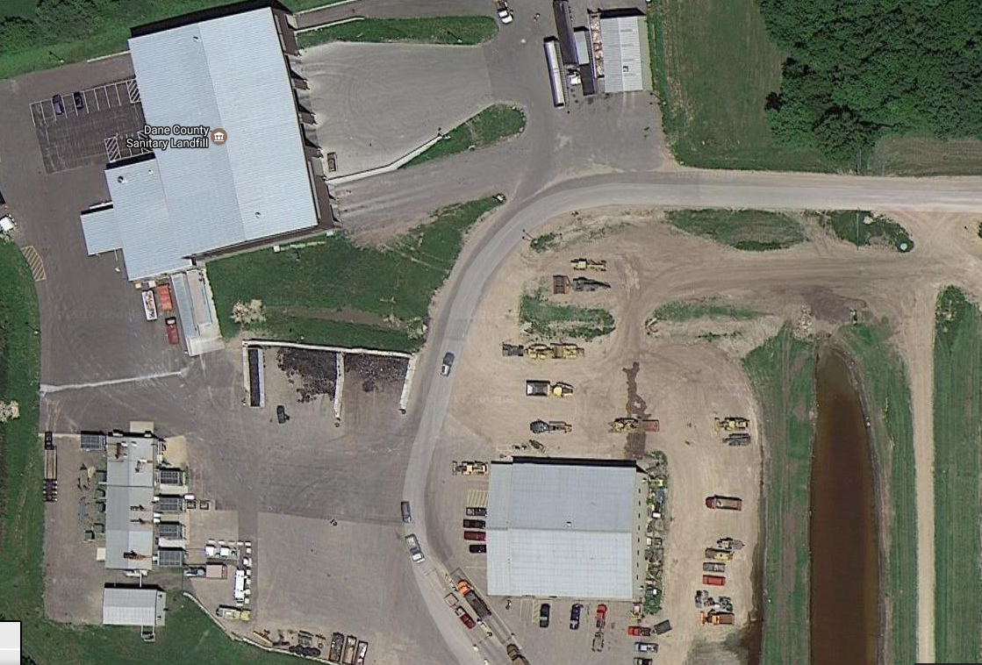
C&D Facility
To Landfill
Scale House / Shop
Inbound/Outbound Scales
Clean Sweep

