|  |  |  |
| --- | --- | --- |
|  | **COUNTY OF DANE**  DEPARTMENT OF ADMINISTRATION  **PURCHASING DIVISION**  Room 425 City-County Building  210 Martin Luther King Jr. Blvd.  Madison, WI 53703-3345  608-266-4131  FAX 608-266-4425 TDD 608-266-4941 |  |
| GREG BROCKMEYER  Director of Administration |  | CHARLES HICKLIN  Controller |

DATE: October 8, 2019

TO: All Proposers

FROM: Carolyn Clow, Purchasing Agent

SUBJECT: ADDENDUM #1 to RFP #119081 – Group Voluntary Vision Insurance

It states that Law Enforcement calls must be reviewed and returned within 7 days and Fire and EMS calls must be reviewed and returned in 3 days.  Is there flexibility on these timeframes?

Flexibility is possible. Vendors should include requests for flexibility in their proposal responses.

Also, under Section 3.2, Required Reports, it mentions these 3 reports:

**SAMPLE Management Report for employees**

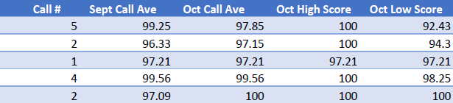

**SAMPLE Monthly report by incident type**

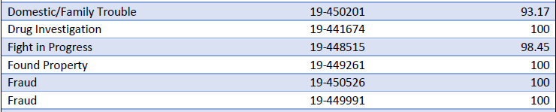

**SAMPLE Quarterly Executive Readouts**

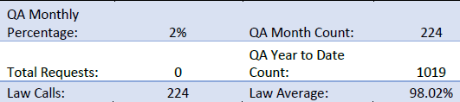

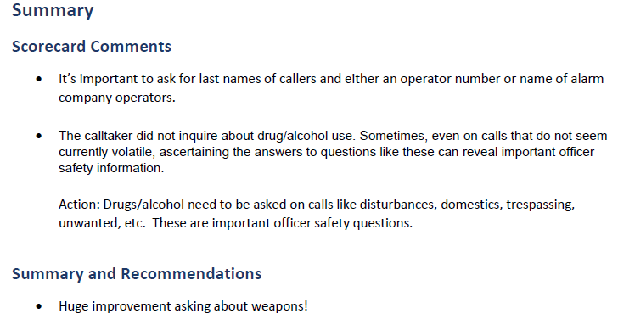

Spreadsheets and graphs, which help to present and organize the data, are welcome. Vendors should provide sample reports as part of their proposal responses.

**All proposals should be emailed to** [**bids@countyofdane.com**](mailto:bids@countyofdane.com) **No hard copy proposals are required.**

**Please acknowledge receipt of this addendum by noting “Addendum #1 Received” on the Signature Affidavit page when you submit your bid. If you have any questions regarding this addendum, please contact me at 608-266-4966.**

Sincerely,

Carolyn A. Clow, CPPB

Lead Purchasing Agent