REQUEST FOR BID (RFB)

DEPARTMENT OF ADMINISTRATION
PURCHASING DIVISION
BID NUMBER | 119083
BID TITLE | HMA Pavement – State Projects
BID DEADLINE | September 26, 2019  2:00 p.m. (CST)  Unsigned, late, faxed, or electronically mailed bids will be rejected.
SUBMIT BID TO THIS ADDRESS | CITY COUNTY BUILDING  DANE COUNTY PURCHASING DIVISION  210 MARTIN LUTHER KING JR BLVD ROOM 425  MADISON, WI 53703-3345
# OF REQUIRED  BID COPIES | Bidders must submit (1) original and (1) copy
DIRECT  ALL INQUIRES TO | NAME | Pete Patten
 | TITLE | Purchasing Agent
 | PHONE # | 608-267-3523
 | EMAIL | patten.peter@countyofdane.com
 | WEB SITE | www.danepurchasing.com
DATE BID ISSUED: September 6, 2019

BID SUBMISSION CHECKLIST
Read Entire Bid Document  Completed Bid Packet (stapled)  Section 2 – Vendor Information  Section 3 – Bid Specifications  Section 4 – Price Proposal  Section 5 – Standard Terms and Conditions | Bid Packets: (1) original and (1) copy  Sealed envelope/package containing bid packets and labeled with:  Vendor Name  Bid Number  Bid Deadline Date/Time  Up-to-date Vendor Registration
PROPOSALS MUST BE DATE/TIME STAMPED BY A DANE COUNTY ADMINISTRATION STAFF MEMBER
Revised 06/2019 (S)(HIGHWAY-NO PREF)

- Introduction
Dane County invites and will accept bids for services outlined within this bid. The County as represented by Purchasing Division, intends to use the results of this process to purchase goods or services here within.

- Clarification/Questions:
Any questions concerning this bid must be submitted in writing by mail, fax or email at least five working days prior to the bid deadline. Requests submitted after that time will not be considered. All inquiries must be directed to the Purchasing Agent indicated on the cover page.

- Addendums:
In the event that it becomes necessary to provide additional clarifying data or information, or to revise any part of this bid, addenda and/or supplements will be posted on the Purchasing Division web site at www.danepurchasing.com. Bidders are responsible to regularly monitor the web site for any such postings. It is recommended to check the website for addenda prior to submitting a proposal. Bidders must acknowledge the receipt/review of any addenda on the Vendor Information page.

The Purchasing Division has the sole authority for modifications to specifications and/or this bid document.

- Vendor Registration Program:
All bidders are strongly encouraged to be a registered vendor with Dane County. Registering allows vendors an opportunity to receive notifications for bids issued by the County and provides the County with up-to-date company contact information.

Provide your Dane County Vendor # in the Vendor Information section of the bid submission packet.

For Non-Registered Vendors:
Complete vendor registration by visiting www.danepurchasing.com. On the top menu bar, click Vendor Registration and then click Create Vendor Account. You will receive an email confirmation once your account is created and again when your vendor registration is complete. Retain your user name/email address and password for ease of re-registration in future years. Within 2-4 days of completing the registration, a vendor number will be assigned and emailed to you.

For Registered Vendors:
Check to make sure your vendor information including commodity codes is up-to-date by signing into your account at www.danepurchasing.com. On the top menu bar, click Vendor Registration and then click Vendor Log In.

- Pricing:
The price quoted shall include all labor, materials, equipment, shipping, and other costs. All prices and conditions outlined in the bid shall remain fixed.

- Bid Submission and Acceptance:
Bids must be received by the Dane County Purchasing Division by the specified date and time stated on the cover page. All proposals must be time-stamped in by a Dane County Purchasing or Administration staff member. Bids not so stamped will not be accepted.

Unsigned, late, faxed, or electronically mailed bids will be rejected.

Vendors must submit an original and the required number of copies of all bid materials required for acceptance as instructed on the cover page of the bid.

Multiple bids from a vendor will be permissible, however, each proposal must conform fully to the requirements for bid submission. Each such bid must be separately submitted and labeled as Bid# 1, Bid# 2, etc.

Dane County reserves the right to accept any part of this bid deemed to be in the best interest
of the County. The County also retains the right to accept or reject any or all bids.

- Cooperative Purchasing
Participating in cooperative purchasing gives vendors opportunities for additional sales without additional bidding. Municipalities and state agencies use cooperative purchasing to expedite purchases. A “municipality” is defined as any county, city, village, town, school district, board of school directors, sewer district, drainage district, vocational, technical and adult education district, or any other public body having authority to award public contracts (s. 16.70(8), Wis. Stats.). Federally recognized Indian tribes and bands in this state may participate in cooperative purchasing with the state or any municipality under ss. 66.0301(1) and (20, Wis. Stats.

On the Vendor Information page, you will have the opportunity to participate in allowing municipalities and state agencies to piggyback this bid. Participation is not mandatory. A vendor’s decision on participating in this service has no effect on awarding the bid.

Dane County is not a party to these purchases or any dispute arising from these purchases and is not liable for delivery or payment of any of these purchases.

- Award:
The County will award the bid to the responsive and responsible bidder whose bid is most advantageous to the County. In determining the most advantageous bid, the County will consider criteria such as, but not limited to, cost, bidder’s past performance and/or service reputation, and service capability, quality of the bidder’s staff or services, customer satisfaction, references, the extent to which the bidder’s staff or services meet the County’s needs, bidder’s past relationship with the County, total long term cost to the County, fleet continuity and any other relevant criteria listed in this solicitation.

Written notice of award to a vendor in the form of a purchase order or other document, mailed or delivered to the address shown on the bid will be considered sufficient notice of acceptance of bid.

This contract and any part thereof shall not be subcontracted or assigned to another Contractor without prior written permission of the County. The Contractor shall be directly responsible for any subcontractor's performance and work quality when used by the Contractor to carry out the scope of the job. Subcontractors must abide by all terms and conditions under this Contract.

- Payment Terms and Invoicing:
Unless otherwise agreed, Dane County will pay properly submitted vendor invoices within thirty (30) days of receipt of goods or services. Payment will not be made until goods or services are delivered, installed (if required), and accepted as specified. Invoices presented for payment shall be submitted to the bill to address and/or County Representative listed on the Dane County purchase order. The Dane County purchase order number must be noted on the submitted invoice.

Other incidental or standard industry charges not identified herein, are not allowed under this contract. Miscellaneous service charges used to help the Contractor pay various fluctuating current and future costs are not allowed. These charges include, but are not limited to, costs directly or indirectly related to the environment, energy issues, fuel charges, service and delivery of goods and services.

- Permits and Licenses:
The Contractor selected under this bid shall be required to obtain the necessary permits and licenses prior to performing any work under this contract. The Contractor will be required to demonstrate valid possession of appropriate required licenses and will keep them in effect for the term of this contract.

Contractor must be financially responsible for obtaining all required permits and licenses to comply with pertinent regulations, municipal, county, State of Wisconsin and Federal laws, and shall assume liability for all applicable taxes.

- Satisfactory Work:
Any work found to be in any way defective or unsatisfactory shall be corrected by the Contractor at its own expense at the order of the County. The County also reserves the right to contract out services not satisfactorily completed and to purchase substitute services elsewhere. The County reserves the right to charge the vendor with any or all costs incurred or retain/deduct the amount of such costs incurred from any monies due or which may become due under this contract.

- Government Standards:
All materials, equipment, and supplies provided to the County must fully comply with all safety requirements as set forth by the Wisconsin Department of Commerce and all applicable OSHA Standards. Bidders shall comply with all local, state and federal regulations, directives and laws.

- Warranty:
The length, time, and conditions of warranty must be attached to or stated in the bid document. The seller and/or manufacturer warrants that the goods sold hereunder will be merchantable quality, will conform to applicable specifications, and will be free from defects in material and workmanship and will be fit for the particular purpose intended.

Warranty does not commence until after the complete unit has been accepted and placed into service by the user agency. Bidder shall indicate the name and the geographical location of the nearest authorized dealer to perform subsequent warranty service. This information shall be stated in the pricing section of bid or otherwise specified.

- Inspection of Premises/Vendor Site Visit:
Bidder’s may inspect site(s) prior to submitting bids to determine all requirements associated with the project by contacting the Purchasing Agent listed on the cover page. Failure to do so will in no way relieve the successful bidder from the necessity of providing, without additional cost to the County, all necessary services that may be required to carry out the intent of the resulting contract.

- Contracting Assignment – Subcontractors
This contract and any part thereof shall not be subcontracted or assigned to another Contractor without prior written permission of the County. The Contractor shall be directly responsible for any subcontractor's performance and work quality when used by the Contractor to carry out the scope of the job. Subcontractors must abide by all terms and conditions under this Contract.

- Contract Additions
The County reserves the right to add new items and locations at a price conforming to other like items on the contract. The procedure for such additions shall be as follows:

The County Purchasing Agent will contact the vendor requesting pricing for the item(s) to be added. The vendor, within three working days, should respond in writing and include the bid number, contract period and the price for each item or service to be provided. Upon receipt, the County shall issue a Change Order adding the service or product(s) to the Contract or Purchase Order. The County reserves the right to accept or reject prices and obtain bids on the open market for these add-ons.

When applicable, Contractor may be required to sign a Dane County Contract.

- Contract/Project Administration
The County department(s) utilizing the service will be responsible for coordinating, monitoring and administering the resulting service contract/purchase order. The department shall be responsible for notifying the awarded vendor about contract renewals or extensions. Any modifications or additions to the contract(s)/purchase order(s) shall be communicated by the department to the Purchasing Division.

- Contract Termination
If for any reason the successful contractor fails to fulfill the requirements of the contract for providing the specified services, the County shall have the right to cancel the contract at any time and negotiate for the services with another contractor.

- Insurance:
The successful vendor is required to submit to Dane County a Certificate of Insurance prior to performing any work under this contract. The certificate is required prior to issuance of purchase order. See Section 20.0 Insurance Responsibility in the Standard Terms & Conditions.

Please contact your insurance representative to issue an Additional Insured Endorsement naming COUNTY OF DANE, a municipal corporation, its boards, commissions, agencies, officers, employees and representatives listed as an ADDITIONAL INSURED on the General Liability policy.

Indicate mailing address as:

COUNTY OF DANE
Risk Management
City County Building Room 425
210 Martin Luther King Jr., Blvd.
Madison, WI 53703

You may fax it (608-266-4425) or mail it to Risk Management.

Please inform your insurance representative that you have agreed to provide us with 30 Days written notice in the event of cancellation for any reason before the expiration date of your policy or policies.

Call 608-266-4965 with any questions.

- Dane County Sustainability Principles:
On October 18, 2012, the Dane County Board of Supervisors adopted Resolution 103, 2012-2013 establishing the following sustainability principles for the county:

- Reduce and eventually eliminate Dane County government’s contribution to fossil fuel dependence and to wasteful use of scarce metals and minerals;
- Reduce and eventually eliminate Dane County government’s contribution to dependence upon persistent chemicals and wasteful use of synthetic substances;
- Reduce and eventually eliminate Dane County government’s contribution to encroachment upon nature and harm to life-sustaining ecosystems (e.g., land, water, wildlife, forest, soil, ecosystems); and
- Reduce and eventually eliminate Dane County government’s contribution to conditions that undermine people’s ability to meet their basic human needs.

- Fair Labor Practices:
Dane County Ord. 25.09 (1) is as follows:
(28) BIDDER RESPONSIBILITY. (a) Any bid, application or proposal for any contract with the county, including public works contracts regulated under chapter 40, shall include a certification indicating whether the bidder has been found by the National Labor Relations Board (NLRB) or the Wisconsin Employment Relations Committee (WERC) to have violated any statute or regulation regarding labor standards or relations within the last seven years. The purchasing manager shall investigate any such finding and make a recommendation to the committee, which shall determine whether the conduct resulting in the finding affects the bidder’s responsibility to perform the contract.

If you indicate that you have been found by the NLRB or WERC to have such a violation on the Vendor Information page, you must include a copy of any relevant information regarding such violation with your proposal, bid or application.

Additional information about the NLRB and WERC can be found using the following links:
www.nlrb.gov and http://werc.wi.gov.

VENDOR INFORMATION

VENDOR NAME:

Vendor Information (address below will be used to confirm Local Vendor Preference)
Address
City |  | County
State |  | Zip+4
Vendor Rep. Name |  | Telephone
Title
Email
Dane County Vendor #

Cooperative Purchasing (Reference General Guidelines #7)
I agree to furnish the commodities or services of this bid to municipalities and state agencies.
I do not agree to furnish the commodities or services of this bid to municipalities and state agencies.

Fair Labor Practice Certification (Reference General Guidelines #21)
Vendor has not been found by the National Labor Relations Board (“NLRB”) or the Wisconsin Employment Relations Commission (“WERC”) to have violated any statute or regulation regarding labor standards or relations in the seven years prior to the date this bid submission is signed.
Vendor has been found by the National Labor Relations Board (“NLRB”) or the Wisconsin Employment Relations Commission (“WERC”) to have violated any statute or regulation regarding labor standards or relations in the seven years prior to the date this bid submission is signed.

Addenda – we hereby acknowledge receipt, review and use of the following addenda, if applicable.
Addendum #1 | Addendum #2 | Addendum #3 | Addendum #4 | None

Signature Affidavit
In signing this bid, we certify that we have not, either directly or indirectly, entered into any agreement or participated in any collusion or otherwise taken any action in restraint of free competition; that no attempt has been made to induce any other person or firm to submit or not to submit a bid; that this bid has been independently arrived at without collusion with any other bidder, competitor or potential competitor; that this bid has not been knowingly disclosed prior to the opening of bids to any other bidder or competitor; that the above statement is accurate under penalty of perjury.

The undersigned, submitting this bid, hereby agrees with all the terms, conditions, and specifications required by the County in this Request for Bid, and declares that the attached bid and pricing are in conformity therewith.
Signature |  | Title
Name (Printed) |  | Date

BID AND SPECIFICATION OVERVIEW

Dane County as represented by the Purchasing Division will accept bids for the purchase of specified item(s) as described within this document.

Specification Compliance: Bidder shall complete every space in the area provided with either a check mark to indicate the item being bid is exactly as specified (Yes), or deviates from bid specification (No). Any deviation from the minimum specifications stated herein must be identified in detail in the Specifications Deviations section of the bid and must include a description of how the proposed item(s) differ from the bid requirements, along with detailed justification for such deviation. Bidder shall include photos and schematics as necessary, for complete clarification.

The specifications below describe an acceptable product. Minor variations in specification may be accepted if, in the opinion of County staff, they do not adversely affect the quality, maintenance or performance of the item(s). Dane County reserves the right to accept or reject any and all bids, to waive informalities and to choose the bid that best meets the specifications and needs of the County.

Term: The contract shall be effective on the date indicated on the Dane County purchase order or the Dane County contract execution date and shall run for one year from that date or project completion.

BID SPECIFICATIONS
ASPHALTIC CONCRETE PRODUCTS
Bids must be submitted on the attached RFB forms. Dane County reserves the right to accept or reject any and all bids submitted; and to accept such bids deemed to be in the best interest of the County. The bids will be reviewed initially to determine if requirements are met.

GENERAL
All work and materials supplied under this proposal shall conform to the Standard Specifications for Road and Bridge Construction, 2019 edition (hereinafter referred to as the "Standard Specifications"), and all subsequent revisions and supplementary specifications, of the Wisconsin Division of Highways, Department of Transportation.

The special provisions in this proposal shall supplement and take precedence over the Standard Specifications.

The Dane County Highway and Transportation Department, the issuer of this bid proposal, shall hereinafter be referred to as "the County". On certain projects, when specified on the schedule of prices, other municipalities or County agencies will be awarding and administering their own contract.

All projects included in this proposal are subject to available funds and budget restraints.

BID DEPOSIT/PERFORMANCE BOND
Each proposal must be accompanied by a certified or cashier’s check payable to the Dane County Highway and Transportation Department, or by a bid bond, in the amount of 5% of the total amount bid.

Successful bidders shall also furnish Dane County with a performance bond equal to 100% of the contracted amount (Wis. Statute 779.14)

INSURANCE
Bidders shall carry insurance as required in the Standard Terms and Conditions, Section 20. The bidder shall furnish Dane County Highway and Transportation Department along with the bid a certificate of insurance showing the type, amount, class of operations covered, effective dates, and expiration dates of policies.

CONTRACTOR QUALIFICATIONS
All contractors must meet the following requirements in order to bid:

- Have proven experience in highway paving and be included on the Wisconsin Department of Transportation list of prequalified contractors.
- Have equipment sufficient to produce, deliver, and pave 200 tons of asphaltic material per hour.
- Paving machines shall conform to the requirements of Section 450 of the Standard Specifications and be equipped with automatic leveling devices in working order.
- Paving machines shall have sufficient power, when paving widths of up to 16 feet, to maintain paving speed, alignment and grade.
- Experienced operators are required on all equipment used in the production and laying of the asphaltic material.
- The contractor shall provide to the County, upon request, a list of equipment to be used on these projects, along with certification as to capacities, etc.
- The following Emerging Small Business (ESB) requirements apply for all individual projects totaling $100,000 or more. The contractor(s) submitting the responsible low bid shall provide required Emerging Small Business (ESB) reports to the Dane County Contract Compliance Officer within 24 hours after bid opening. The Contract Compliance Officer can be contacted at (608) 266-5623 to obtain the required forms or if there are any questions regarding the ESB requirements. If, upon evaluation of any of the bids submitted for any project over $100,000 the low bids bidder(s) are not awarded a contract, the next lowest responsible bidder(s) shall submit the required ESB reports within 24 hours of notification by the Contract Compliance Officer.

NOTICE TO BEGIN WORK
The contractor is required to begin work within ten calendar days after official notice from the County. Liquidated damages of $200 per weekday will be assessed for any delay after this notification to begin.

The contractor will notify the County 48 hours in advance of beginning the project in order for the County to provide an inspector. An inspector may not be furnished if notice of starting work by the contractor is not given to the County prior to 3:00 p.m. of the preceding day for projects starting on Tuesday thru Friday, or prior to 3:00 p.m. on Friday for projects starting on Saturday thru Monday. Failure to notify the County could result in non-payment for that part of the work that is completed when an inspector is absent.

TERMINATION DATE
Asphaltic paving on these projects shall be terminated before November 15, 2019. Any work performed beyond that date will be only by permission of the County.

PRODUCTION
On certain projects, when specified on the schedule of prices, the contractor shall supply a minimum of 200 ton per hour of asphaltic material on a continuous basis to provide a reasonable rate of production. If the contractor falls below this rate, the County shall have the option of suspending work and liquidated damages of $300 per day will be assessed until full production is resumed.

After the asphaltic paving has started, the contractor shall proceed to complete the project at the earliest possible date. If the contractor should determine it necessary to stop the paving operation, the contractor shall make a request to the County for permission to stop work. The request shall be received by the County at least 24 hours before the proposed time of work stoppage. The request shall specify the proposed date and time of work stoppage, the reason for stopping work, and the period of time before paving is to resume. If permission is granted to discontinue work, the same liquidated damages as noted above will apply to further delays beyond the agreed resumption date.

The above conditions apply to all work on projects covered under this proposal. Contractors or sub-contractors, whether performing paving, grinding, milling and shaping, or pulverizing, are expected to maintain normal progress. Normal progress is defined as that which is reasonable for the scope of work involved.

TRUCK ROUTES
Hauling of asphalt paving material shall be done using County Class "A" highways and State highways, where possible.

TRAFFIC CONTROL
The contractor will be responsible for all traffic control, including furnishing and maintaining all signs, flags, flag-persons, barricades and lights where required, to protect the safety of the traveling public, all in accordance with Section 643 of the Standard Specifications, and the Federal Highway Administration, Manual on Uniform Traffic Control Devices and its supplements. All work is to be done under traffic unless otherwise specified or allowed by the County.

REMOVING PAVEMENT, Item 204.0100
This work shall be in accordance with the requirements of Section 204 of the Standard Specifications, except as hereinafter amended.

- Description. Removing pavement will involve milling a 4” patch area and creating 4” vertical "butt" joints on all sides of the patch in order to match existing pavement. Should topographic or other physical constraints prevent a milling machine from making a satisfactory straight line, vertical "butt" joint, the contractor shall provide all labor and equipment necessary to complete the joint by other means.

- Method of Measurement. Milling shall be measured by the square yard of pavement surface ground. Widths of grinding greater than designated by the County shall be at the contractor's expense.

- Basis of Payment. Milling will be paid for at the contract unit price bid for grinding, and shall be full compensation for grinding the existing pavement surface, constructing vertical butt joints, for street cleaning, and for all equipment, tools, labor, and incidentals necessary to complete the work in accordance with this contract.

HMA PAVEMENT – ITEMS 460.5000 THRU 460.8999
A. Description. Materials covered under this provision shall conform to the State of Wisconsin, Department of Transportation's specifications for each “Type” mix.

The contractor will be responsible for providing mix design(s) and for testing required to insure uniformity of mix and adequacy of compaction. A mix design must be submitted to the County for approval a minimum of 2 weeks prior to the start of paving. In no case will paving be allowed to begin until the County is in receipt of said mix design(s).

Section 460.2.1 Replace the entire text with the following:
      - Furnish a homogeneous mixture of coarse aggregate, fine aggregate, mineral filler if required, SMA stabilizer if required, recycled material if used, warm mix asphalt additive or process if used, and asphaltic material. Design mixtures conforming to table 460-1 and table 460-2 to 4.0% air voids to establish the aggregate structure. HMA Pavement is per the WisDOT 2019 HMA specification using 3% air voids by the addition of liquid asphalt to achieve the required air voids.
      - Determine the target JMF asphalt binder content for production from the mix design data corresponding to 3.0% air voids (97% Gmm) target at the design the number of gyrations (Ndes). Add liquid asphalt to achieve the required air voids at Ndes.
      - For SMA, determine the target JMF asphalt binder content for production from the mix design data corresponding to 4.0% air voids (96% Gmm) target at Ndes.

B. Method of Measurement. Payment will be made only for supplied material accompanied by a ticket containing the following information:

1. Ticket number, date, and time
2. Type of material
3. Gross and net weights
A copy of the tickets will be given to the County inspector on the job site.

C. Basis of Payment. HMA Pavement bid items is full compensation for providing HMA pavement including binder, accepted as stated above, compacted in place and shall include all work necessary to provide quality management programs in accordance with QMP Management Program (QMP) listed below.

Partial payments will be made no sooner than monthly by the County as the work proceeds. Final payment will be withheld until final acceptance is made by the County.

D. Acceptance. Final acceptance of all asphaltic mixes shall be based primarily on the overall quality of finished pavement, compacted densities, the quality of workmanship and QMP documentation. QMP Documentation must be turned into the County before final acceptance. Documentation of the contractor's quality management program are definite factors in determining final acceptance, however the County reserves the right to reject any pavement on the basis of an obvious inconsistency, poor appearance, or poor ride.

Quality Management PROGRAM (QMP)
- Description. The provisions of WisDOT Specification 460.2.8 (QMP) are removed from these specifications and replaced with the Specifications listed under field quality control.

- Field Quality Control:
- The Contractor is required to maintain an in-house Quality Control Program. Contractor personnel must be qualified per section 8-36 of the WisDOT Construction and Materials Manual to run this program. The engineer shall implement a Quality Assurance Program to reasonably assure that the specification are adhered to. The Contractor shall notify the Engineer of Work stages as they progress. The presence or absence of inspection or field observations shall not relieve the Contractor from inherent responsibility to conform to the specifications.
    - The contractor shall submit a proposed Job Mix Formula (JMF) for the Engineer’s review at a minimum of 2 weeks prior to paving. The JMF shall be based on properties as specified by the Project’s Detailed Specifications.
    - A WisDOT HTCP Certified Mix Design Technician shall sign the JMF. If certified personnel are not available, a Professional Engineer shall sign the above statement.
    - Mix designs must be preapproved by the Wisconsin Department of Transportation.
    - The Contractor shall take samples under their Quality Control Program. For each mix produced, the contractor will sample and test as per the frequency requirements listed in the materials section of the QMP specifications. Each sample shall be tested for gradation and air voids. The average of all tests shall comply with the following specifications when compared to the JMF:
25.0 | mm | +/- | 6.0%
19.0 | mm | +/- | 5.0%
12.5 | mm | +/- | 5.0%
9.5 | mm | +/- | 5.0%
2.36 | mm | +/- | 5.0%
75 | µm | +/- | 2.0%
Asphaltic Content |  | +/- | 0.3%
Air Voids |  | +/- | 1.3%
VMA² |  | +/- | 0.5%

² VMA limits based on minimum requirement for mix design nominal maximum aggregate size in table 460-1.

- For each mix produced, the contractor shall submit one Asphalt Binder sample to be tested for compliance. This sample shall be in a one quart can and clearly labeled.

- Testing Agency: Contractor shall engage qualified testing agency to perform density tests.

- Thickness: In place compacted thickness of hot-mix asphalt courses will be checked by Engineer.

- Surface Smoothness: Finished surface of each hot-mix asphalt course will be observed by Engineer for compliance with smoothness tolerances.

- In-Place Density: Testing agency will determine density using nuclear density methods.
  - Testing shall be performed the day of placement.
  - There shall be a minimum of five density tests for every 500 tons placed. The five tests should be taken across the mat at given location as may be designated by the Engineer. The average
of these five tests shall meet the minimum required density conforming to Table 460-3 of the WisDOT Specifications ASP-6.

TABLE 460-3 MINIMUM REQUIRED DENSITY[1]

Location | Layer | Percent of Target Maximum Density
 |  | Mixture Type
 |  | LT and MT | HT | SMA
Traffic Lanes [2] | Lower | 93.0 [3] | 93.0 [4] | [5]
 | Upper | 93.0 | 93.0 | [5]
Side Roads, Crossovers,  Turn Lanes & Ramps | Lower | 93.0 [3] | 93.0 [4] | [5]
 | Upper | 93.0 | 93.0 | [5]
Shoulders and Appurtenances | Lower | 91.0 | 91.0 | [5]
 | Upper | 92.0 | 92.0 | [5]
[1] The table values are for average lot density. If any individual density test result falls more than 3.0 percent below the minimum required target maximum density, the engineer may investigate the acceptability of that material.
[2] Includes parking lanes as determined by the engineer.
[3] Minimum reduced by 2.0 percent for a lower layer constructed directly on crushed aggregate or recycled base courses.
[4] Minimum reduced by 1.0 percent for a lower layer constructed directly on crushed aggregate or recycled base courses.
[5] The minimum required densities for SMA mixtures are determined according to CMM-8-15.

  - Density tests will not be performed on leveling (scratch) courses.

- Mixtures with failing densities will be accepted and paid for as provided in WisDOT Section 460.5.2.2.

- Materials: The Contractor will randomly take samples of the delivered asphalt mix to be tested for compliance with the mix design.
  - Frequency of Testing. Daily sampling is required per each range of tonnage placed: 50-600 TN; 601-1,500 TN; 1,501-2,700 TN; 2,701-4200 TN.
  - Asphalt sample(s) to be tested for asphalt content, gradation, Bulk Specific Gravity (Gmb), Maximum Specific Gravity (Gmm), Air Voids (VA), Voids in Mineral Aggregates (VMA), and Percent Binder (Pb%).

- Materials: The Contractor will randomly take samples of the delivered asphalt binder to be tested for compliance with the mix design. The Contractor will take one test at a minimum one test per mix; testing for penetration and viscosity.
- Basis of Payment: The contractor (bidder) shall include the Quality Management Program in the unit bid price for the asphaltic mixture. Said bid price shall be full compensation for all work herein specified and for all labor, tools, equipment, sampling, testing, record keeping and incidentals necessary to complete the work. A copy of all testing records shall be submitted to the County at the completion of paving operations. Testing records may be submitted as hard copies or electronically.

TRAFFIC CONTROL, Item 643.5000
This work shall be in accordance with the requirements of Section 643 of the Standard Specifications, except as hereinafter amended.

- Description. The traffic control item when specified on a project is a Lump Sum (LS) item to create plans and provide all traffic control items necessary to meet Federal MUTCD standards. All other specifications for this items remain the same.

- Method of Measurement. Traffic control will be measured by as a lump sum for a project as described in the bid.

- Basis of Payment. Traffic control is full compensation for all planning, entry into the WisDOT LCS system, labor, equipment, tools and materials necessary to complete the work.

MARKING LINE SAME DAY EPOXY X-INCH MODIFIED, Item 646.4520a and Item 646.4620a
This work shall be in accordance with the requirements of Section 646 of the Standard Specifications, except as hereinafter amended.

- Description. Item 646.4520 and Item 646.4620 followed by an “a” designation are modified to measure quantities as a lump sum for projects with minor quantities. All other specifications for this items remain the same.

- Method of Measurement. Marking Line Same Day Epoxy X-inch Modified will be paid as a L.S and shall be full compensation for all labor, tools and equipment required to complete the project.

- Basis of Payment. Payment for Marking Line Same Day Epoxy X-Inch Modified is full compensation for all labor, tools, materials and equipment required to complete the project.

BID SPECIFICATIONS
Individual Project Description and Specifications

I39 (Mile Marker 126.6 “CTH V” north to Mile Marker 125.6) Town of Vienna, Sections 13-14

This is a Wisconsin Department of Transportation (WisDOT) maintenance project. On behalf of WisDOT the Dane County Highway Department is advertising this maintenance pavement repair project. NOTE: This project is subject to Davis Bacon Wage Rate. General Decision Number: WI20190010 08/16/2019 (Attachment B)

This project is to mill the top 4-inches of concrete pavement as per the patching schedule in attachment A and replace it with HMA Pavement. Contractor will construct vertical joints on all 4 sides of patches as per removing pavement specification in this bid.

Contractor work on this project will include the following items: Traffic Control, Removing Pavement, HMA Pavement and Same Day Pavement Marking. Estimated quantities for LS Pavement Marking items are included in attachment A. Tack Coat application rate on this project is 0.07 Gal/SY.

Traffic Control: The contractor is responsible for all traffic control on this project. A copy of the traffic control plan must be submitted to Dane County a minimum of 2-weeks prior to the start of work for WisDOT review and approval. Contractor will be responsible for lane closure entry into the LCS.

The following constraints must be taken into account in development of the traffic control plan.
- Work on the number 2 & 3 lanes is restricted to the following hours: 7 p.m. to 7 a.m.
- CTH V “On-Ramp” may be closed overnight between the following hours: 9 p.m. to 5 a.m.
- PCMS message boards will be required on I-39 a minimum of 3 working days prior to start of construction
- PCMS boards will be required on CTH V and on I39 informing motorists of ramp closures

Proposed Pavement Structure
Pavement: | 4 HT 58-28 H Upper
Approx. Length | Varies
Width: | 12 feet
Depth: | 4” Nominal

SPECIFICATION DEVIATIONS

Check One:
No deviations from bid specifications
Deviations from the bid specifications are present – see list below

Item # Deviation Explanation

_________ ________________________________________________________________________

_________ ________________________________________________________________________

_________ ________________________________________________________________________

_________ ________________________________________________________________________

_________ ________________________________________________________________________

_________ ________________________________________________________________________

_________ ________________________________________________________________________

_________ ________________________________________________________________________

_________ ________________________________________________________________________

_________ ________________________________________________________________________

_________ ________________________________________________________________________

_________ ________________________________________________________________________

_________ ________________________________________________________________________

_________ ________________________________________________________________________

_________ ________________________________________________________________________

_________ ________________________________________________________________________

_________ ________________________________________________________________________

_________ ________________________________________________________________________

_________ ________________________________________________________________________

_________ ________________________________________________________________________

PRICE PROPOSAL

VENDOR NAME:
Pricing shall be inclusive of all labor, delivery costs and other expenses necessary to provide product in accordance with the specifications and terms and conditions of this bid document and your proposal.

CTH PD (Approx. 700 feet west of Shady Oak Lane)
Towns of Verona, Section 8
Project No. 67633-1803

# | Item # | Approx. Quantity |  | Item | Unit Price | Total Price
1 | 204.0100 | 2,330 | SY | Removing Pavement | $ | $
2 | 455.0605 | 163 | GAL | Asphaltic Material for Tack Coat | $ | $
3 | 460.7424 | 522 | TON | HMA Pavement, 4 HT 58-28 H Upper Course | $ | $
4 | 619.1000 | 1 | LS | Mobilization | $ | $
5 | 643.5000 | 1 | LS | Traffic Control | $ | $
6 | 646.4520a | 1 | LS | Marking Line Same Day Epoxy 4-Inch Modified | $ | $
7 | 646.4620a | 1 | LS | Marking Line Same Day Epoxy 8-Inch Modified | $ | $
8 | TOTAL BID |  |  |  |  | $

I39 (CTH V to CTH DM) Pavement Repair
LANE 2
Distance from Mile Marker 126.2 in feet | Mile Marker Location | Patch Length (ft) | Width (ft) | Area (SY)
5586 | 125.14 | 6 | 12 | 8.0
4848 | 125.28 | 6 | 12 | 8.0
4545 | 125.34 | 4 | 12 | 5.3
4258 | 125.39 | 16 | 12 | 21.3
3728 | 125.49 | 18 | 12 | 24.0
3669 | 125.51 | 8 | 12 | 10.7
3616 | 125.52 | 6 | 12 | 8.0
2782 | 125.67 | 6 | 12 | 8.0
2683 | 125.69 | 15 | 12 | 20.0
2573 | 125.71 | 4 | 12 | 5.3
2313 | 125.76 | 96 | 12 | 128.0
2217 | 125.78 | 6 | 12 | 8.0
1892 | 125.84 | 6 | 12 | 8.0
1856 | 125.85 | 10 | 12 | 13.3
1782 | 125.86 | 8 | 12 | 10.7
1743 | 125.87 | 20 | 12 | 26.7
1669 | 125.88 | 6 | 12 | 8.0
1596 | 125.90 | 15 | 12 | 20.0
1581 | 125.90 | 8 | 12 | 10.7
1563 | 125.90 | 6 | 12 | 8.0
1504 | 125.92 | 6 | 12 | 8.0
1112 | 125.99 | 8 | 12 | 10.7
1021 | 126.01 | 4 | 12 | 5.3
912 | 126.03 | 4 | 12 | 5.3
842 | 126.04 | 4 | 12 | 5.3
838 | 126.04 | 4 | 12 | 5.3
746 | 126.06 | 4 | 12 | 5.3
678 | 126.07 | 4 | 12 | 5.3
 |  |  | Lane 2 Total | 410.7

I39 (CTH V to CTH DM) Pavement Repair
LANE 3
Distance from Mile Marker 126.2 in feet | Mile Marker Location | Patch Length (ft) | Width (ft) | Area (SY)
5424 | 125.17 | 6 | 12 | 8.0
4760 | 125.30 | 4 | 12 | 5.3
4545 | 125.34 | 16 | 12 | 21.3
4258 | 125.39 | 4 | 12 | 5.3
4090 | 125.43 | 12 | 12 | 16.0
3728 | 125.49 | 23 | 12 | 30.7
3677 | 125.50 | 4 | 12 | 5.3
3491 | 125.54 | 6 | 12 | 8.0
3420 | 125.55 | 18 | 12 | 24.0
3314 | 125.57 | 4 | 12 | 5.3
3285 | 125.58 | 6 | 12 | 8.0
3271 | 125.58 | 6 | 12 | 8.0
3060 | 125.62 | 4 | 12 | 5.3
2820 | 125.67 | 10 | 12 | 13.3
2774 | 125.67 | 14 | 12 | 18.7
2702 | 125.69 | 4 | 12 | 5.3
2674 | 125.69 | 15 | 12 | 20.0
2648 | 125.70 | 4 | 12 | 5.3
2447 | 125.74 | 6 | 12 | 8.0
2312 | 125.76 | 96 | 12 | 128.0
2252 | 125.77 | 4 | 12 | 5.3
2217 | 125.78 | 6 | 12 | 8.0
2163 | 125.79 | 6 | 12 | 8.0
2089 | 125.80 | 4 | 12 | 5.3
775 | 126.05 | 1,150 | 12 | 1533.3
691 | 126.07 | 4 | 12 | 5.3
677 | 126.07 | 4 | 12 | 5.3
 |  |  | Lane 3 Total | 1920.0

Miscellaneous Pavement Marking Estimated Quantities
Marking Line Same Day Epoxy 4-Inch Modified: 1192 L.F.
Marking Line Same Day Epoxy 8-Inch Modified: 35 L.F.

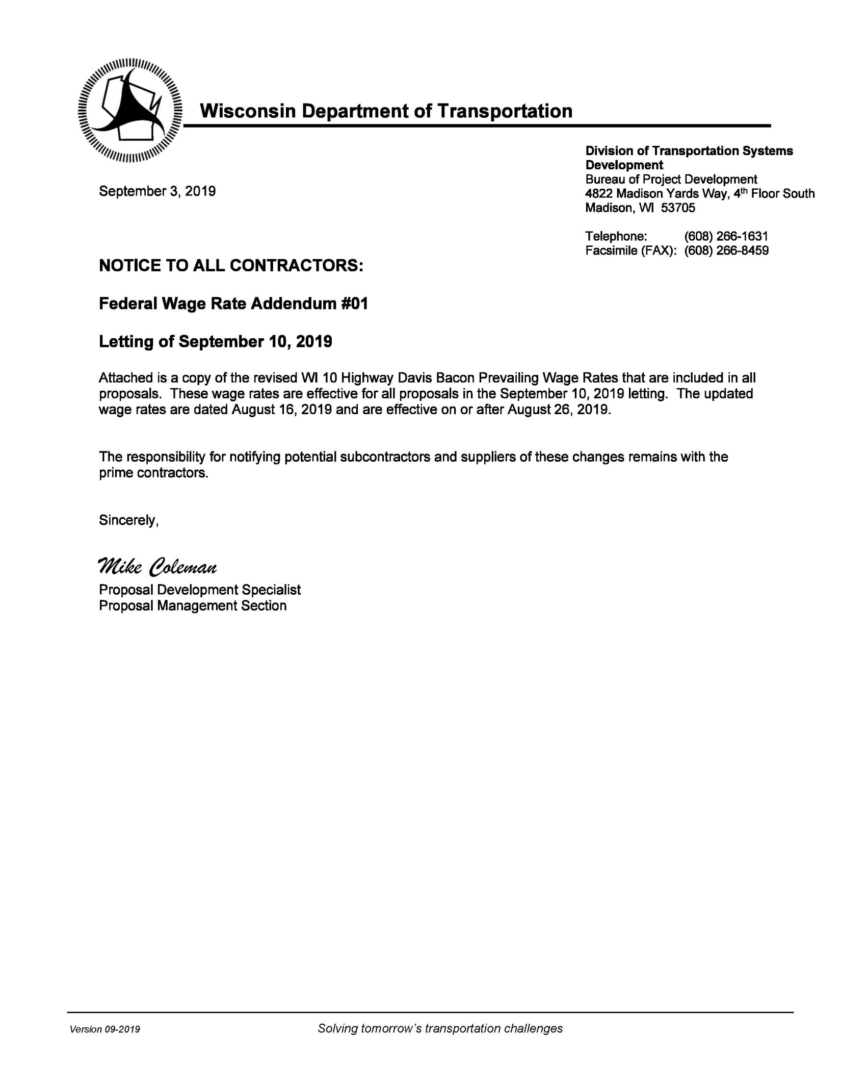

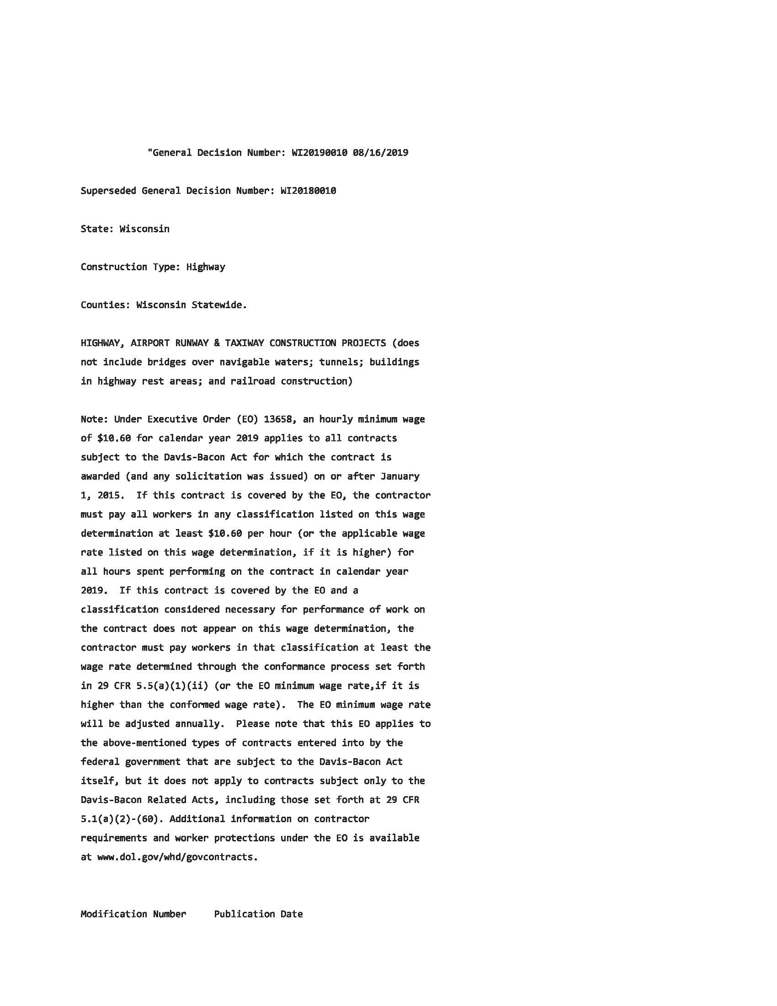
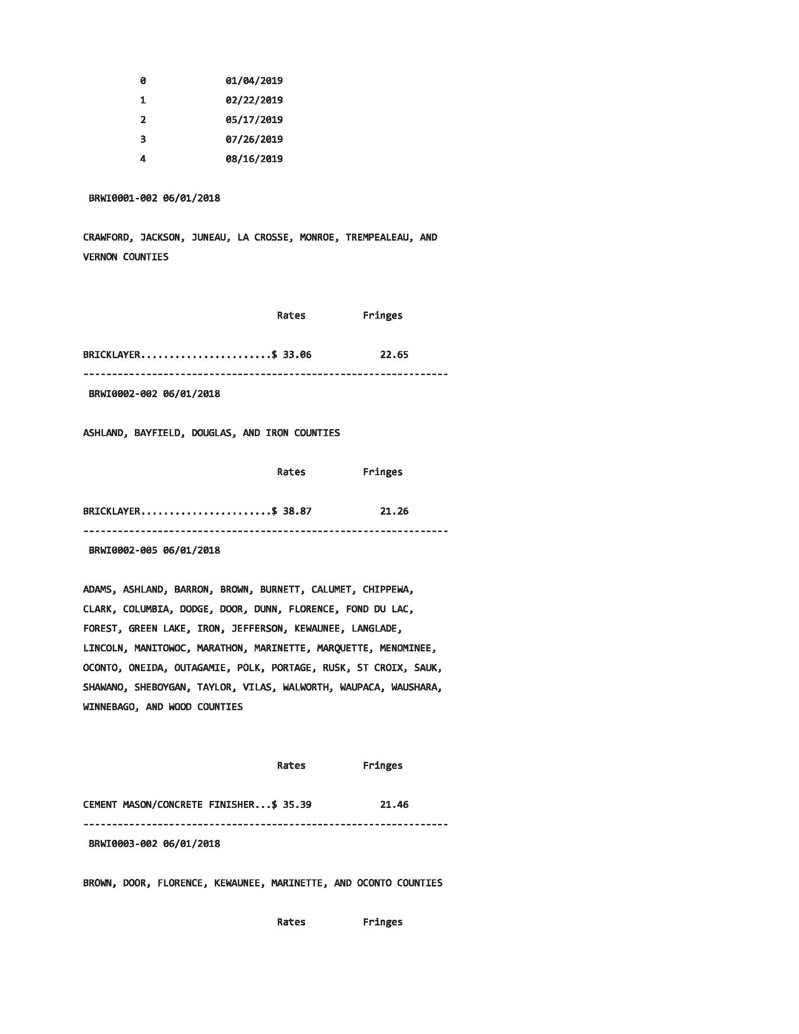

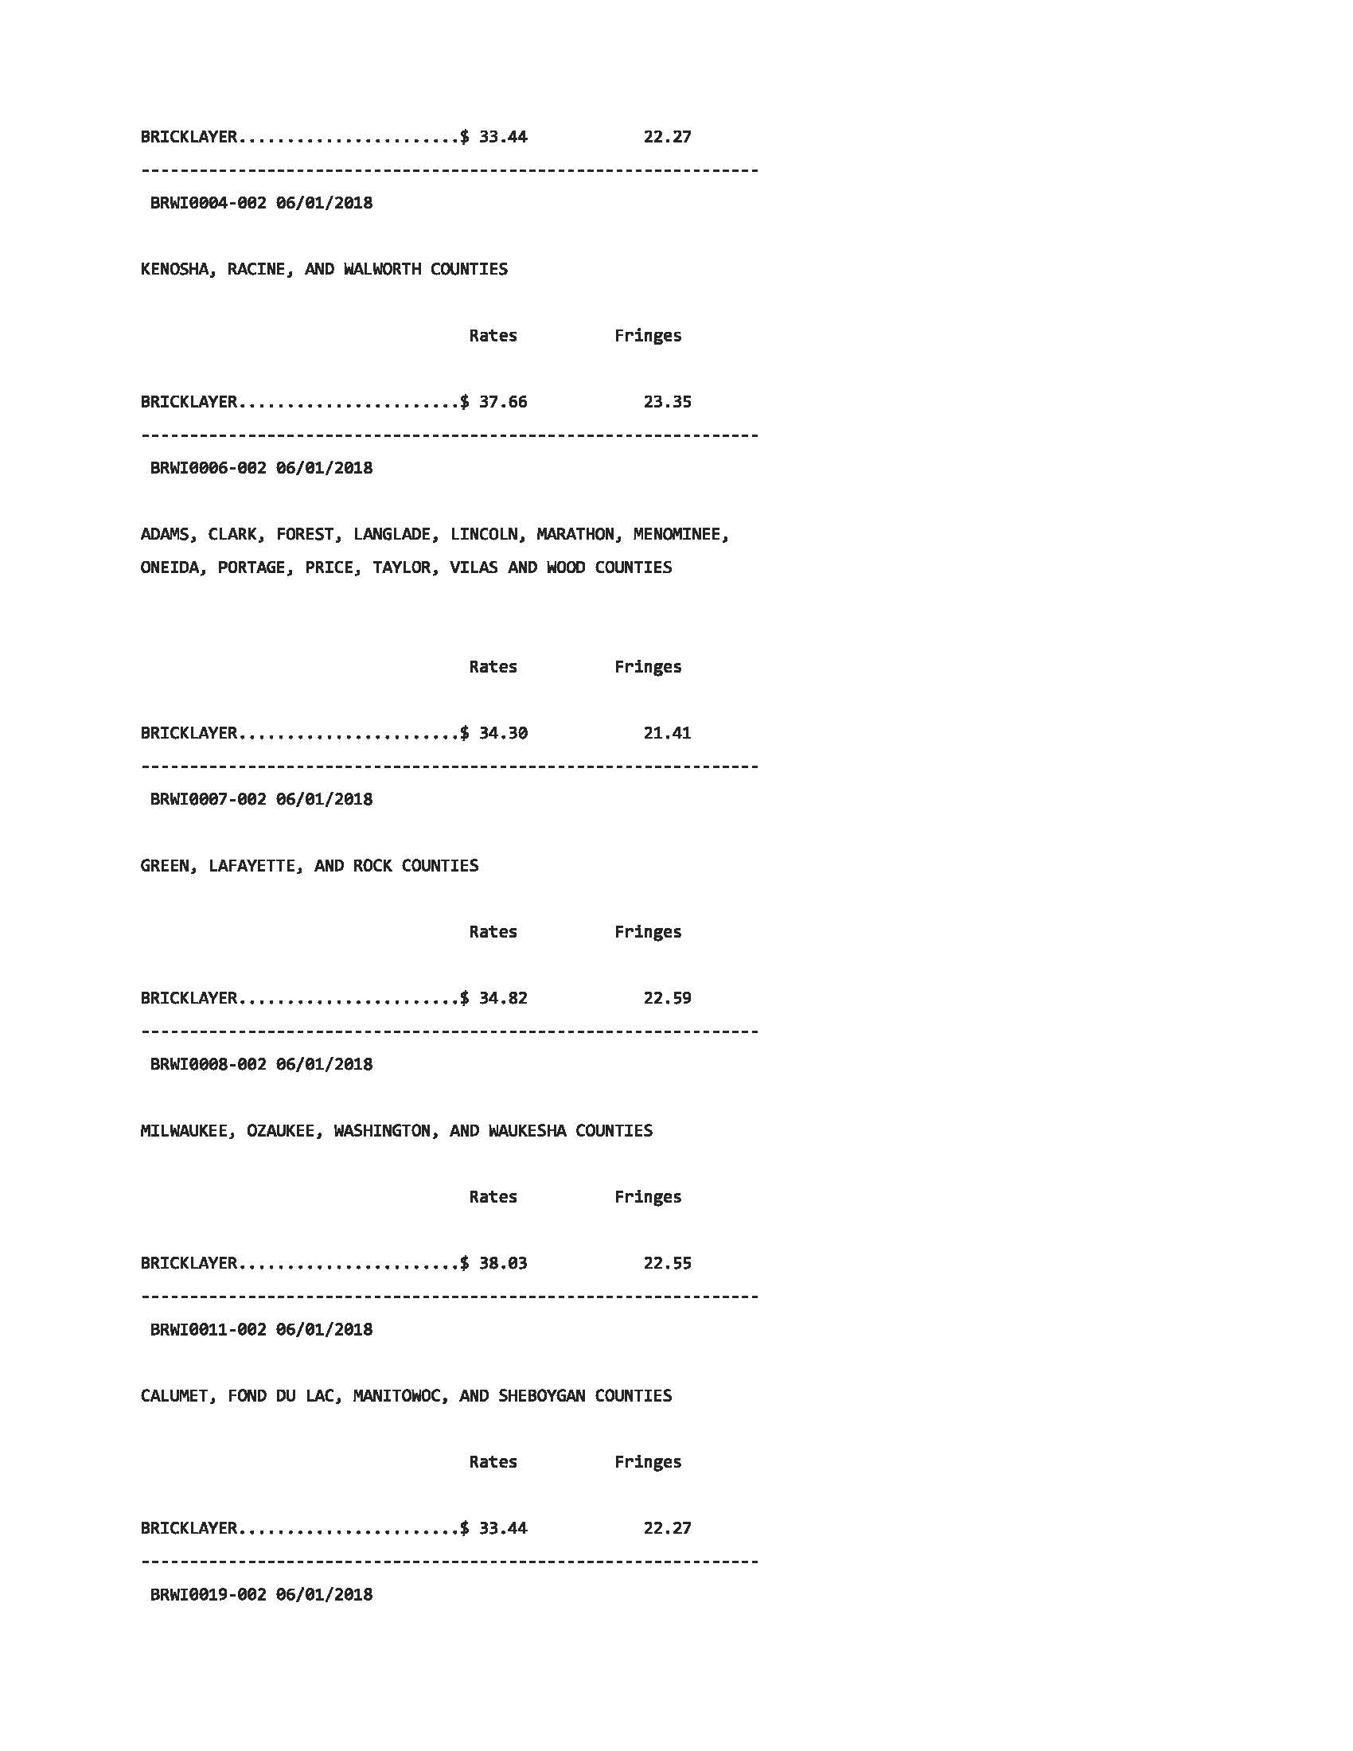

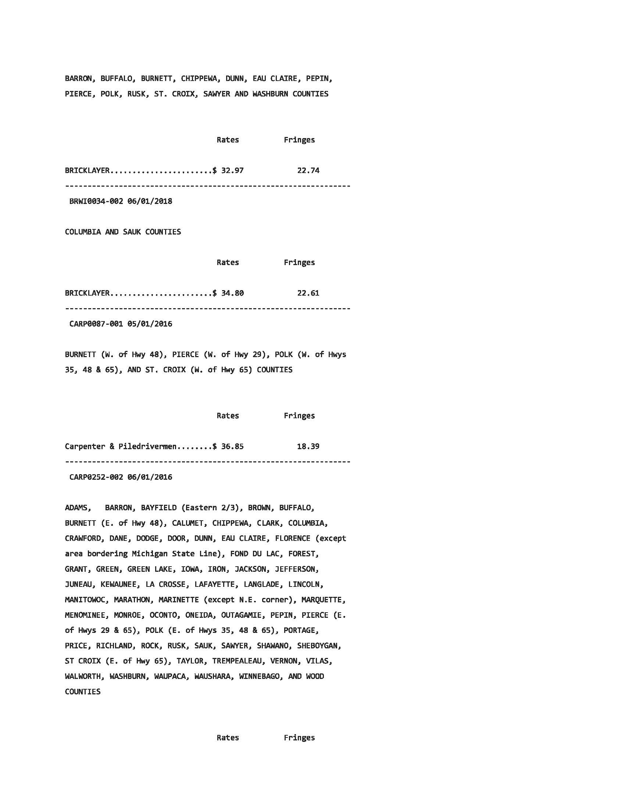

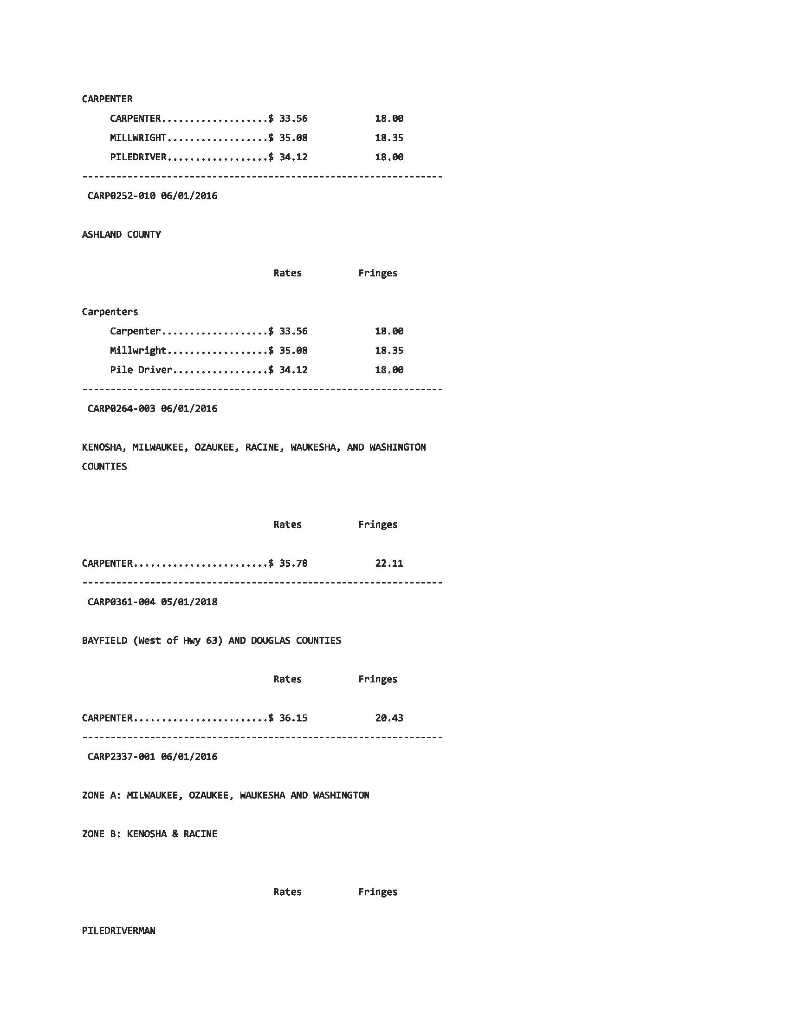

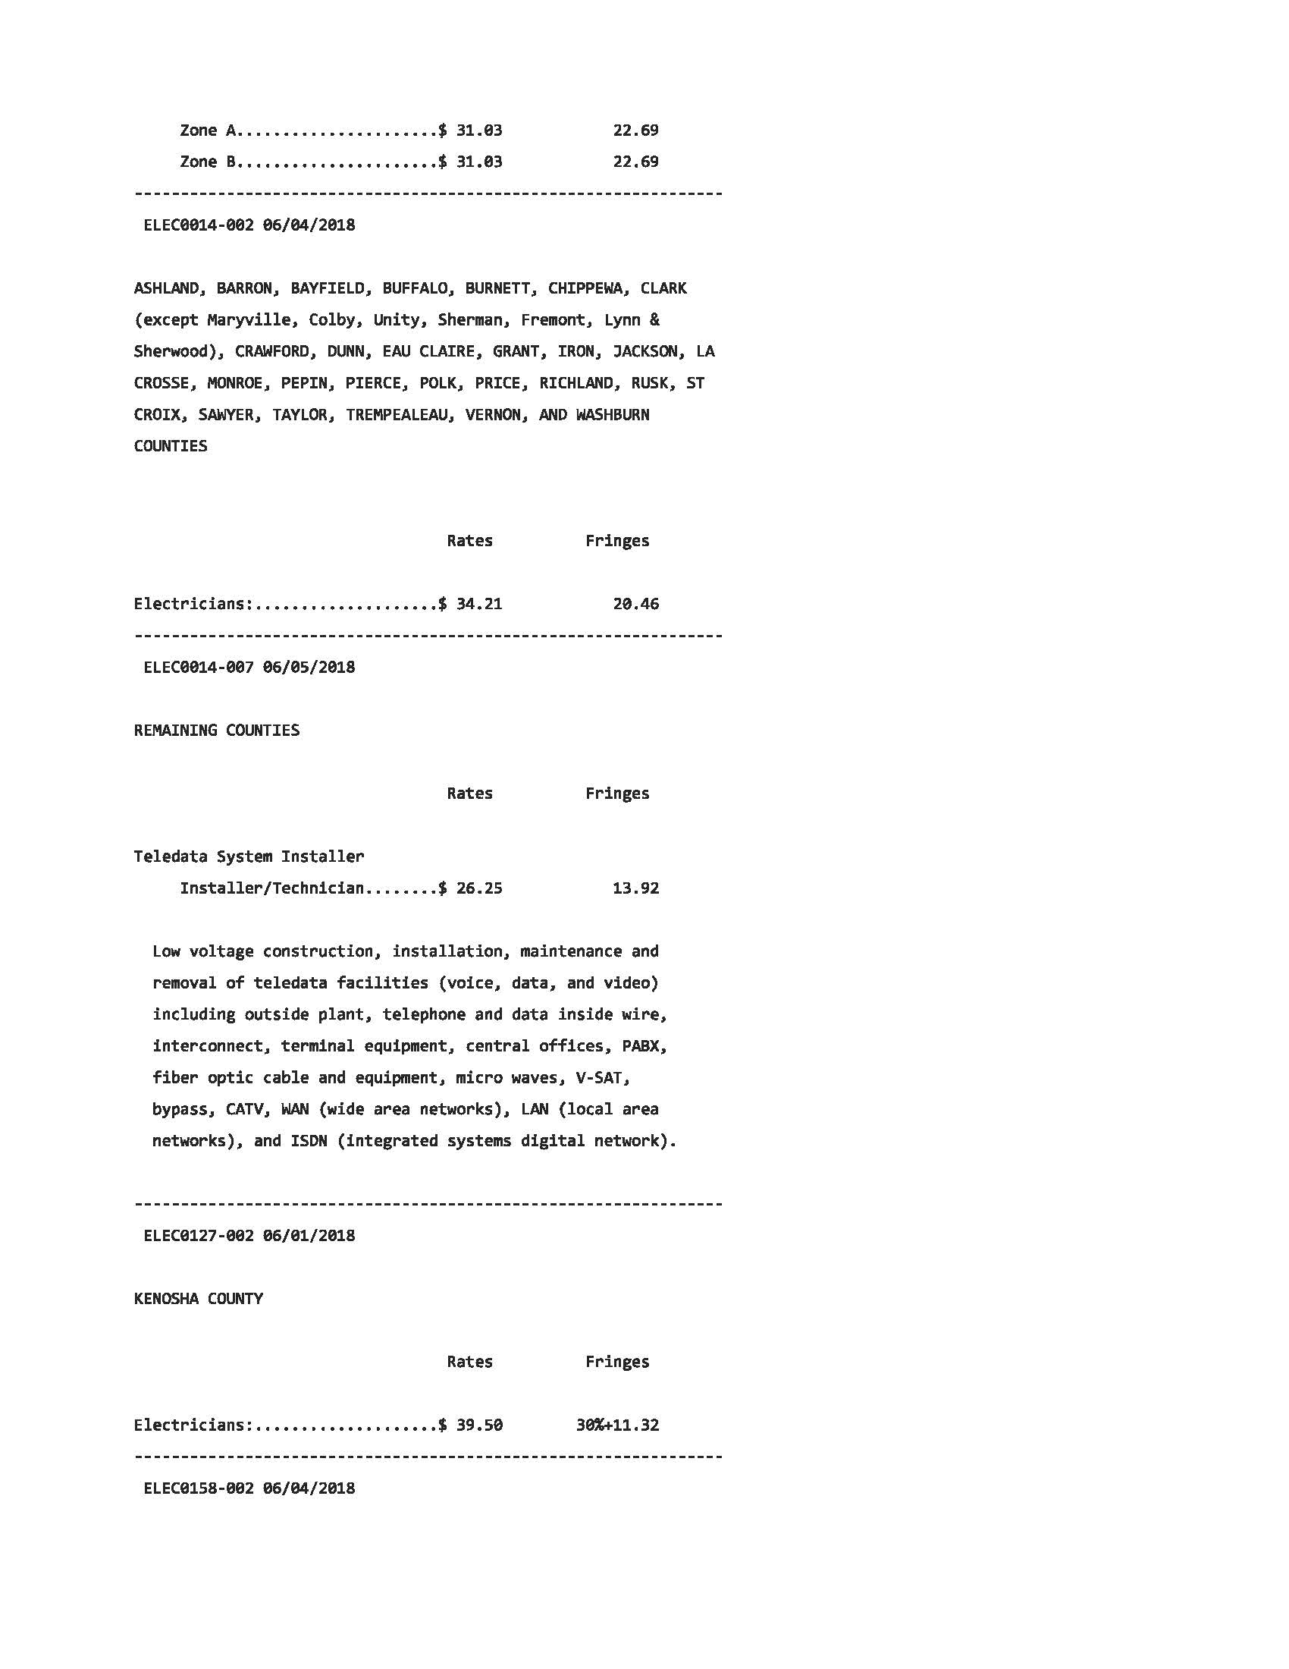

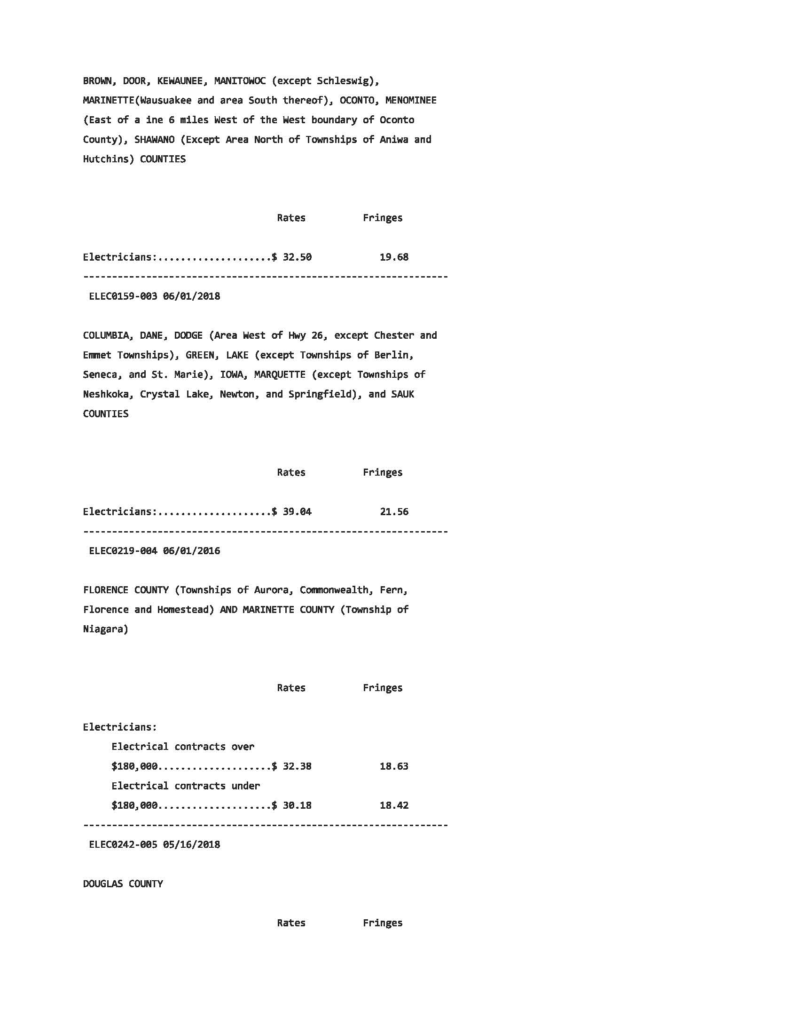

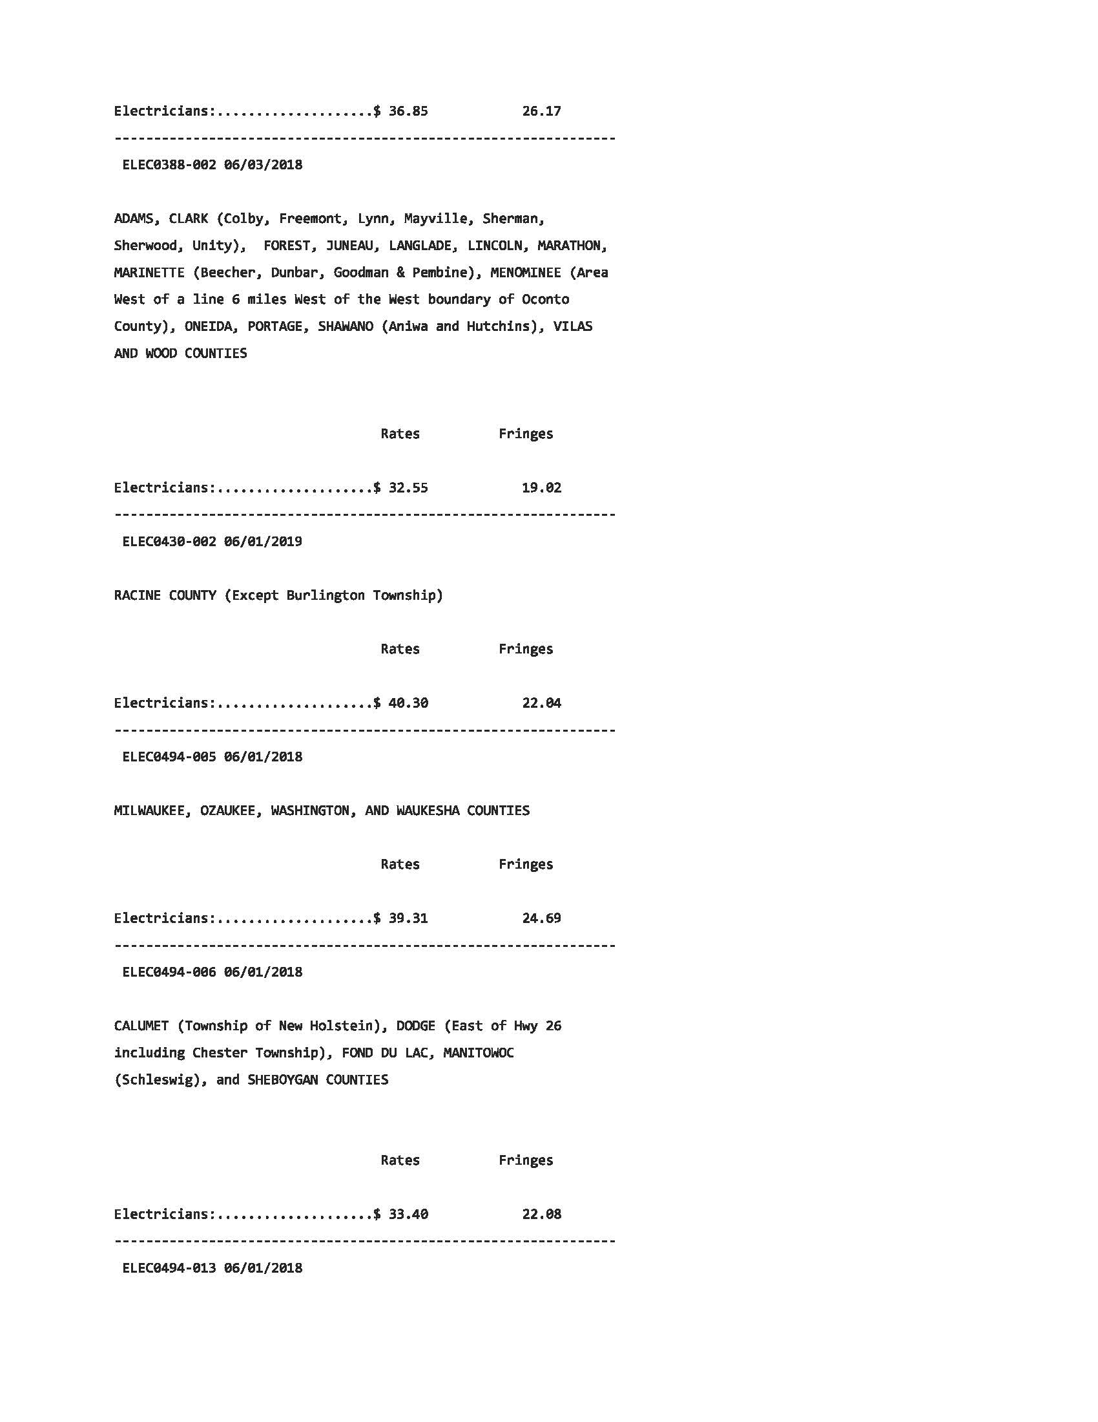

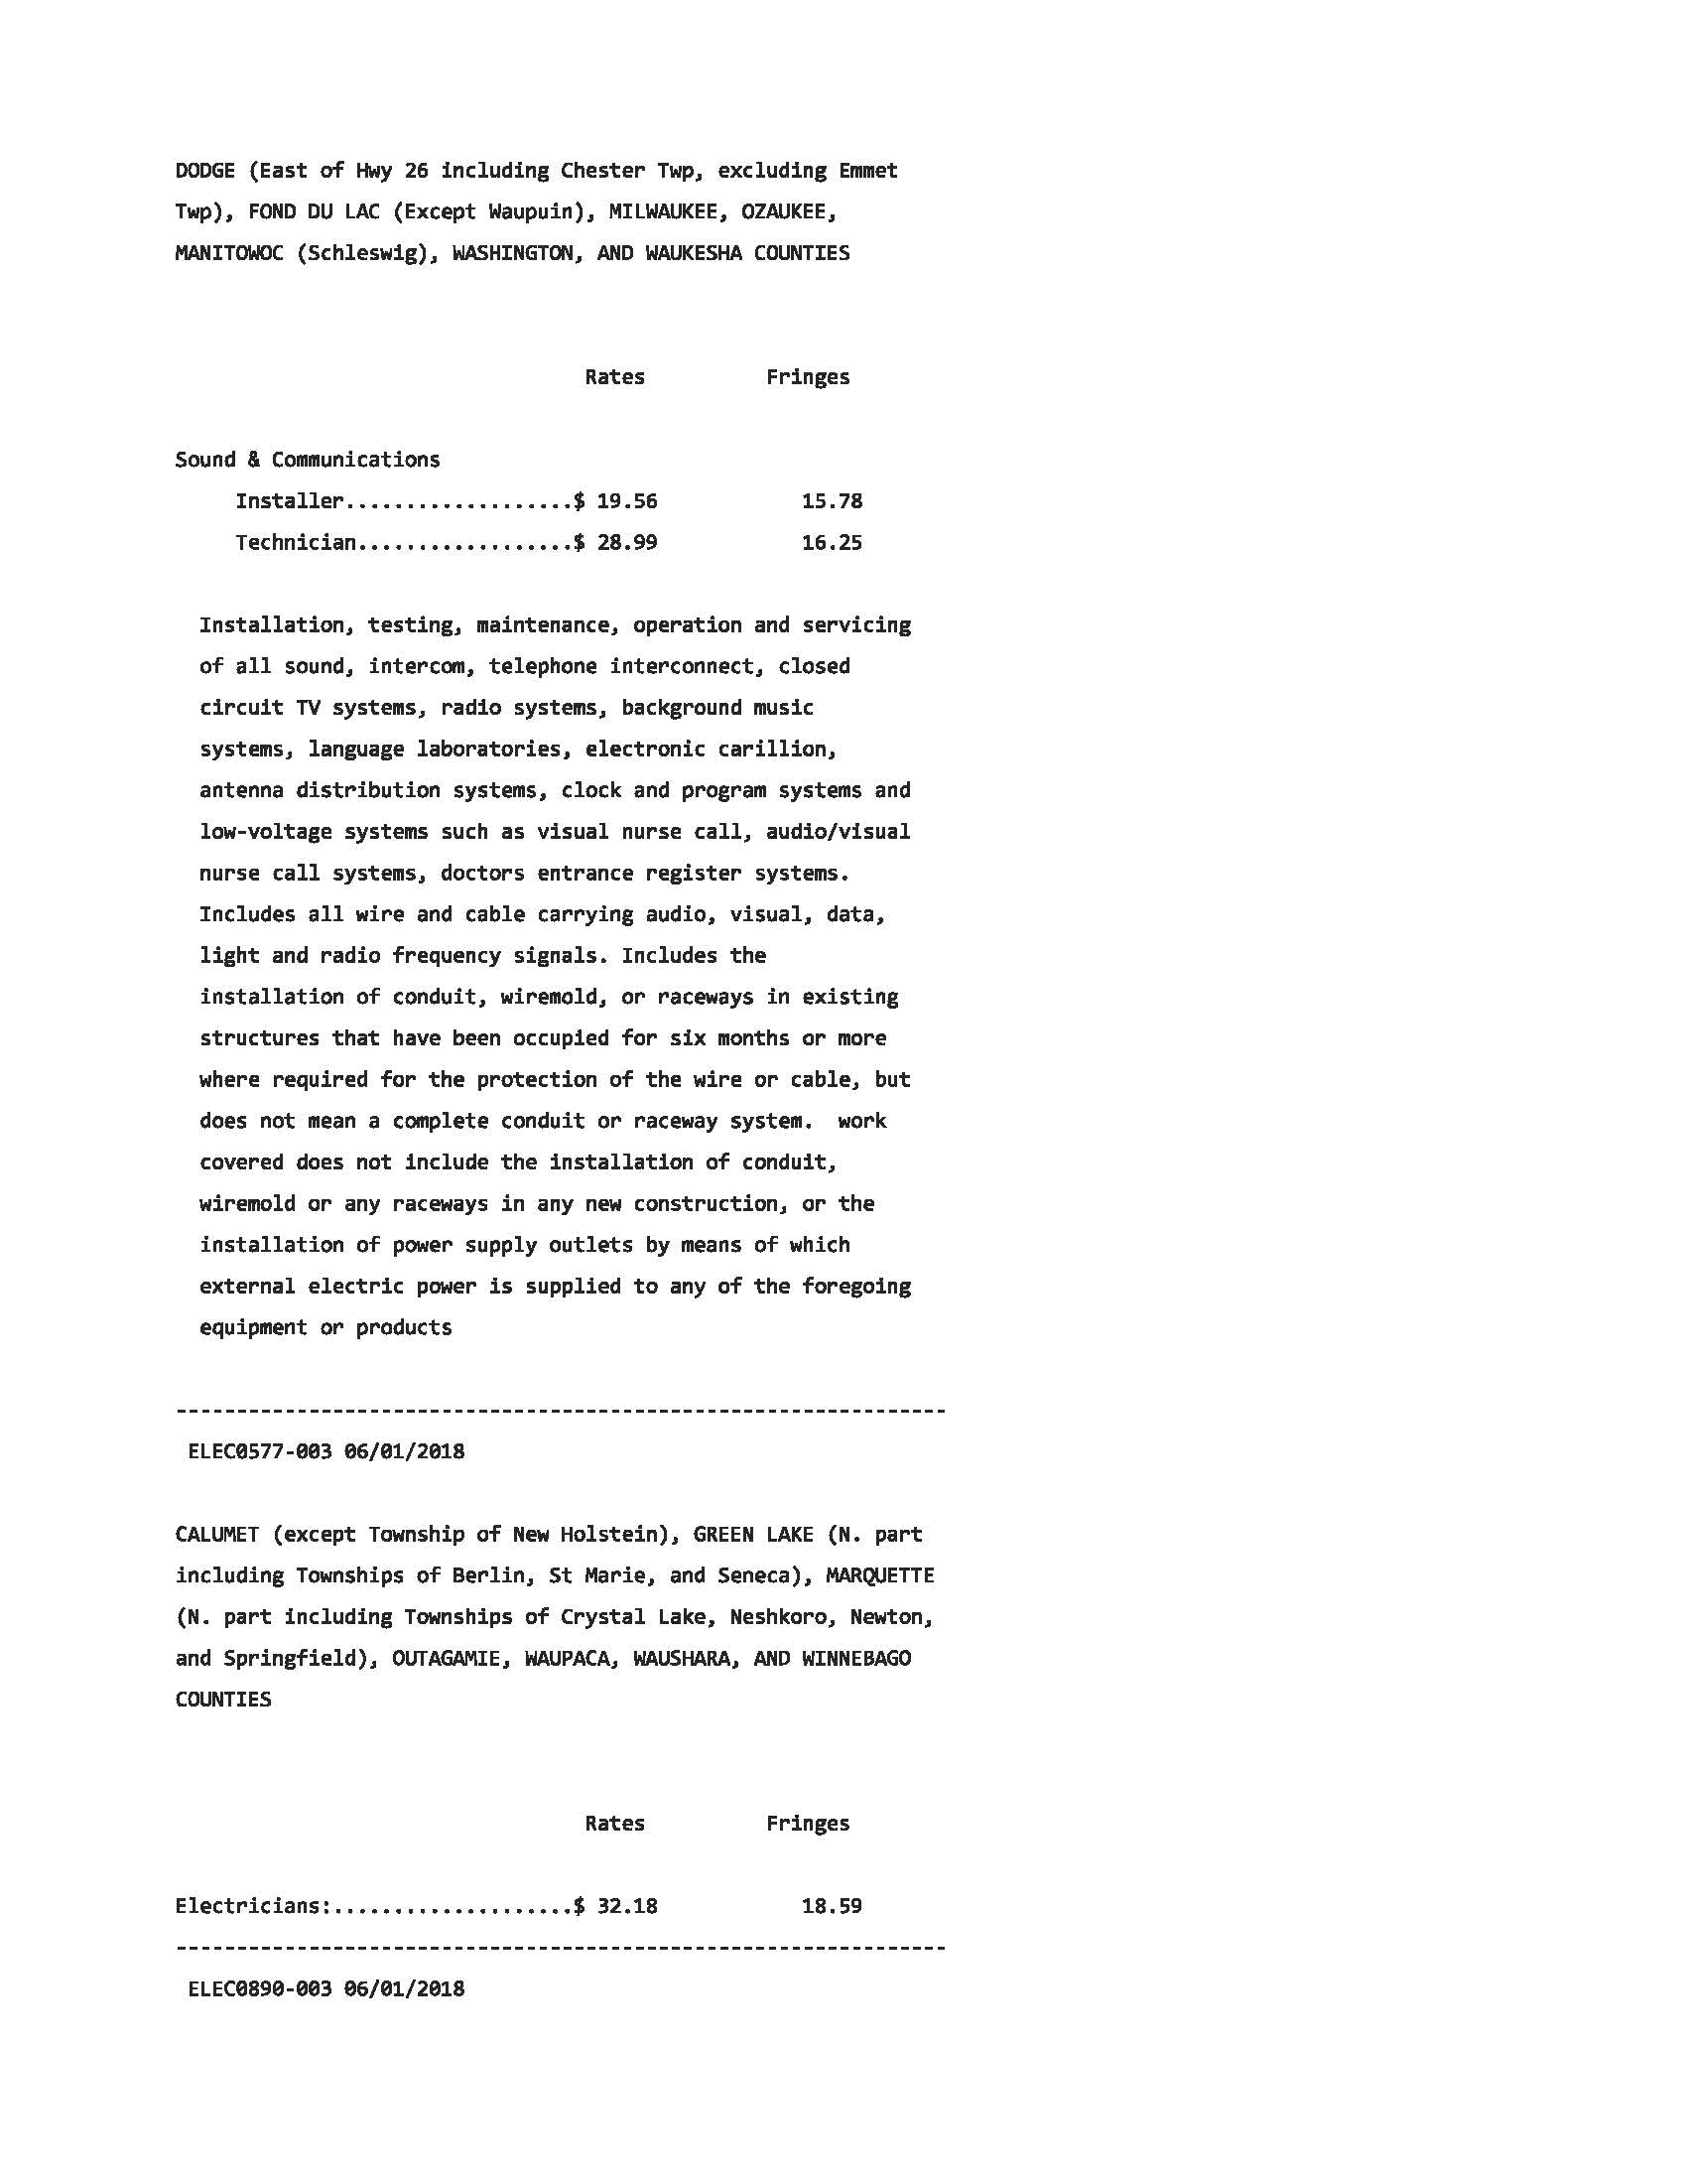

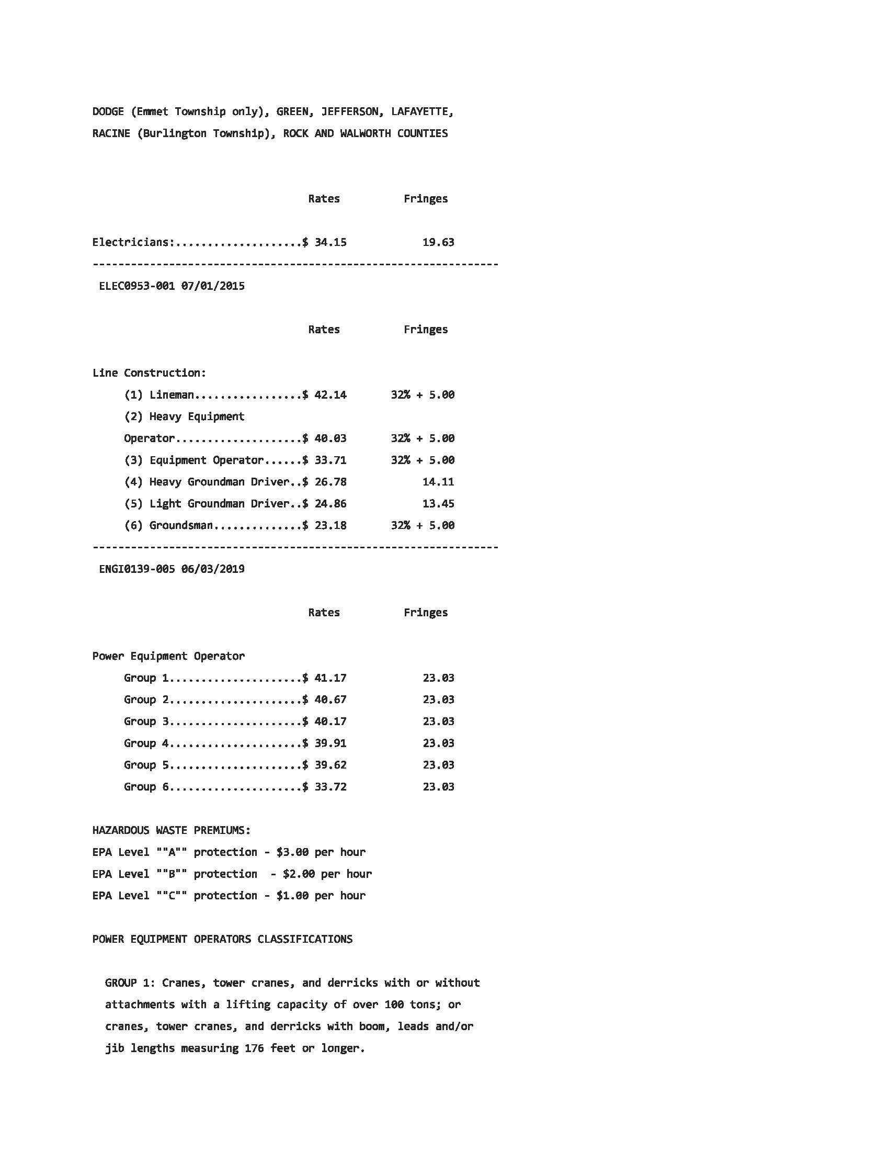

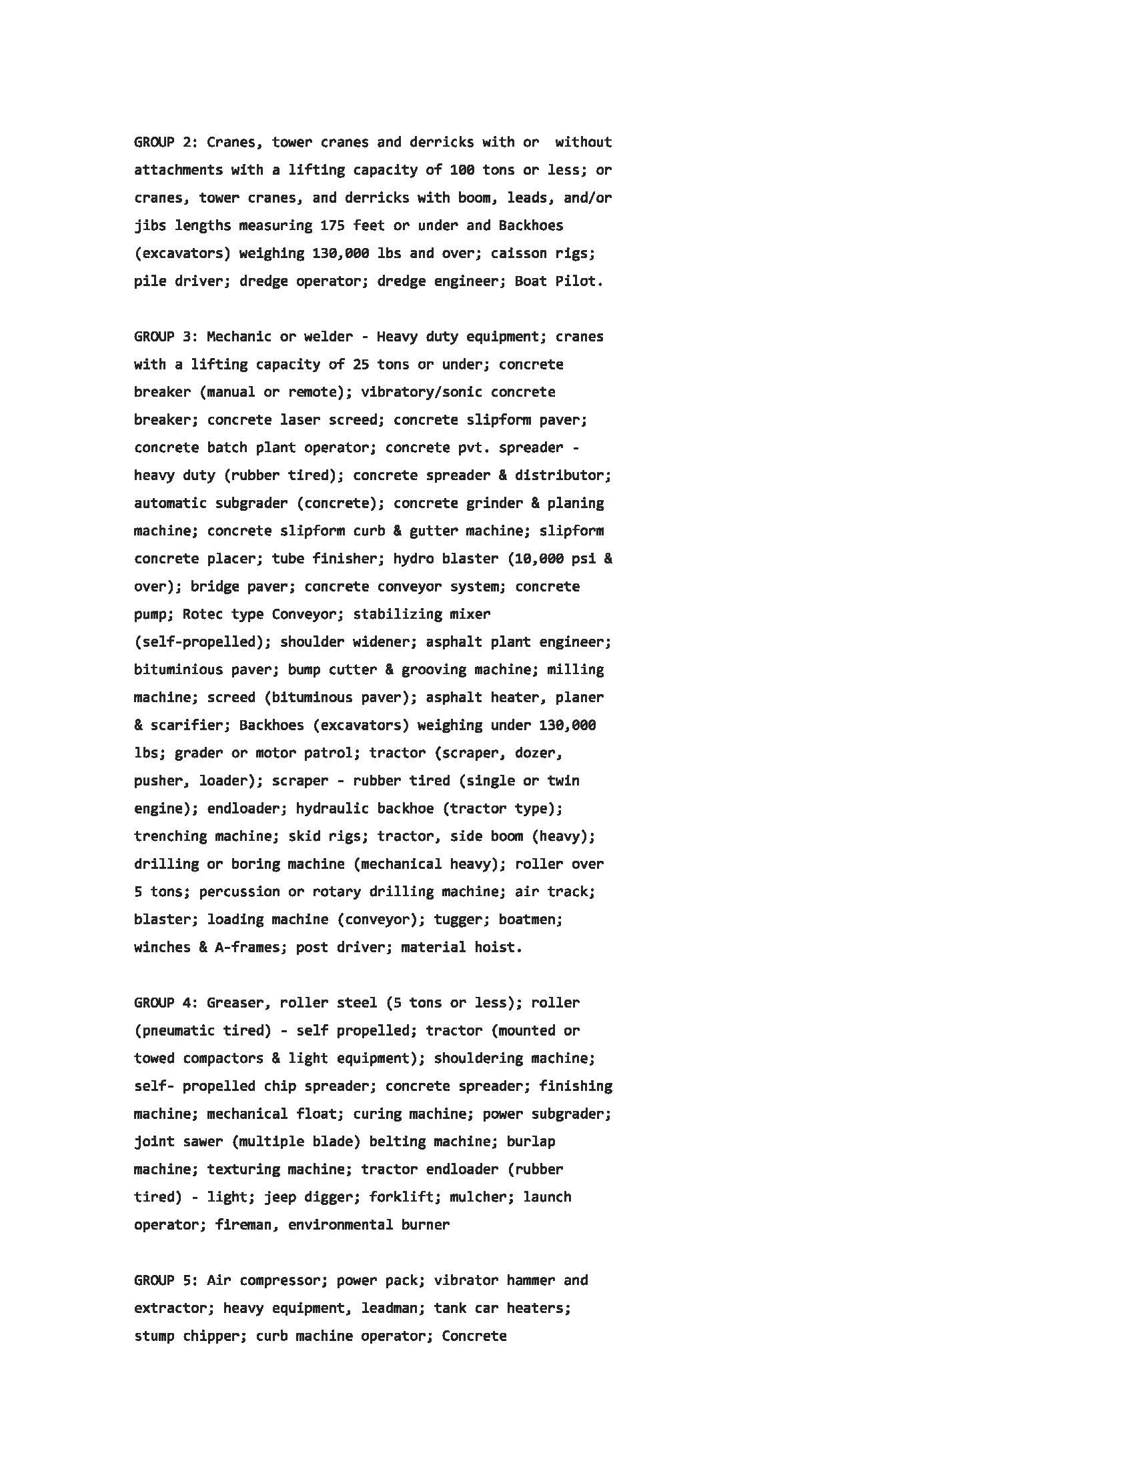

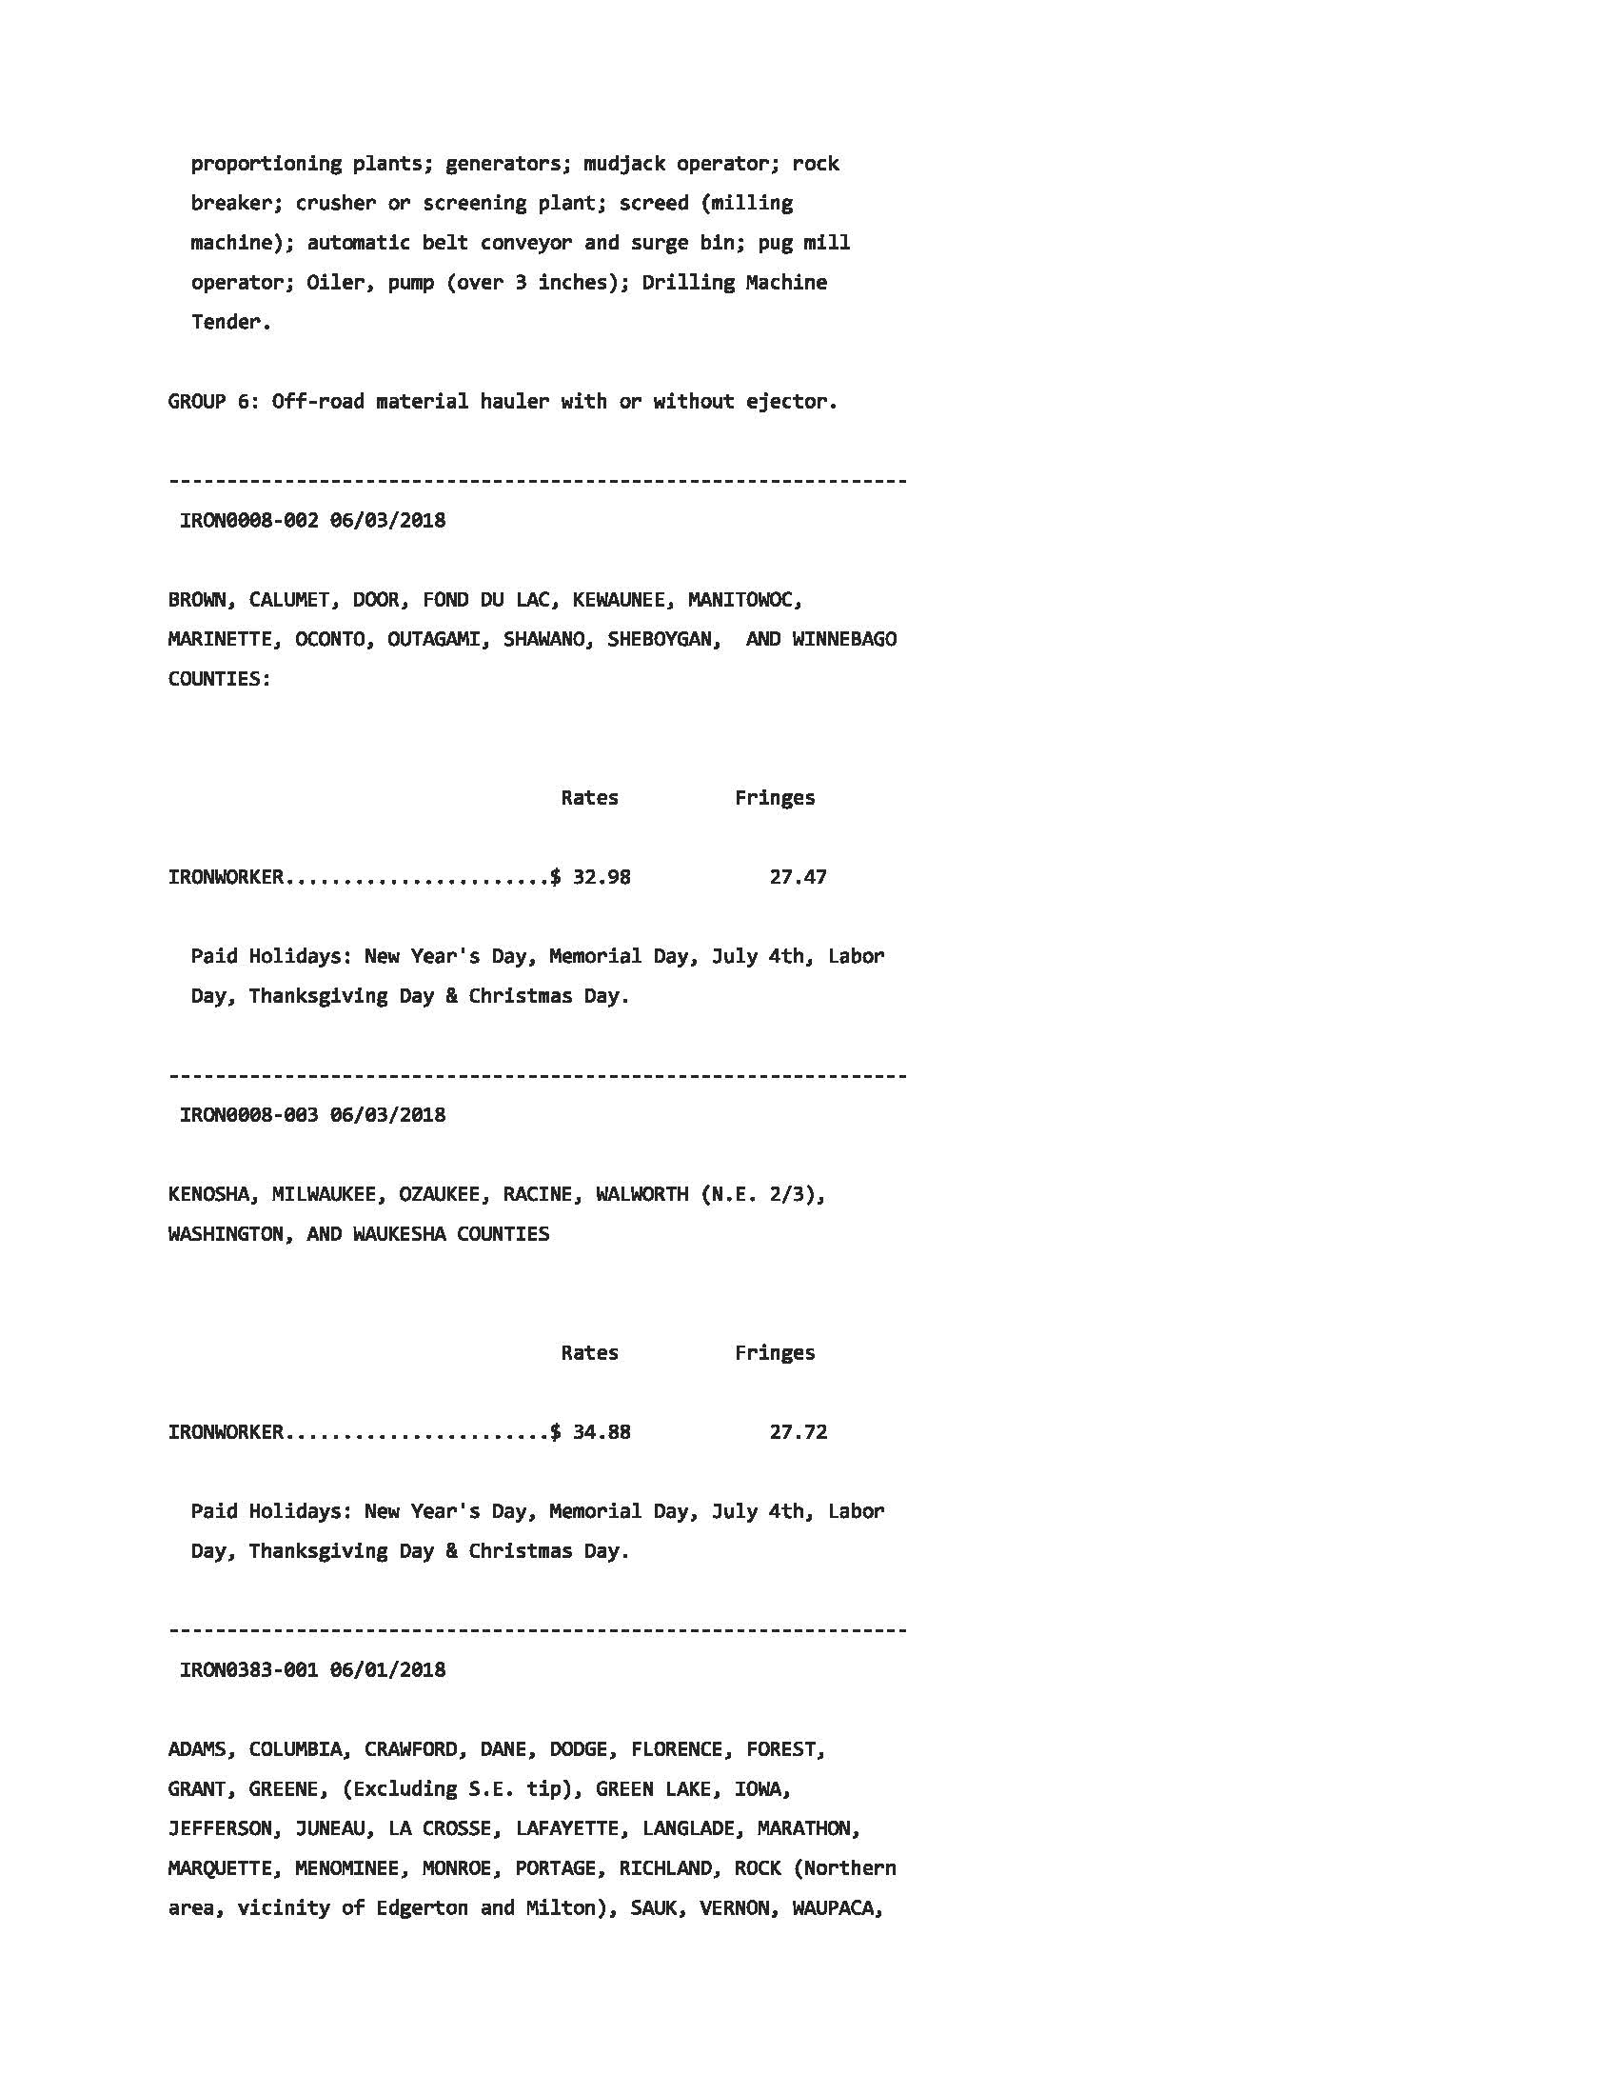

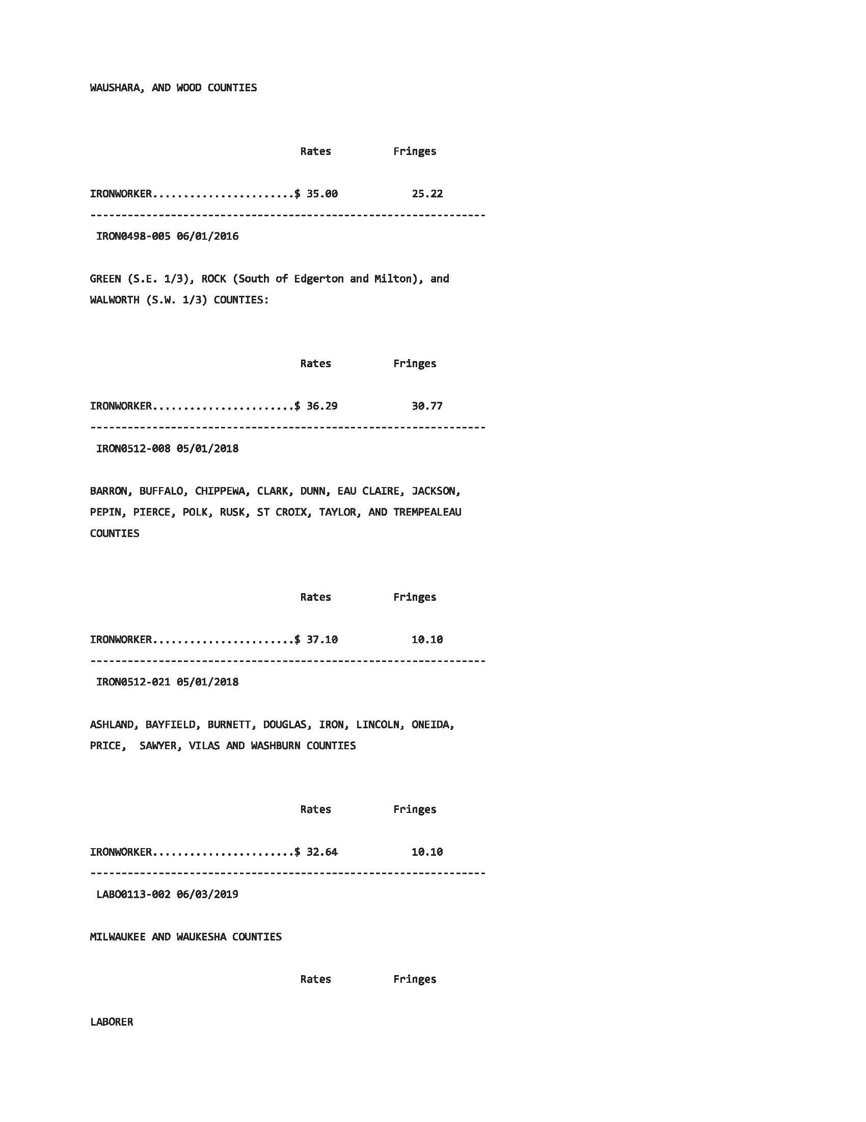

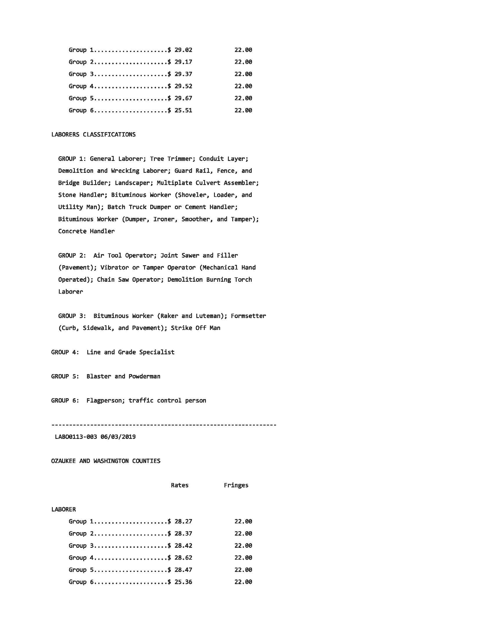

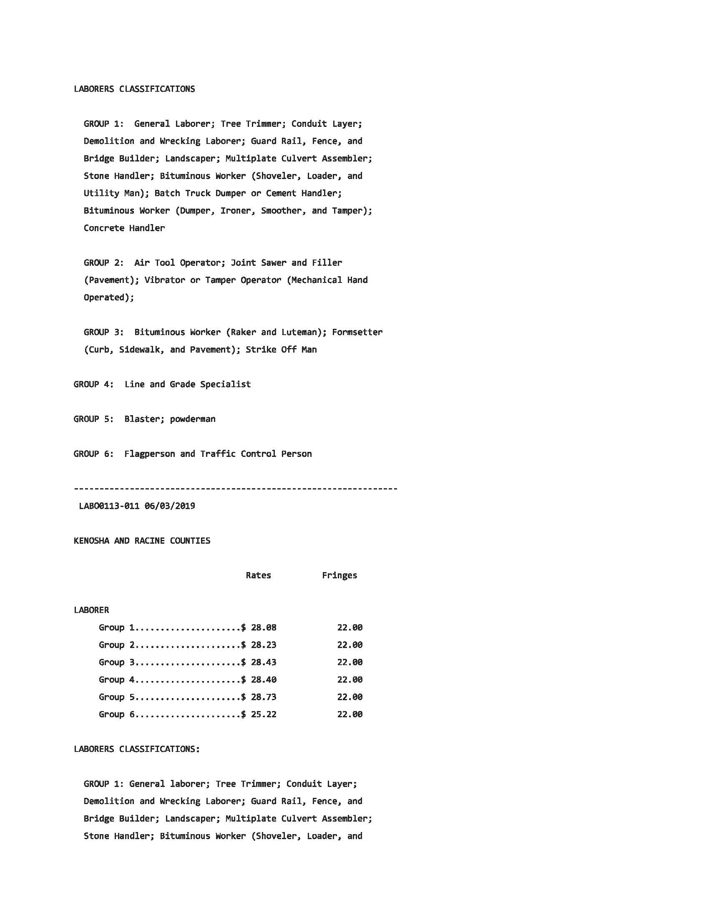

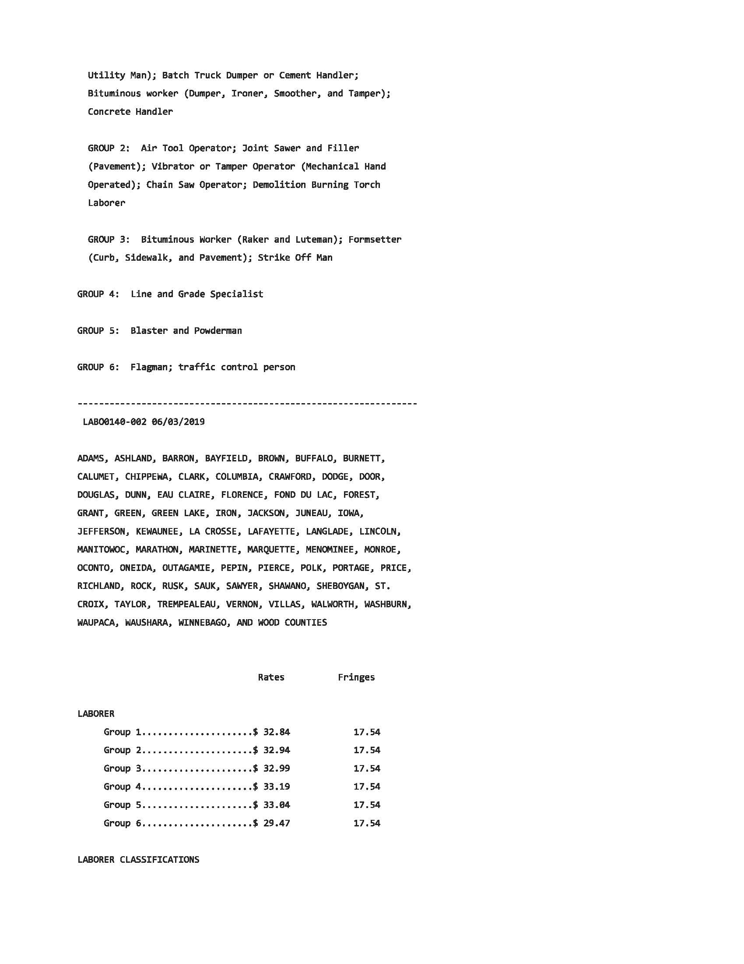

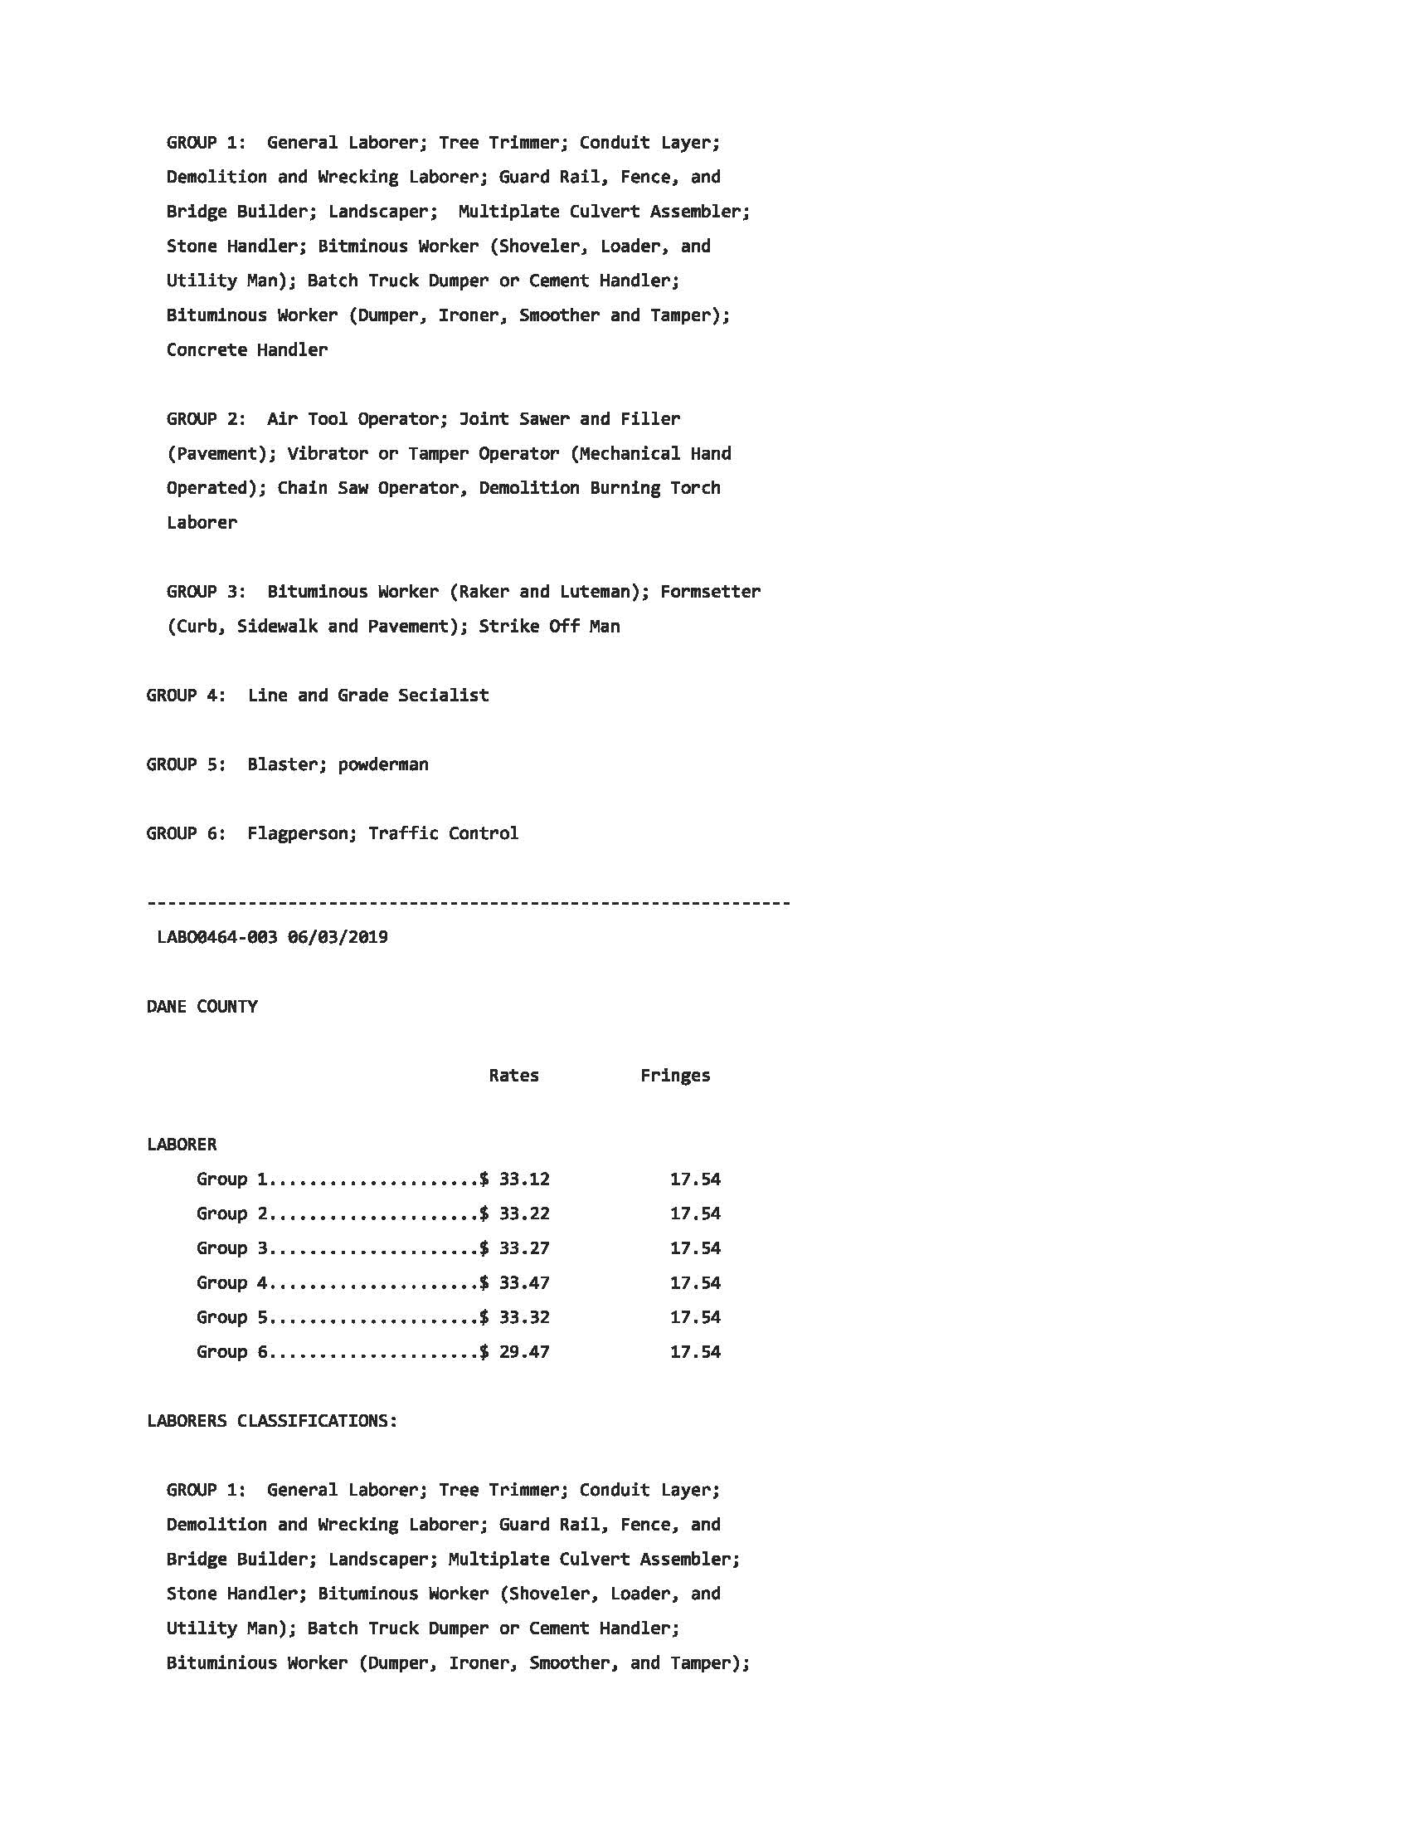

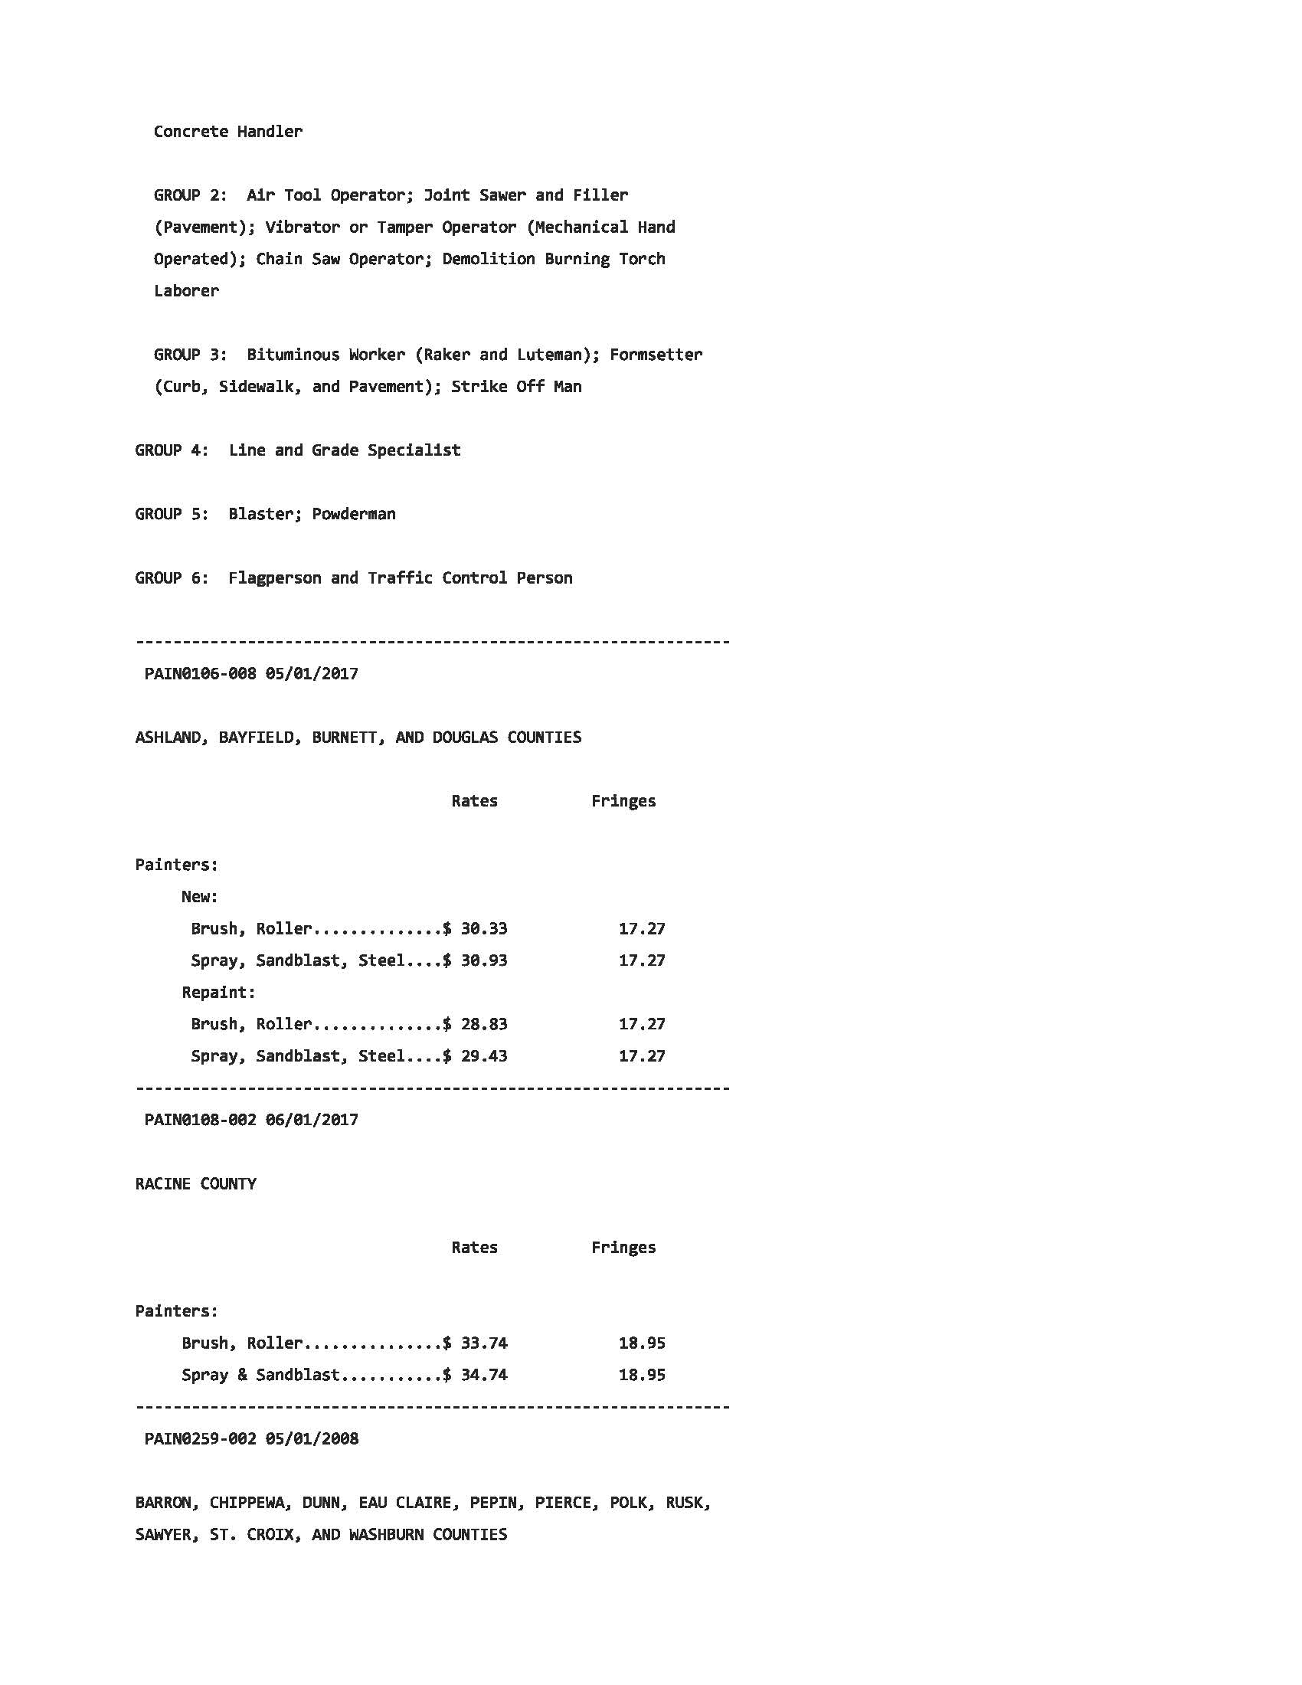

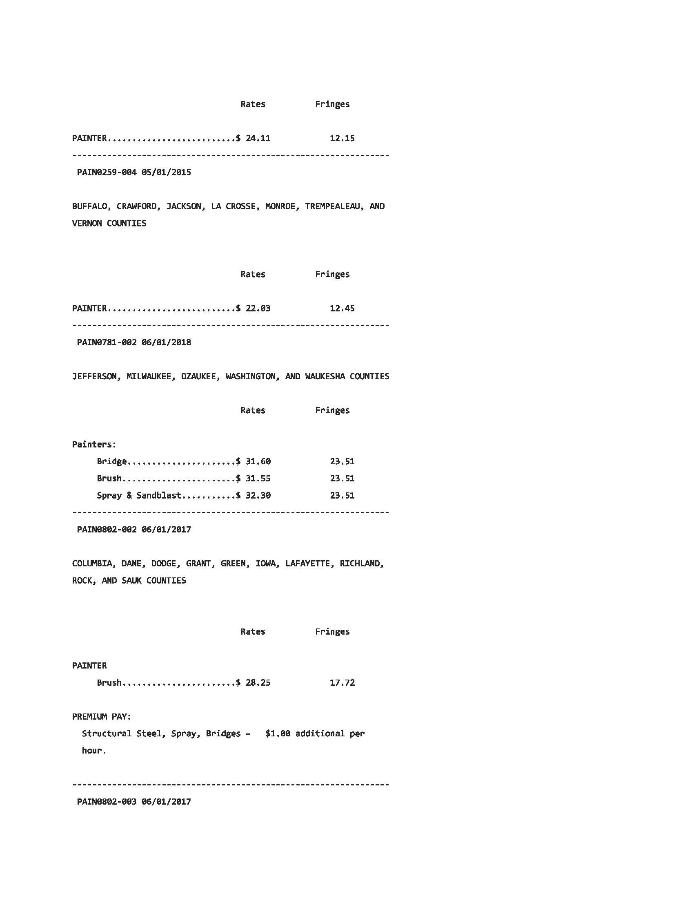

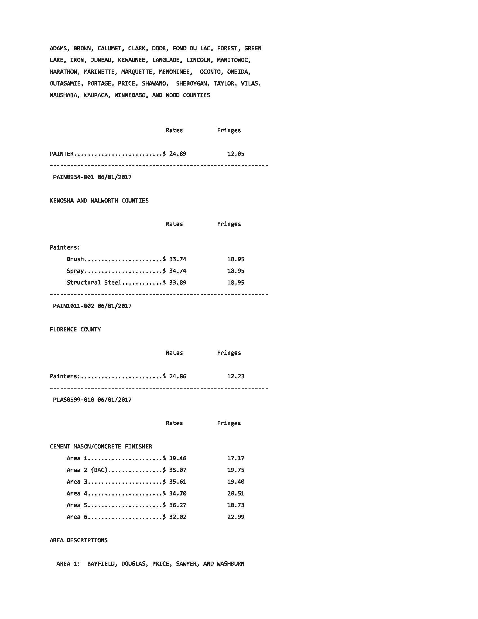

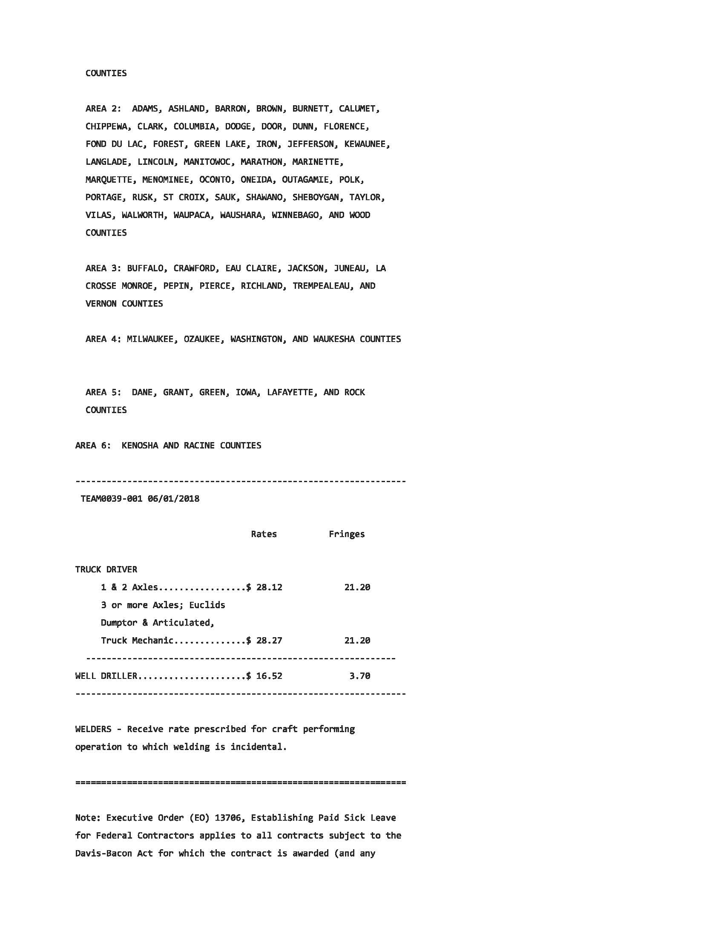

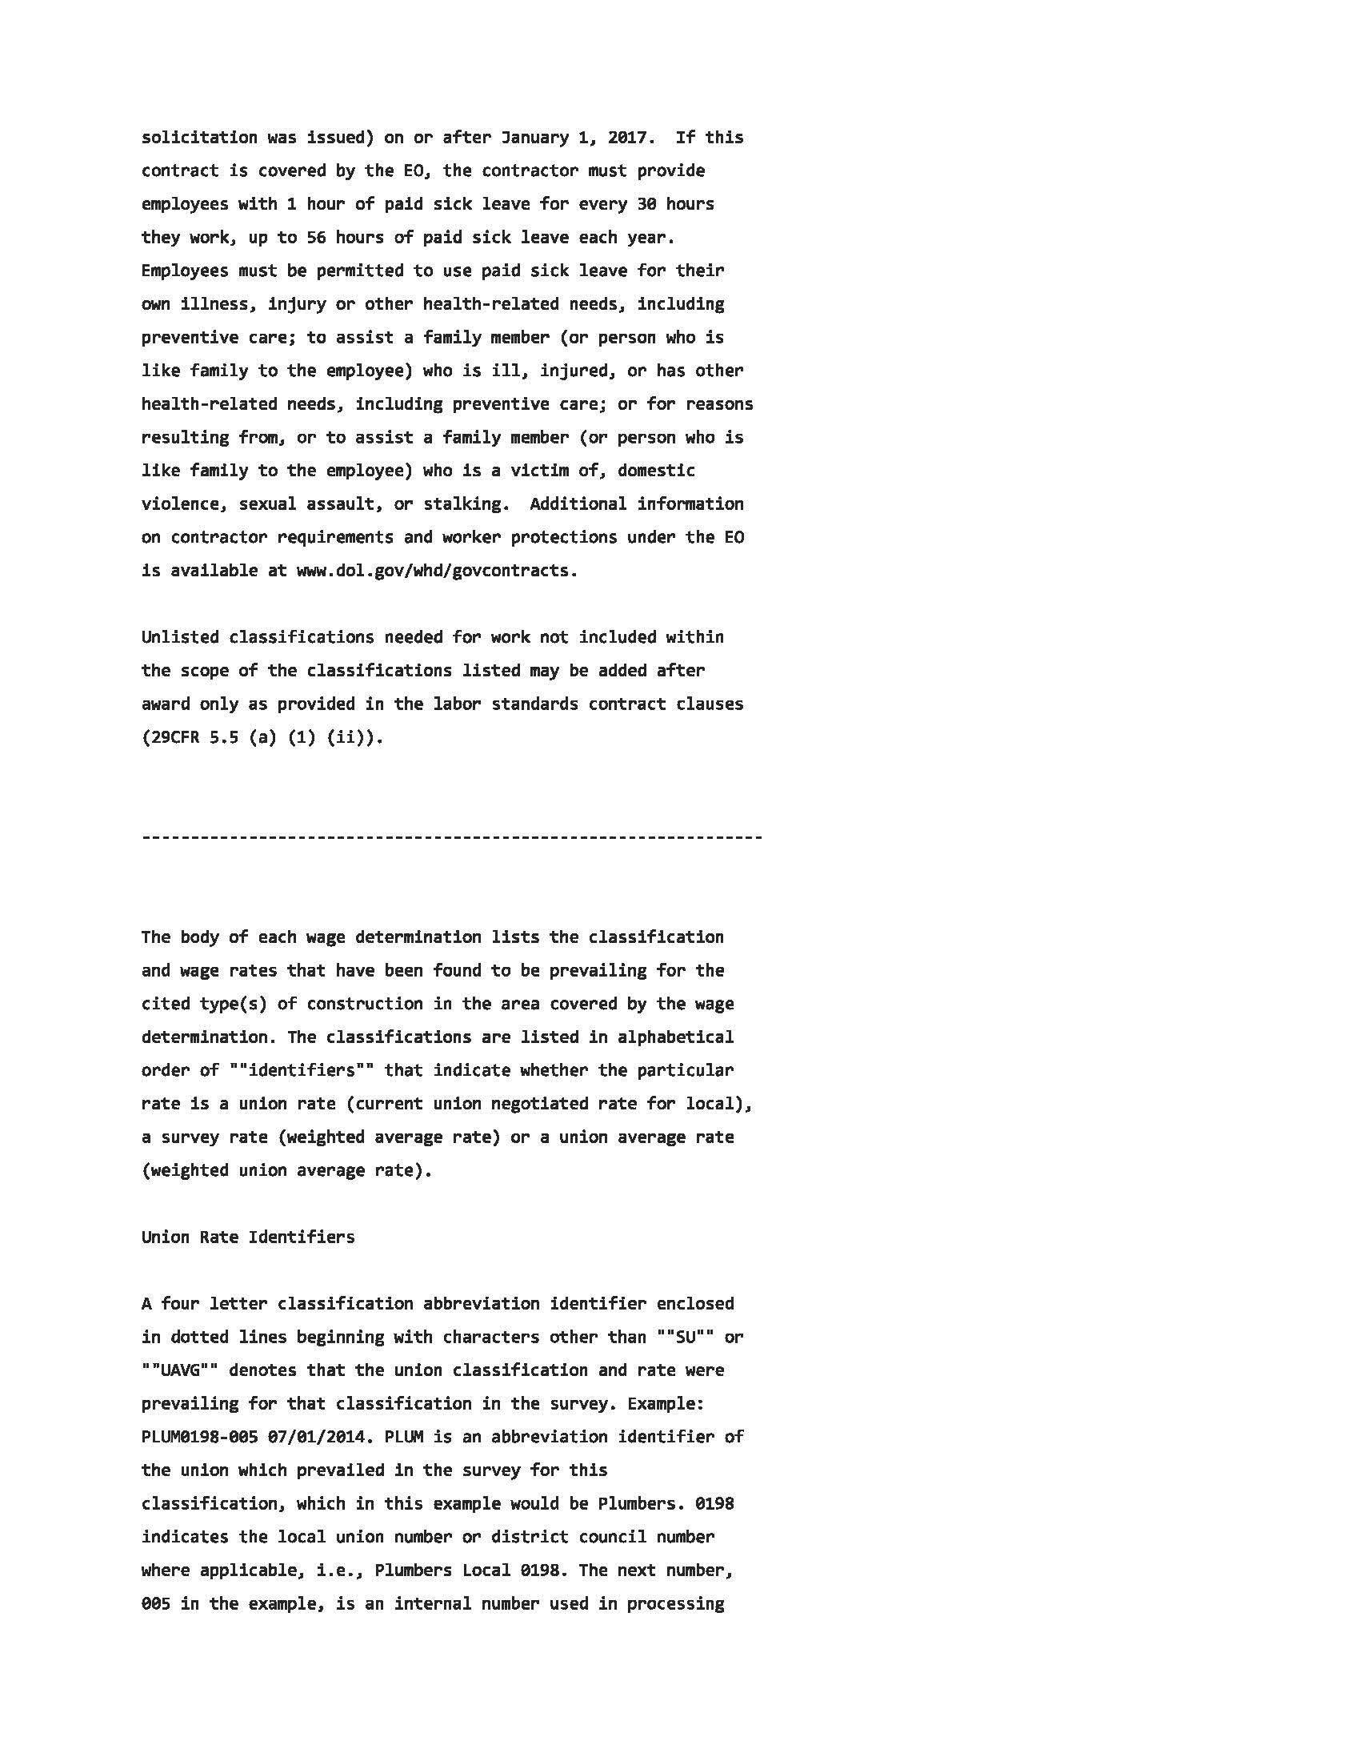

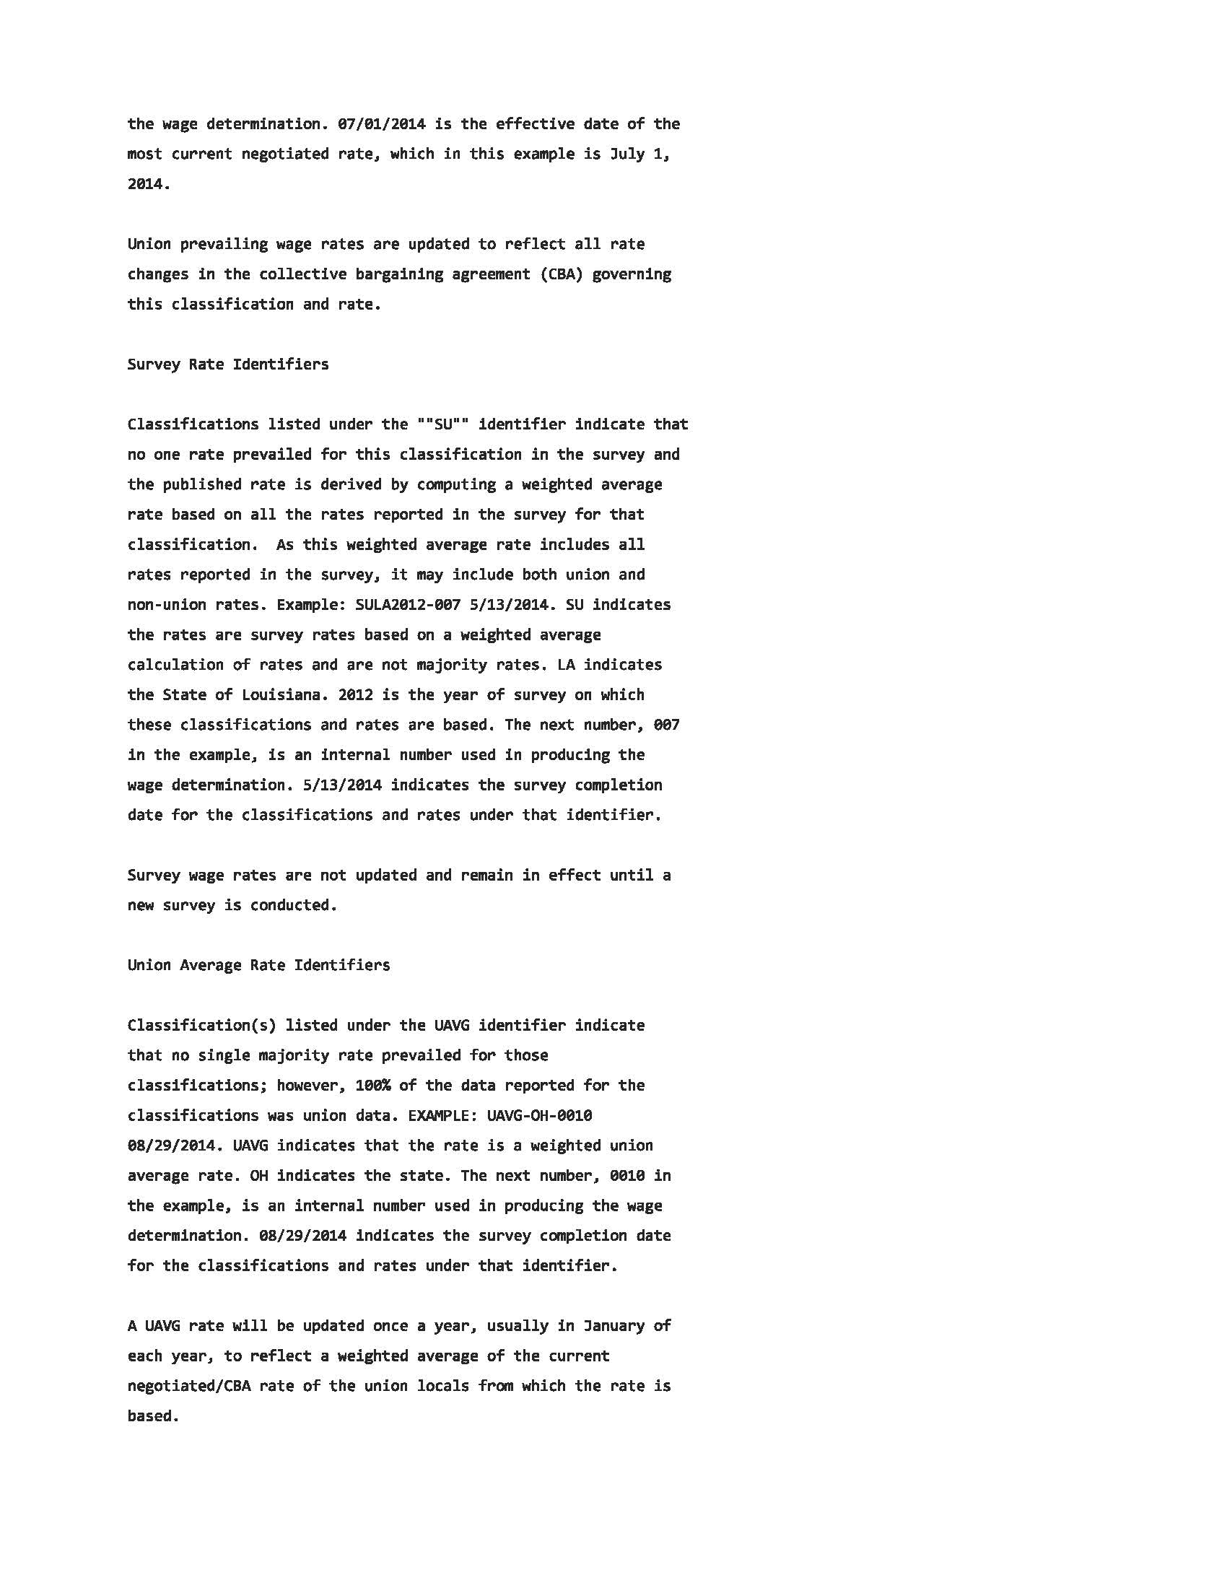

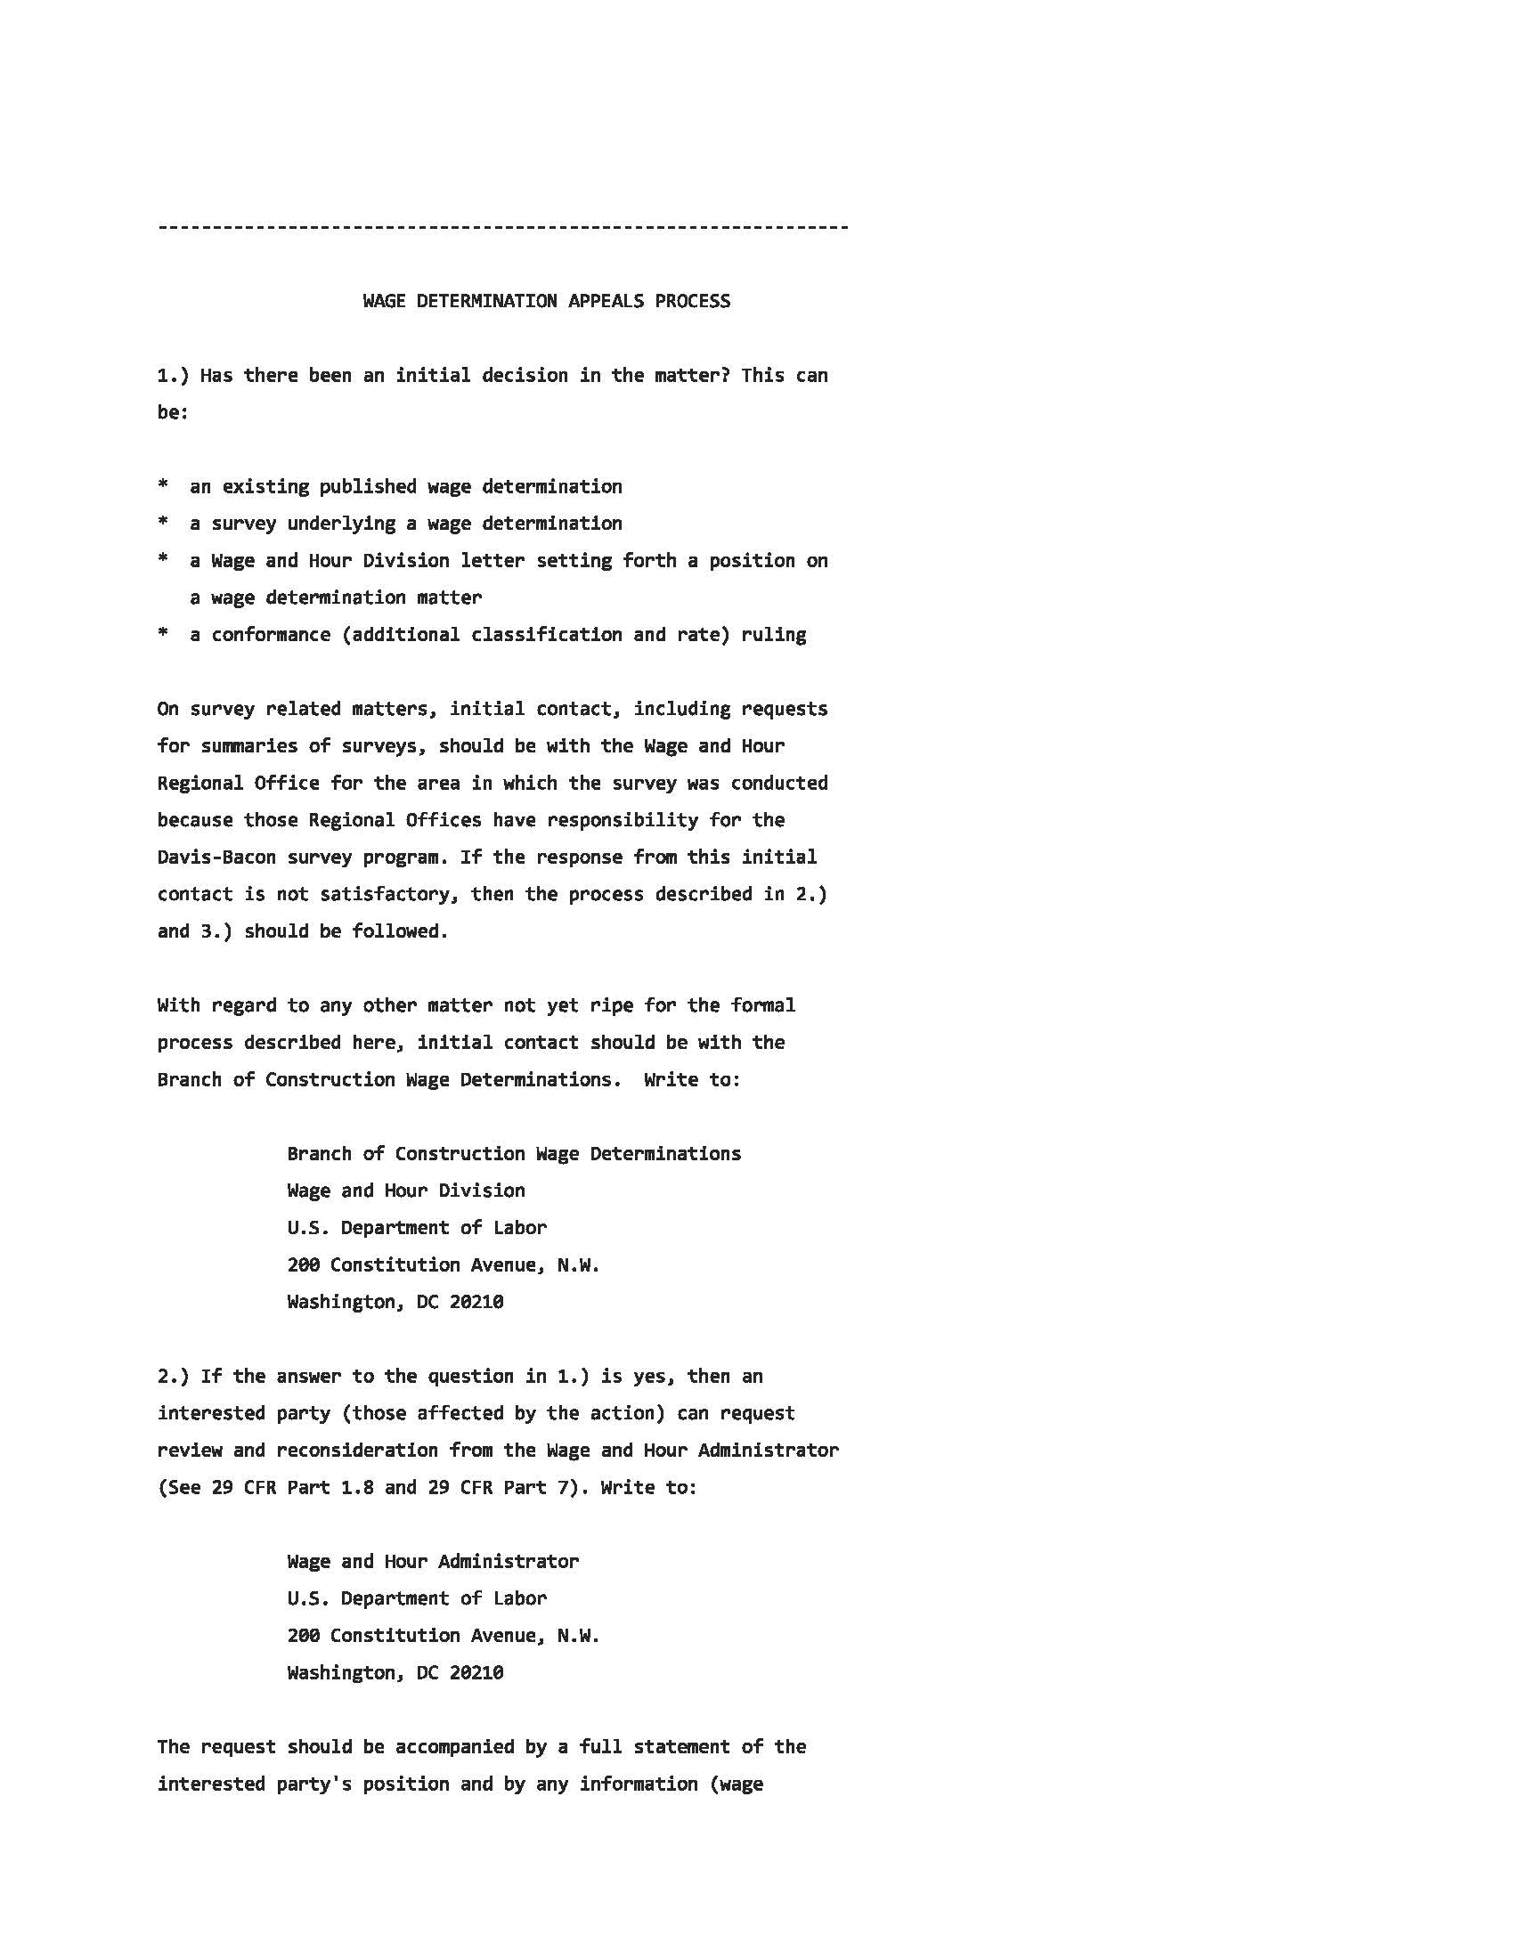

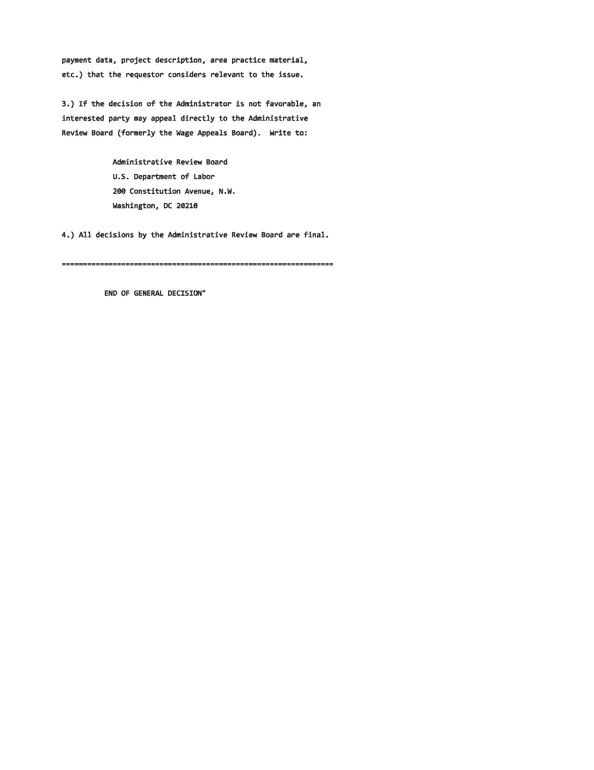

STANDARD TERMS AND CONDITIONS
Request for Bids/Proposals/Contracts
Rev. 4/2018

1.0 APPLICABILITY: The terms and conditions set forth in this document apply to Requests for Proposals (RFP), Bids and all other transactions whereby the County of Dane acquires goods or services, or both.

1.1 ENTIRE AGREEMENT: These Standard Terms and Conditions shall apply to any contract, including any purchase order, awarded as a result of this request. Special requirements of a resulting contract may also apply. Said written contract with referenced parts and attachments shall constitute the entire agreement, and no other terms and conditions in any document, acceptance, or acknowledgment shall be effective or binding unless expressly agreed to in writing by the County. Unless otherwise stated in the agreement, these standard terms conditions supersede any other terms and/or conditions applicable to this agreement.

1.2 DEFINITIONS: As used herein, “vendor” includes a provider of goods or services, or both, who is responding to an RFP or a bid, and “bid” includes a response to either an RFP or a bid.

2.0 SPECIFICATIONS: The specifications herein are the minimum acceptable. When specific manufacturer and model numbers are used, they are to establish a design, type of construction, quality, functional capability or performance level, or any combination thereof, desired. When alternates are proposed, they must be identified by manufacturer, stock number, and such other information necessary to establish equivalency. Dane County shall be the sole judge of equivalency. Vendors are cautioned to avoid proposing alternates to the specifications that may result in rejection of their bid.

3.0 DEVIATIONS AND EXCEPTIONS: Deviations and exceptions from terms, conditions, or specifications shall be described fully in writing, signed, and attached to the bid. In the absence of such statement, the bid shall be accepted as in strict compliance with all terms, conditions, and specifications and vendor shall be held liable for injury resulting from any deviation.

4.0 QUALITY: Unless otherwise indicated in the request, all material shall be first quality. No pre-owned, obsolete, discontinued or defective materials may be used.

5.0 QUANTITIES: The quantities shown herein are based on estimated needs. The County reserves the right to increase or decrease quantities to meet actual needs.

6.0 DELIVERY: Deliveries shall be FOB destination freight prepaid and included unless otherwise specified. County will reject shipments sent C.O.D. or freight collect.

7.0 PRICING: Unit prices shown on the bid shall be the price per unit of sale as stated on the request or contract. For any given item, the quantity multiplied by the unit price shall establish the extended price, the unit price shall govern in the bid evaluation and contract administration.
7.1 Prices established in continuing agreements and term contracts may be lowered due to market conditions, but prices shall not be subject to increase for the term specified in the award. Vendor shall submit proposed increases to the Purchasing Division thirty (30) calendar days before the proposed effective date of the price increase. Proposed increases shall be limited to fully documented cost increases to the vendor that are demonstrated to be industry wide. Price increases may not be granted unless they are expressed in bid documents and contracts or agreements.

7.2 Submission of a bid constitutes bidder’s certification that no financial or personal relationship exists between the bidder and any county official or employee except as specially set forth in writing attached to and made a part of the bid. The successful bidder shall disclose any such relationship which develops during the term of the contract.

8.0 ACCEPTANCE-REJECTION: Dane County reserves the right to accept or reject any or all bids, to waive any technicality in any bid submitted and to accept any part of a bid as deemed to be in the best interests of the County. Submission of a proposal or a bid constitutes the making of an offer to contract and gives the County an option valid for 60 days after the date of submission to the County.

8.1 Bids MUST be dated and time stamped by the Dane County Purchasing Division Office on or before the date and time that the bid is due. Bids deposited or time stamped in another office will be rejected. Actual receipt in the office of the purchasing division is necessary; timely deposit in the mail system is not sufficient. THERE WILL BE NO EXCEPTIONS TO THIS POLICY.

9.0 METHOD OF AWARD: Award shall be made to the lowest responsible responsive bidder conforming to specifications, terms, and conditions, or to the most advantageous bid submitted to the County on a quality versus price basis.

10.0 ORDERING/ACCEPTANCE: Written notice of award to a vendor in the form of a purchase order or other document, mailed or delivered to the address shown on the bid will be considered sufficient notice of acceptance of bid. A formal contract containing all provisions of the contract signed by both parties shall be used when required by the Dane County Purchasing Division.

11.0 PAYMENT TERMS AND INVOICING: Unless otherwise agreed, Dane County will pay properly submitted vendor invoices within thirty (30) days of receipt of goods and services. Payment will not be made until goods or services are delivered, installed (if required), and accepted as specified. Invoices presented for payment must be submitted in accordance with instructions contained on the purchase order.

11.1 NO WAIVER OF DEFAULT: In no event shall the making of any payment or acceptance of any service or product required by this Agreement constitute or be construed as a waiver by County of any breach of the covenants of the Agreement or a waiver of any default of the successful vendor, and the making of any such payment or acceptance of any such service or product by County while any such default or breach shall exist shall in no way impair or prejudice the right of County with respect to recovery of damages or other remedy as a result of such breach or default.

12.0 TAXES: The County and its departments are exempt from payment of all federal tax and Wisconsin state and local taxes on its purchases except Wisconsin excise taxes as described below. The State of Wisconsin Department of Revenue has issued tax exempt number ES41279 to Dane County.

12.1 The County is required to pay the Wisconsin excise or occupation tax on its purchase of beer, liquor, wine, cigarettes, tobacco products, motor vehicle fuel and general aviation fuel. The County is exempt from Wisconsin sales or use tax on these purchases. The County may be subject to other states’ taxes on its purchases in that state depending on the laws of that state. Vendors performing construction activities are required to pay state use tax on the cost of materials.

13.0 GUARANTEED DELIVERY: Failure of the vendor to adhere to delivery schedules as specified or to promptly replace rejected materials shall render the vendor liable for all costs in excess of the contract price when alternate procurement is necessary. Excess costs shall include administrative costs.

14.0 APPLICABLE LAW AND VENUE: This contract shall be governed under the laws of the State of Wisconsin, and venue for any legal action between the parties shall be in Dane County Circuit Court. The vendor shall at all times comply with and observe all federal and state laws, local laws, ordinances, and regulations which are in effect during the period of this contract and which in any manner affect the work or its conduct.

15.0 ASSIGNMENT: No right or duty in whole or in part of the vendor under this contract may be assigned or delegated without the prior written consent of Dane County.

16.0 NONDISCRIMINATION/AFFIRMATIVE ACTION: During the term of this Agreement the vendor agrees, in accordance with sec. 111.321, Wis. Stats., and Chapter 19 of the Dane County Code of Ordinances, not to discriminate against any person, whether an applicant or recipient of services, an employee or applicant for employment, on the basis of age, race, ethnicity, religion, color, gender, disability, marital status, sexual orientation, national origin, cultural differences, ancestry, physical appearance, arrest record or conviction record, military participation or membership in the national guard, state defense force or any other reserve component of the military forces of the United States, or political beliefs. The vendor shall provide a harassment-free work environment. These provisions shall include, but not be limited to, the following: employment, upgrading, demotion, transfer, recruitment, advertising, layoff, termination, training, including apprenticeships, rates of pay or other forms of compensation.

16.1 Vendors who have twenty (20) or more employees and a contract of twenty thousand dollars ($20,000) or more must submit a written affirmative action plan to the County’s Contract Compliance Officer within fifteen (15) working days of the effective date of the contract. The County may elect to accept a copy of the current affirmative action plan filed with and approved by a federal, state or local government unit.

16.2 The vendor agrees to post in conspicuous places, available for employees and applicants for employment, notices setting forth the provisions of this Agreement as they relate to affirmative action and nondiscrimination.

16.3 Failure to comply with these Terms and Conditions may result in the vendor being debarred, termination of the contract and/or withholding of payment.

16.4 The vendor agrees to furnish all information and reports required by Dane County’s Contract Compliance Officer as the same relate to affirmative action and nondiscrimination, which may include any books, records, or accounts deemed appropriate to determine compliance with Chapter 19, D.C. Ords. and the provisions of this Agreement.

16.5 AMERICANS WITH DISABILITIES ACT: The vendor agrees to the requirements of the ADA, providing for physical and programmatic access to service delivery and treatment in all programs and activities.

17.0 PATENT, COPYRIGHT AND TRADEMARK INFRINGEMENT: The vendor guarantees goods sold to the County were manufactured or produced in accordance with applicable federal labor laws, and that the sale or use of the articles described herein do not infringe any patent, copyright or trademark. The vendor covenants that it will, at its own expense, defend every suit which shall be brought against the County (provided that such vendor is promptly notified of such suit, and all papers therein are delivered to it) for any alleged infringement of any patent, copyright or trademark by reason of the sale or use of such articles, and agrees that it will pay all costs, damages, and profits recoverable in any such suit.

18.0 SAFETY REQUIREMENTS: All materials, equipment, and supplies provided to the County must fully comply with all safety requirements as set forth by the Wisconsin Department of Commerce and all applicable OSHA Standards.

18.1 MATERIAL SAFETY DATA SHEET: If any item(s) on an order(s) resulting from this award(s) is a hazardous chemical, as defined under 29 CFR 1910.1200, provide one (1) copy of the Material Safety Data Sheet for each item with the shipped container(s) and one (1) copy with the invoice(s).

19.0 WARRANTY: Unless specifically expressed otherwise in writing, goods and equipment purchased as a result of this request shall be warranted against defects by the vendor for one (1) year from date of receipt. An equipment manufacturer’s standard warranty shall apply as a minimum and must be honored by the vendor.

20.0 INDEMNIFICATION & INSURANCE.

20.1. Vendor shall indemnify, hold harmless and defend County, its boards, commissions, agencies, officers, employees and representatives against any and all liability, loss (including, but not limited to, property damage, bodily injury and loss of life), damages, costs or expenses which County, its officers, employees, agencies, boards, commissions and representatives may sustain, incur or be required to pay by reason of vendor furnishing the services or goods required to be provided under this Agreement, provided, however, that the provisions of this paragraph shall not apply to liabilities, losses, charges, costs, or expenses caused by or resulting from the acts or omissions of County, its agencies, boards, commissions, officers, employees or representatives. The obligations of vendor under this paragraph shall survive the expiration or termination of this Agreement.

20.2. In order to protect itself and County its officers, boards, commissions, agencies, agents, volunteers, employees and representatives under the indemnity provisions of the subparagraph above, vendor shall, at vendor’s own expense, obtain and at all times during the term of this Agreement keep in full force and effect the insurance coverages, limits, and endorsements listed below. When obtaining required insurance under this Agreement and otherwise, vendor agrees to preserve County’s subrogation rights in all such matters that may arise that are covered by vendor’s insurance. Neither these requirements nor the County’s review or acceptance of vendor’s certificates of insurance is intended to limit or qualify the liabilities or obligations assumed by the vendor under this Agreement. The County expressly reserves the right to require higher or lower insurance limits where County deems necessary.

20.2.1. Commercial General Liability.
Vendor agrees to maintain Commercial General Liability insurance at a limit of not less than $1,000,000 per occurrence. Coverage shall include, but not be limited to, Bodily Injury and Property Damage to Third Parties, Contractual Liability, Personal Injury and Advertising Injury Liability, Premises-Operations, Independent vendors and Subcontractors, and Fire Legal Liability. The policy shall not exclude Explosion, Collapse, and Underground Property Damage Liability Coverage. The policy shall list DANE COUNTY as an Additional Insured.

20.2.2. Commercial/Business Automobile Liability.
Vendor agrees to maintain Commercial/Business Automobile Liability insurance at a limit of not less than $1,000,000 Each Occurrence. Vendor further agrees coverage shall include liability for Owned, Non-Owned & Hired automobiles. In the event vendor does not own automobiles, vendor agrees to maintain coverage for Hired & Non-Owned Auto Liability, which may be satisfied by way of endorsement to the Commercial General Liability policy or separate Business Auto Liability policy.

20.2.3. Environmental Impairment (Pollution) Liability
Vendor agrees to maintain Environmental Impairment (Pollution) Liability insurance at a limit of not less than $1,000,000 per occurrence for bodily injury, property damage, and environmental cleanup costs caused by pollution conditions, both sudden and non-sudden. This requirement can be satisfied by either a separate environmental liability policy or through a modification to the Commercial General Liability policy. Evidence of either must be provided.

20.2.4. Workers’ Compensation.
Vendor agrees to maintain Workers Compensation insurance at Wisconsin statutory limits.

20.2.5. Umbrella or Excess Liability.
Vendor may satisfy the minimum liability limits required above for Commercial General Liability and Business Auto Liability under an Umbrella or Excess Liability policy. There is no minimum Per Occurrence limit of liability under the Umbrella or Excess Liability; however, the Annual Aggregate limit shall not be less than the highest “Each Occurrence” limit for the Commercial General Liability and Business Auto Liability. vendor agrees to list DANE COUNTY as an “Additional Insured” on its Umbrella or Excess Liability policy.

20.3. Upon execution of this Agreement, vendor shall furnish County with a Certificate of Insurance listing County as an additional insured and, upon request, certified copies of the required insurance policies. If vendor's insurance is underwritten on a claims-made basis, the retroactive date shall be prior to or coincide with the date of this Agreement, the Certificate of Insurance shall state that professional malpractice or errors and omissions coverage, if the services being provided are professional services coverage is claims-made and indicate the retroactive date, vendor shall maintain coverage for the duration of this Agreement and for six (6) years following the completion of this Agreement. Vendor shall furnish County, annually on the policy renewal date, a Certificate of Insurance as evidence of coverage. It is further agreed that vendor shall furnish the County with a 30-day notice of aggregate erosion, in advance of the Retroactive Date, cancellation, or renewal. It is also agreed that on claims-made policies, either vendor or County may invoke the tail option on behalf of the other party and that the extended reporting period premium shall be paid by vendor. In the event any action, suit or other proceeding is brought against County upon any matter herein indemnified against, County shall give reasonable notice thereof to vendor and shall cooperate with vendor's attorneys in the defense of the action, suit or other proceeding. Vendor shall furnish evidence of adequate Worker's Compensation Insurance. In case of any sublet of work under this Agreement, vendor shall furnish evidence that each and every subcontractor has in force and effect insurance policies providing coverage identical to that required of vendor. In case of any sublet of work under this Agreement, vendor shall furnish evidence that each and every subcontractor has in force and effect insurance policies providing coverage identical to that required of vendor.

20.4. The parties do hereby expressly agree that County, acting at its sole option and through its Risk Manager, may waive any and all requirements contained in this Agreement, such waiver to be in writing only. Such waiver may include or be limited to a reduction in the amount of coverage required above. The extent of waiver shall be determined solely by County's Risk Manager taking into account the nature of the work and other factors relevant to County's exposure, if any, under this Agreement.

21.0 CANCELLATION: County reserves the right to terminate any Agreement due to non-appropriation of funds or failure of performance by the vendor. This paragraph shall not relieve County of its responsibility to pay for services or goods provided or furnished to County prior to the effective date of termination.

22.0 PUBLIC RECORDS ACCESS: It is the intention of the County to maintain an open and public process in the solicitation, submission, review, and approval of procurement activities. Bid openings are public unless otherwise specified. Records are not available for public inspection prior to issuance of the notice of intent to award or the award of the contract. Bid results may be obtained by visiting the Dane County Purchasing Office Monday – Friday, between 8:00 a.m. and 4:00 p.m. Prior appointment is advisable.

22.1 PROPRIETARY INFORMATION: If the vendor asserts any of its books and records of its business practices and other matters collectively constitute a trade secret as that term is defined in s. 134.90(1)(c), Wis. Stats., County will not release such records to the public without first notifying the vendor of the request for the records and affording the vendor an opportunity to challenge in a court of competent jurisdiction the requester’s right to access such records. The entire burden of maintaining and defending the trade secret designation shall be upon the vendor. The vendor acknowledges and agrees that if the vendor shall fail, in a timely manner, to initiate legal action to defend the trade secret designation or be unsuccessful in its defense of that designation, County shall be obligated to and will release the records.

22.2 Any material submitted by the vendor in response to this request that the vendor considers confidential and proprietary information and which vendor believes qualifies as a trade secret, as provided in section 19.36(5), Wis. Stats., must be identified on a designation of Confidential and Proprietary Information form. Pricing will not be held confidential after award of contract.

22.3 Data contained in a bid, all documentation provided therein, and innovations developed as a result of the contracted commodities or services cannot be copyrighted or patented. All data, documentation, and innovations shall be the property of the County.

23.0 RECYCLED MATERIALS: Dane County is required to purchase products incorporating recycled materials whenever technically and economically feasible. Vendors are encouraged to bid products with recycled content which meet specifications.

24.0 PROMOTIONAL ADVERTISING: Reference to or use of Dane County, any of its departments or sub-units, or any county official or employee for commercial promotion is prohibited.

25.0 ANTITRUST ASSIGNMENT: The vendor and the County of Dane recognize that in actual economic practice, overcharges resulting from antitrust violation are in fact usually borne by the Purchaser. Therefore, the successful vendor hereby assigns to the County of Dane any and all claims for such overcharges as to goods, materials or services purchased in connection with this contract.

26.0 RECORDKEEPING AND RECORD RETENTION-COST REIMBURSEMENT CONTRACTS: Where payment to the vendor is based on the vendor’s costs, vendor shall establish and maintain adequate records of all expenditures incurred under the contract. All records must be kept in accordance with generally accepted accounting procedures. The County contracting agency shall have the right to audit, review, examine, copy, and transcribe any pertinent records or documents relating to any contract resulting from this bid/proposal held by the vendor. The vendor will retain all documents applicable to the contract for a period of not less than three (3) years after final payment is made.

27.03 COMPLIANCE WITH FAIR LABOR STANDARDS. During the term of this Agreement, vendor shall report to the Controller, within ten (10) days, any allegations to, or findings by the National Labor Relations Board (NLRB) or Wisconsin Employment Relations commission (WERC) that vendor has violated a statute or regulation regarding labor standards or relations within the seven years prior to entering this Agreement. If an investigation by the Controller results in a final determination that the matter adversely affects vendor’s responsibilities under this Agreement, and which recommends termination, suspension or cancellation of this agreement, the County may take such action.

27.04 VENDOR may appeal any adverse finding by the Controller as set forth in sec. 25.08(20)(c) through (e).

27.05 VENDOR shall post the following statement in a prominent place visible to employees: “As a condition of receiving and maintaining a contract with Dane County, this employer shall comply with federal, state and all other applicable laws prohibiting retaliation for union organizing.

