 | REQUEST FOR BID  Department of Administration  Purchasing Division
COUNTY DEPT | Dane County Public Works, Highway & Transportation
BID NUMBER | 117075
RFB TITLE | HMA & Cold Mix Pavement Projects
PURPOSE | The purpose of this RFB is to solicit bids from responsive and responsible bidders to provide HMA & Cold Mix Pavement in accordance with the specifications.
DEADLINE FOR  BID SUBMISSIONS | 2:00 P.M. Central Time  July 31, 2017  Late bids, faxed bid, electronic mail bids or unsigned bid will be rejected.
SUBMIT BID TO THIS ADDRESS | DANE COUNTY PURCHASING DIVISION  ROOM 425 CITY COUNTY BUILDING  210 MARTIN LUTHER KING JR BLVD  MADISON, WI 53703-3345
REQUIRED BID COPIES | Bidders must submit (1) original and (1) copy
PLEASE DIRECT  ALL INQUIRES TO | NAME | Pete Patten
PLEASE DIRECT  ALL INQUIRES TO | TITLE | Purchasing Agent
PLEASE DIRECT  ALL INQUIRES TO | PHONE # | 608-267-3523
PLEASE DIRECT  ALL INQUIRES TO | FAX # | 608-266-4425
PLEASE DIRECT  ALL INQUIRES TO | EMAIL | patten.peter@countyofdane.com
PLEASE DIRECT  ALL INQUIRES TO | WEB SITE | www.danepurchasing.com
THIS RFB IS COMPRISED OF:  Part 1 – General Guidelines & Information  Part 2 – Bid Forms  Part 3 – Detailed Specifications  Part 4 – Price Proposal |  | RESPONSE CHECKLIST:  - Signed Affidavit – Completed Bid Forms  - Submit (1) original and one (1) copy  - Label the lower corner of the outermost envelope of your bid with the  bid number.
DATE BID ISSUED: July 12, 2017

Part 1 – General Guidelines &

Information

- Introduction:
Dane County invites and will accept bids for item(s) outlined within this bid. The County as represented by Purchasing Division, intends to use the results of this process to purchase item(s).

- Clarification/Questions:
Any questions concerning this Bid must be submitted in writing by mail, fax or email at least FIVE WORKING DAYS prior to the bid deadline. Requests submitted after that time WILL NOT be considered. All inquiries must be directed to the person indicated on the cover page.

- Addendums:
In the event that it becomes necessary to provide additional clarifying data or information, or to revise any part of this RFB, revisions/amendments and/or supplements will be posted on the Purchasing Division web site at www.danepurchasing.com Bidders are reminded to regularly monitor the web site for any such postings. Bidders must acknowledge the receipt/review of any addendum(s) on the bottom of the Signature Affidavit.

The Purchasing Division has the sole authority for modifications of this specifications and or bid.

- Vendor Registration Program:
All bidders wishing to submit a bid/proposal must be a paid registered vendor with Dane County. Prior to the bid opening, you can complete a registration form online by visiting our web site at www.danepurchasing.com or you can obtain a Vendor Registration Form by calling 608-266-4131. Your completed Vendor Registration Form and Registration Fee must be received for your bid to be considered for an award.

- Acceptance:
Bid shall remain fixed and valid for acceptance for sixty (60) calendar days starting on the due date of the bid.

Dane County reserves the right to accept any part of this bid deemed to be in the best interest
of the County. The County also retains the right to accept or reject any or all bids.

- Pricing:
- The price quoted shall include all labor, materials, equipment, shipping, and other costs. If there is a freight or transportation increase prior to delivery of the unit, the additional increase must be at the dealer/manufacturer's expense.

- All prices, costs, and conditions outlined in the bid shall remain fixed.

State Sale Tax/Federal Excise Tax: Bids should not include Federal Excise and Wisconsin Sales Taxes, as Dane County is exempt from payment of such taxes. Sec. State Statute No. 77.54(9a). Wis. Stats. The Dane County’s CES number is ES 41279.

- Payment Terms And Invoicing:
Unless otherwise agreed, Dane County will pay properly submitted vendor invoices within thirty (30) days of receipt of goods or services, or combination of both. Payment will not be made until goods or services are delivered, installed (if required), and accepted as specified. Invoices presented for payment must be submitted in accordance with instructions contained on the purchase order.

NON-ALLOWED CHARGES. other incidental or standard industry charges not identified herein, are not allowed under this contract. Miscellaneous service charges used to help the Contractor pay various fluctuating current and future costs are not allowed. These include, but are not limited to, costs directly or indirectly related to the environment, energy issues, fuel charges, service and delivery of goods and services.

- Award:
The County will award the bid to the responsive and responsible bidder whose bid is most advantageous to the County. In determining the most advantageous bid, the County will consider criteria such as, but not limited to, cost, bidder’s past performance and/or service reputation, and service capability, quality of the bidder’s staff or services, customer satisfaction, references, the extent to which the bidder’s staff or services meet the County’s needs, bidder’s past relationship with the County, total long term cost to the County, fleet continuity and any other relevant criteria listed elsewhere in this solicitation. The County may opt to establish alternate selection criteria to protect its best interest or meet performance or operational standards.

Written notice of award to a vendor in the form of a purchase order or other document, mailed or delivered to the address shown on the bid will be considered sufficient notice of acceptance of bid.

This contract and any part thereof shall not be subcontracted or assigned to another Contractor
without prior written permission of the County. The Contractor shall be directly responsible for any
subcontractor's performance and work quality when used by the Contractor to carry out the scope
of the job. Subcontractors must abide by all terms and conditions under this Contract

- Permits & Licenses:
The Contractor selected under this bid shall be required to obtain the necessary permits and licenses prior to performing any work under this contract. The Contractor will be required to demonstrate valid possession of appropriate required licenses and will keep them in effect for the term of this contract.

Contractor must be financially responsible for obtaining all required permits and licenses to comply with pertinent regulations, municipal, county, State of Wisconsin and Federal laws, and shall assume liability for all applicable taxes.

- Satisfactory Work:
Any work found to be in any way defective or unsatisfactory shall be corrected by the Contractor at its own expense at the order of the County. The County also reserves the right to contract out services not satisfactorily completed and to purchase substitute services elsewhere. The County reserves the right to charge the vendor with any or all costs incurred or retain/deduct the amount of such costs incurred from any monies due or which may become due under this contract.

- Government Standards:
All materials, equipment, and supplies provided to the County must fully comply with all safety requirements as set forth by the Wisconsin Department of Commerce and all applicable OSHA Standards. Bidders shall comply with all local, state and federal regulations, directives and laws.

Warranty:
The length, time, and conditions of warranty must be attached to or stated in the bid document. The seller and/or manufacturer warrants that the goods sold hereunder will be merchantable quality, will conform to applicable specifications, and will be free from defects in material and workmanship and will be fit for the particular purpose intended.

Warranty does not commence until after the complete unit has been accepted and placed into service by the user agency.

Bidder shall indicate the name and the geographical location of the nearest authorized dealer to perform subsequent warranty service. This information shall be stated in the pricing section of bid or otherwise specified.

- Dane County Sustainability Principles:
On October 18, 2012, the Dane County Board of Supervisors adopted Resolution 103, 2012-2013 establishing the following sustainability principles for the county:

- Reduce and eventually eliminate Dane County government’s contribution to fossil fuel dependence and to wasteful use of scarce metals and minerals;
- Reduce and eventually eliminate Dane County government’s contribution to dependence upon persistent chemicals and wasteful use of synthetic substances;
- Reduce and eventually eliminate Dane County government’s contribution to encroachment upon nature and harm to life-sustaining ecosystems (e.g., land, water, wildlife, forest, soil, ecosystems); and
- Reduce and eventually eliminate Dane County government’s contribution to conditions that undermine people’s ability to meet their basic human needs.

STANDARD TERMS AND CONDITIONS
(Request For Bids/Proposals/Contracts)
Dane County Purchasing Division
Rev. 11/13

1.0 APPLICABILITY: The terms and conditions set forth in this document apply to Requests for Proposals (RFP), Bids and all other transactions whereby the County of Dane acquires goods or services, or both.

1.1 ENTIRE AGREEMENT: These Standard Terms and Conditions shall apply to any contract, including any purchase order, awarded as a result of this request. Special requirements of a resulting contract may also apply. Said written contract with referenced parts and attachments shall constitute the entire agreement, and no other terms and conditions in any document, acceptance, or acknowledgment shall be effective or binding unless expressly agreed to in writing by the County. Unless otherwise stated in the agreement, these standard terms conditions supersede any other terms and/or conditions applicable to this agreement.

1.2 DEFINITIONS: As used herein, “vendor” includes a provider of goods or services, or both, who is responding to an RFP or a bid, and “bid” includes a response to either an RFP or a bid.

2.0 SPECIFICATIONS: The specifications herein are the minimum acceptable. When specific manufacturer and model numbers are used, they are to establish a design, type of construction, quality, functional capability or performance level, or any combination thereof, desired. When alternates are proposed, they must be identified by manufacturer, stock number, and such other information necessary to establish equivalency. Dane County shall be the sole judge of equivalency. Vendors are cautioned to avoid proposing alternates to the specifications that may result in rejection of their bid.

3.0 DEVIATIONS AND EXCEPTIONS: Deviations and exceptions from terms, conditions, or specifications shall be described fully on the vendor’s letterhead, signed, and attached to the bid. In the absence of such statement, the bid shall be accepted as in strict compliance with all terms, conditions, and specifications and vendor shall be held liable for injury resulting from any deviation.

4.0 QUALITY: Unless otherwise indicated in the request, all material shall be first quality. No pre-owned, obsolete, discontinued or defective materials may be used.

5.0 QUANTITIES: The quantities shown herein are based on estimated needs. The County reserves the right to increase or decrease quantities to meet actual needs.

6.0 DELIVERY: Deliveries shall be FOB destination freight prepaid and included unless otherwise specified. County will reject shipments sent C.O.D. or freight collect.

7.0 PRICING: Unit prices shown on the bid shall be the price per unit of sale as stated on the request or contract. For any given item, the quantity multiplied by the unit price shall establish the extended price, the unit price shall govern in the bid evaluation and contract administration.
7.1 Prices established in continuing agreements and term contracts may be lowered due to market conditions, but prices shall not be subject to increase for the term specified in the award. Vendor shall submit proposed increases to the contracting department thirty (30) calendar days before the proposed effective date of the price increase. Proposed increases shall be limited to fully documented cost increases to the vendor that are demonstrated to be industry wide. Price increases may not be granted unless they are expressed in bid documents and contracts or agreements.

7.2 Submission of a bid constitutes bidder’s certification that no financial or personal relationship exists between the bidder and any county official or employee except as specially set forth in writing attached to and made a part of the bid. The successful bidder shall disclose any such relationship which develops during the term of the contract.

8.0 ACCEPTANCE-REJECTION: Dane County reserves the right to accept or reject any or all bids, to waive any technicality in any bid submitted and to accept any part of a bid as deemed to be in the best interests of the County. Submission of a proposal or a bid constitutes the making of an offer to contract and gives the County an option valid for 60 days after the date of submission to the County.

8.1 Bids MUST be dated and time stamped by the Dane County Purchasing Division Office on or before the date and time that the bid is due. Bids deposited or time stamped in another office will be rejected. Actual receipt in the office of the purchasing division is necessary; timely deposit in the mail system is not sufficient. THERE WILL BE NO EXCEPTIONS TO THIS POLICY.

9.0 METHOD OF AWARD: Award shall be made to the lowest responsible responsive vendor conforming to specifications, terms, and conditions, or to the most advantageous bid submitted to the County on a quality versus price basis.

10.0 ORDERING/ACCEPTANCE: Written notice of award to a vendor in the form of a purchase order or other document, mailed or delivered to the address shown on the bid will be considered sufficient notice of acceptance of bid. A formal contract containing all provisions of the contract signed by both parties shall be used when required by the Dane County Purchasing Division.

11.0 PAYMENT TERMS AND INVOICING: Unless otherwise agreed, Dane County will pay properly submitted vendor invoices within thirty (30) days of receipt of goods and services. Payment will not be made until goods or services are delivered, installed (if required), and accepted as specified. Invoices presented for payment must be submitted in accordance with instructions contained on the purchase order.

11.1 NO WAIVER OF DEFAULT: In no event shall the making of any payment or acceptance of any service or product required by this Agreement constitute or be construed as a waiver by County of any breach of the covenants of the Agreement or a waiver of any default of the successful vendor, and the making of any such payment or acceptance of any such service or product by County while any such default or breach shall exist shall in no way impair or prejudice the right of County with respect to recovery of damages or other remedy as a result of such breach or default.

12.0 TAXES: The County and its departments are exempt from payment of all federal tax and Wisconsin state and local taxes on its purchases except Wisconsin excise taxes as described below. The State of Wisconsin Department of Revenue has issued tax exempt number ES41279 to Dane County.

12.1 The County is required to pay the Wisconsin excise or occupation tax on its purchase of beer, liquor, wine, cigarettes, tobacco products, motor vehicle fuel and general aviation fuel. The County is exempt from Wisconsin sales or use tax on these purchases. The County may be subject to other states’ taxes on its purchases in that state depending on the laws of that state. Vendors performing construction activities are required to pay state use tax on the cost of materials.

13.0 GUARANTEED DELIVERY: Failure of the vendor to adhere to delivery schedules as specified or to promptly replace rejected materials shall render the vendor liable for all costs in excess of the contract price when alternate procurement is necessary. Excess costs shall include administrative costs.

14.0 APPLICABLE LAW AND VENUE: This contract shall be governed under the laws of the State of Wisconsin, and venue for any legal action between the parties shall be in Dane County Circuit Court. The vendor shall at all times comply with and observe all federal and state laws, local laws, ordinances, and regulations which are in effect during the period of this contract and which in any manner affect the work or its conduct.

15.0 ASSIGNMENT: No right or duty in whole or in part of the vendor under this contract may be assigned or delegated without the prior written consent of Dane County.

16.0 NONDISCRIMINATION/AFFIRMATIVE ACTION: During the term of this Agreement the vendor agrees, in accordance with sec. 111.321, Wis. Stats., and Chapter 19 of the Dane County Code of Ordinances, not to discriminate against any person, whether an applicant or recipient of services, an employee or applicant for employment, on the basis of age, race, ethnicity, religion, color, gender, disability, marital status, sexual orientation, national origin, cultural differences, ancestry, physical appearance, arrest record or conviction record, military participation or membership in the national guard, state defense force or any other reserve component of the military forces of the United States, or political beliefs. The vendor shall provide a harassment-free work environment. These provisions shall include, but not be limited to, the following: employment, upgrading, demotion, transfer, recruitment, advertising, layoff, termination, training, including apprenticeships, rates of pay or other forms of compensation.

16.1 Vendors who have twenty (20) or more employees and a contract of twenty thousand dollars ($20,000) or more must submit a written affirmative action plan to the County’s Contract Compliance Officer within fifteen (15) working days of the effective date of the contract. The County may elect to accept a copy of the current affirmative action plan filed with and approved by a federal, state or local government unit.

16.2 The vendor agrees to post in conspicuous places, available for employees and applicants for employment, notices setting forth the provisions of this Agreement as they relate to affirmative action and nondiscrimination.

16.3 Failure to comply with these Terms and Conditions may result in the vendor being debarred, termination of the contract and/or withholding of payment.

16.4 The vendor agrees to furnish all information and reports required by Dane County’s Contract Compliance Officer as the same relate to affirmative action and nondiscrimination, which may include any books, records, or accounts deemed appropriate to determine compliance with Chapter 19, D.C. Ords. and the provisions of this Agreement.

16.5 Americans with Disabilities Act: The vendor agrees to the requirements of the ADA, providing for physical and programmatic access to service delivery and treatment in all programs and activities.

17.0 PATENT, COPYRIGHT AND TRADEMARK INFRINGEMENT: The vendor guarantees goods sold to the County were manufactured or produced in accordance with applicable federal labor laws, and that the sale or use of the articles described herein do not infringe any patent, copyright or trademark. The vendor covenants that it will, at its own expense, defend every suit which shall be brought against the County (provided that such vendor is promptly notified of such suit, and all papers therein are delivered to it) for any alleged infringement of any patent, copyright or trademark by reason of the sale or use of such articles, and agrees that it will pay all costs, damages, and profits recoverable in any such suit.

18.0 SAFETY REQUIREMENTS: All materials, equipment, and supplies provided to the County must fully comply with all safety requirements as set forth by the Wisconsin Department of Commerce and all applicable OSHA Standards.

18.1 MATERIAL SAFETY DATA SHEET: If any item(s) on an order(s) resulting from this award(s) is a hazardous chemical, as defined under 29 CFR 1910.1200, provide one (1) copy of the Material Safety Data Sheet for each item with the shipped container(s) and one (1) copy with the invoice(s).

19.0 WARRANTY: Unless specifically expressed otherwise in writing, goods and equipment purchased as a result of this request shall be warranted against defects by the vendor for one (1) year from date of receipt. An equipment manufacturer’s standard warranty shall apply as a minimum and must be honored by the vendor. The time limitation in this paragraph does not apply to the warranty provided in paragraph 27.0.

20.0 INDEMNIFICATION & INSURANCE.

20.1. PROVIDER shall indemnify, hold harmless and defend COUNTY, its boards, commissions, agencies, officers, employees and representatives against any and all liability, loss (including, but not limited to, property damage, bodily injury and loss of life), damages, costs or expenses which COUNTY, its officers, employees, agencies, boards, commissions and representatives may sustain, incur or be required to pay by reason of PROVIDER furnishing the services or goods required to be provided under this Agreement, provided, however, that the provisions of this paragraph shall not apply to liabilities, losses, charges, costs, or expenses caused by or resulting from the acts or omissions of COUNTY, its agencies, boards, commissions, officers, employees or representatives. The obligations of PROVIDER under this paragraph shall survive the expiration or termination of this Agreement.

20.2. In order to protect itself and COUNTY, its officers, boards, commissions, agencies, agents, volunteers, employees and representatives under the indemnity provisions of the subparagraph above, PROVIDER shall, at PROVIDER’s own expense, obtain and at all times during the term of this Agreement keep in full force and effect the insurance coverages, limits, and endorsements listed below. When obtaining required insurance under this Agreement and otherwise, PROVIDER agrees to preserve COUNTY’s subrogation rights in all such matters that may arise that are covered by PROVIDER’s insurance. Neither these requirements nor the COUNTY’s review or acceptance of PROVIDER’s certificates of insurance is intended to limit or qualify the liabilities or obligations assumed by the PROVIDER under this Agreement. The County expressly reserves the right to require higher or lower insurance limits where County deems necessary.

20.2.1. Commercial General Liability.
PROVIDER agrees to maintain Commercial General Liability insurance at a limit of not less than $1,000,000 per occurrence. Coverage shall include, but not be limited to, Bodily Injury and Property Damage to Third Parties, Contractual Liability, Personal Injury and Advertising Injury Liability, Premises-Operations, Independent PROVIDERs and Subcontractors, and Fire Legal Liability. The policy shall not exclude Explosion, Collapse, and Underground Property Damage Liability Coverage. The policy shall list DANE COUNTY as an Additional Insured.

20.2.2. Commercial/Business Automobile Liability.
PROVIDER agrees to maintain Commercial/Business Automobile Liability insurance at a limit of not less than $1,000,000 Each Occurrence. PROVIDER further agrees coverage shall include liability for Owned, Non-Owned & Hired automobiles. In the event PROVIDER does not own automobiles, PROVIDER agrees to maintain coverage for Hired & Non-Owned Auto Liability, which may be satisfied by way of endorsement to the Commercial General Liability policy or separate Business Auto Liability policy.

20.2.3. Environmental Impairment (Pollution) Liability
PROVIDER agrees to maintain Environmental Impairment (Pollution) Liability insurance at a limit of not less than $1,000,000 per occurrence for bodily injury, property damage, and environmental cleanup costs caused by pollution conditions, both sudden and non-sudden. This requirement can be satisfied by either a separate environmental liability policy or through a modification to the Commercial General Liability policy. Evidence of either must be provided.

20.2.4. Workers’ Compensation.
PROVIDER agrees to maintain Workers Compensation insurance at Wisconsin statutory limits.

20.2.5. Umbrella or Excess Liability.
PROVIDER may satisfy the minimum liability limits required above for Commercial General Liability and Business Auto Liability under an Umbrella or Excess Liability policy. There is no minimum Per Occurrence limit of liability under the Umbrella or Excess Liability; however, the Annual Aggregate limit shall not be less than the highest “Each Occurrence” limit for the Commercial General Liability and Business Auto Liability. PROVIDER agrees to list DANE COUNTY as an “Additional Insured” on its Umbrella or Excess Liability policy.

20.3. Upon execution of this Agreement, PROVIDER shall furnish COUNTY with a Certificate of Insurance listing COUNTY as an additional insured and, upon request, certified copies of the required insurance policies. If PROVIDER's insurance is underwritten on a Claims-Made basis, the Retroactive Date shall be prior to or coincide with the date of this Agreement, the Certificate of Insurance shall state that professional malpractice or errors and omissions coverage, if the services being provided are professional services coverage is Claims-Made and indicate the Retroactive Date, PROVIDER shall maintain coverage for the duration of this Agreement and for six (6) years following the completion of this Agreement. PROVIDER shall furnish COUNTY, annually on the policy renewal date, a Certificate of Insurance as evidence of coverage. It is further agreed that PROVIDER shall furnish the COUNTY with a 30-day notice of aggregate erosion, in advance of the Retroactive Date, cancellation, or renewal. It is also agreed that on Claims-Made policies, either PROVIDER or COUNTY may invoke the tail option on behalf of the other party and that the Extended Reporting Period premium shall be paid by PROVIDER. In the event any action, suit or other proceeding is brought against COUNTY upon any matter herein indemnified against, COUNTY shall give reasonable notice thereof to PROVIDER and shall cooperate with PROVIDER's attorneys in the defense of the action, suit or other proceeding. PROVIDER shall furnish evidence of adequate Worker's Compensation Insurance. In case of any sublet of work under this Agreement, PROVIDER shall furnish evidence that each and every subcontractor has in force and effect insurance policies providing coverage identical to that required of PROVIDER. In case of any sublet of work under this Agreement, PROVIDER shall furnish evidence that each and every subcontractor has in force and effect insurance policies providing coverage identical to that required of PROVIDER.

20.4. The parties do hereby expressly agree that COUNTY, acting at its sole option and through its Risk Manager, may waive any and all requirements contained in this Agreement, such waiver to be in writing only. Such waiver may include or be limited to a reduction in the amount of coverage required above. The extent of waiver shall be determined solely by COUNTY's Risk Manager taking into account the nature of the work and other factors relevant to COUNTY's exposure, if any, under this Agreement.

21.0 CANCELLATION: County reserves the right to terminate any Agreement due to non-appropriation of funds or failure of performance by the vendor. This paragraph shall not relieve County of its responsibility to pay for services or goods provided or furnished to County prior to the effective date of termination.

22.0 PUBLIC RECORDS ACCESS: It is the intention of the County to maintain an open and public process in the solicitation, submission, review, and approval of procurement activities. Bid openings are public unless otherwise specified. Records are not available for public inspection prior to issuance of the notice of intent to award or the award of the contract. Bid results may be obtained by visiting the Dane County Purchasing Office Monday – Friday, between 8:00 a.m. and 4:00 p.m. Prior appointment is advisable.

22.1 PROPRIETARY INFORMATION: If the vendor asserts any of its books and records of its business practices and other matters collectively constitute a trade secret as that term is defined in s. 134.90(1)(c), Wis. Stats., County will not release such records to the public without first notifying the vendor of the request for the records and affording the vendor an opportunity to challenge in a court of competent jurisdiction the requester’s right to access such records. The entire burden of maintaining and defending the trade secret designation shall be upon the vendor. The vendor acknowledges and agrees that if the vendor shall fail, in a timely manner, to initiate legal action to defend the trade secret designation or be unsuccessful in its defense of that designation, County shall be obligated to and will release the records.

22.2 Any material submitted by the vendor in response to this request that the vendor considers confidential and proprietary information and which vendor believes qualifies as a trade secret, as provided in section 19.36(5), Wis. Stats., must be identified on a designation of Confidential and Proprietary Information form. Pricing will not be held confidential after award of contract.

22.3 Data contained in a bid, all documentation provided therein, and innovations developed as a result of the contracted commodities or services cannot be copyrighted or patented. All data, documentation, and innovations shall be the property of the County.

23.0 RECYCLED MATERIALS: Dane County is required to purchase products incorporating recycled materials whenever technically and economically feasible. Vendors are encouraged to bid products with recycled content which meet specifications.

24.0 PROMOTIONAL ADVERTISING: Reference to or use of Dane County, any of its departments or sub-units, or any county official or employee for commercial promotion is prohibited.

25.0 ANTITRUST ASSIGNMENT: The vendor and the County of Dane recognize that in actual economic practice, overcharges resulting from antitrust violation are in fact usually borne by the Purchaser. Therefore, the successful vendor hereby assigns to the County of Dane any and all claims for such overcharges as to goods, materials or services purchased in connection with this contract.

26.0 RECORDKEEPING AND RECORD RETENTION-PUBLIC WORKS CONTRACTS: The successful bidder on a public works contract shall comply with the State of Wisconsin prevailing wage scale and shall establish and maintain adequate payroll records for all labor utilized as well as records for expenditures relating to all subcontracts, materialmen and suppliers. All records must be kept in accordance with generally accepted accounting procedures. The County shall have the right to audit, review, examine, copy, and transcribe any such records or documents. The vendor will retain all documents applicable to the contract for a period of not less than three (3) years after final payment is made.

26.1 RECORDKEEPING AND RECORD RETENTION-COST REIMBURSEMENT CONTRACTS: Where payment to the vendor is based on the vendor’s costs, vendor shall establish and maintain adequate records of all expenditures incurred under the contract. All records must be kept in accordance with generally accepted accounting procedures. The County contracting agency shall have the right to audit, review, examine, copy, and transcribe any pertinent records or documents relating to any contract resulting from this bid/proposal held by the vendor. The vendor will retain all documents applicable to the contract for a period of not less than three (3) years after final payment is made.

27.0 LIVING WAGE REQUIREMENT: The vendor shall, where appropriate, comply with the County’s Living Wage requirements as set forth in section 25.015, Dane County Ordinances.

27.01 In the event its payroll records contain any false, misleading or fraudulent information, or if the vendor fails to comply with the provisions of s. 25.015, D.C. Ords., the County may withhold payments on the contract, terminate, cancel or suspend the contract in whole or in part, or, after a due process hearing, deny the vendor the right to participate in bidding on future County contracts for a period of one (1) year after the first violation is found and for a period of three (3) years after a second violation is found.

27.02 Bidders are exempt from the requirement of this section if:
- The maximum value of services to be provided is less than $5,000;
- The bid involves only the sale of goods to the County;
- The bid is for professional services;
- The bid is for a public works contract where wages are regulated under s. 62.293, Wis. Stats.;
- The bidder is a school district, a municipality, or other unit of government;
- The service to be provided is residential services at an established per bed rate;
- The bidder’s employees are persons with disabilities working in employment programs and the successful bidder holds a current sub-minimum wage certificate issued by the U.S. Department of Labor or where such a certificate could be issued but for the fact that the employer is paying a wage higher than the minimum wage;
- The bidder is an individual providing services to a family member; or
- The bidder’s employees are student interns.

27.03 COMPLIANCE WITH FAIR LABOR STANDARDS. During the term of this Agreement, PROVIDER shall report to the County Contract Compliance Officer, within ten (10) days, any allegations to, or findings by the National Labor Relations Board (NLRB) or Wisconsin Employment Relations commission (WERC) that PROVIDER has violated a statute or regulation regarding labor standards or relations within the seven years prior to entering this Agreement. If an investigation by the Contract Compliance Officer results in a final determination that the matter adversely affects PROVIDER’S responsibilities under this Agreement, and which recommends termination, suspension or cancellation of this agreement, the County may take such action.

27.04 PROVIDER may appeal any adverse finding by the Contract Compliance Officer as set forth in sec. 25.015(11)(c) through (e).

27.05 PROVIDER shall post the following statement in a prominent place visible to employees: “As a condition of receiving and maintaining a contract with Dane County, this employer shall comply with federal, state and all other applicable laws prohibiting retaliation for union organizing.”

Part 2 – Bid Forms
Submit With Bid

BIDDER COVER PAGE
SIGNATURE AFFIDAVIT

COMPANY NAME:

In signing this bid, we also certify that we have not, either directly or indirectly, entered into any agreement or participated in any collusion or otherwise taken any action in restraint of free competition; that no attempt has been made to induce any other person or firm to submit or not to submit a bid; that this bid has been independently arrived at without collusion with any other bidder, competitor or potential competitor; that this bid has not been knowingly disclosed prior to the opening of bids to any other bidder or competitor; that the above statement is accurate under penalty of perjury.

The undersigned, submitting this bid, hereby agrees with all the terms, conditions, and specifications required by the County in this Request for Bid, and declares that the attached bid and pricing are in conformity therewith.

_____________________________________ _______________________
Signature Title

_____________________________________ _______________________
Name (type or print) Date

ADDRESS:
CITY: |  |  |  | COUNTY:
STATE: |  |  |  | ZIP+4:
TEL: |  | TOLL FREE TEL: |  |  | FAX:
2. | Contact person in the event there are questions about your bid/proposal:
NAME |  |  | TITLE:
TEL |  |  | TOLL FREE TEL
FAX |  |  | E-MAIL

- Addendums -This firm herby acknowledges receipt / review of the following addendum(s) (If any)

Addendum #_____ Addendum #_____Addendum #_____Addendum #_____

Part 2 – Bid Forms
Submit With Bid

VENDOR REGISTRATION CERTIFICATION

Per Dane County Ordinance, Section 62.15, “Any person desiring to bid on any county contract must register with the purchasing manager and pay an annual registration fee of $20.”

Your completed Vendor Registration Form and Registration Fee must be received for your bid to be considered for an award. Your bid/proposal may not be evaluated for failure to comply with this provision.

For Non-Registered Vendors:
Complete a registration form online by visiting our web site at www.danepurchasing.com. You will prompted to create an account and complete the registration which includes paying the annual registration fee of $20. You will receive an email confirmation once your account is created and again when your vendor registration is complete. Retain your user name/email address and password for ease of re-registration in future years. Within 2-4 days of completing the registration, a vendor number will be assigned and emailed to you.

For Registered Vendors:
If you are submitted a bid or proposal, check to make sure your vendor information and annual registration fee is up-to-date.

Payment may be made via credit card on-line or by check in the mail or in person at the Purchasing Division office. If paying by check make check payable to Dane County Treasurer and indicate your federal identification number (FIN) on the subject line. Once paid, the annual registration fee is valid for one year.

CERTIFICATION

The undersigned, for and on behalf of the PROPOSER, BIDDER OR APPLICANT named herein, certifies as follows:

- This firm is a paid, registered vendor with Dane County in accordance with the bid terms and conditions.

Vendor Number #_________ Date Last Paid: ____________________

Date Signed: _________________________________
Officer or Authorized Agent

________________________________
Business Name
Part 2 – Bid Forms

Submit With Bid

FAIR LABOR PRACTICES CERTIFICATION
Dane County Ordinance 25.11(28)

The undersigned, for and on behalf of the PROPOSER, BIDDER OR APPLICANT named herein, certifies as follows:

1. That he or she is an officer or duly authorized agent of the above-referenced PROPOSER, BIDDER OR APPLLICANT, which has a submitted a proposal, bid or application for a contract with the county of Dane.

- That PROPOSER, BIDDER OR APPLLICANT has: (Check One)

________ not been found by the National Labor Relations Board (“NLRB”) or the Wisconsin Employment Relations Commission (“WERC”) to have violated any statute or regulation regarding labor standards or relations in the seven years prior to the date this Certification is signed.

________ been found by the National Labor Relations Board (“NLRB”) or the Wisconsin Employment Relations Commission (“WERC”) to have violated any statute or regulation regarding labor standards or relations in the seven years prior to the date this Certification is signed

Date Signed: _________________________________
Officer or Authorized Agent

_________________________________
Business Name

NOTE: You can find information regarding the violations described above at: www.nlrb.gov and http://werc.wi.gov.

For Reference Dane County Ord. 28.11 (28) is as follows:

(28) BIDDER RESPONSIBILITY. (a) Any bid, application or proposal for any contract with the county, including public works contracts regulated under chapter 40, shall include a certification indicating whether the bidder has been found by the National Labor Relations Board (NLRB) or the Wisconsin Employment Relations Committee (WERC) to have violated any statute or regulation regarding labor standards or relations within the last seven years. The purchasing manager shall investigate any such finding and make a recommendation to the committee, which shall determine whether the conduct resulting in the finding affects the bidder’s responsibility to perform the contract.

If you indicated that you have been found by the NLRB or WERC to have such a violation, you must include a copy of any relevant information regarding such violation with your proposal, bid or application.
Part 3 – Detailed Specifications

Submit with Bid

SPECIFICATIONS OVERVIEW

Dane County as represented by the Purchasing Division will accept bids for the purchase of specified item(s) as described further in this document.

The intended user agency is: Public Works, Highway & Transportation Department

Any deviation from the minimum specifications stated herein must be identified in detail on the form provided and must include a description of how the proposed item/s differ from the bid requirements, along with detailed justification for such deviation. Bidder shall include photos and schematics as necessary, for complete clarification.

The specifications below describe an acceptable unit(s) /item(s). Minor variations in specification may be accepted if, in the opinion of County staff, they do not adversely affect the quality, maintenance or performance of the item(s). Dane County reserves the right to accept or reject any and all bids, to waive informalities and to choose the bid that best meets the specifications and needs of the County.

Part 3 – Detailed Specifications

Submit with Bid

HMA & COLD MIX PAVEMENT SPECIFICATIONS

Bids must be submitted on the attached RFB forms. Dane County reserves the right to accept or reject any and all bids submitted; and to accept such bids deemed to be in the best interest of the County. The bids will be reviewed initially to determine if technical requirements are met.

GENERAL
All work and materials supplied under this proposal shall conform to the Standard Specifications for Road and Bridge Construction, 2017 edition (hereinafter referred to as the "Standard Specifications"), and all subsequent revisions and supplementary specifications, of the Wisconsin Division of Highways, Department of Transportation.

The special provisions in this proposal shall supplement and take precedence over the Standard Specifications.

The Dane County Highway and Transportation Department, the issuer of this bid proposal, shall hereinafter be referred to as "the County". On certain projects, when specified on the schedule of prices, other municipalities or County agencies will be awarding and administering their own contract.

All projects included in this proposal are subject to available funds and budget restraints.

Bid Deposit/Performance Bond
Each proposal must be accompanied by a certified or cashier’s check payable to the Dane County Highway and Transportation Department, or by a bid bond, in the amount of 5% of the total amount bid.

Successful bidders shall also furnish Dane County with a performance bond equal to 100% of the contracted amount (Wis. Statute 779.14)

INSURANCE
Bidders shall carry insurance as required in the Standard Terms and Conditions, Section 20. The bidder shall furnish Dane County Highway and Transportation Department along with the bid a certificate of insurance showing the type, amount, class of operations covered, effective dates, and expiration dates of policies.

CONTRACTOR QUALIFICATIONS
All contractors must meet the following requirements in order to bid:

- Have proven experience in highway paving and be included on the Wisconsin Department of Transportation list of prequalified contractors.
- Have equipment sufficient to produce, deliver, and pave 200 tons of asphaltic material per hour.
- Paving machines shall conform to the requirements of Section 450 of the Standard Specifications and be equipped with automatic leveling devices in working order.
- Paving machines shall have sufficient power, when paving widths of up to 16 feet, to maintain paving speed, alignment and grade.
- Experienced operators are required on all equipment used in the production and laying of the asphaltic material.
- The contractor shall provide to the County, upon request, a list of equipment to be used on these projects, along with certification as to capacities, etc.
- The following Emerging Small Business (ESB) requirements apply for all individual projects totaling $100,000 or more. The contractor(s) submitting the responsible low bid shall provide required Emerging Small Business (ESB) reports to the Dane County Contract Compliance Officer within 24 hours after bid opening. The Contract Compliance Officer can be contacted at (608) 266-5623 to obtain the required forms or if there are any questions regarding the ESB requirements. If, upon evaluation of any of the bids submitted for any project over $100,000 the low bids bidder(s) are not awarded a contract, the next lowest responsible bidder(s) shall submit the required ESB reports within 24 hours of notification by the Contract Compliance Officer.

NOTICE TO BEGIN WORK
The contractor is required to begin work within ten calendar days after official notice from the County. Liquidated damages of $200 per weekday will be assessed for any delay after this notification to begin.

The contractor will notify the County 48 hours in advance of beginning the project in order for the County to provide an inspector. An inspector may not be furnished if notice of starting work by the contractor is not given to the County prior to 3:00 p.m. of the preceding day for projects starting on Tuesday thru Friday, or prior to 3:00 p.m. on Friday for projects starting on Saturday thru Monday. Failure to notify the County could result in non-payment for that part of the work that is completed when an inspector is absent.

TERMINATION DATE
Asphaltic paving on these projects shall be terminated before November 15, 2017. Any work performed beyond that date will be only by permission of the County.

PRODUCTION
On certain projects, when specified on the schedule of prices, the contractor shall supply a minimum of 200 ton per hour of asphaltic material on a continuous basis to provide a reasonable rate of production. If the contractor falls below this rate, the County shall have the option of suspending work and liquidated damages of $300 per day will be assessed until full production is resumed.

After the asphaltic paving has started, the contractor shall proceed to complete the project at the earliest possible date. If the contractor should determine it necessary to stop the paving operation, the contractor shall make a request to the County for permission to stop work. The request shall be received by the County at least 24 hours before the proposed time of work stoppage. The request shall specify the proposed date and time of work stoppage, the reason for stopping work, and the period of time before paving is to resume. If permission is granted to discontinue work, the same liquidated damages as noted above will apply to further delays beyond the agreed resumption date.

The above conditions apply to all work on projects covered under this proposal. Contractors or sub-contractors, whether performing paving, grinding, milling and shaping, or pulverizing, are expected to maintain normal progress. Normal progress is defined as that which is reasonable for the scope of work involved.

TRUCK ROUTES
Hauling of asphalt paving material shall be done using County Class "A" highways and State highways, where possible.

TRAFFIC CONTROL
The contractor will be responsible for all traffic control, including furnishing and maintaining all signs, flags, flag-persons, barricades and lights where required, to protect the safety of the traveling public, all in accordance with Section 643 of the Standard Specifications, and the Federal Highway Administration, Manual on Uniform Traffic Control Devices and its supplements. All work is to be done under traffic unless otherwise specified or allowed by the County.

REMOVING ASPHALT SURFACE MILLING, Item 204.0120
This work shall be in accordance with the requirements of Section 204 of the Standard Specifications, except as hereinafter amended.

- Description. In most cases, milling will involve at least one vertical "butt" joint in order to match existing pavement. Should topographic or other physical constraints prevent a milling machine from making a satisfactory straight line, vertical "butt" joint, the contractor shall provide all labor and equipment necessary to complete the joint by other means.

- Construction Methods. When adjacent to an existing concrete gutter, the contractor shall "wedge" cut the existing pavement surface to a width as specified by the County.

The depth of the "wedge" cut shall be a minimum of 1 1/2 inches adjacent to the gutter and 1/8 inch on the outside edge towards the street centerline. The depth of cut shall be measured to the top of the ridges.

- Method of Measurement. Milling shall be measured by the square yard of pavement surface ground. Widths of grinding greater than designated by the County shall be at the contractor's expense.

- Basis of Payment. Milling will be paid for at the contract unit price bid for grinding, and shall be full compensation for grinding the existing pavement surface, constructing vertical butt joints, for wedging utility castings after grinding, for street cleaning, and for all equipment, tools, labor, and incidentals necessary to complete the work in accordance with this contract.

HMA PAVEMENT – ITEMS 460.5000 THRU 460.8999
A. Description. Materials covered under this provision shall conform to the State of Wisconsin, Department of Transportation's specifications for each “Type” mix.

The contractor will be responsible for providing mix design(s) and for testing required to insure uniformity of mix and adequacy of compaction. A mix design must be submitted to the County for approval a minimum of 2 weeks prior to the start of paving. In no case will paving be allowed to begin until the County is in receipt of said mix design(s).

Section 460.2.1 Replace the entire text with the following:
      - Furnish a homogeneous mixture of coarse aggregate, fine aggregate, mineral filler if required, SMA stabilizer if required, recycled material if used, warm mix asphalt additive or process if used, and asphaltic material. Design mixtures conforming to table 460-1 and table 460-2 to 4.0% air voids to establish the aggregate structure.
      - Determine the target JMF asphalt binder content for production from the mix design data corresponding to 3.0% air voids (97% Gmm) target at the design the number of gyrations (Ndes). Add liquid asphalt to achieve the required air voids at Ndes.
      - For SMA, determine the target JMF asphalt binder content for production from the mix design data corresponding to 4.0% air voids (96% Gmm) target at Ndes.

B. Method of Measurement. Payment will be made only for supplied material accompanied by a ticket containing the following information:

1. Ticket number, date, and time
2. Type of material
3. Gross and net weights
A copy of the tickets will be given to the County inspector on the job site.

C. Basis of Payment. HMA Pavement bid items is full compensation for providing HMA pavement including binder, accepted as stated above, compacted in place and shall include all work necessary to provide quality management programs in accordance with QMP Management Program (QMP) listed below.

Partial payments will be made no sooner than monthly by the County as the work proceeds. Final payment will be withheld until final acceptance is made by the County.

D. Acceptance. Final acceptance of all asphaltic mixes shall be based primarily on the overall quality of finished pavement, compacted densities, the quality of workmanship and QMP documentation. QMP Documentation must be turned into the County before final acceptance. Documentation of the contractor's quality management program are definite factors in determining final acceptance, however the County reserves the right to reject any pavement on the basis of an obvious inconsistency, poor appearance, or poor ride.

Quality Management PROGRAM (QMP)
- Description. The provisions of WisDOT Specification 460.2.8 (QMP) are removed from these specifications and replaced with the Specifications listed under field quality control.

- Field Quality Control:
- The Contractor is required to maintain an in-house Quality Control Program. Contractor personnel must be qualified per section 8-36 of the WisDOT Construction and Materials Manual to run this program. The engineer shall implement a Quality Assurance Program to reasonably assure that the specification are adhered to. The Contractor shall notify the Engineer of Work stages as they progress. The presence or absence of inspection or field observations shall not relieve the Contractor from inherent responsibility to conform to the specifications.
    - The contractor shall submit a proposed Job Mix Formula (JMF) for the Engineer’s review at a minimum of 2 weeks prior to paving. The JMF shall be based on properties as specified by the Project’s Detailed Specifications.
    - A WisDOT HTCP Certified Mix Design Technician shall sign the JMF. If certified personnel are not available, a Professional Engineer shall sign the above statement.
    - Mix designs must be preapproved by the Wisconsin Department of Transportation.
    - The Contractor shall take samples under their Quality Control Program. For each mix produced, the contractor will sample and test as per the frequency requirements listed in the materials section of the QMP specifications. Each sample shall be tested for gradation and air voids. The average of all tests shall comply with the following specifications when compared to the JMF:
25.0 mm +/- 6.0%
19.0 mm +/- 5.0%
12.5 mm +/- 5.0%
9.5 mm +/- 5.0%
2.36 mm +/- 5.0%
75-µm +/- 2.0%
Asphaltic Content +/- 0.3%
Air Voids +/- 1.3%
VMA² +/- 0.5%
² VMA limits based on minimum requirement for mix design nominal maximum aggregate size in table 460-1.

- For each mix produced, the contractor shall submit one Asphalt Binder sample to be tested for compliance. This sample shall be in a one quart can and clearly labeled.

- Testing Agency: Contractor shall engage qualified testing agency to perform density tests.

- Thickness: In place compacted thickness of hot-mix asphalt courses will be checked by Engineer.

- Surface Smoothness: Finished surface of each hot-mix asphalt course will be observed by Engineer for compliance with smoothness tolerances.

- In-Place Density: Testing agency will determine density using nuclear density methods.
  - Testing shall be performed the day of placement.
  - There shall be a minimum of five density tests for every 500 tons placed. The five tests should be taken across the mat at given location as may be designated by the Engineer. The average of these five tests shall meet the minimum required density conforming to Table 460-3 of the WisDOT Specifications ASP-6.
TABLE 460-3 MINIMUM REQUIRED DENSITY[1]

LOCATION | LAYER | PERCENT OF TARGET MAXIMUM DENSITY
LOCATION | LAYER | MIXTURE TYPE
LOCATION | LAYER | LT and MT | HT | SMA[5]
TRAFFIC LANES[2] | LOWER  UPPER | 93.0[3]  93.0 | 93.0[4]  93.0  93.0
SIDE ROADS, | LOWER | 93.0[3] | 93.0[4]
CROSSOVERS,
TURN LANES & RAMPS | UPPER | 93.0 | 93.0
SHOULDERS & | LOWER | 91.0  .0 | 91.0  .0
APPURTENANCES | UPPER | 93.0  .0 | 92.0  .0

[1] The table values are for average lot density. If any individual density test result falls more than 3.0 percent below the minimum required target maximum density, the engineer may investigate the acceptability of that material.
[2] Includes parking lanes as determined by the engineer.
[3] Minimum reduced by 2.0 percent for a lower layer constructed directly on crushed aggregate or recycled base courses.
[4] Minimum reduced by 1.0 percent for a lower layer constructed directly on crushed aggregate or recycled base courses.
[5] The minimum required densities for SMA mixtures are determined according to CMM-8-15.

  - Density tests will not be performed on leveling (scratch) courses.

- Mixtures with failing densities will be accepted and paid for as provided in WisDOT Section 460.5.2.2.

- Materials: The Contractor will randomly take samples of the delivered asphalt mix to be tested for compliance with the mix design.
  - Frequency of Testing. Daily sampling is required per each range of tonnage placed: 50-600 TN; 601-1,500 TN; 1,501-2,700 TN; 2,701-4200 TN.
  - Asphalt sample(s) to be tested for asphalt content, gradation, Bulk Specific Gravity (Gmb), Maximum Specific Gravity (Gmm), Air Voids (VA), Voids in Mineral Aggregates (VMA), and Percent Binder (Pb%).

- Materials: The Contractor will randomly take samples of the delivered asphalt binder to be tested for compliance with the mix design. The Contractor will take one test at a minimum one test per mix; testing for penetration and viscosity.
- Basis of Payment: The contractor (bidder) shall include the Quality Management Program in the unit bid price for the asphaltic mixture. Said bid price shall be full compensation for all work herein specified and for all labor, tools, equipment, sampling, testing, record keeping and incidentals necessary to complete the work.

CONCRETE DRIVEWAY 5-Inch, ITEM SPV.0095.01.
- Description This special provision describes constructing concrete driveway as shown in the plans in accordance to standard spec 416.

- (Vacant)

- (Vacant)

- Measurement The department will measure Concrete Driveway 5-Inch Special in accordance to standard spec 416.4.

- Payment The department will pay for measured quantities at the contract unit price under the following bid item:

ITEM NUMBER DESCRIPTION UNIT
SPV.0095.01 CONCRETE DRIVEWAY, 5-Inch SY

Payment is full compensation for furnishing all work, equipment, materials, labor, and incidentals required to complete the work as set for in the description.

Pulverized Pavement, Item SPV.0180.4
- Description. This section describes full depth in-place milling/pulverizing of the existing asphaltic pavement along with a portion of the underlying base for the County to grade & shape.

- Construction. Pulverize the full depth of the existing asphaltic pavement until 97 percent or more will pass the 2-inch (50 mm) sieve. Also pulverize the existing base to the depth the plans show or as directed by the engineer.

- Measurement Pulverize pavement will be measured by the square yard of asphalt pavement acceptably milled/pulverized, measured using the centerline length and the width from outside to outside of existing pavement.

- Basis of Payment. The County will pay for the measured quantity at the contract unit price under the following item. SPV.0180.4. Payment is full compensation for pulverizing, mixing, and blending additional County-furnished base course and for furnishing all labor, equipment tools and incidentals necessary to complete the work as specified. Cost for the addition of water shall be considered incidental to the item of pulverized pavement.

SPECIAL WATERWAY, Item SPV.0195.01.
- Description This special provision describes the installation of a “Special Waterway” (Valley Gutter) at an intersection.

B. Measurement Special Waterway shall be measured by the square foot for completed and accepted work as shown in the SDD 3.01.

- Payment The department will pay for measured quantities at the contract unit price under the following bid item:

ITEM NUMBER | DESCRIPTION | UNIT
SPV.0195.01 | SPECIAL WATERWAY | SF

The quantity, measured as provided above, shall be paid for at the contract unit price per square foot, which price shall be full compensation for all preparation of subgrade and all special construction required at driveways, crosswalks, sidewalk ramps and special waterways; for furnishing all materials, including concrete masonry and expansion joints; for placing, finishing, protecting and curing; and for all labor, tools, equipment and incidentals necessary to complete the work including disposal of surplus material from excavation and restoring the site of the work.
Installing reinforcing steel, including tie bars, for concrete curb and gutter shall include furnishing the specified materials and all labor, tools, equipment and incidentals necessary to complete the work and shall be included in the unit price bid special waterway.

GENERAL DESCRIPTIONS – INDIVIDUAL PROJECTS
HMA Pavement for County and Municipal Projects

CTH A (STH 73 to the East County Line) – Towns of Christiana and Albion
Project No. 69991-1700
This project is to construct a hot mix scratch overlay. Dane County will construct gravel shoulders after contract work is complete.

Contractor work on this project will include the following items: Removing Asphalt Surface Butt Joints & HMA Pavement. Removing Asphalt Surface Butt Joints includes the following locations.
- East and West End of the project
- 4 driveways
- 2 side roads
- 2 bridge approaches (2 = each end of bridge)

CTH A will be open to traffic during construction. The contractor is responsible for traffic control signing and flagging during their operations. A minimum of two flaggers are required for all operations. The contractors traffic control is incidental to construction.

Proposed Pavement Structure
Pavement: | Scratch 4 LT 58-28 S, Contractor may option 5 LT 58-28 S  Overlay 4 LT 58-28 S
Approx. Length: | 2.60 Miles
Width: | 22 feet
Depth: | 1” Scratch  2” Overlay

CTH DD (South County Line to CTH D) – Town Montrose
Project No. 69021-1700
This project is to construct a hot mix scratch overlay.

Contractor work on this project will include the following items: Removing Asphalt Surface Butt Joints & HMA Pavement. Removing Asphalt Surface Butt Joints includes the following locations.
- North and South End of the project – North end of project will include the entire are between the curb radii at the County Road D Intersection
- 2 driveways

CTH DD will be open to traffic during construction. The contractor is responsible for traffic control signing and flagging during their operations. A minimum of two flaggers are required for all operations. The contractors traffic control is incidental to construction.

Proposed Pavement Structure
Pavement: | Scratch 4 LT 58-28 S, Contractor may option 5 LT 58-28 S  Overlay 4 LT 58-28 S
Approx. Length: | 1.05 Miles
Width: | 22 feet
Depth: | 1” Scratch  2” Overlay

County Road TT (County Rd N to Ridge Rd) – Town of Sun Prairie: Project 69198-1700
County Road T (Ridge Rd to Oak Park Rd) – Town of Medina: Project 69198-1700
County Road T (Oak Park Rd to STH 19) – T of Medina & V Marshall: Project 69070-1600 CHIP Funded
This project is broken into three sections which will be awarded as a single project.
- Section 1: CTH TT (CTH N to Ridge Road) & CTH T (Ridge Road to Oak Park Road)
- Section 2: CTH T (Oak Park Road to School Street)
- Section 3: CTH T (School Street to STH 19)

Dane County will be responsible for the following items: Replacing culverts in sections 1 & 2 and excavate and construct base for new curb and gutter and special waterway in section 3. Undercut in sections 2 & 3 will be done by County Forces, if required.

Contractor work on Sections 1 will include the following items: Milling Butt Joints & HMA Pavement. HMA pavement. HMA pavement will require a Carlson Curb to match existing section at various locations. Milling Butt Joints includes the following locations.
- West End of the Project
- 2 @ Bridge east of Kramer Ct
- 11 Intersections
- 16 Driveways

Contractor work on Section 2 will include the following items: Pulverized and Re-laid Pavement and HMA Pavement. In areas of curb and gutter and at butt joints hauling of excess material is the responsibility of the contractor and is incidental to the Pulverized Item. Contractor is responsible for providing squared off butt joints which is incidental to construction.

Contractor work on Section 3 will include the following items. Removing Asphaltic Surface (5-inches deep), Concrete Curb & Gutter, Concrete Sidewalk, Special Waterway and HMA Pavement. A detail drawing for the special waterway is available in Attachment A. Curb and gutter plans showing areas of new curb and cross-slopes throughout the curbed area is available in attachment B.

All roads will be open to traffic during construction. The contractor is responsible for traffic control signing and flagging during their operations. A minimum of two flaggers are required for all operations. The contractors traffic control is incidental to construction.

Proposed Pavement Structure
Pavement: Scratch: 4 LT 58-28 S, Contractor may option 5 LT 58-28 S
Lower: 4 LT 58-28 S
Upper: 4 LT 58-28 S

Approx. CTH N to Ridge Road: 4.79 miles
Length : Ridge Road to Oak Park Rd 2.34 Miles

Oak Park to School Street 0.70 miles
School Street to STH 19 0.34 miles

Width: CTH N to Ridge Road 30 feet

Ridge Road to Oak Park Rd 30 feet

Oak Park to School Street Varies 30’ to 44’
School Street to STH 19 Varies 34’ to 40’

Depth: CTH N to Ridge Road 1” Scratch, 2” Overlay

Ridge Road to Oak Park Rd 1” Scratch, 2” Overlay

Oak Park to School Street 3” Lower, 2” Upper
School Street to STH 19 3” Upper, 2” Lower
USH 51 (Pierstorff St to Hoepker Road) – City of Madison, Town of Burke
NOTE: US 51 project is subject to Davis Bacon Wage Rate attached to this document. General Decision Number: WI170010 06/23/2017 WI10
This project is to mill and pave the existing shoulders on US 51. Shoulders are to be milled to a uniform depth of 2” and repaved. A copy of the plans showing milling areas is available in attachment C

Proposed Pavement Structure
Pavement: | 4 LT 58-28 S
Approx. Length | 11,320 Feet of Centerline
Width: | Inside Shoulders: 3-3.5 feet  Outside Shoulders: 6 feet
Depth: | 2-inch

Specification Deviations

Check One:
◻ Deviations – No deviations from specs
◻ Deviations – See list below

Item # Deviation Explanation

________ _______________________________________________________________

________ _______________________________________________________________

________ _______________________________________________________________

________ _______________________________________________________________

________ _______________________________________________________________

________ _______________________________________________________________

________ _______________________________________________________________

________ _______________________________________________________________

________ _______________________________________________________________

________ _______________________________________________________________

________ _______________________________________________________________

________ _______________________________________________________________

________ _______________________________________________________________

________ _______________________________________________________________

________ _______________________________________________________________

________ _______________________________________________________________

Part 4 – Price Proposal
Submit With Bid

PRICE PROPOSAL – CTH A
NAME OF COMPANY:
For the price(s) listed below, our company hereby offers to provide the following item(s) in accordance with the specifications of this bid. Pricing must include delivery.

CTH A (State Highway 73 to East County Line) – Towns of Christiana and Albion
Project No. 69991-1700

Item  No. | Approx.  Quantity |  | Item |  | Unit  Bid |  |  | Net  Bid
204.0120 | 500 | REMOVING ASPHALT
 | SY | SURFACE MILLING |  | $ |  | $
455.0605 | 2,650 | ASPHALTIC MATERIAL
 | GAL | FOR TACK COAT |  | $ |  | $
460.5224 | 5,900 | HMA PAVEMENT
 | TON | 4 LT 58-28 S, UPPER COURSE |  | $ |  | $
649.0300 | 550 | TEMP PAVEMENT MARKING
 | LF | 4-INCH, REFLECTIVE TAPE |  | $ |  | $
 |  | TOTAL BID |  |  |  | $

Part 4 – Price Proposal
Submit With Bid

PRICE PROPOSAL – CTH DD
NAME OF COMPANY:
For the price(s) listed below, our company hereby offers to provide the following item(s) in accordance with the specifications of this bid. Pricing must include delivery.

CTH DD (South County Line to CTH D) Town Montrose
Project No. 69021-1700

Item  No. | Approx.  Quantity |  | Item |  | Unit  Bid |  | Net  Bid
204.0120 |  | 675 | REMOVING ASPHALT
 |  | SY | SURFACE MILLING | $ |  | $
455.0605 |  | 1,100 | ASPHALTIC MATERIAL
 |  | GAL | FOR TACK COAT | $ |  | $
460.5224 |  | 2,350 | HMA PAVEMENT
 |  | TON | 4 LT 58-28 S, UPPER COURSE | $ |  | $
649.0300 |  | 110 | TEMP PAVEMENT MARKING
 |  | LF | 4-INCH, REFLECTIVE TAPE | $ |  | $
 |  |  | TOTAL BID |  |  | $

Part 4 – Price Proposal
Submit With Bid

PRICE PROPOSAL – County Road TT and T
NAME OF COMPANY:
For the price(s) listed below, our company hereby offers to provide the following item(s) in accordance with the specifications of this bid. Pricing must include delivery.

County Road TT (County Rd N to Ridge Rd) – Town of Sun Prairie: Project 69198-1700
County Road T (Ridge Rd to Oak Park Rd) – Town of Medina: Project 69198-1700
(NOTE: THIS PROJECT WILL BE AWARDED WITH PROJECT 69070-1600)

Item  No. |  | Approx.  Quantity |  | Item |  |  |  |  |  | Unit  Bid |  |  |  |  | Net  Bid
204.0120 |  | 900 |  | REMOVING ASPHALTIC
 |  | SY |  | SURFACE, MILLING |  |  | $ |  |  |  |  |  | $
455.0605 |  | 10,000 |  | ASPHALTIC MATERIAL
 |  | GAL |  | FOR TACK COAT |  |  | $ |  |  |  |  |  | $
460.6224 |  | 21,500 |  | HMA PAVEMENT
 |  | TON |  | 4 MT 58-28 S, UPPER CRSE. |  |  | $ |  |  |  |  |  | $
649.0300 |  | 1,500 |  | TEMP PAVEMENT MARKING
 |  | LF |  | 4-INCH, REFLECTIVE TAPE |  |  |  | $ |  |  |  |  | $
 |  |  | TOTAL BID |  |  |  |  |  |  |  |  |  |  | $
Part 4 – Price Proposal
Submit With Bid

PRICE PROPOSAL – County Road T
NAME OF COMPANY:
For the price(s) listed below, our company hereby offers to provide the following item(s) in accordance with the specifications of this bid. Pricing must include delivery.

County Road T (Oak Park Rd to STH 19) – T of Medina & V Marshall:
Project 69070-1600 CHIP Funded
(NOTE: THIS PROJECT WILL BE AWARDED WITH PROJECT 69198-1700)

Item  No. |  | Approx.  Quantity |  | Item |  |  |  |  |  | Unit  Bid |  |  |  |  | Net  Bid
204.0120 |  | 7,500 |  | REMOVING ASPHALTIC
 |  | SY |  | SURFACE, MILLING |  |  | $ |  |  |  |  |  | $
211.0120 |  | 1 |  | PREPARE FOUNDATION FOR
 |  | LS |  | ASPHALTIC PAVING (69198-1700) |  |  | $ |  |  |  |  |  | $
305.0100 |  | 14,600 |  | PULVERIZE AND RELAY
 |  | SY |  |  |  |  | $ |  |  |  |  |  | $
455.0605 |  | 900 |  | ASPHALTIC MATERIAL
 |  | GAL |  | FOR TACK COAT |  |  | $ |  |  |  |  |  | $
460.6223 |  | 3,990 |  | HMA PAVEMENT
 |  | TON |  | 4 MT 58-28 S, LOWER CRSE. |  |  | $ |  |  |  |  |  | $
460.6224 |  | 2,660 |  | HMA PAVEMENT
 |  | TON |  | 4 MT 58-28 S, UPPER CRSE. |  |  | $ |  |  |  |  |  | $
601.0411 |  | 676 |  | CONCRETE CURB & GUTTER
 |  | LF |  | 30-INCH, TYPE D |  |  | $ |  |  |  |  |  | $
602.0420 |  | 1,440 |  | CONCRETE SIDEWALK,
 |  | SF |  | 5-INCH |  |  | $ |  |  |  |  |  | $
602.0505 |  | 40 |  | CURB RAMP DETECTABLE
 |  | SF |  | WARNING FIELD, YELLOW |  |  | $ |  |  |  |  |  | $
649.0300 |  | 80 |  | TEMP PAVEMENT MARKING
 |  | LF |  | 4-INCH, REFLECTIVE TAPE |  |  |  | $ |  |  |  |  | $
SPV.0195.01 |  | 614 |  | SPECIAL WATERWAY
 |  | SF |  | PER SDD 3.01 |  |  |  | $ |  |  |  |  | $
 |  |  | TOTAL BID |  |  |  |  |  |  |  |  |  |  | $
Part 4 – Price Proposal
Submit With Bid

PRICE PROPOSAL – US 51
NAME OF COMPANY:
For the price(s) listed below, our company hereby offers to provide the following item(s) in accordance with the specifications of this bid. Pricing must include delivery.

US 51 (Pierstorff St to Hoepker Road) – City of Madison, Town of Burke
NOTE: The US 51 project is subject to Davis Bacon Wage Rate attached to this document. General Decision Number: WI170010 06/23/2017 WI10

Item  No. | Approx.  Quantity |  | Item |  | Unit  Bid |  | Net  Bid
204.0120 |  | 23,270 | REMOVING ASPHALT
 |  | SY | SURFACE MILLING | $ |  | $
455.0605 |  | 930 | ASPHALTIC MATERIAL
 |  | GAL | FOR TACK COAT | $ |  | $
460.5224 |  | 2,700 | HMA PAVEMENT
 |  | TON | 4 LT 58-28 S, UPPER COURSE | $ |  | $
 |  |  | TOTAL BID |  |  | $

ATTACHMENT A – SPECIAL WATERWAY
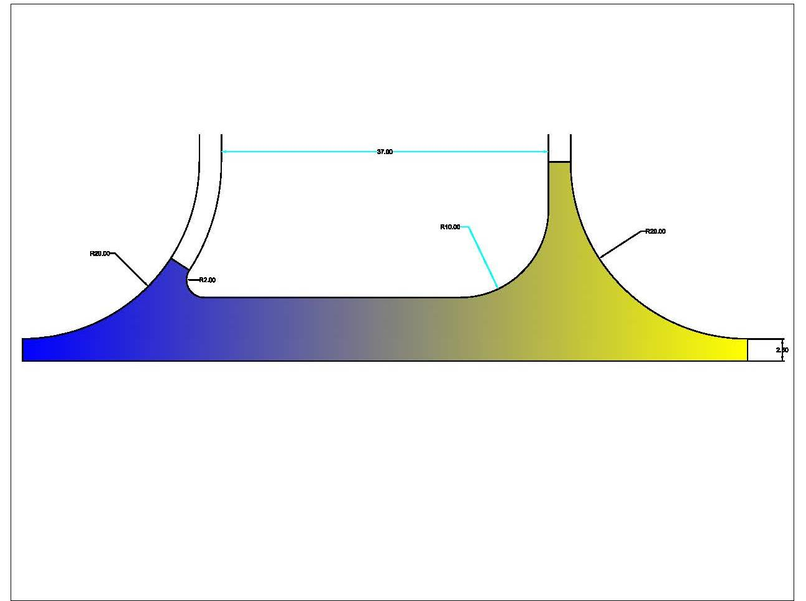

ATTACHMENT B – CTH T PLAN

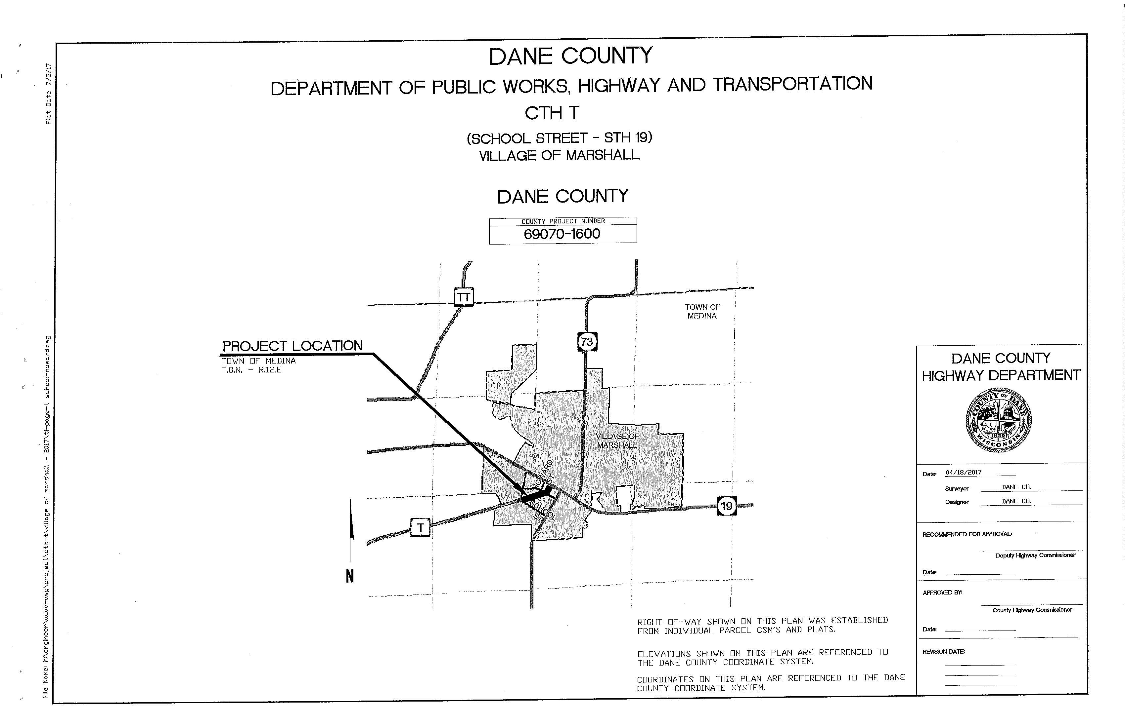
C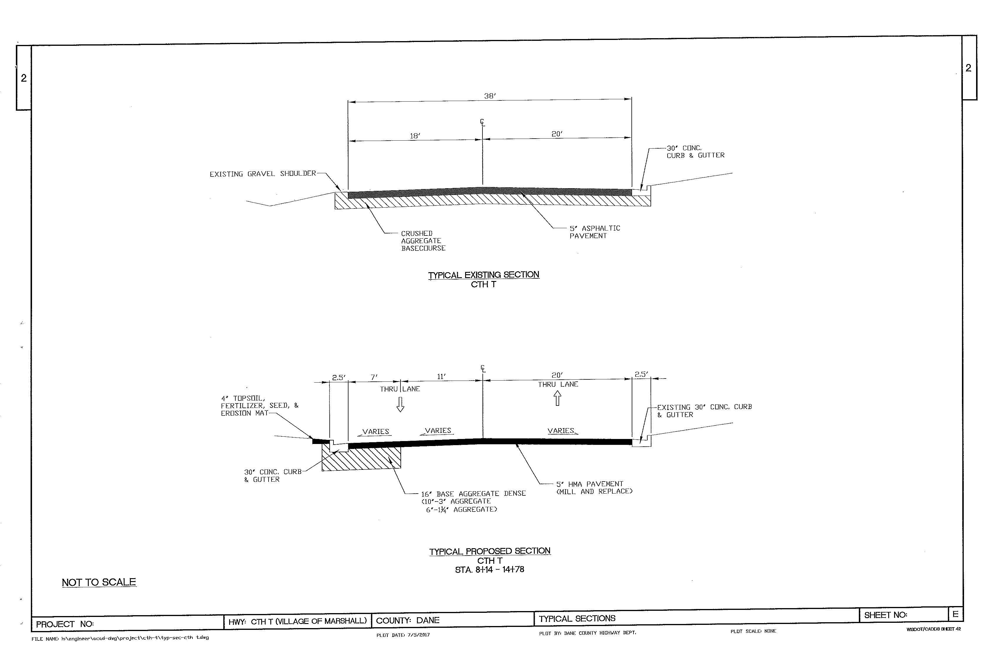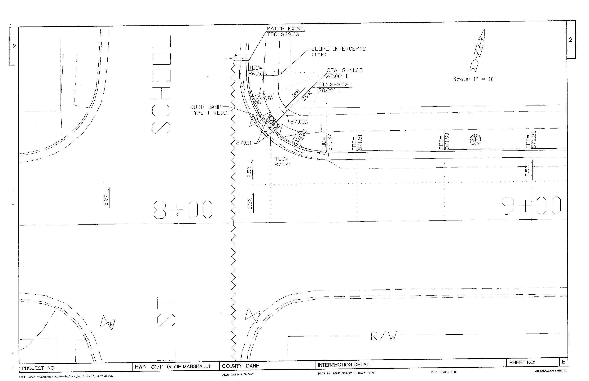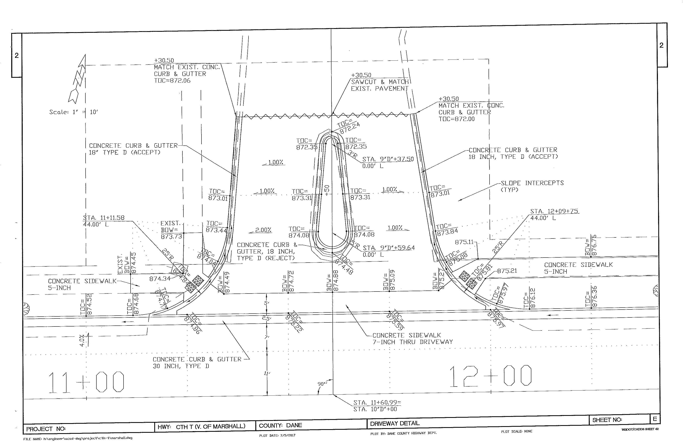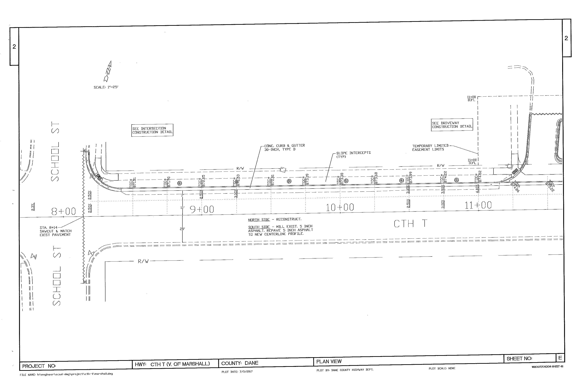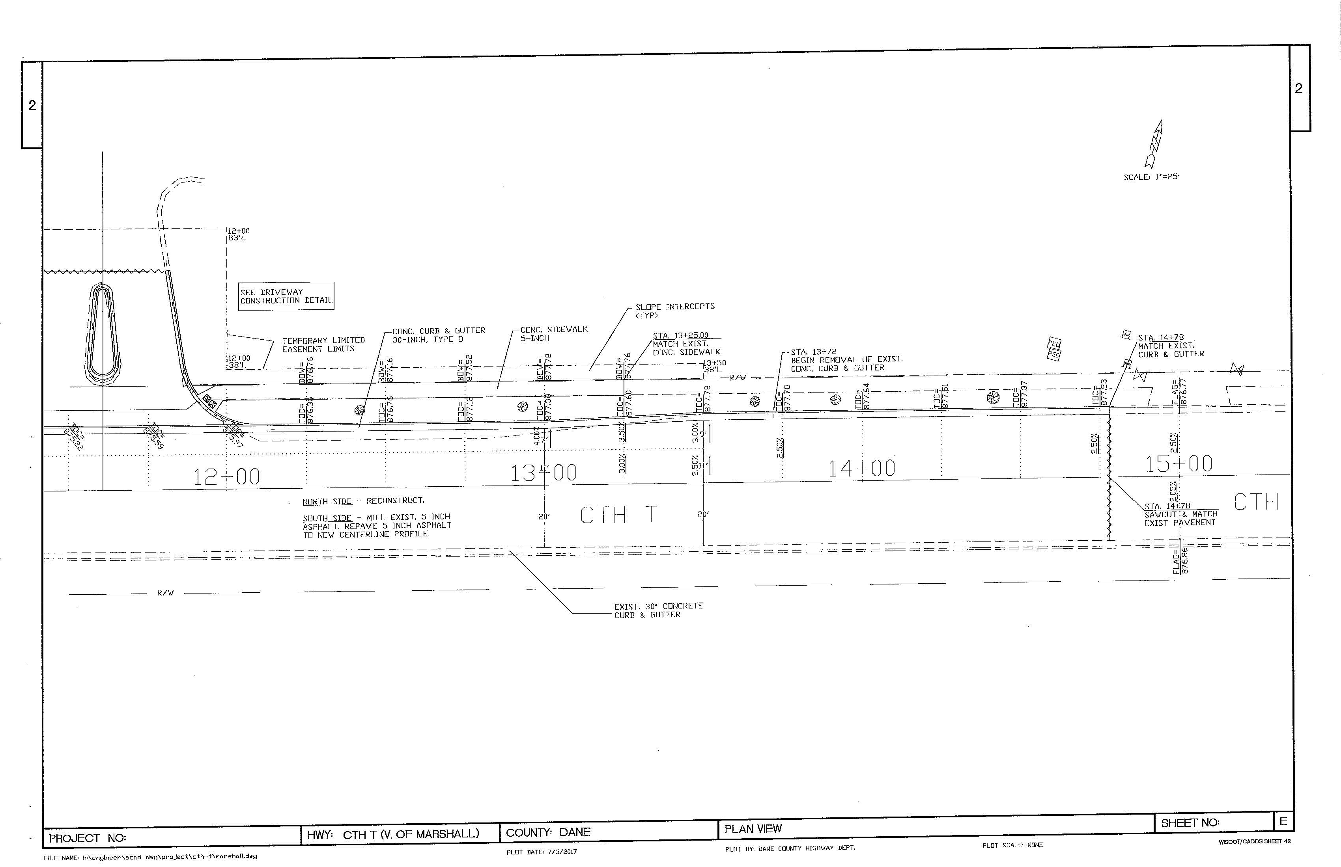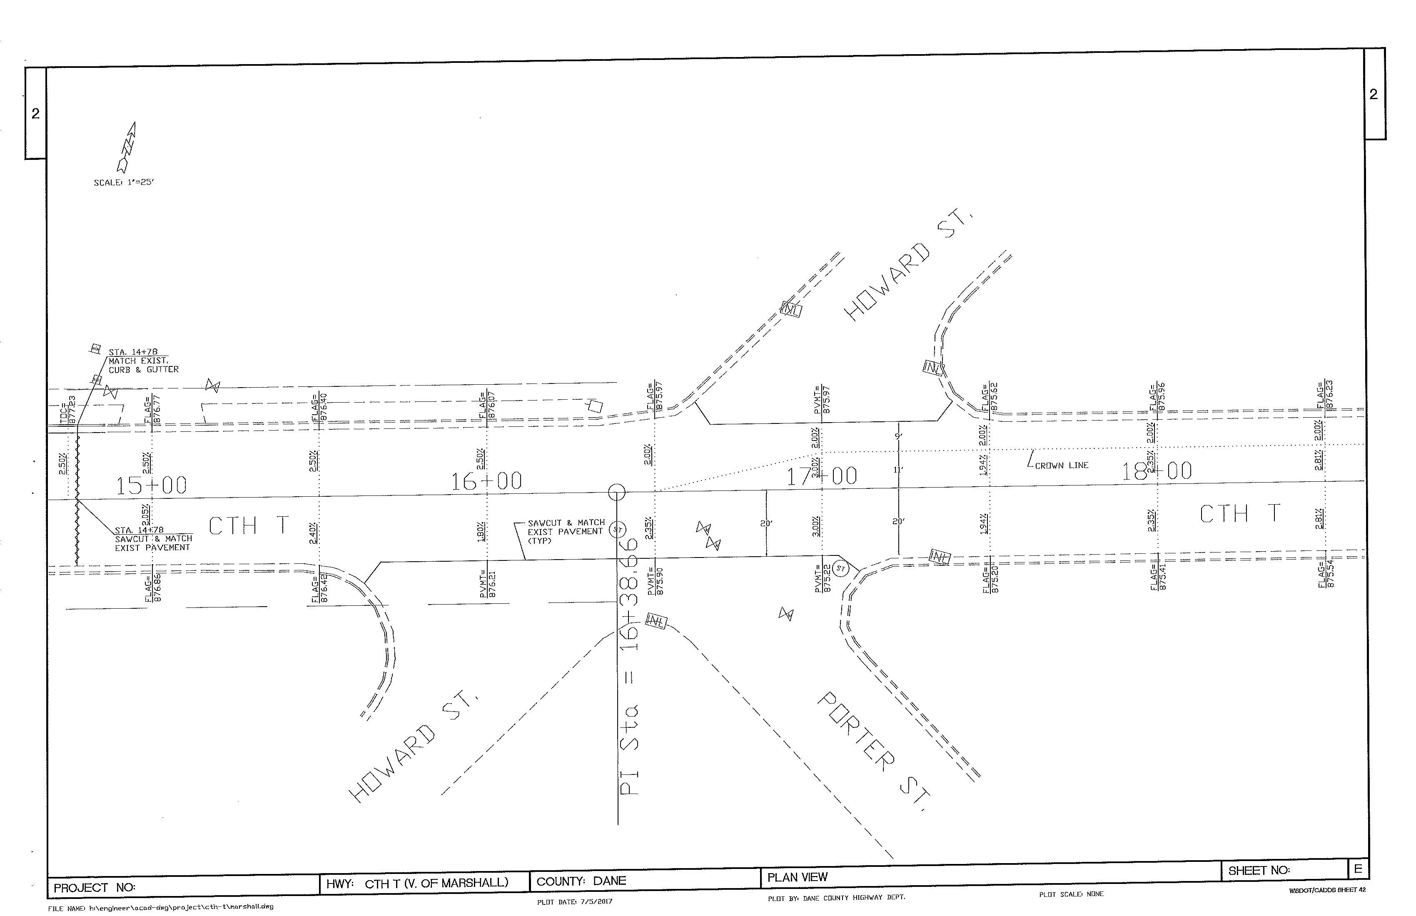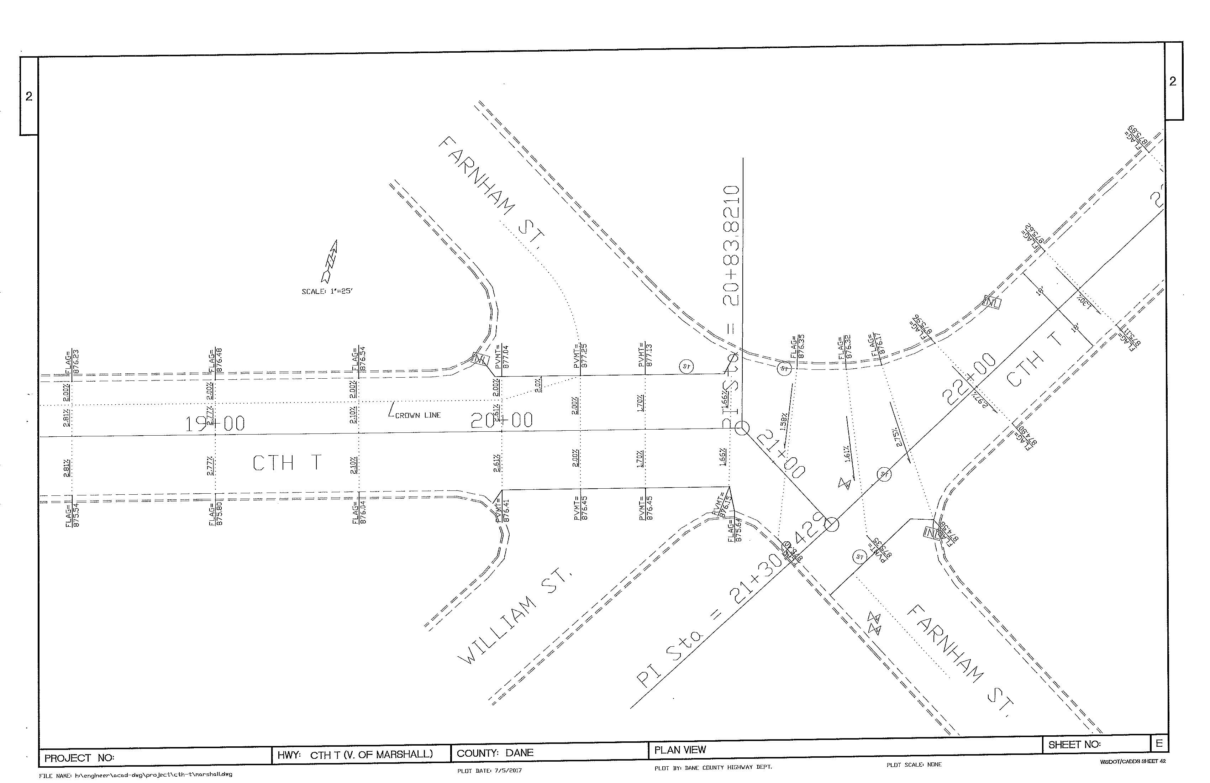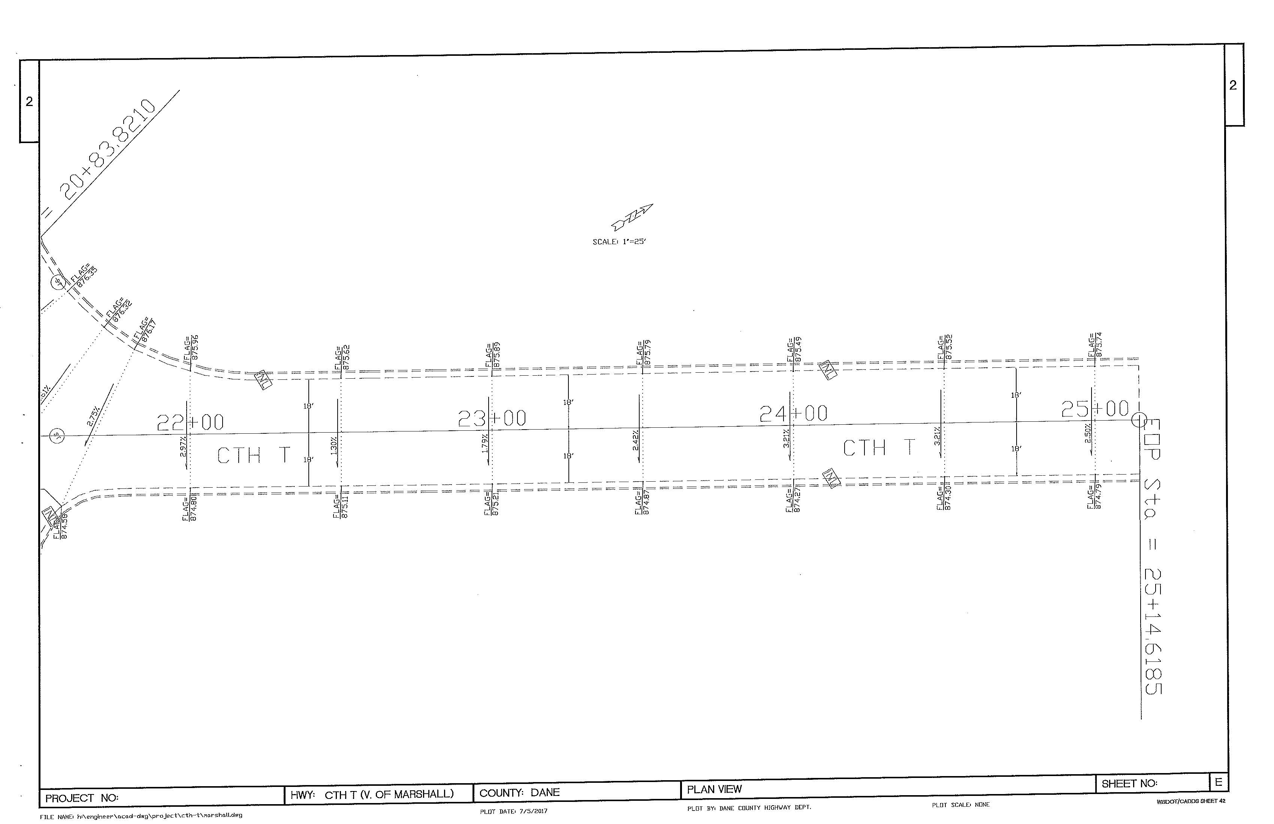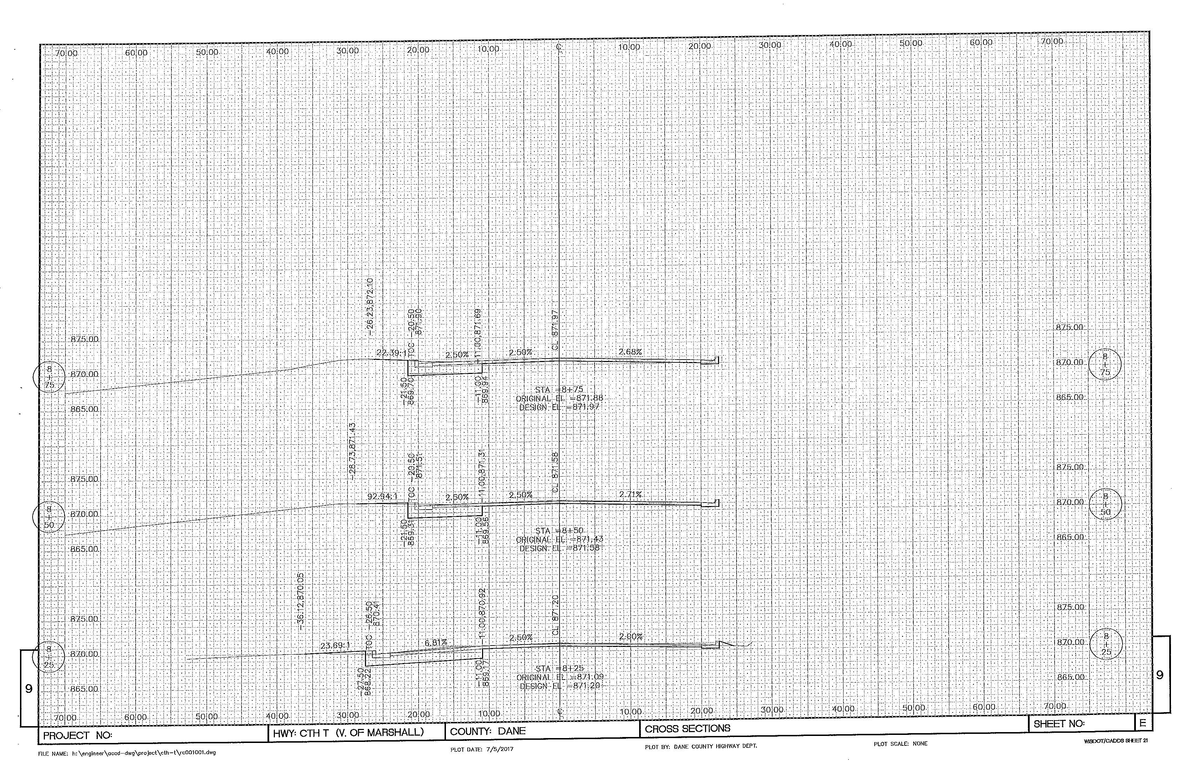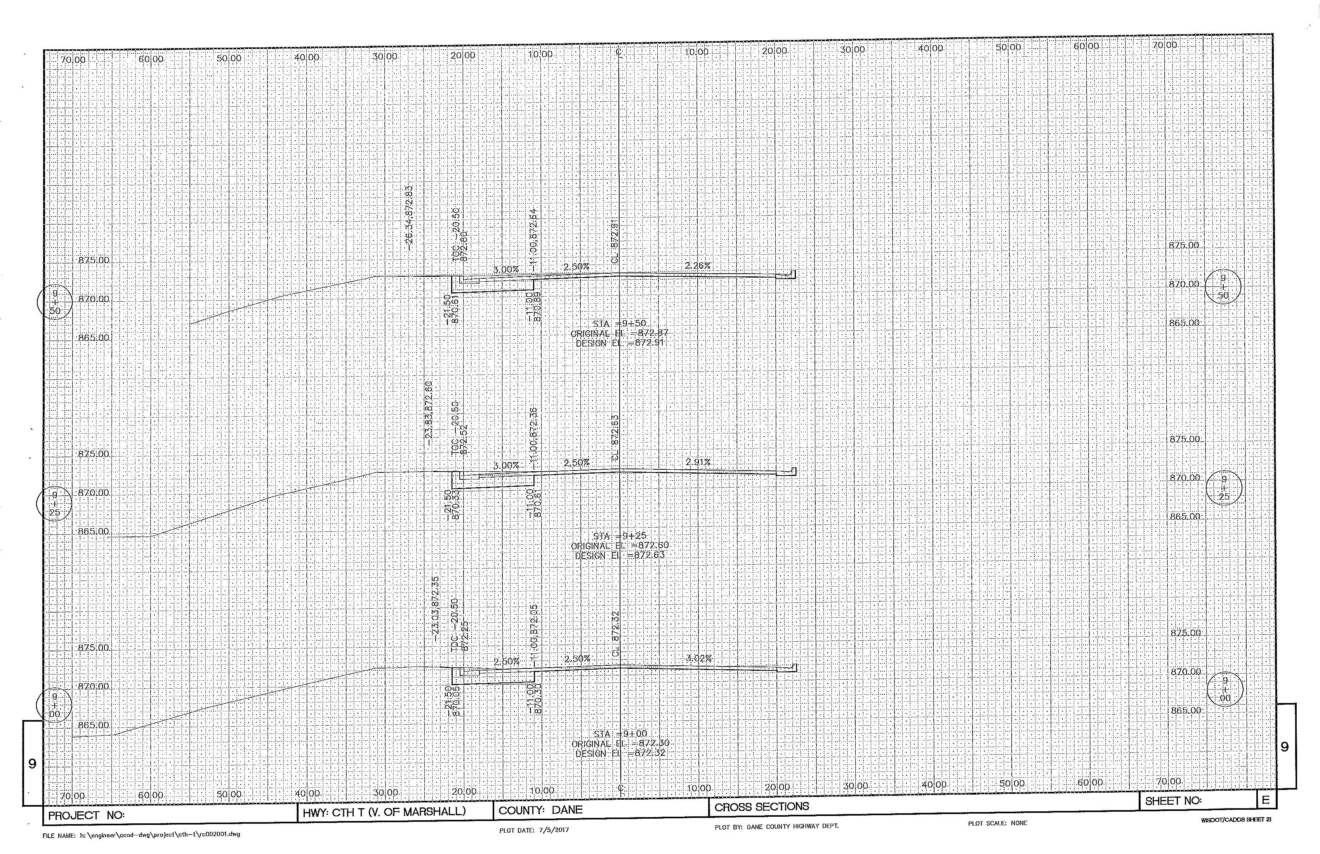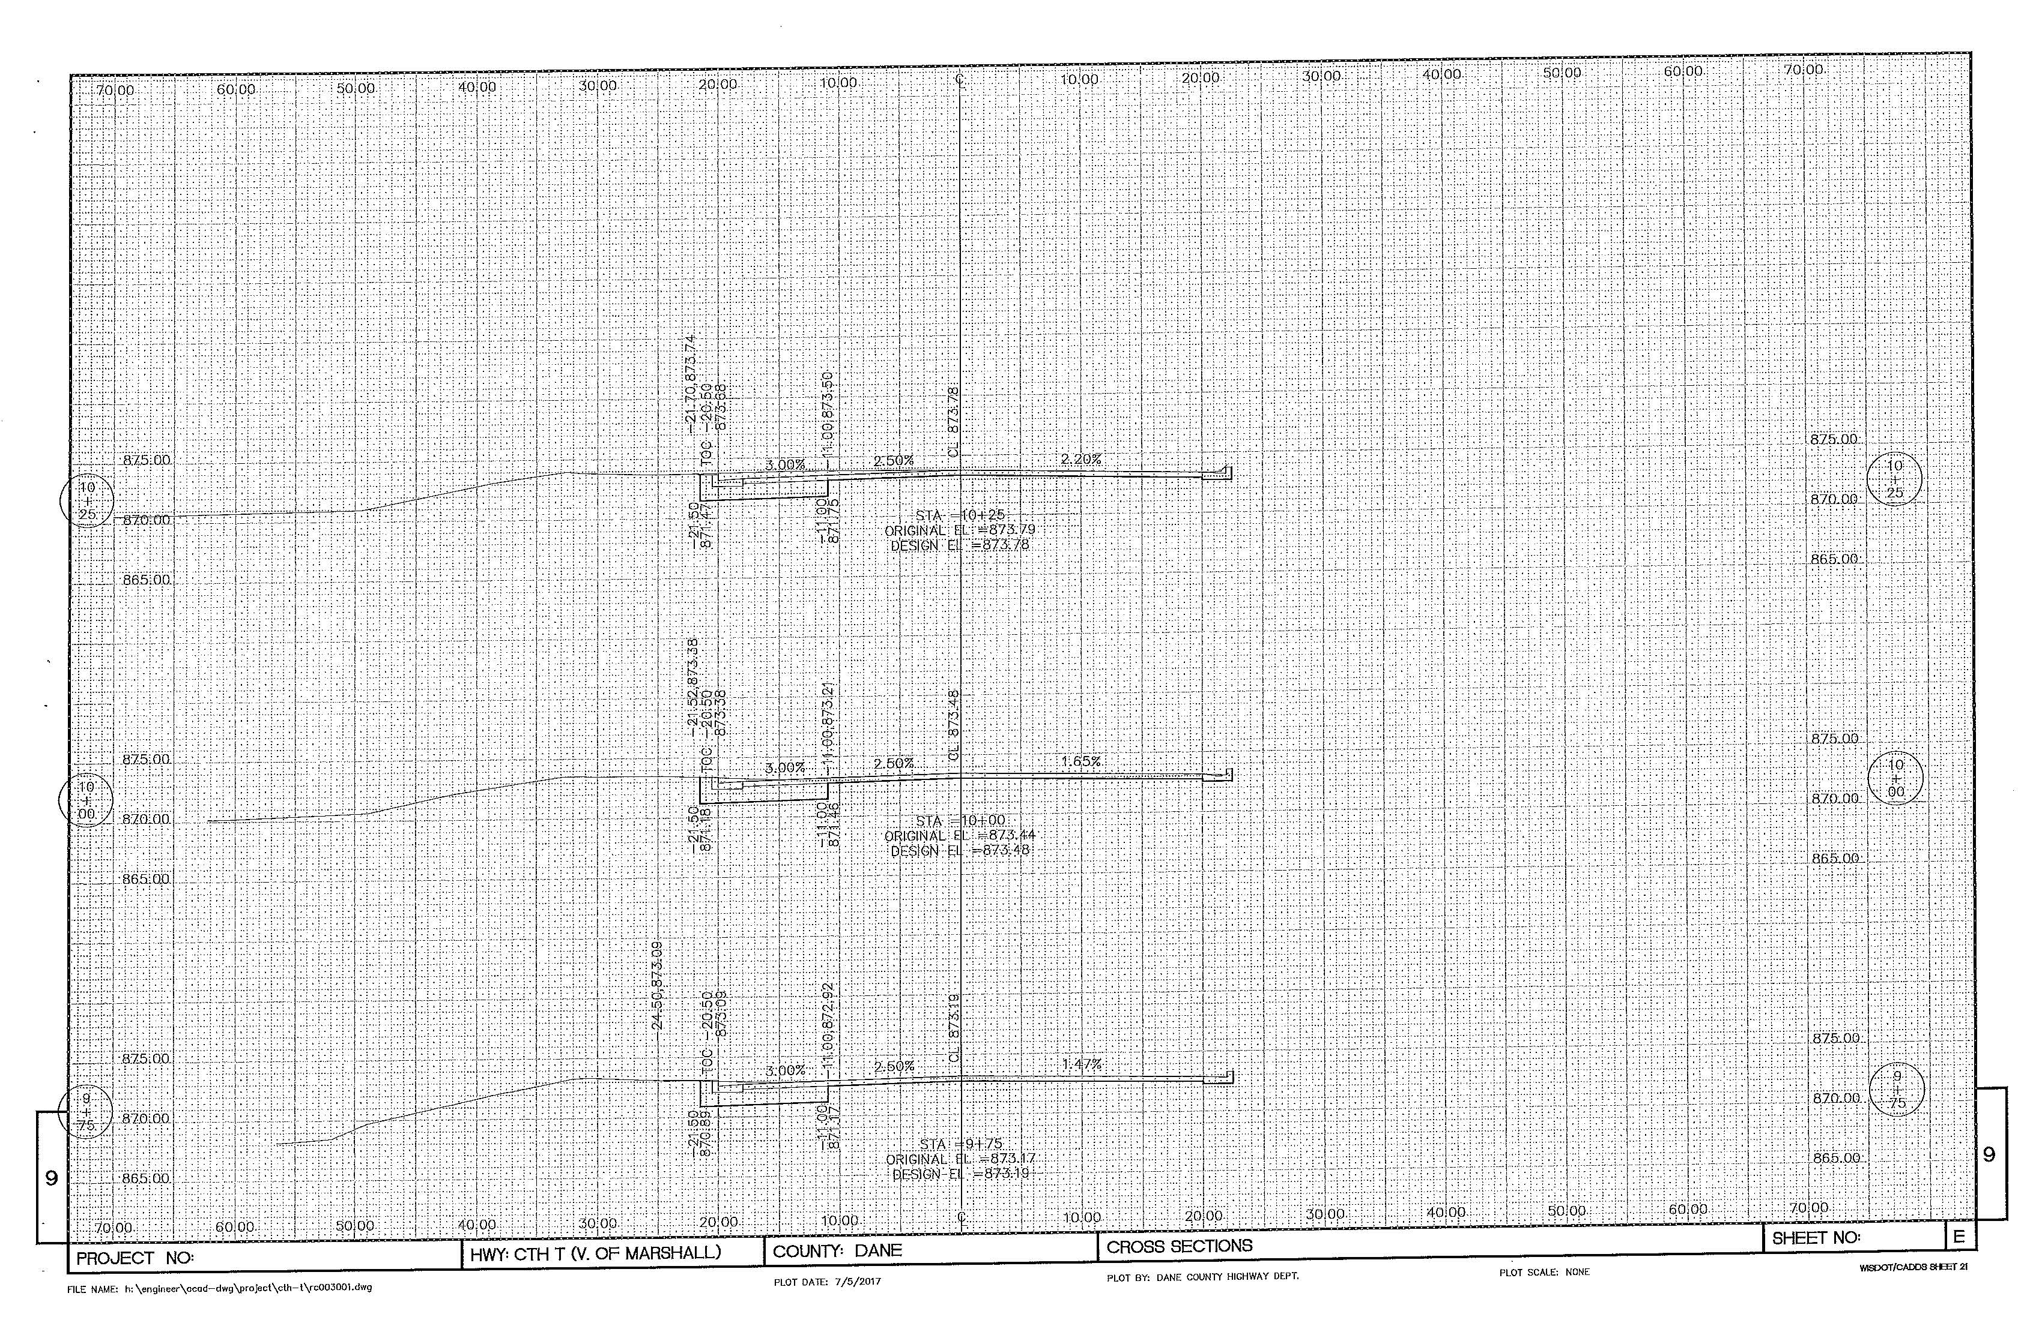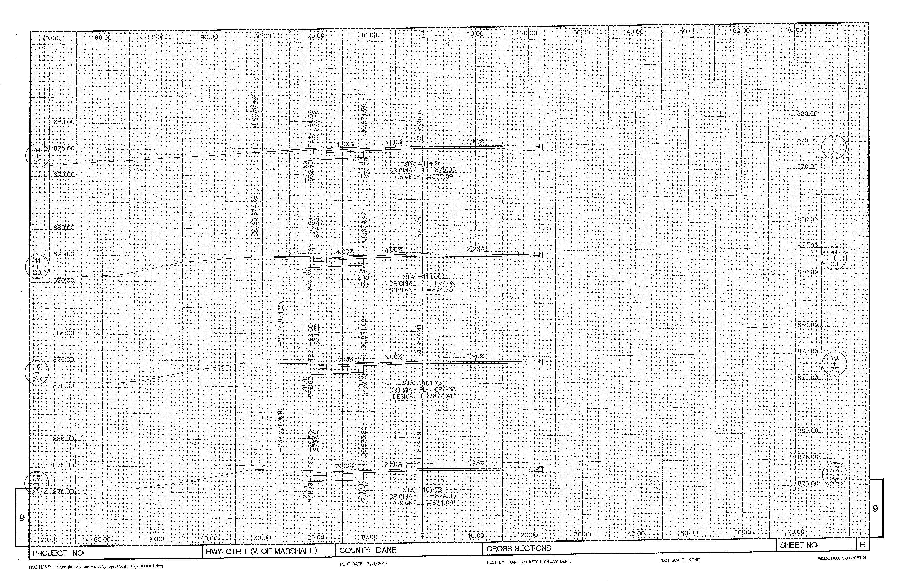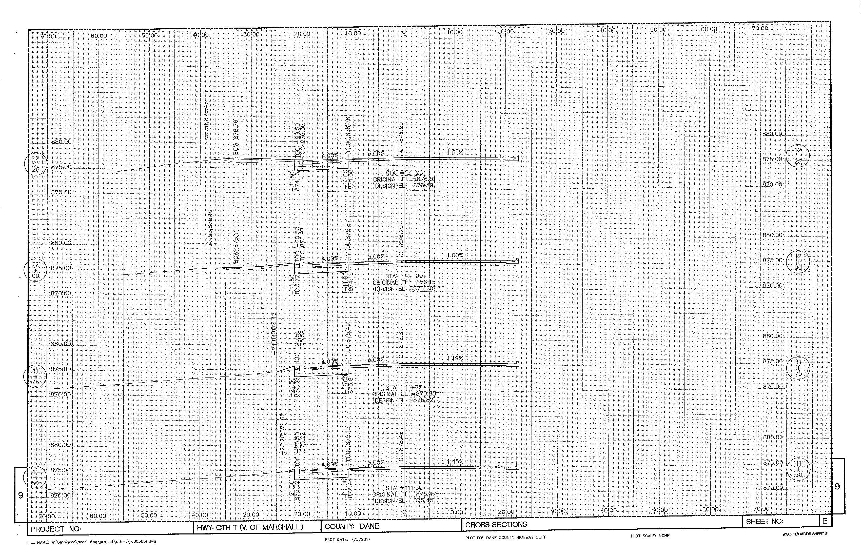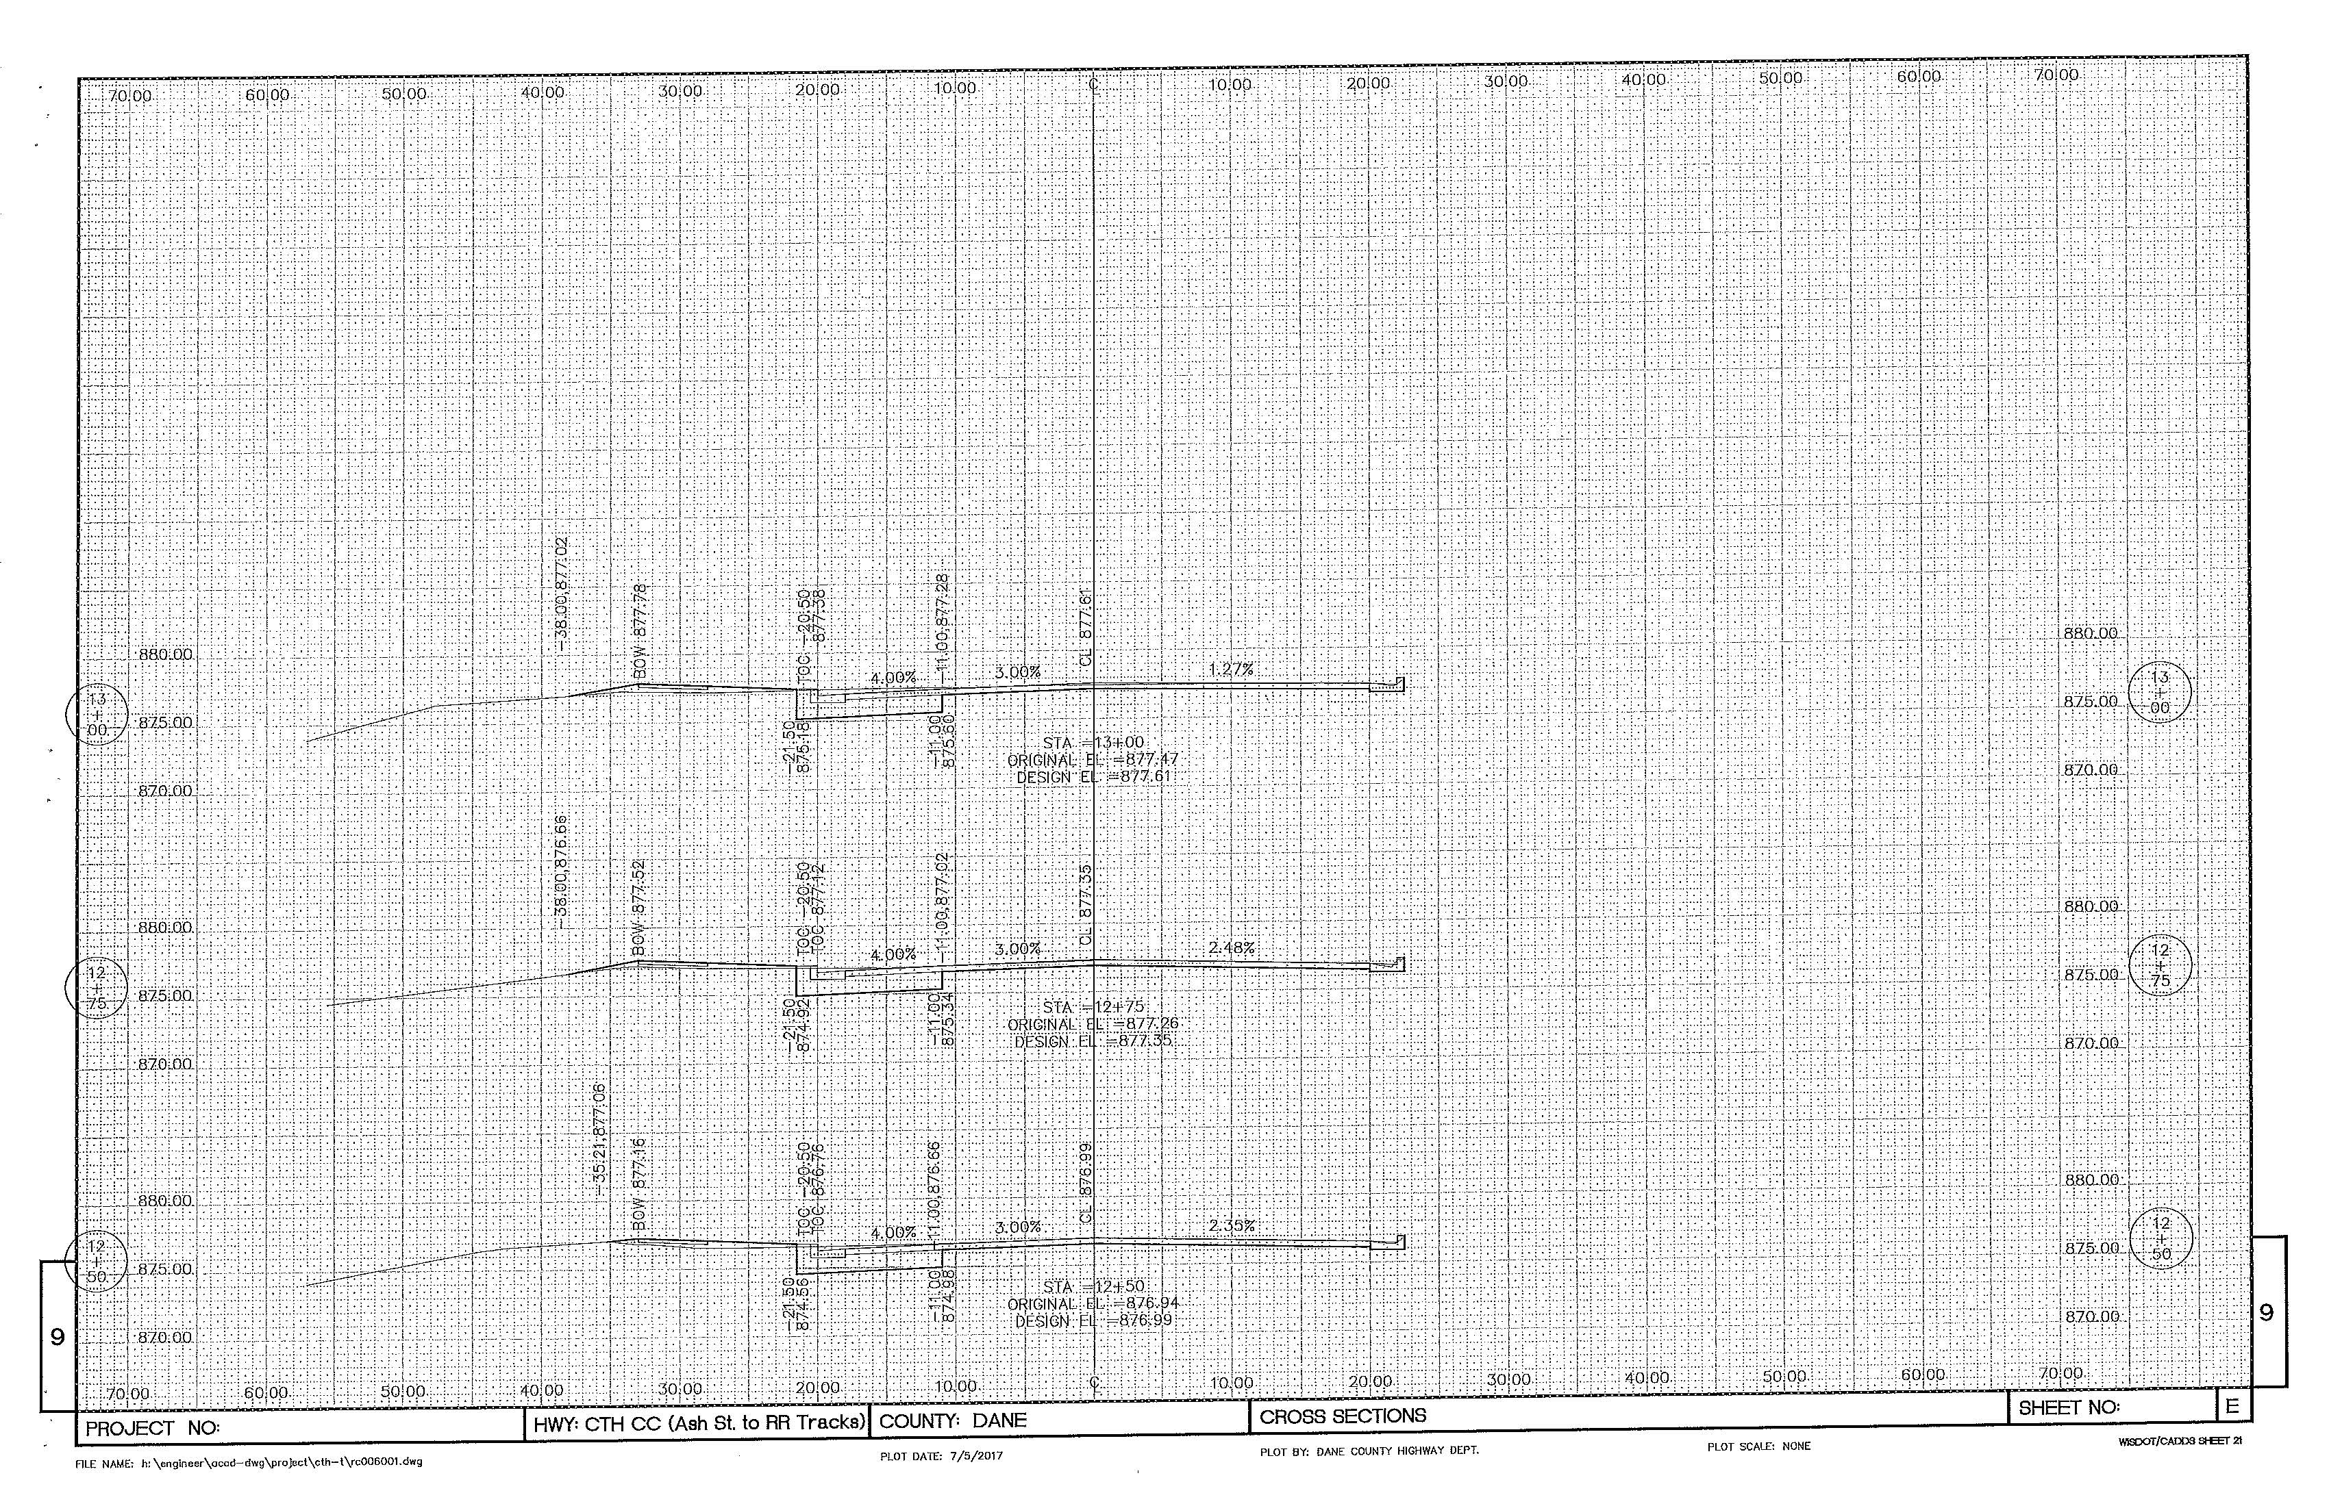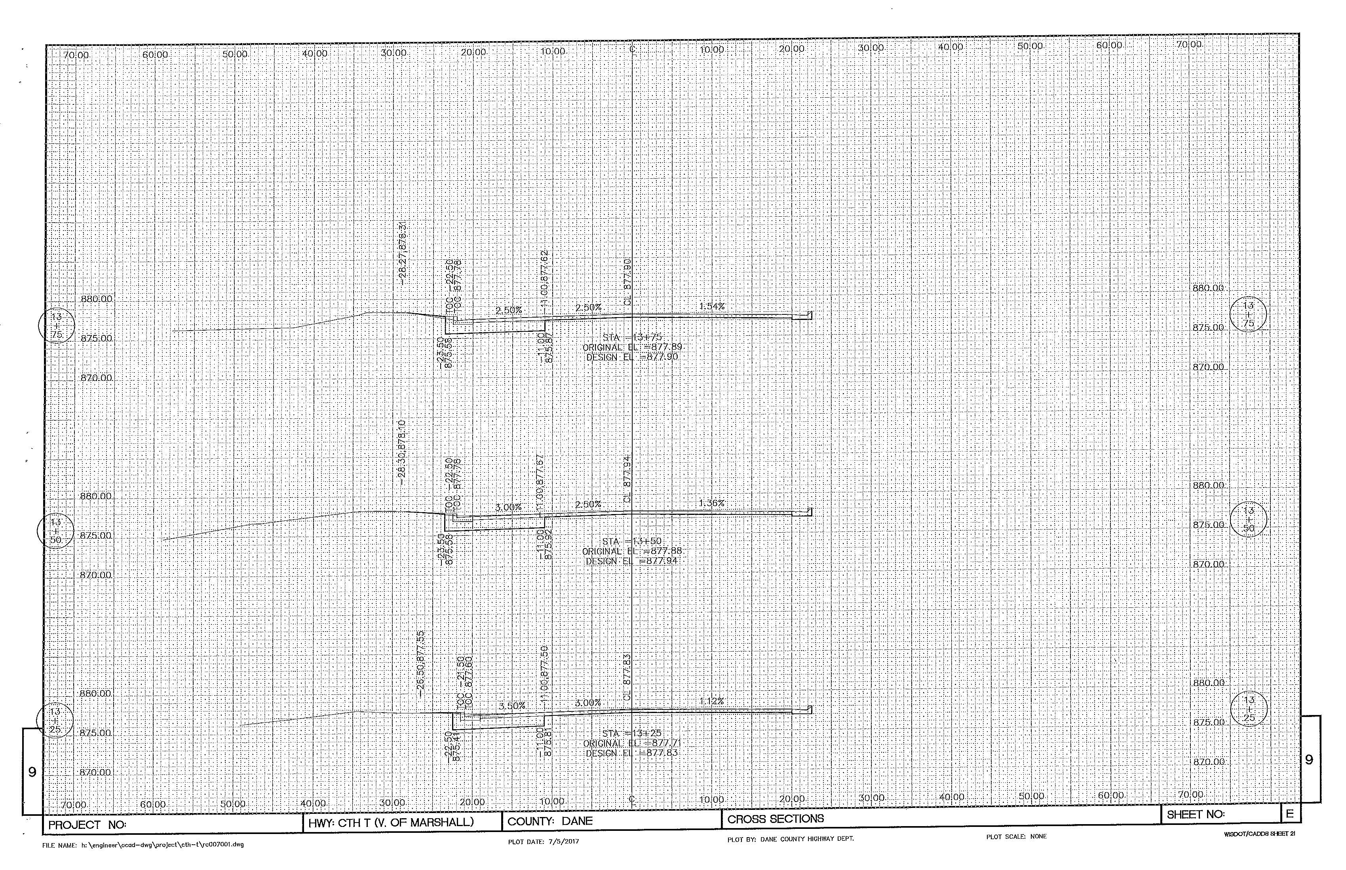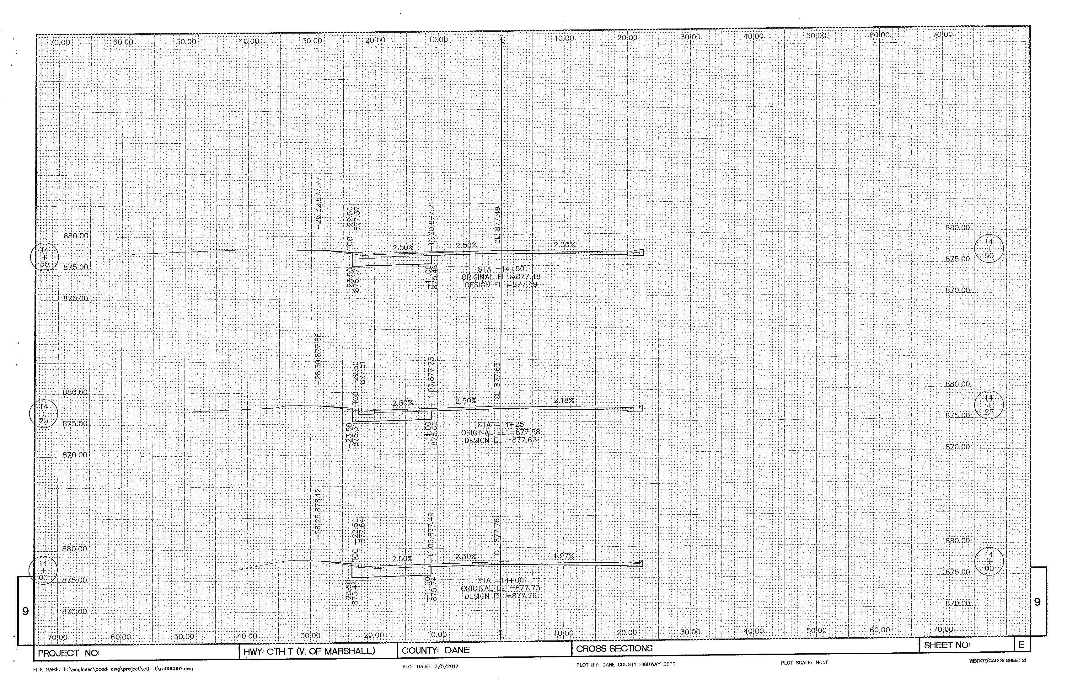

ATTACHMENT C – US 51

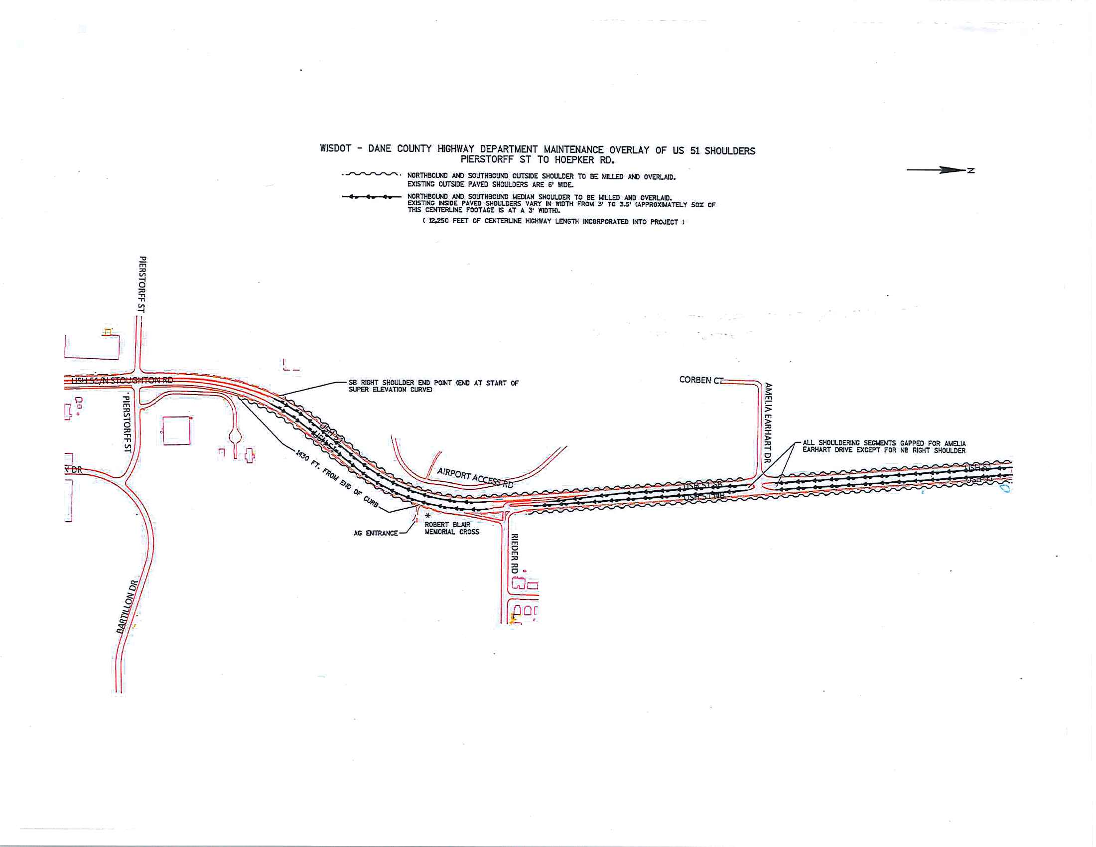
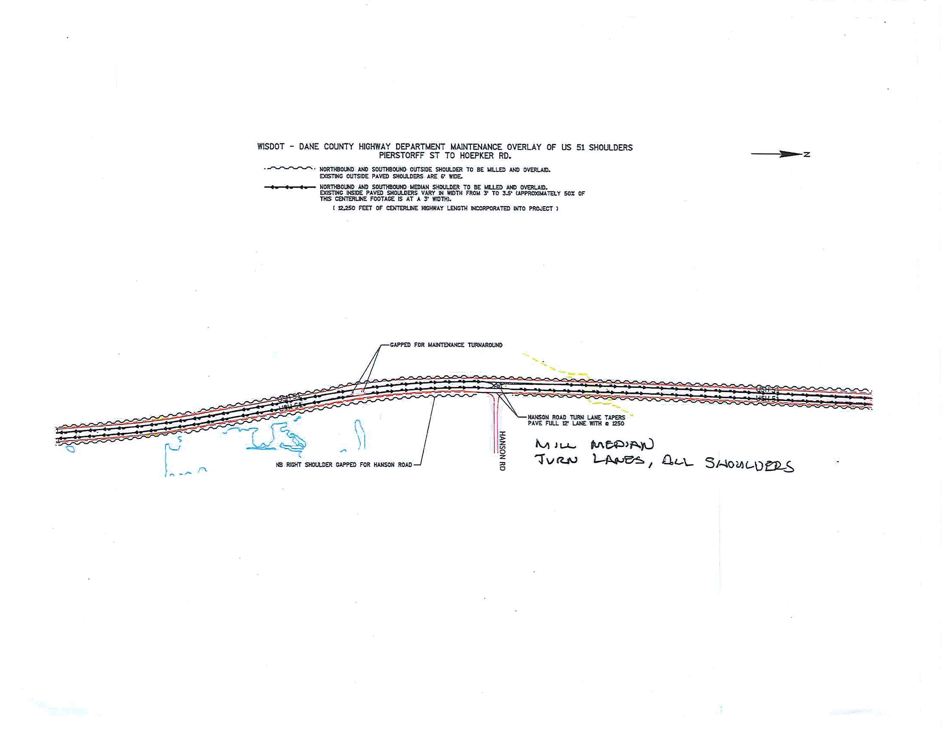
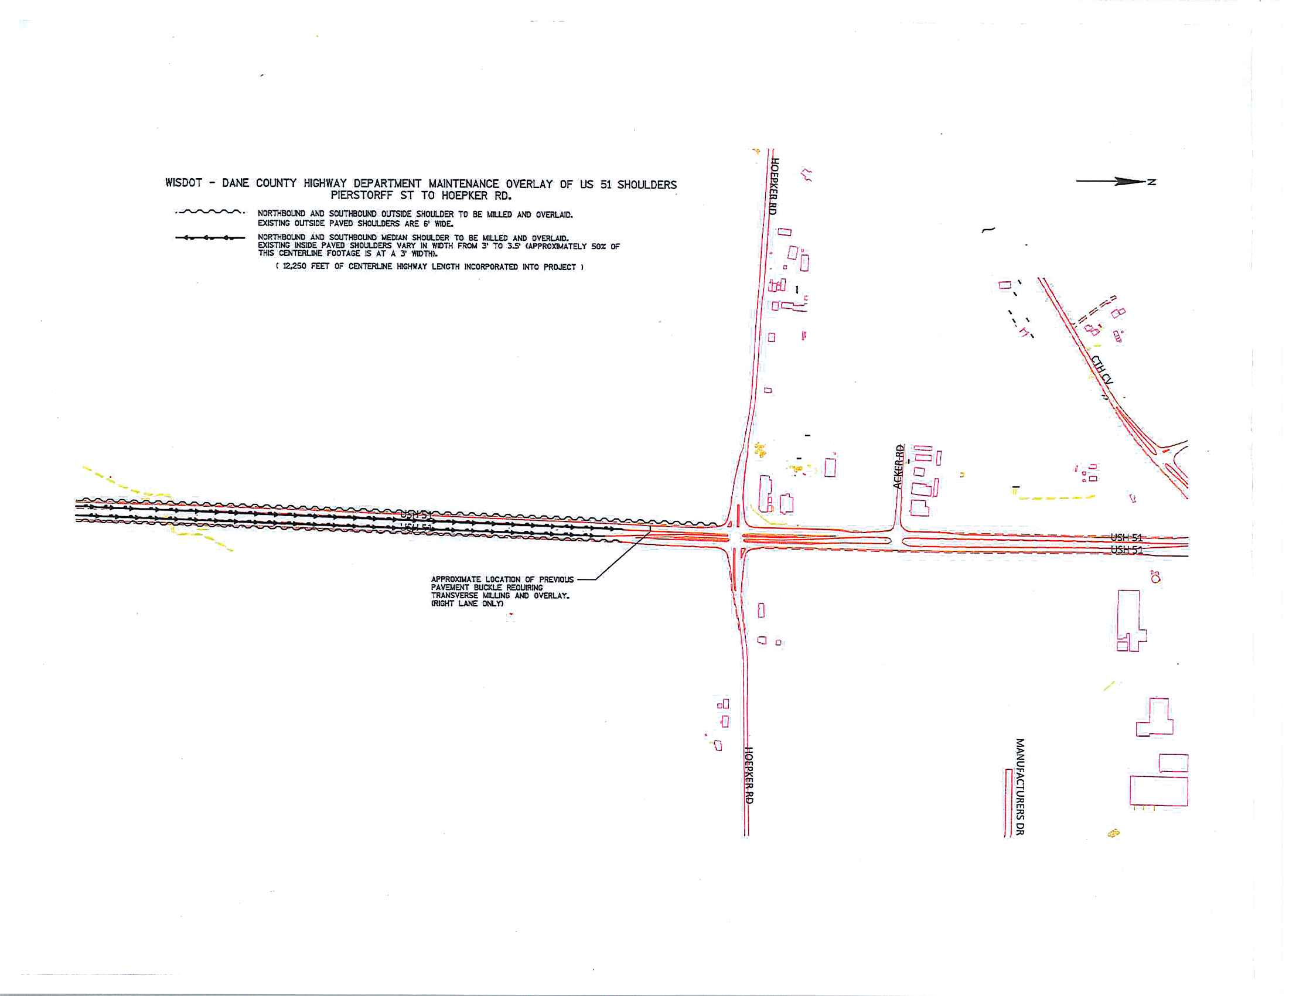
General Decision Number: WI170010 06/23/2017 WI10

Superseded General Decision Number: WI20160010

State: Wisconsin

Construction Type: Highway

Counties: Wisconsin Statewide.

HIGHWAY, AIRPORT RUNWAY & TAXIWAY CONSTRUCTION PROJECTS (does
not include bridges over navigable waters; tunnels; buildings
in highway rest areas; and railroad construction)

Note: Under Executive Order (EO) 13658, an hourly minimum wage of $10.20 for calendar year 2017 applies to all contracts subject to the Davis-Bacon Act for which the contract is awarded (and any solicitation was issued) on or after January 1, 2015. If this contract is covered by the EO, the contractor must pay all workers in any classification listed on this wage determination at least $10.20 (or the applicable wage rate listed on this wage determination, if it is higher) for all hours spent performing on the contract in calendar year 2017. The EO minimum wage rate will be adjusted annually. Additional information on contractor requirements and worker protections under the EO is available at www.dol.gov/whd/govcontracts.

Modification Number Publication Date
0 01/06/2017
1 02/03/2017
2 02/10/2017
3 02/24/2017
4 03/17/2017
5 03/31/2017
6 04/21/2017
7 04/28/2017
8 06/02/2017
9 06/23/2017

BRWI0001-002 06/01/2016

CRAWFORD, JACKSON, JUNEAU, LA CROSSE, MONROE, TREMPEALEAU, AND VERNON COUNTIES

Rates Fringes

BRICKLAYER.......................$ 31.84 20.95
----------------------------------------------------------------
BRWI0002-002 06/01/2016

ASHLAND, BAYFIELD, DOUGLAS, AND IRON COUNTIES

Rates Fringes

BRICKLAYER.......................$ 37.04 19.70
----------------------------------------------------------------
BRWI0002-005 06/01/2016

ADAMS, ASHLAND, BARRON, BROWN, BURNETT, CALUMET, CHIPPEWA,CLARK, COLUMBIA, DODGE, DOOR, DUNN, FLORENCE, FOND DU LAC, FOREST, GREEN LAKE, IRON, JEFFERSON, KEWAUNEE, LANGLADE, LINCOLN, MANITOWOC, MARATHON, MARINETTE, MARQUETTE, MENOMINEE, OCONTO, ONEIDA, OUTAGAMIE, POLK, PORTAGE, RUSK, ST CROIX, SAUK, SHAWANO, SHEBOYGAN, TAYLOR, VILAS, WALWORTH, WAUPACA, WAUSHARA, WINNEBAGO, AND WOOD COUNTIES

Rates Fringes

CEMENT MASON/CONCRETE FINISHER...$ 35.07 20.51
----------------------------------------------------------------
BRWI0003-002 06/01/2016

BROWN, DOOR, FLORENCE, KEWAUNEE, MARINETTE, AND OCONTO COUNTIES

Rates Fringes

BRICKLAYER.......................$ 32.22 20.57
----------------------------------------------------------------
BRWI0004-002 06/01/2016

KENOSHA, RACINE, AND WALWORTH COUNTIES

Rates Fringes

BRICKLAYER.......................$ 36.59 21.49
----------------------------------------------------------------
BRWI0006-002 06/01/2016

ADAMS, CLARK, FOREST, LANGLADE, LINCOLN, MARATHON, MENOMINEE, ONEIDA, PORTAGE, PRICE, TAYLOR, VILAS AND WOOD COUNTIES

Rates Fringes

BRICKLAYER.......................$ 33.04 19.75
----------------------------------------------------------------
BRWI0007-002 06/01/2016

GREEN, LAFAYETTE, AND ROCK COUNTIES

Rates Fringes

BRICKLAYER.......................$ 33.53 20.95
----------------------------------------------------------------
BRWI0008-002 06/01/2016

MILWAUKEE, OZAUKEE, WASHINGTON, AND WAUKESHA COUNTIES

Rates Fringes

BRICKLAYER.......................$ 36.98 20.62
----------------------------------------------------------------
BRWI0011-002 06/01/2016

CALUMET, FOND DU LAC, MANITOWOC, AND SHEBOYGAN COUNTIES

Rates Fringes

BRICKLAYER.......................$ 32.22 20.57
----------------------------------------------------------------
BRWI0019-002 06/01/2016

BARRON, BUFFALO, BURNETT, CHIPPEWA, DUNN, EAU CLAIRE, PEPIN, PIERCE, POLK, RUSK, ST. CROIX, SAWYER AND WASHBURN COUNTIES

Rates Fringes

BRICKLAYER.......................$ 31.98 20.81
----------------------------------------------------------------
BRWI0034-002 06/01/2015

COLUMBIA AND SAUK COUNTIES

Rates Fringes

BRICKLAYER.......................$ 32.86 17.22
----------------------------------------------------------------
CARP0087-001 05/01/2016

BURNETT (W. of Hwy 48), PIERCE (W. of Hwy 29), POLK (W. of Hwys 35, 48 & 65), AND ST. CROIX (W. of Hwy 65) COUNTIES

Rates Fringes

Carpenter & Piledrivermen........$ 36.85 18.39
----------------------------------------------------------------
CARP0252-002 06/01/2016

ADAMS, BARRON, BAYFIELD (Eastern 2/3), BROWN, BUFFALO, BURNETT (E. of Hwy 48), CALUMET, CHIPPEWA, CLARK, COLUMBIA, CRAWFORD, DANE, DODGE, DOOR, DUNN, EAU CLAIRE, FLORENCE (except
area bordering Michigan State Line), FOND DU LAC, FOREST, GRANT, GREEN, GREEN LAKE, IOWA, IRON, JACKSON, JEFFERSON, JUNEAU, KEWAUNEE, LA CROSSE, LAFAYETTE, LANGLADE, LINCOLN, MANITOWOC, MARATHON, MARINETTE (except N.E. corner), MARQUETTE, MENOMINEE, MONROE, OCONTO, ONEIDA, OUTAGAMIE, PEPIN, PIERCE (E. of Hwys 29 & 65), POLK (E. of Hwys 35, 48 & 65), PORTAGE, PRICE, RICHLAND, ROCK, RUSK, SAUK, SAWYER, SHAWANO, SHEBOYGAN, ST CROIX (E. of Hwy 65), TAYLOR, TREMPEALEAU, VERNON, VILAS, WALWORTH, WASHBURN, WAUPACA, WAUSHARA, WINNEBAGO, AND WOOD COUNTIES

Rates Fringes

CARPENTER
CARPENTER.................$ 33.56 18.00
MILLWRIGHT.................$ 35.08 18.35
PILEDRIVER..................$ 34.12 18.00
----------------------------------------------------------------
CARP0252-010 06/01/2016

ASHLAND COUNTY

Rates Fringes

Carpenters
Carpenter..................$ 33.56 18.00
Millwright..... .............$ 35.08 18.35
Pile Driver... .............$ 34.12 18.00
----------------------------------------------------------------
CARP0264-003 06/01/2016

KENOSHA, MILWAUKEE, OZAUKEE, RACINE, WAUKESHA, AND WASHINGTON COUNTIES

Rates Fringes

CARPENTER........................$ 35.78 22.11
----------------------------------------------------------------
CARP0361-004 05/01/2016

BAYFIELD (West of Hwy 63) AND DOUGLAS COUNTIES

Rates Fringes

CARPENTER........................$ 34.57 18.16
----------------------------------------------------------------
CARP2337-001 06/01/2016

ZONE A: MILWAUKEE, OZAUKEE, WAUKESHA AND WASHINGTON

ZONE B: KENOSHA & RACINE

Rates Fringes

PILEDRIVERMAN
Zone A......................$ 31.03 22.69
Zone B......................$ 31.03 22.69
----------------------------------------------------------------
ELEC0014-002 05/30/2016

ASHLAND, BARRON, BAYFIELD, BUFFALO, BURNETT, CHIPPEWA, CLARK (except Maryville, Colby, Unity, Sherman, Fremont, Lynn & Sherwood), CRAWFORD, DUNN, EAU CLAIRE, GRANT, IRON, JACKSON, LA CROSSE, MONROE, PEPIN, PIERCE, POLK, PRICE, RICHLAND, RUSK, ST CROIX, SAWYER, TAYLOR, TREMPEALEAU, VERNON, AND WASHBURN COUNTIES

Rates Fringes

Electricians:....................$ 32.00 19.28
----------------------------------------------------------------
ELEC0014-007 05/30/2016

REMAINING COUNTIES

Rates Fringes

Teledata System Installer
Installer/Technician........$ 24.35 13.15

Low voltage construction, installation, maintenance and removal of teledata facilities (voice, data, and video) including outside plant, telephone and data inside wire, interconnect, terminal equipment, central offices, PABX, fiber optic cable and equipment, micro waves, V-SAT, bypass, CATV, WAN (wide area networks), LAN (local area networks), and ISDN (integrated systems digital network).

----------------------------------------------------------------
ELEC0127-002 06/01/2016

KENOSHA COUNTY

Rates Fringes

Electricians:....................$ 37.71 30%+10.02
----------------------------------------------------------------
ELEC0158-002 05/30/2016

BROWN, DOOR, KEWAUNEE, MANITOWOC (except Schleswig), MARINETTE(Wausuakee and area South thereof), OCONTO, MENOMINEE (East of a ine 6 miles West of the West boundary of Oconto County), SHAWANO (Except Area North of Townships of Aniwa and Hutchins) COUNTIES

Rates Fringes

Electricians:....................$ 30.50 29.50% + 9.57
----------------------------------------------------------------
ELEC0159-003 05/30/2016

COLUMBIA, DANE, DODGE (Area West of Hwy 26, except Chester and Emmet Townships), GREEN, LAKE (except Townships of Berlin, Seneca, and St. Marie), IOWA, MARQUETTE (except Townships of Neshkoka, Crystal Lake, Newton, and Springfield), and SAUK COUNTIES

Rates Fringes

Electricians:....................$ 36.50 20.39
----------------------------------------------------------------
ELEC0219-004 06/01/2016

FLORENCE COUNTY (Townships of Aurora, Commonwealth, Fern, Florence and Homestead) AND MARINETTE COUNTY (Township of Niagara)

Rates Fringes

Electricians:
Electrical contracts over
$180,000....................$ 32.38 18.63
Electrical contracts under
$180,000....................$ 30.18 18.42
----------------------------------------------------------------
* ELEC0242-005 06/04/2017

DOUGLAS COUNTY

Rates Fringes

Electricians:....................$ 35.90 25.64
----------------------------------------------------------------
ELEC0388-002 05/30/2016

ADAMS, CLARK (Colby, Freemont, Lynn, Mayville, Sherman, Sherwood, Unity), FOREST, JUNEAU, LANGLADE, LINCOLN, MARATHON, MARINETTE (Beecher, Dunbar, Goodman & Pembine), MENOMINEE (Area West of a line 6 miles West of the West boundary of Oconto County), ONEIDA, PORTAGE, SHAWANO (Aniwa and Hutchins), VILAS AND WOOD COUNTIES

Rates Fringes

Electricians:....................$ 30.69 26.00% +10.05
----------------------------------------------------------------
ELEC0430-002 06/01/2016

RACINE COUNTY (Except Burlington Township)

Rates Fringes

Electricians:....................$ 36.07 21.84
----------------------------------------------------------------
ELEC0494-005 06/01/2016

MILWAUKEE, OZAUKEE, WASHINGTON, AND WAUKESHA COUNTIES

Rates Fringes

Electricians:....................$ 36.01 24.00
----------------------------------------------------------------
ELEC0494-006 06/01/2017

CALUMET (Township of New Holstein), DODGE (East of Hwy 26 including Chester Township), FOND DU LAC, MANITOWOC (Schleswig), and SHEBOYGAN COUNTIES

Rates Fringes

Electricians:....................$ 32.06 21.88
----------------------------------------------------------------
ELEC0494-013 06/01/2015

DODGE (East of Hwy 26 including Chester Twp, excluding Emmet Twp), FOND DU LAC (Except Waupuin), MILWAUKEE, OZAUKEE, MANITOWOC (Schleswig), WASHINGTON, AND WAUKESHA COUNTIES

Rates Fringes

Sound & Communications
Installer...................$ 16.47 14.84
Technician...............$ 26.00 17.70

Installation, testing, maintenance, operation and servicing of all sound, intercom, telephone interconnect, closed circuit TV systems, radio systems, background music systems, language laboratories, electronic carillion, antenna distribution systems, clock and program systems and low-voltage systems such as visual nurse call, audio/visual nurse call systems, doctors entrance register systems. Includes all wire and cable carrying audio, visual, data, light and radio frequency signals. Includes the installation of conduit, wiremold, or raceways in existing structures that have been occupied for six months or more where required for the protection of the wire or cable, but does not mean a complete conduit or raceway system. work covered does not include the installation of conduit, wiremold or any raceways in any new construction, or the installation of power supply outlets by means of which external electric power is supplied to any of the foregoing equipment or products

----------------------------------------------------------------
ELEC0577-003 05/30/2016

CALUMET (except Township of New Holstein), GREEN LAKE (N. partincluding Townships of Berlin, St Marie, and Seneca), MARQUETTE (N. part including Townships of Crystal Lake, Neshkoro, Newton, and Springfield), OUTAGAMIE, WAUPACA, WAUSHARA, AND WINNEBAGO COUNTIES

Rates Fringes

Electricians:....................$ 30.68 17.28
----------------------------------------------------------------
ELEC0890-003 06/01/2016

DODGE (Emmet Township only), GREEN, JEFFERSON, LAFAYETTE, RACINE (Burlington Township), ROCK AND WALWORTH COUNTIES

Rates Fringes

Electricians:....................$ 32.45 26.10% + $10.56
----------------------------------------------------------------
ELEC0953-001 07/01/2015

Rates Fringes

Line Construction:
(1) Lineman.................$ 42.14 32% + 5.00
(2) Heavy Equipment
Operator....................$ 40.03 32% + 5.00
(3) Equipment Operator......$ 33.71 32% + 5.00
(4) Heavy Groundman Driver..$ 26.78 14.11
(5) Light Groundman Driver..$ 24.86 13.45
(6) Groundsman..............$ 23.18 32% + 5.00
----------------------------------------------------------------
ENGI0139-005 06/01/2016

Rates Fringes

Power Equipment Operator
Group 1.....................$ 39.27 21.80
Group 2.....................$ 38.77 21.80
Group 3.....................$ 38.27 21.80
Group 4.....................$ 38.01 21.80
Group 5.....................$ 37.72 21.80
Group 6.....................$ 31.82 21.80

HAZARDOUS WASTE PREMIUMS:
EPA Level "A" protection - $3.00 per hour
EPA Level "B" protection - $2.00 per hour
EPA Level "C" protection - $1.00 per hour

POWER EQUIPMENT OPERATORS CLASSIFICATIONS

GROUP 1: Cranes, tower cranes, and derricks with or without attachments with a lifting capacity of over 100 tons; or cranes, tower cranes, and derricks with boom, leads and/or jib lengths measuring 176 feet or longer.

GROUP 2: Cranes, tower cranes and derricks with or without attachments with a lifting capacity of 100 tons or less; or cranes, tower cranes, and derricks with boom, leads, and/or jibs lengths measuring 175 feet or under and Backhoes (excavators) weighing 130,000 lbs and over; caisson rigs; pile driver; dredge operator; dredge engineer; Boat Pilot.

GROUP 3: Mechanic or welder - Heavy duty equipment; cranes with a lifting capacity of 25 tons or under; concrete breaker (manual or remote); vibratory/sonic concrete breaker; concrete laser screed; concrete slipform paver; concrete batch plant operator; concrete pvt. spreader - heavy duty (rubber tired); concrete spreader & distributor; automatic subgrader (concrete); concrete grinder & planing machine; concrete slipform curb & gutter machine; slipform concrete placer; tube finisher; hydro blaster (10,000 psi & over); bridge paver; concrete conveyor system; concrete pump; Rotec type Conveyor; stabilizing mixer (self-propelled); shoulder widener; asphalt plant engineer;
bituminious paver; bump cutter & grooving machine; milling machine; screed (bituminous paver); asphalt heater, planer & scarifier; Backhoes (excavators) weighing under 130,000 lbs; grader or motor patrol; tractor (scraper, dozer,
pusher, loader); scraper - rubber tired (single or twin engine); endloader; hydraulic backhoe (tractor type); trenching machine; skid rigs; tractor, side boom (heavy); drilling or boring machine (mechanical heavy); roller over
5 tons; percussion or rotary drilling machine; air track; blaster; loading machine (conveyor); tugger; boatmen; winches & A-frames; post driver; material hoist.

GROUP 4: Greaser, roller steel (5 tons or less); roller (pneumatic tired) - self propelled; tractor (mounted or towed compactors & light equipment); shouldering machine; self- propelled chip spreader; concrete spreader; finishing machine; mechanical float; curing machine; power subgrader; joint sawer (multiple blade) belting machine; burlap machine; texturing machine; tractor endloader (rubber tired) - light; jeep digger; forklift; mulcher; launch operator; fireman, environmental burner

GROUP 5: Air compressor; power pack; vibrator hammer and extractor; heavy equipment, leadman; tank car heaters; stump chipper; curb machine operator; Concrete proportioning plants; generators; mudjack operator; rock breaker; crusher or screening plant; screed (milling machine); automatic belt conveyor and surge bin; pug mill operator; Oiler, pump (over 3 inches); Drilling Machine Tender.

GROUP 6: Off-road material hauler with or without ejector.

----------------------------------------------------------------
IRON0008-002 06/01/2016

BROWN, CALUMET, DOOR, FOND DU LAC, KEWAUNEE, MANITOWOC, MARINETTE, OCONTO, OUTAGAMI, SHAWANO, SHEBOYGAN, AND WINNEBAGO COUNTIES:

Rates Fringes

IRONWORKER.......................$ 30.86 25.42

Paid Holidays: New Year's Day, Memorial Day, July 4th, Labor Day, Thanksgiving Day & Christmas Day.

----------------------------------------------------------------
IRON0008-003 06/01/2016

KENOSHA, MILWAUKEE, OZAUKEE, RACINE, WALWORTH (N.E. 2/3), WASHINGTON, AND WAUKESHA COUNTIES

Rates Fringes

IRONWORKER.......................$ 33.15 25.42

Paid Holidays: New Year's Day, Memorial Day, July 4th, Labor Day, Thanksgiving Day & Christmas Day.

----------------------------------------------------------------
IRON0383-001 06/01/2015

ADAMS, COLUMBIA, CRAWFORD, DANE, DODGE, FLORENCE, FOREST, GRANT, GREENE, (Excluding S.E. tip), GREEN LAKE, IOWA, JEFFERSON, JUNEAU, LA CROSSE, LAFAYETTE, LANGLADE, MARATHON, MARQUETTE, MENOMINEE, MONROE, PORTAGE, RICHLAND, ROCK (Northern area, vicinity of Edgerton and Milton), SAUK, VERNON, WAUPACA, WAUSHARA, AND WOOD COUNTIES

Rates Fringes

IRONWORKER.......................$ 32.85 21.84
----------------------------------------------------------------
IRON0498-005 06/01/2016

GREEN (S.E. 1/3), ROCK (South of Edgerton and Milton), and WALWORTH (S.W. 1/3) COUNTIES:

Rates Fringes

IRONWORKER.......................$ 36.29 30.77
----------------------------------------------------------------
IRON0512-008 05/01/2015

BARRON, BUFFALO, CHIPPEWA, CLARK, DUNN, EAU CLAIRE, JACKSON, PEPIN, PIERCE, POLK, RUSK, ST CROIX, TAYLOR, AND TREMPEALEAU COUNTIES

Rates Fringes

IRONWORKER.......................$ 35.50 23.45
----------------------------------------------------------------
IRON0512-021 05/01/2015

ASHLAND, BAYFIELD, BURNETT, DOUGLAS, IRON, LINCOLN, ONEIDA, PRICE, SAWYER, VILAS AND WASHBURN COUNTIES

Rates Fringes

IRONWORKER.......................$ 31.04 23.45
----------------------------------------------------------------
LABO0113-002 06/01/2016

MILWAUKEE AND WAUKESHA COUNTIES

Rates Fringes

LABORER
Group 1.....................$ 27.51 20.35
Group 2.....................$ 27.66 20.35
Group 3.....................$ 27.86 20.35
Group 4.....................$ 28.01 20.35
Group 5.....................$ 28.16 20.35
Group 6.....................$ 24.00 20.35

LABORERS CLASSIFICATIONS

GROUP 1: General Laborer; Tree Trimmer; Conduit Layer; Demolition and Wrecking Laborer; Guard Rail, Fence, and Bridge Builder; Landscaper; Multiplate Culvert Assembler; Stone Handler; Bituminous Worker (Shoveler, Loader, and Utility Man); Batch Truck Dumper or Cement Handler; Bituminous Worker (Dumper, Ironer, Smoother, and Tamper); Concrete Handler

GROUP 2: Air Tool Operator; Joint Sawer and Filler (Pavement); Vibrator or Tamper Operator (Mechanical Hand Operated); Chain Saw Operator; Demolition Burning Torch Laborer

GROUP 3: Bituminous Worker (Raker and Luteman); Formsetter (Curb, Sidewalk, and Pavement); Strike Off Man

GROUP 4: Line and Grade Specialist

GROUP 5: Blaster and Powderman

GROUP 6: Flagperson; traffic control person

----------------------------------------------------------------
LABO0113-003 06/01/2016

OZAUKEE AND WASHINGTON COUNTIES

Rates Fringes

LABORER
Group 1.....................$ 26.76 20.35
Group 2.....................$ 26.86 20.35
Group 3.....................$ 26.91 20.35
Group 4.....................$ 27.11 20.35
Group 5.....................$ 26.96 20.35
Group 6.....................$ 23.85 20.35

LABORERS CLASSIFICATIONS

GROUP 1: General Laborer; Tree Trimmer; Conduit Layer; Demolition and Wrecking Laborer; Guard Rail, Fence, and Bridge Builder; Landscaper; Multiplate Culvert Assembler; Stone Handler; Bituminous Worker (Shoveler, Loader, and Utility Man); Batch Truck Dumper or Cement Handler; Bituminous Worker (Dumper, Ironer, Smoother, and Tamper); Concrete Handler

GROUP 2: Air Tool Operator; Joint Sawer and Filler (Pavement); Vibrator or Tamper Operator (Mechanical Hand Operated);

GROUP 3: Bituminous Worker (Raker and Luteman); Formsetter (Curb, Sidewalk, and Pavement); Strike Off Man

GROUP 4: Line and Grade Specialist

GROUP 5: Blaster; powderman

GROUP 6: Flagperson and Traffic Control Person

----------------------------------------------------------------
LABO0113-011 06/01/2016

KENOSHA AND RACINE COUNTIES

Rates Fringes

LABORER
Group 1.....................$ 26.57 20.35
Group 2.....................$ 26.72 20.35
Group 3.....................$ 26.92 20.35
Group 4.....................$ 26.89 20.35
Group 5.....................$ 27.22 20.35
Group 6.....................$ 23.71 20.35

LABORERS CLASSIFICATIONS:

GROUP 1: General laborer; Tree Trimmer; Conduit Layer; Demolition and Wrecking Laborer; Guard Rail, Fence, and Bridge Builder; Landscaper; Multiplate Culvert Assembler; Stone Handler; Bituminous Worker (Shoveler, Loader, and Utility Man); Batch Truck Dumper or Cement Handler; Bituminous worker (Dumper, Ironer, Smoother, and Tamper); Concrete Handler

GROUP 2: Air Tool Operator; Joint Sawer and Filler (Pavement); Vibrator or Tamper Operator (Mechanical Hand Operated); Chain Saw Operator; Demolition Burning Torch Laborer

GROUP 3: Bituminous Worker (Raker and Luteman); Formsetter (Curb, Sidewalk, and Pavement); Strike Off Man

GROUP 4: Line and Grade Specialist

GROUP 5: Blaster and Powderman

GROUP 6: Flagman; traffic control person

----------------------------------------------------------------
LABO0140-002 06/01/2016

ADAMS, ASHLAND, BARRON, BAYFIELD, BROWN, BUFFALO, BURNETT, CALUMET, CHIPPEWA, CLARK, COLUMBIA, CRAWFORD, DODGE, DOOR, DOUGLAS, DUNN, EAU CLAIRE, FLORENCE, FOND DU LAC, FOREST, GRANT, GREEN, GREEN LAKE, IRON, JACKSON, JUNEAU, IOWA, JEFFERSON, KEWAUNEE, LA CROSSE, LAFAYETTE, LANGLADE, LINCOLN, MANITOWOC, MARATHON, MARINETTE, MARQUETTE, MENOMINEE, MONROE, OCONTO, ONEIDA, OUTAGAMIE, PEPIN, PIERCE, POLK, PORTAGE, PRICE, RICHLAND, ROCK, RUSK, SAUK, SAWYER, SHAWANO, SHEBOYGAN, ST. CROIX, TAYLOR, TREMPEALEAU, VERNON, VILLAS, WALWORTH, WASHBURN, WAUPACA, WAUSHARA, WINNEBAGO, AND WOOD COUNTIES

Rates Fringes

LABORER
Group 1.....................$ 30.67 16.55
Group 2.....................$ 30.77 16.55
Group 3.....................$ 30.82 16.55
Group 4.....................$ 31.02 16.55
Group 5.....................$ 30.87 16.55
Group 6.....................$ 27.30 16.55

LABORER CLASSIFICATIONS

GROUP 1: General Laborer; Tree Trimmer; Conduit Layer; Demolition and Wrecking Laborer; Guard Rail, Fence, and Bridge Builder; Landscaper; Multiplate Culvert Assembler; Stone Handler; Bitminous Worker (Shoveler, Loader, and Utility Man); Batch Truck Dumper or Cement Handler; Bituminous Worker (Dumper, Ironer, Smoother and Tamper); Concrete Handler

GROUP 2: Air Tool Operator; Joint Sawer and Filler (Pavement); Vibrator or Tamper Operator (Mechanical Hand Operated); Chain Saw Operator, Demolition Burning Torch Laborer

GROUP 3: Bituminous Worker (Raker and Luteman); Formsetter (Curb, Sidewalk and Pavement); Strike Off Man

GROUP 4: Line and Grade Secialist

GROUP 5: Blaster; powderman

GROUP 6: Flagperson; Traffic Control

----------------------------------------------------------------
LABO0464-003 06/01/2016

DANE COUNTY

Rates Fringes

LABORER
Group 1.....................$ 30.95 16.41
Group 2.....................$ 31.05 16.41
Group 3.....................$ 31.10 16.41
Group 4.....................$ 31.30 16.41
Group 5.....................$ 31.15 16.41
Group 6.....................$ 27.30 16.41

LABORERS CLASSIFICATIONS:

GROUP 1: General Laborer; Tree Trimmer; Conduit Layer; Demolition and Wrecking Laborer; Guard Rail, Fence, and Bridge Builder; Landscaper; Multiplate Culvert Assembler; Stone Handler; Bituminous Worker (Shoveler, Loader, and Utility Man); Batch Truck Dumper or Cement Handler; Bituminious Worker (Dumper, Ironer, Smoother, and Tamper); Concrete Handler

GROUP 2: Air Tool Operator; Joint Sawer and Filler (Pavement); Vibrator or Tamper Operator (Mechanical Hand Operated); Chain Saw Operator; Demolition Burning Torch Laborer

GROUP 3: Bituminous Worker (Raker and Luteman); Formsetter (Curb, Sidewalk, and Pavement); Strike Off Man

GROUP 4: Line and Grade Specialist

GROUP 5: Blaster; Powderman

GROUP 6: Flagperson and Traffic Control Person

----------------------------------------------------------------
PAIN0106-008 05/02/2016

ASHLAND, BAYFIELD, BURNETT, AND DOUGLAS COUNTIES

Rates Fringes

Painters:
New:
Brush, Roller.............. $ 29.86 16.35
Spray, Sandblast, Steel.... $ 30.46 16.35
Repaint:
Brush, Roller.............. $ 28.36 16.35
Spray, Sandblast, Steel.... $ 28.96 16.35
----------------------------------------------------------------
PAIN0108-002 06/01/2016

RACINE COUNTY

Rates Fringes

Painters:
Brush, Roller............... $ 32.74 18.70
Spray & Sandblast........... $ 33.74 18.70
----------------------------------------------------------------
PAIN0259-002 05/01/2008

BARRON, CHIPPEWA, DUNN, EAU CLAIRE, PEPIN, PIERCE, POLK, RUSK, SAWYER, ST. CROIX, AND WASHBURN COUNTIES

Rates Fringes

PAINTER.......................... $ 24.11 12.15
----------------------------------------------------------------
PAIN0259-004 05/01/2015

BUFFALO, CRAWFORD, JACKSON, LA CROSSE, MONROE, TREMPEALEAU, AND VERNON COUNTIES

Rates Fringes

PAINTER.......................... $ 22.03 12.45
----------------------------------------------------------------
PAIN0781-002 06/01/2016

JEFFERSON, MILWAUKEE, OZAUKEE, WASHINGTON, AND WAUKESHA COUNTIES

Rates Fringes

Painters:
Bridge...................... $ 30.42 22.19
Brush....................... $ 30.07 22.19
Spray & Sandblast........... $ 30.82 22.19
----------------------------------------------------------------
PAIN0802-002 06/01/2016

COLUMBIA, DANE, DODGE, GRANT, GREEN, IOWA, LAFAYETTE, RICHLAND, ROCK, AND SAUK COUNTIES

Rates Fringes

PAINTER
Brush....................... $ 27.50 17.72

PREMIUM PAY:
Structural Steel, Spray, Bridges = $1.00 additional per
hour.

----------------------------------------------------------------
PAIN0802-003 06/01/2016

ADAMS, BROWN, CALUMET, CLARK, DOOR, FOND DU LAC, FOREST, GREEN LAKE, IRON, JUNEAU, KEWAUNEE, LANGLADE, LINCOLN, MANITOWOC, MARATHON, MARINETTE, MARQUETTE, MENOMINEE, OCONTO, ONEIDA, OUTAGAMIE, PORTAGE, PRICE, SHAWANO, SHEBOYGAN, TAYLOR, VILAS, WAUSHARA, WAUPACA, WINNEBAGO, AND WOOD COUNTIES

Rates Fringes

PAINTER.......................... $ 24.39 11.72
----------------------------------------------------------------
PAIN0934-001 06/01/2016

KENOSHA AND WALWORTH COUNTIES

Rates Fringes

Painters:
Brush....................... $ 32.74 18.70
Spray....................... $ 33.74 18.70
Structural Steel............ $ 32.89 18.70
----------------------------------------------------------------
PAIN1011-002 06/01/2016

FLORENCE COUNTY

Rates Fringes

Painters:........................ $ 24.56 11.93
----------------------------------------------------------------
PLAS0599-010 06/01/2016

Rates Fringes

CEMENT MASON/CONCRETE FINISHER
Area 1...................... $ 39.46 17.17
Area 2 (BAC)................ $ 35.07 19.75
Area 3...................... $ 35.61 19.40
Area 4...................... $ 34.70 20.51
Area 5...................... $ 36.27 18.73
Area 6..................... $ 32.02 22.99

AREA DESCRIPTIONS

AREA 1: BAYFIELD, DOUGLAS, PRICE, SAWYER, AND WASHBURN COUNTIES

AREA 2: ADAMS, ASHLAND, BARRON, BROWN, BURNETT, CALUMET, CHIPPEWA, CLARK, COLUMBIA, DODGE, DOOR, DUNN, FLORENCE, FOND DU LAC, FOREST, GREEN LAKE, IRON, JEFFERSON, KEWAUNEE, LANGLADE, LINCOLN, MANITOWOC, MARATHON, MARINETTE, MARQUETTE, MENOMINEE, OCONTO, ONEIDA, OUTAGAMIE, POLK, PORTAGE, RUSK, ST CROIX, SAUK, SHAWANO, SHEBOYGAN, TAYLOR, VILAS, WALWORTH, WAUPACA, WAUSHARA, WINNEBAGO, AND WOOD COUNTIES

AREA 3: BUFFALO, CRAWFORD, EAU CLAIRE, JACKSON, JUNEAU, LA CROSSE MONROE, PEPIN, PIERCE, RICHLAND, TREMPEALEAU, AND VERNON COUNTIES

AREA 4: MILWAUKEE, OZAUKEE, WASHINGTON, AND WAUKESHA COUNTIES

AREA 5: DANE, GRANT, GREEN, IOWA, LAFAYETTE, AND ROCK COUNTIES

AREA 6: KENOSHA AND RACINE COUNTIES

----------------------------------------------------------------
* TEAM0039-001 06/01/2017

Rates Fringes

TRUCK DRIVER
1 & 2 Axles................. $ 27.40 20.48
3 or more Axles; Euclids
Dumptor & Articulated,
Truck Mechanic.............. $ 27.55 20.48
------------------------------------------------------------
WELL DRILLER..................... $ 16.52 3.70
----------------------------------------------------------------

WELDERS - Receive rate prescribed for craft performing operation to which welding is incidental.

================================================================

Note: Executive Order (EO) 13706, Establishing Paid Sick Leave for Federal Contractors applies to all contracts subject to the Davis-Bacon Act for which the contract is awarded (and any solicitation was issued) on or after January 1, 2017. If this contract is covered by the EO, the contractor must provide employees with 1 hour of paid sick leave for every 30 hours they work, up to 56 hours of paid sick leave each year. Employees must be permitted to use paid sick leave for their own illness, injury or other health-related needs, including preventive care; to assist a family member (or person who is like family to the employee) who is ill, injured, or has other health-related needs, including preventive care; or for reasons resulting from, or to assist a family member (or person who is like family to the employee) who is a victim of, domestic violence, sexual assault, or stalking. Additional information on contractor requirements and worker protections under the EO is available at www.dol.gov/whd/govcontracts.

Unlisted classifications needed for work not included within the scope of the classifications listed may be added after award only as provided in the labor standards contract clauses (29CFR 5.5 (a) (1) (ii)).

----------------------------------------------------------------

The body of each wage determination lists the classification and wage rates that have been found to be prevailing for the cited type(s) of construction in the area covered by the wage determination. The classifications are listed in alphabetical order of "identifiers" that indicate whether the particular rate is a union rate (current union negotiated rate for local), a survey rate (weighted average rate) or a union average rate (weighted union average rate). Union Rate Identifiers

A four letter classification abbreviation identifier enclosed in dotted lines beginning with characters other than "SU" or "UAVG" denotes that the union classification and rate were prevailing for that classification in the survey. Example: PLUM0198-005 07/01/2014. PLUM is an abbreviation identifier of the union which prevailed in the survey for this classification, which in this example would be Plumbers. 0198 indicates the local union number or district council number where applicable, i.e., Plumbers Local 0198. The next number, 005 in the example, is an internal number used in processing the wage determination. 07/01/2014 is the effective date of the most current negotiated rate, which in this example is July 1,2014.

Union prevailing wage rates are updated to reflect all rate changes in the collective bargaining agreement (CBA) governing this classification and rate.

Survey Rate Identifiers

Classifications listed under the "SU" identifier indicate that no one rate prevailed for this classification in the survey and the published rate is derived by computing a weighted average rate based on all the rates reported in the survey for that classification. As this weighted average rate includes all rates reported in the survey, it may include both union and non-union rates. Example: SULA2012-007 5/13/2014. SU indicates the rates are survey rates based on a weighted average calculation of rates and are not majority rates. LA indicates the State of Louisiana. 2012 is the year of survey on which these classifications and rates are based. The next number, 007 in the example, is an internal number used in producing the wage determination. 5/13/2014 indicates the survey completion date for the classifications and rates under that identifier. Survey wage rates are not updated and remain in effect until a new survey is conducted.

Union Average Rate Identifiers

Classification(s) listed under the UAVG identifier indicate that no single majority rate prevailed for those classifications; however, 100% of the data reported for the classifications was union data. EXAMPLE: UAVG-OH-0010 08/29/2014. UAVG indicates that the rate is a weighted union average rate. OH indicates the state. The next number, 0010 in the example, is an internal number used in producing the wage determination. 08/29/2014 indicates the survey completion date for the classifications and rates under that identifier.

A UAVG rate will be updated once a year, usually in January of each year, to reflect a weighted average of the current negotiated/CBA rate of the union locals from which the rate is based.

----------------------------------------------------------------

WAGE DETERMINATION APPEALS PROCESS

1.) Has there been an initial decision in the matter? This can
be:

* an existing published wage determination
* a survey underlying a wage determination
* a Wage and Hour Division letter setting forth a position on
a wage determination matter
* a conformance (additional classification and rate) ruling

On survey related matters, initial contact, including requests for summaries of surveys, should be with the Wage and Hour Regional Office for the area in which the survey was conducted because those Regional Offices have responsibility for the Davis-Bacon survey program. If the response from this initial contact is not satisfactory, then the process described in 2.) and 3.) should be followed.

With regard to any other matter not yet ripe for the formal process described here, initial contact should be with the Branch of Construction Wage Determinations. Write to:

Branch of Construction Wage Determinations
Wage and Hour Division
U.S. Department of Labor
200 Constitution Avenue, N.W.
Washington, DC 20210

2.) If the answer to the question in 1.) is yes, then an interested party (those affected by the action) can request review and reconsideration from the Wage and Hour Administrator (See 29 CFR Part 1.8 and 29 CFR Part 7). Write to:

Wage and Hour Administrator
U.S. Department of Labor
200 Constitution Avenue, N.W.
Washington, DC 20210

The request should be accompanied by a full statement of the interested party's position and by any information (wage payment data, project description, area practice material, etc.) that the requestor considers relevant to the issue.

3.) If the decision of the Administrator is not favorable, an interested party may appeal directly to the Administrative Review Board (formerly the Wage Appeals Board). Write to:

Administrative Review Board
U.S. Department of Labor
200 Constitution Avenue, N.W.
Washington, DC 20210

4.) All decisions by the Administrative Review Board are final.

================================================================

END OF GENERAL DECISION

